






Comply with workplace hygiene procedures
D1.HRS.CL1.05
D1.HOT.CL1.04
D2.TTO.CL4.10
Trainer Guide

Comply with workplace hygiene procedures

D1.HRS.CL1.05
D1.HOT.CL1.04
D2.TTO.CL4.10

Trainer Guide





Project Base
William Angliss Institute of TAFE
555 La Trobe Street
Melbourne 3000 Victoria
Telephone: | (03) 9606 2111
Facsimile: | (03) 9670 1330
Acknowledgements
Project Director: | Wayne Crosbie
Chief Writer: | Alan Hickman
Subject Writer: | Alan Hickman
Project Manager: | Alan Maguire
Editor: | Jim Irwin
DTP/Production | Daniel Chee, Mai Vu, Jirayu Thangcharoensamut, Kaly Quach

The Association of Southeast Asian Nations (ASEAN) was established on 8 August 1967. The Member States of the Association are Brunei Darussalam, Cambodia, Indonesia, Lao PDR, Malaysia, Myanmar, Philippines, Singapore, Thailand and Viet Nam.
The ASEAN Secretariat is based in Jakarta, Indonesia.
General Information on ASEAN appears online at the ASEAN Website: www.asean.org.
All text is produced by William Angliss Institute of TAFE for the ASEAN Project on “Toolbox Development for Priority Tourism Labour Division”.
This publication is supported by the Australian Government’s aid program through the ASEAN-Australia Development Cooperation Program Phase II (AADCP II).
Copyright: Association of Southeast Asian Nations (ASEAN) 2012.
All rights reserved.
Disclaimer
Every effort has been made to ensure that this publication is free from errors or omissions. However, you should conduct your own enquiries and seek professional advice before relying on any fact, statement or matter contained in this book. The ASEAN Secretariat and William Angliss Institute of TAFE are not responsible for any injury, loss or damage as a result of material included or omitted from this course. Information in this module is current at the time of publication. Time of publication is indicated in the date stamp at the bottom of each page.
Some images appearing in this resource have been purchased from stock photography suppliers Shutterstock and iStockphoto and other third party copyright owners and as such are non-transferable and non-exclusive. Clip arts, font images and illustrations used are from the Microsoft Office Clip Art and Media Library. Some images have been provided by and are the property of William Angliss Institute.
Additional images have been sourced from Flickr and SXC and are used under Creative Commons licence: http://creativecommons.org/licenses/by/2.0/deed.en

File name: TG_Comply_with_wp_hygiene_proc_refined





Table of contents
Competency Based Training (CBT) and assessment an introduction for trainers 1
Competency standard 11
Notes and PowerPoint slides 17
Recommended training equipment 211
Instructions for Trainers for using PowerPoint – Presenter View 213
Appendix – ASEAN acronyms 215

Competency Based Training (CBT) and assessment an introduction for trainers

Competency
Competency refers to the ability to perform particular tasks and duties to the standard of performance expected in the workplace.
Competency requires the application of specified knowledge, skills and attitudes relevant to effective participation, consistently over time and in the workplace environment.
The essential skills and knowledge are either identified separately or combined.
Knowledge identifies what a person needs to know to perform the work in an informed and effective manner.
Skills describe the application of knowledge to situations where understanding is converted into a workplace outcome.
Attitude describes the founding reasons behind the need for certain knowledge or why skills are performed in a specified manner.
Competency covers all aspects of workplace performance and involves:
- Performing individual tasks
- Managing a range of different tasks
- Responding to contingencies or breakdowns
- Dealing with the responsibilities of the workplace
- Working with others.

Unit of Competency
Like with any training qualification or program, a range of subject topics are identified that focus on the ability in a certain work area, responsibility or function.
Each manual focuses on a specific unit of competency that applies in the hospitality workplace.
In this manual a unit of competency is identified as a ‘unit’.
Each unit of competency identifies a discrete workplace requirement and includes:
- Knowledge and skills that underpin competency
- Language, literacy and numeracy
- Occupational safety and health requirements.
Each unit of competency must be adhered to in training and assessment to ensure consistency of outcomes.

Element of Competency
An element of competency describes the essential outcomes within a unit of competency.
The elements of competency are the basic building blocks of the unit of competency. They describe in terms of outcomes the significant functions and tasks that make up the competency.
In this manual elements of competency are identified as an ‘element’.

Performance criteria
Performance criteria indicate the standard of performance that is required to demonstrate achievement within an element of competency. The standards reflect identified industry skill needs.
Performance criteria will be made up of certain specified skills, knowledge and attitudes.

Learning
For the purpose of this manual learning incorporates two key activities:
- Training
- Assessment.
Both of these activities will be discussed in detail in this introduction.
Today training and assessment can be delivered in a variety of ways. It may be provided to participants:
- On-the-job – in the workplace
- Off-the-job – at an educational institution or dedicated training environment
- As a combination of these two options.
No longer is it necessary for learners to be absent from the workplace for long periods of time in order to obtain recognised and accredited qualifications.

Learning Approaches
This manual will identify two avenues to facilitate learning:
Competency Based Training (CBT)
This is the strategy of developing a participant’s competency.
Educational institutions utilise a range of training strategies to ensure that participants are able to gain the knowledge and skills required for successful:
- Completion of the training program or qualification
- Implementation in the workplace.
The strategies selected should be chosen based on suitability and the learning styles of participants.

Competency Based Assessment (CBA)
This is the strategy of assessing competency of a participant.
Educational institutions utilise a range of assessment strategies to ensure that participants are assessed in a manner that demonstrates validity, fairness, reliability, flexibility and fairness of assessment processes.

Flexibility in Learning
It is important to note that flexibility in training and assessment strategies is required to meet the needs of participants who may have learning difficulties. The strategies used will vary, taking into account the needs of individual participants with learning difficulties. However they will be applied in a manner which does not discriminate against the participant or the participant body as a whole.
Catering for Participant Diversity
Participants have diverse backgrounds, needs and interests. When planning training and assessment activities to cater for individual differences, trainers and assessors should:
- Consider individuals’ experiences, learning styles and interests
- Develop questions and activities that are aimed at different levels of ability
- Modify the expectations for some participants
- Provide opportunities for a variety of forms of participation, such as individual, pair and small group activities
- Assess participants based on individual progress and outcomes.
The diversity among participants also provides a good reason for building up a learning community in which participants support each other’s learning.
Participant Centred Learning
This involves taking into account structuring training and assessment that:
- Builds on strengths – Training environments need to demonstrate the many positive features of local participants (such as the attribution of academic success to effort, and the social nature of achievement motivation) and of their trainers (such as a strong emphasis on subject disciplines and moral responsibility). These strengths and uniqueness of local participants and trainers should be acknowledged and treasured
- Acknowledges prior knowledge and experience – The learning activities should be planned with participants’ prior knowledge and experience in mind
- Understands learning objectives – Each learning activity should have clear learning objectives and participants should be informed of them at the outset. Trainers should also be clear about the purpose of assignments and explain their significance to participants
- Teaches for understanding – The pedagogies chosen should aim at enabling participants to act and think flexibly with what they know
- Teaches for independent learning – Generic skills and reflection should be nurtured through learning activities in appropriate contexts of the curriculum. Participants should be encouraged to take responsibility for their own learning
- Enhances motivation – Learning is most effective when participants are motivated. Various strategies should be used to arouse the interest of participants
- Makes effective use of resources – A variety of teaching resources can be employed as tools for learning
- Maximises engagement – In conducting learning activities, it is important for the minds of participants to be actively engaged
- Aligns assessment with learning and teaching – Feedback and assessment should be an integral part of learning and teaching
- Caters for learner diversity – Trainers should be aware that participants have different characteristics and strengths and try to nurture these rather than impose a standard set of expectations.
Active Learning
The goal of nurturing independent learning in participants does not imply that they always have to work in isolation or solely in a classroom. On the contrary, the construction of knowledge in tourism and hospitality studies can often best be carried out in collaboration with others in the field. Sharing experiences, insights and views on issues of common concern, and working together to collect information through conducting investigative studies in the field (active learning) can contribute a lot to their eventual success.
Active learning has an important part to play in fostering a sense of community in the class. First, to operate successfully, a learning community requires an ethos of acceptance and a sense of trust among participants, and between them and their trainers. Trainers can help to foster acceptance and trust through encouragement and personal example, and by allowing participants to take risks as they explore and articulate their views, however immature these may appear to be. Participants also come to realise that their classmates (and their trainers) are partners in learning and solving.
Trainers can also encourage cooperative learning by designing appropriate group learning tasks, which include, for example, collecting background information, conducting small-scale surveys, or producing media presentations on certain issues and themes. Participants need to be reminded that, while they should work towards successful completion of the field tasks, developing positive peer relationships in the process is an important objective of all group work.

Competency Based Training (CBT)
Principle of Competency Based Training
Competency based training is aimed at developing the knowledge, skills and attitudes of participants, through a variety of training tools.
Training Strategies
The aims of this curriculum are to enable participants to:
- Undertake a variety of subject courses that are relevant to industry in the current environment
- Learn current industry skills, information and trends relevant to industry
- Learn through a range of practical and theoretical approaches
- Be able to identify, explore and solve issues in a productive manner
- Be able to become confident, equipped and flexible managers of the future
- Be ‘job ready’ and a valuable employee in the industry upon graduation of any qualification level.
To ensure participants are able to gain the knowledge and skills required to meet competency in each unit of competency in the qualification, a range of training delivery modes are used.
Types of Training
In choosing learning and teaching strategies, trainers should take into account the practical, complex and multi-disciplinary nature of the subject area, as well as their participant’s prior knowledge, learning styles and abilities.
Training outcomes can be attained by utilising one or more delivery methods:
Lecture/Tutorial
This is a common method of training involving transfer of information from the trainer to the participants. It is an effective approach to introduce new concepts or information to the learners and also to build upon the existing knowledge. The listener is expected to reflect on the subject and seek clarifications on the doubts.
Demonstration
Demonstration is a very effective training method that involves a trainer showing a participant how to perform a task or activity. Through a visual demonstration, trainers may also explain reasoning behind certain actions or provide supplementary information to help facilitate understanding.
Group Discussions
Brainstorming in which all the members in a group express their ideas, views and opinions on a given topic, is a free flow and exchange of knowledge among the participants and the trainer. The discussion is carried out by the group on the basis of their own experience, perceptions and values. This will facilitate acquiring new knowledge. When everybody is expected to participate in the group discussion, even the introverted persons will also get stimulated and try to articulate their feelings.
The ideas that emerge in the discussions should be noted down and presentations are to be made by the groups. Sometimes consensus needs to be arrived at on a given topic. Group discussions are to be held under the moderation of a leader guided by the trainer. Group discussion technique triggers thinking process, encourages interactions and enhances communication skills.
Role Play
This is a common and very effective method of bringing into the classroom real life situations, which may not otherwise be possible. Participants are made to enact a particular role so as to give a real feel of the roles they may be called upon to play. This enables participants to understand the behaviour of others as well as their own emotions and feelings. The instructor must brief the role players on what is expected of them. The role player may either be given a ready-made script, which they can memorise and enact, or they may be required to develop their own scripts around a given situation. This technique is extremely useful in understanding creative selling techniques and human relations. It can be entertaining and energising and it helps the reserved and less literate to express their feelings.

Simulation Games
When trainees need to become aware of something that they have not been conscious of, simulations can be a useful mechanism. Simulation games are a method based on "here and now" experience shared by all the participants. The games focus on the participation of the trainees and their willingness to share their ideas with others. A "near real life" situation is created providing an opportunity to which they apply themselves by adopting certain behaviour. They then experience the impact of their behaviour on the situation. It is carried out to generate responses and reactions based on the real feelings of the participants, which are subsequently analysed by the trainer.
While use of simulation games can result in very effective learning, it needs considerable trainer competence to analyse the situations.
Individual /Group Exercises
Exercises are often introduced to find out how much the participant has assimilated. This method involves imparting instructions to participants on a particular subject through use of written exercises. In the group exercises, the entire class is divided into small groups, and members are asked to collaborate to arrive at a consensus or solution to a problem.
Case Study
This is a training method that enables the trainer and the participant to experience a real life situation. It may be on account of events in the past or situations in the present, in which there may be one or more problems to be solved and decisions to be taken. The basic objective of a case study is to help participants diagnose, analyse and/or solve a particular problem and to make them internalise the critical inputs delivered in the training. Questions are generally given at the end of the case study to direct the participants and to stimulate their thinking towards possible solutions. Studies may be presented in written or verbal form.
Field Visit
This involves a carefully planned visit or tour to a place of learning or interest. The idea is to give first-hand knowledge by personal observation of field situations, and to relate theory with practice. The emphasis is on observing, exploring, asking questions and understanding. The trainer should remember to brief the participants about what they should observe and about the customs and norms that need to be respected.
Group Presentation
The participants are asked to work in groups and produce the results and findings of their group work to the members of another sub-group. By this method participants get a good picture of each other's views and perceptions on the topic and they are able to compare them with their own point of view. The pooling and sharing of findings enriches the discussion and learning process.
Practice Sessions
This method is of paramount importance for skills training. Participants are provided with an opportunity to practice in a controlled situation what they have learnt. It could be real life or through a make-believe situation.

Games
This is a group process and includes those methods that involve usually fun-based activity, aimed at conveying feelings and experiences, which are everyday in nature, and applying them within the game being played. A game has set rules and regulations, and may or may not include a competitive element. After the game is played, it is essential that the participants be debriefed and their lessons and experiences consolidated by the trainer.
Research
Trainers may require learners to undertake research activities, including online research, to gather information or further understanding about a specific subject area.

Competency Based Assessment (CBA)
Principle of Competency Based Assessment
Competency based assessment is aimed at compiling a list of evidence that shows that a person is competent in a particular unit of competency.
Competencies are gained through a multitude of ways including:
- Training and development programs
- Formal education
- Life experience
- Apprenticeships
- On-the-job experience
- Self-help programs.
All of these together contribute to job competence in a person. Ultimately, assessors and participants work together, through the ‘collection of evidence’ in determining overall competence.
This evidence can be collected:
- Using different formats
- Using different people
- Collected over a period of time.
The assessor, who is ideally someone with considerable experience in the area being assessed, reviews the evidence and verifies the person as being competent or not.
Flexibility in Assessment
Whilst allocated assessment tools have been identified for this subject, all attempts are made to determine competency and suitable alternate assessment tools may be used, according to the requirements of the participant.
The assessment needs to be equitable for all participants, taking into account their cultural and linguistic needs.
Competency must be proven regardless of:
- Language
- Delivery Method
- Assessment Method.
Assessment Objectives
The assessment tools used for subjects are designed to determine competency against the ‘elements of competency’ and their associated ‘performance criteria’.
The assessment tools are used to identify sufficient:
- Knowledge, including underpinning knowledge
- Skills
- Attitudes
Assessment tools are activities that trainees are required to undertake to prove participant competency in this subject.
All assessments must be completed satisfactorily for participants to obtain competence in this subject. There are no exceptions to this requirement, however, it is possible that in some cases several assessment items may be combined and assessed together.
Types of Assessment
Allocated Assessment Tools
There are a number of assessment tools that are used to determine competency in this subject:
- Work projects
- Written questions
- Oral questions
- Third Party Report
- Observation Checklist.
Instructions on how assessors should conduct these assessment methods are explained in the Assessment Manuals.
Alternative Assessment Tools
Whilst this subject has identified assessment tools, as indicated above, this does not restrict the assessor from using different assessment methods to measure the competency of a participant.
Evidence is simply proof that the assessor gathers to show participants can actually do what they are required to do.
Whilst there is a distinct requirement for participants to demonstrate competency, there are many and diverse sources of evidence available to the assessor.
Ongoing performance at work, as verified by a supervisor or physical evidence, can count towards assessment. Additionally, the assessor can talk to customers or work colleagues to gather evidence about performance.
A range of assessment methods to assess competency include:
- Practical demonstrations
- Practical demonstrations in simulated work conditions
- Problem solving
- Portfolios of evidence
- Critical incident reports
- Journals
- Oral presentations
- Interviews
- Videos
- Visuals: slides, audio tapes
- Case studies
- Log books
- Projects
- Role plays
- Group projects
- Group discussions
- Examinations.
Recognition of Prior Learning
Recognition of Prior Learning is the process that gives current industry professionals who do not have a formal qualification, the opportunity to benchmark their extensive skills and experience against the standards set out in each unit of competency/subject.
Also known as a Skills Recognition Audit (SRA), this process is a learning and assessment pathway which encompasses:
- Recognition of Current Competencies (RCC)
- Skills auditing
- Gap analysis and training
- Credit transfer.
Assessing competency
As mentioned, assessment is the process of identifying a participant’s current knowledge, skills and attitudes sets against all elements of competency within a unit of competency. Traditionally in education, grades or marks were given to participants, dependent on how many questions the participant successfully answered in an assessment tool.
Competency based assessment does not award grades, but simply identifies if the participant has the knowledge, skills and attitudes to undertake the required task to the specified standard.
Therefore, when assessing competency, an assessor has two possible results that can be awarded:
- Pass Competent (PC)
- Not Yet Competent (NYC).
Pass Competent (PC)
If the participant is able to successfully answer or demonstrate what is required, to the expected standards of the performance criteria, they will be deemed as ‘Pass Competent’ (PC).
The assessor will award a ‘Pass Competent’ (PC) if they feel the participant has the necessary knowledge, skills and attitudes in all assessment tasks for a unit.
Not Yet Competent’ (NYC)
If the participant is unable to answer or demonstrate competency to the desired standard, they will be deemed to be ‘Not Yet Competent’ (NYC).
This does not mean the participant will need to complete all the assessment tasks again. The focus will be on the specific assessment tasks that were not performed to the expected standards.
The participant may be required to:
a) Undertake further training or instruction
b) Undertake the assessment task again until they are deemed to be ‘Pass Competent’.

Competency standard
UNIT TITLE: COMPLY WITH WORKPLACE HYGIENE PROCEDURES |  |  |  | NOMINAL HOURS: 20
UNIT NUMBER: D1.HRS.CL1.05 D1.HOT.CL 1.04 D2.TTO.CL4.10
UNIT DESCRIPTOR: This unit deals with skills and knowledge required to follow safe food handling procedures which apply in hospitality and tourism enterprises. It is particularly relevant to any staff working with food especially in kitchens, housekeeping, food and beverage and tour operations where duties involve the preparation, handling and service of food
ELEMENTS AND PERFORMANCE CRITERIA | UNIT VARIABLE AND ASSESSMENT GUIDE
Element 1: Follow hygiene procedures  - Identify relevant workplace hygiene procedures that need to be adhered to  - Identify enterprise standards and legislated requirements that apply to relevant workplace hygiene procedures  - Follow workplace hygiene procedures in accordance with enterprise standards and legislated requirements  - Receive, handle and store all food items according to enterprise standards and legislated requirements  - Prepare, serve and store food in compliance with enterprise standards and legislated requirements  - Clean food-related items, utensils and areas in compliance with enterprise standards and legislated requirements | Unit Variables  The Unit Variables provide advice to interpret the scope and context of this unit of competence, allowing for differences between enterprises and workplaces. It relates to the unit as a whole and facilitates holistic assessment.  This unit applies to all industry sectors that are responsible for complying with workplace hygiene procedures within the labour divisions of the hotel and travel industries and may include:  1. Front Office  2. Housekeeping  3. Food and Beverage Service  4. Food Production  5. Tour Operation  Hygiene procedures may be related to:  Receiving of food into the premises  Storing of food prior to preparation/service  Preparing of raw materials for sale/service  Serving of food
Element 2: Identify and prevent hygiene risks  - Identify potential food, personal, environmental and other risks in the workplace promptly  - Take action to minimise or remove the risk of food contamination within the scope of individual responsibility  - Handle and dispose of food waste and rubbish in compliance with enterprise standards and legislated requirements | Defrosting/thawing of food  Re-heating of food  Cleaning and sanitising of food preparation surfaces and equipment.  Enterprise standards and legislated requirements will include:  Details of policies and procedures of the host enterprise  Details of the food standards that the enterprise has determined as appropriate  Details of the statutory requirements of the legislation of the host country.
Element 3: Maintain safe personal food handling and personal presentation standards  - Identify the enterprise standards and legislated requirements that apply to personal practices and presentation for food handling staff  - Follow enterprise standards and legislated requirements that apply personal practices and presentation for food handling staff | Store may be related to:  Dry storage  Refrigerated storage  Frozen storage  Storage of raw materials and prepared food items  Correct conditions and temperatures for storage  Avoidance of cross contamination. Food items may include:  - Raw ingredients  - Ready to eat foods  - Partially prepared products, such as: meat, fruit & vegetables, processed foods  - Containers that food may be stored in or served in/on, including single use items, crockery and cutlery.
Prepare may relate to:
Preparing raw and pre-prepared foods for inclusion in menu items
Cooking of food
De-frosting of food
Re-heating of food
Safe food handling techniques
Avoidance of cross contamination.
Clean should relate to:
Chemicals used in cleaning
Safety issues
Sanitising
Cleaning schedules
Storage of cleaning materials and equipment.
Food, personal, environmental and other risks may include:
Chemical contamination
Physical contamination
Micro-biological contamination
Temperature danger zone requirements
Safe re-heating and defrosting practices
Airborne contamination
Vermin
Food recall and disposal procedures.
Risk of food contamination may relate to:
Auditing staff skills
Training provision
Adherence to policies and procedures
Internal and external audits
Involvement of outside professionals and experts
Taking of appropriate remedial action.
Food waste and rubbish may relate to:
Internal disposal of rubbish and food waste
Removal of food and other waste from the external premises
Re-cycling options
Sanitising of waste containers and rubbish areas.
Personal practices may relate to:
Uniforms
Hand washing
Personal sickness, illness and injury
Control of personal habits that may cause cross contamination, including touching nose, mouth, or hair, coughing, sneezing, smoking, etc.
Assessment Guide
The following skills and knowledge must be assessed as part of this unit:
The enterprise’s policies and procedures in regard to workplace hygiene
Overview of the relevant legislation in relation to workplace hygiene of the host country, local authorities and the enterprise
Knowledge of common causes of workplace hygiene breaches
Principles of risk management
Communication, leadership, interpersonal and negotiation skills
Knowledge of insurance requirements and liability issues
Knowledge of cleaning and sanitising chemicals, techniques and protocols
Knowledge of the relevant legislation in relation to food handling, personal hygiene and general premises and food hygiene and safety
Knowledge of the principles of safe food handling, preparation, storage, re-constitution and service
Ability to use safe food handling techniques and display good personal hygiene
Ability to adhere to the food safety plan/program used by the host enterprise
Knowledge of the general food safety hazards in the workplace
Knowledge of the sources of contamination and how to identify and minimise/eliminate them.
Linkages To Other Units
Apply standard safety procedures for handling foodstuffs
Clean and maintain kitchen equipment and utensils
Implement occupational safety and health procedures
Maintain strategies for safe storage of prepared foods
Establish and maintain a safe working environment.
Critical Aspects of Assessment
Evidence of the following is essential:
Understanding of why correct food handling procedures must be followed
Demonstrated ability to apply safe food handling practices
Demonstrated ability to adhere to correct personal hygiene practices and personal presentation standards.
Context of Assessment
This unit may be assessed on or off the job:
Assessment should include practical demonstration either in the workplace or through a simulation activity, supported by a range of methods to assess underpinning knowledge
Assessment must relate to the individual’s work area or area of responsibility.
Resource Implications
Training and assessment to include access to a real or simulated workplace: and access to workplace standards, procedures, policies, guidelines, tools and equipment.
Assessment Methods
The following methods may be used to assess competency for this unit:
case studies
Observation of practical candidate performance
Oral and written questions
Portfolio evidence
Problem solving
Role plays
Third party reports completed by a supervisor
Project and assignment work.
Key Competencies in this Unit
Level 1 = competence to undertake tasks effectively
Level 2 = competence to manage tasks
Level 3 = competence to use concepts for evaluating
 | Key Competencies | Level | Examples
 | Collecting, organising and analysing information | 1 | Read and interpret the requirements of internal food safety plans/programs
 | Communicating ideas and information | 1 | Receive instructions and give instructions to others relating to safe food handling practices
 | Planning and organising activities | 1 | Sequence workloads, prepare requirements and customer service
 | Working with others and in teams | 1 | Cooperate with others to produce safe food to the standard required by the enterprise
 | Using mathematical ideas and techniques | 1 | Calculate quantities of chemicals required for cleaning and identifying food-related times and temperatures
 | Solving problems | 1 | Determine the action to take to address identified unsafe food handling issues
 | Using technology | 1 | Use thermometers, food preparation items and communication systems to report issues

Notes and PowerPoint slides
Slide
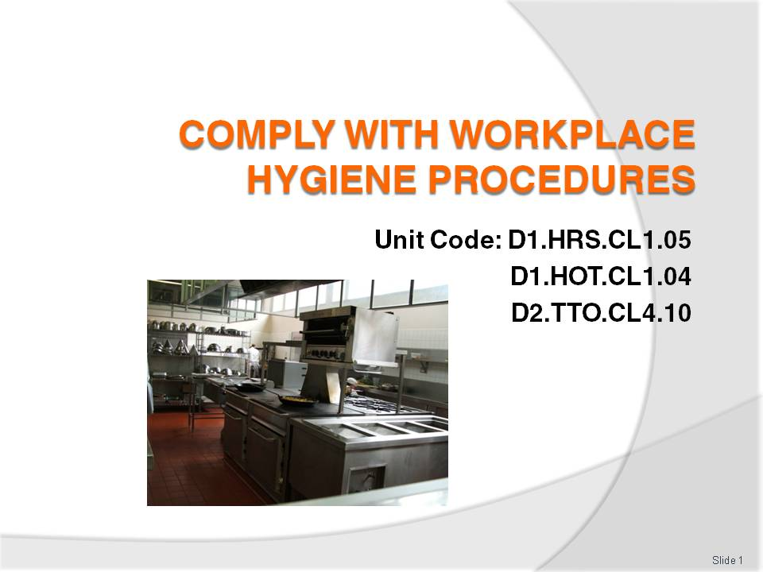
Slide No | Trainer Notes
 | Trainer welcomes trainees to class.

Slide
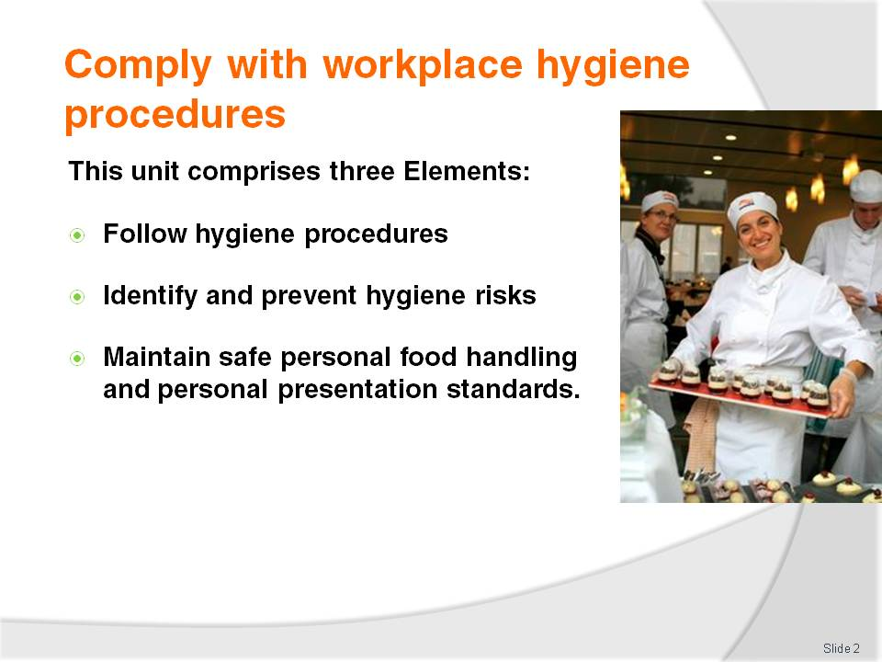
Slide No | Trainer Notes
Trainer advises trainees this Unit comprises five Elements, as listed on the slide explaining:
Each Element comprises a number of Performance Criteria which will be identified throughout the class and explained in detail
Trainees can obtain more detail from their Trainee Manual
At times the course presents advice and information about various protocols but where their workplace requirements differ to what is presented, the workplace practices and standards, as well as policies and procedures must be observed.

Slide
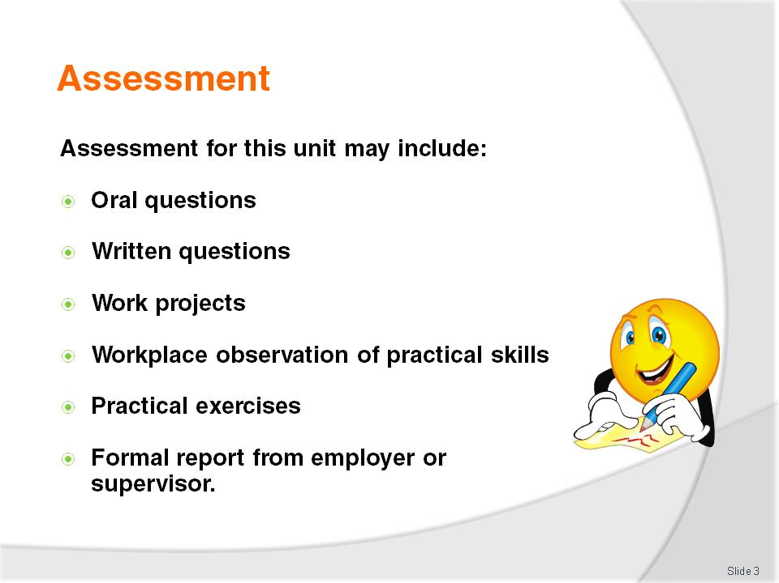
Slide No | Trainer Notes
Trainer advises trainees that assessment for this Unit may take several forms all of which are aimed at verifying they have achieved competency for the Unit as required.
Trainer indicates to trainees the methods of assessment that will be applied to them for this Unit.

Slide
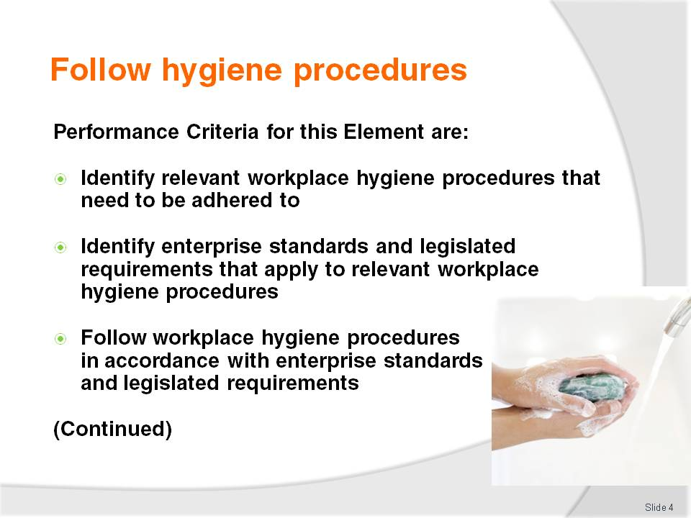
Slide No | Trainer Notes
 | Trainer identifies for trainees the Performance Criteria for this Element, as listed on the slide.

Slide
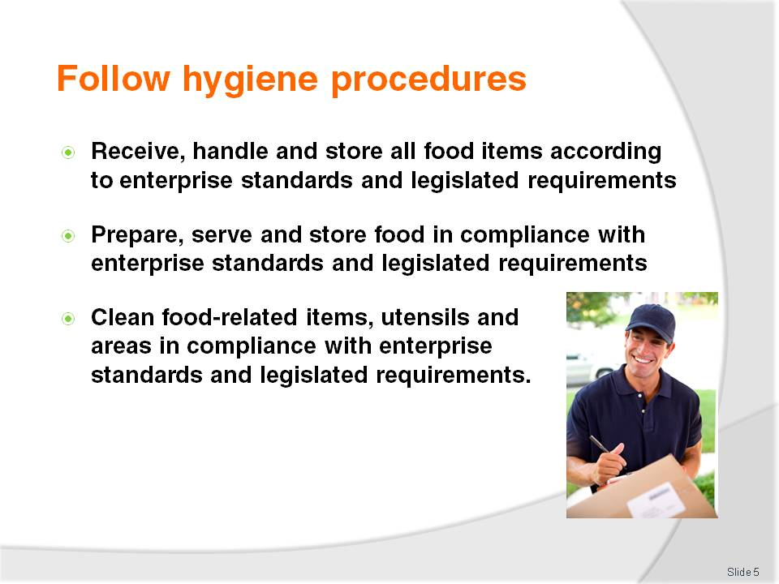
Slide No | Trainer Notes
Trainer continues to identify for trainees the Performance Criteria for this Element, as listed on the slide.
Class Activity – General Discussion
Trainer leads a general class discussion on food safety by asking questions such as:
Why is food safety so important?
What can be the results of not having safe food handling procedures in place in a workplace?
What do you do in your everyday work to optimise food safety?
What do you think are the legal requirements in your workplace applying to food safety?
What legislation are you required to comply with?
What enterprise-specific safe food handling protocols are you required to comply with?
What legal obligations are food handlers under in relation to ensuring the safety of food they handle?
What safe food handling protocols apply in your workplace regarding the receiving of food into the premises?
What sorts of storage facilities for food exist in your workplace, how do they differ and what are the safe food handling protocols that apply for them?
What safe food handling practices do you observe when preparing food for human consumption?
How do you ensure the food you serve to customers is safe?
What protocols apply to the display of food for sale and service where you work?
What is involved in cleaning cutlery and crockery, pots and pans, food preparation equipment and food areas in your workplace?

Slide
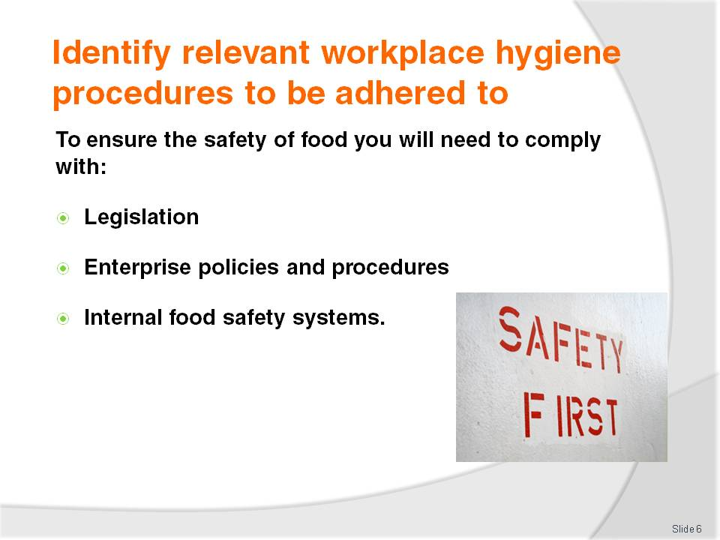
Slide No | Trainer Notes
Trainer informs trainees food handlers are required to comply with workplace and legislated requirements to ensure the safety of food prepared and served for human consumption noting in their workplace they will be expected to comply with safe food handling practices as indicated by:
Legislation – which can include national legislation, regional legislation or local legislation
Enterprise policies and procedures – as determined by the individual employer
The requirements of any internal safe food handling system implemented by the business – these may be a legal requirement or they may be in addition to other legislated obligations imposed by law on a food premises.
Class Activity – Handout and Discussion
Trainer names the local relevant food safety legislation for trainees advising them how to obtain a copy of same, and:
Distributes sample copies
Explains the requirements of same.

Slide
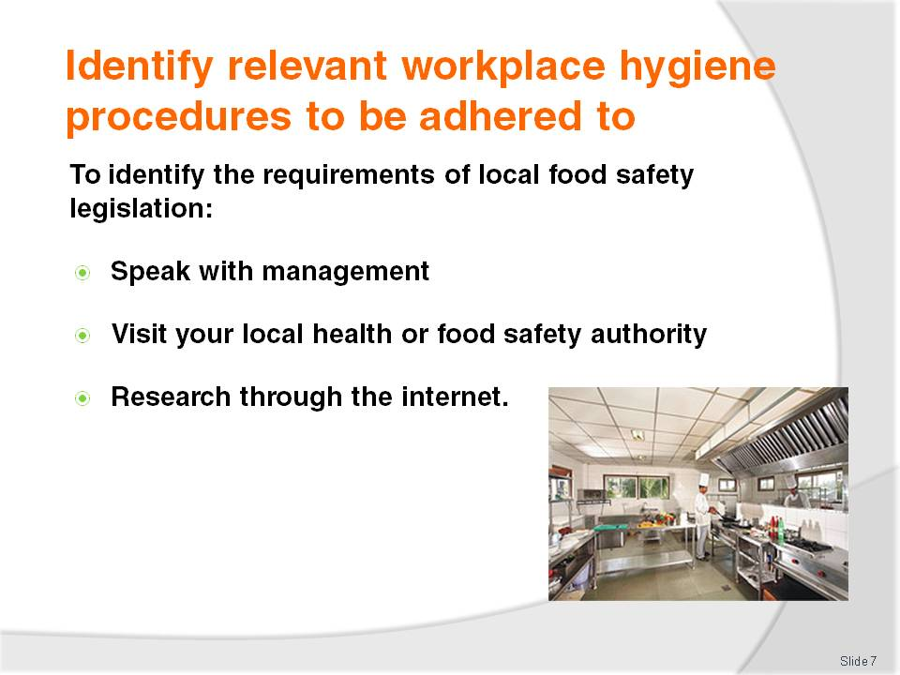
Slide No | Trainer Notes
Trainer advises trainees they should use the following strategies to determine what their local food safety legislation requires them to do:
Speak with management, the owner, supervisor and more senior staff and enquire about what applies in the workplace
Visit local health authority and ask what applies and what obligations apply
Research the requirements on the internet.
Class Activity – Guest Speaker
Trainer arranges for local health authority to visit trainees and:
Explain role of food safety legislation
Describe the safe food practices required under the legislation
Identify assistance available from authorities to optimise food safety
Describe the inspection and monitoring role of health authorities
Identify the penalties for failing to meet food safety obligations.

Slide
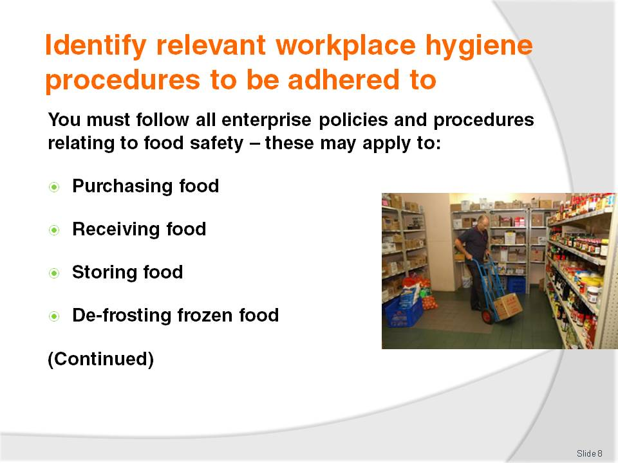
Slide No | Trainer Notes
Trainer tells trainees many workplaces will have individual policies and procedures relating to food safety requirements informing them these support legal requirements, may require more than the law requires, and must be followed by all staff.
Trainer advises house policies and procedures will vary between food premises and can be expected to address all stages of food handling:
Purchasing food from suppliers for use in the food premises
From suppliers into the premises
Food storage prior to preparation and/or service
De-frosting or thawing frozen food.

Slide
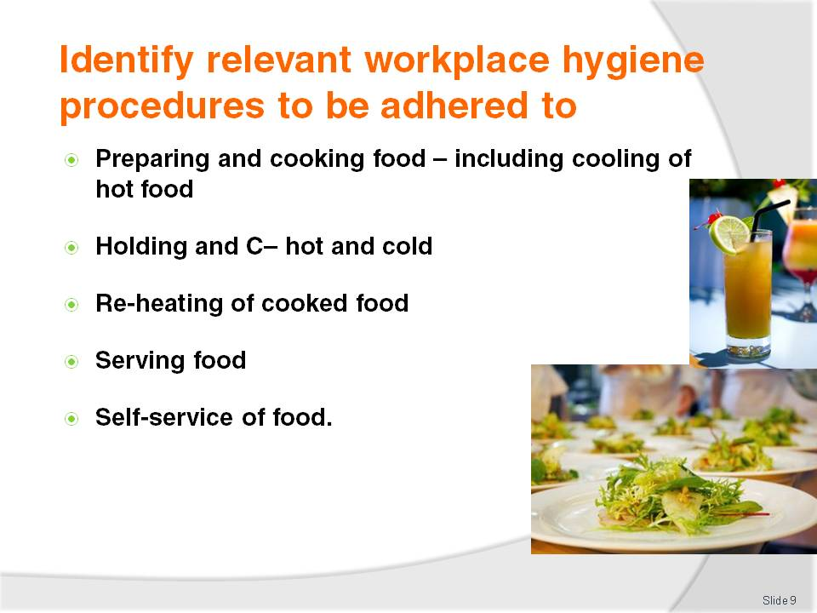
Slide No | Trainer Notes
Trainer continues to present stages of food handling about which most venues can be expected to have food safety policies and procedures:
Preparing of raw materials for sale and service and the cooking food (including the cooling hot food for storage after it has been cooked)
Cold holding and hot holding and display of prepared food for sale and service
Re-heating of prepared food
Serving food to customers for consumption on the premises or as take away food
Self-service of food by customers to themselves.

Slide
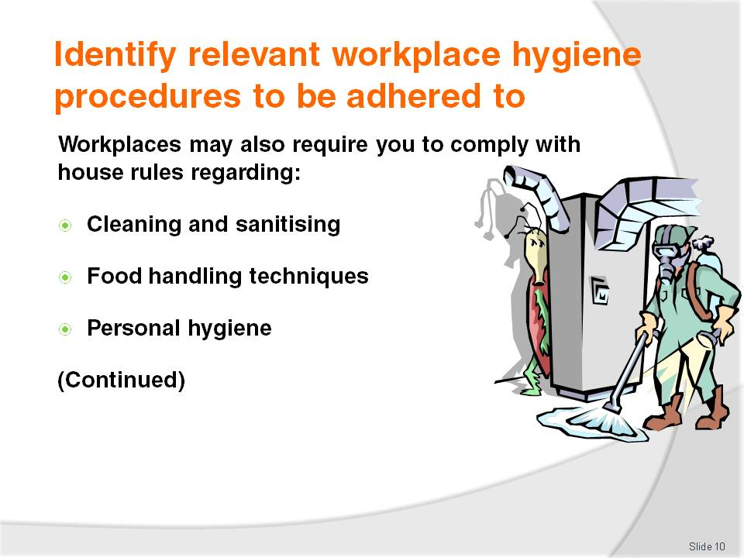
Slide No | Trainer Notes
Trainer highlights to trainees enterprises may also have policies and procedures relating to food safety-related topics such as:
Cleaning and sanitising of food utensils, equipment, areas and food contact and preparation surfaces
Specific food handling techniques required by the workplace to optimise food safety – as applicable to the equipment they use, the food they prepare and other factors applying in the premises
Personal hygiene – and requirements applying to ensure staff do not contaminate food by their actions

Slide
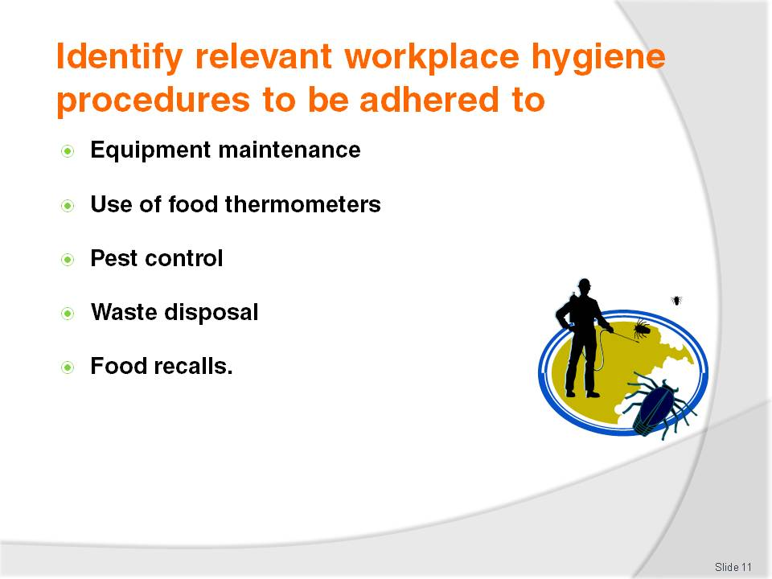
Slide No | Trainer Notes
Trainer continues identifying for trainees associated food safety topics about which workplaces may have policies and procedures:
Equipment maintenance – and the need to keep food equipment, utensils (including food thermometers) and areas properly maintained to ensure they operate as required (for example, it is important for refrigerators, freezers and hot and cold holding units to reach the temperatures they are supposed to reach)
Use of food thermometers – to check food and equipment temperatures
Pest control – to control vermin
Waste disposal – to enable the proper removal of waste from kitchens and from the garbage storage area
Food recalls – to allow unsafe food to be recalled and safely disposed of.

Slide
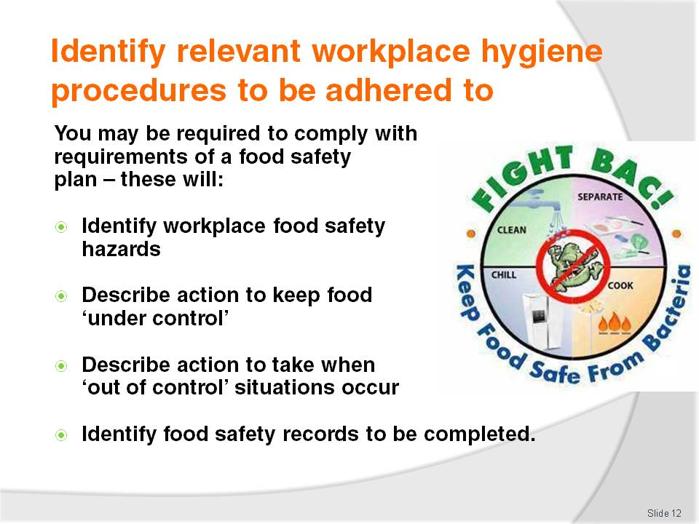
Slide No | Trainer Notes
Trainer presents to trainees some venues will also require them to comply with requirements of a food safety plan (or program) explaining these will:
Identify the workplace food safety hazards – at each stage of the food handling process and in all areas where food is handled
Describe specific action to take to keep food safe at the premises – these are known as ‘safe food handling practices and procedures’ designed to keep food ‘under control’ (meaning the food is always handled and stored within parameters of time and temperature to ensure it remains ‘under control’ and hence safe to eat)
Describe specific action to take if the food becomes unsafe – such as recalling the food from sale/consumption, disposing of it and investigating the cause of the ‘out of control’ situation so remedial action can be taken to prevent a recurrence of the problem
Identify food safety records to be completed to prove compliance with safe food protocols, to identify out of control situations and the action taken to address these situations.
Class Activity – Handouts
Trainer obtains a range of food safety records used in food safety plans and programs, and:
Distributes same to trainees
Explains how to complete them.

Slide
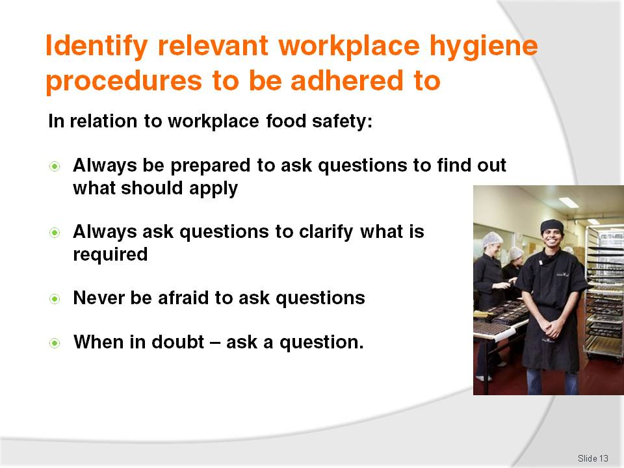
Slide No | Trainer Notes
Trainer highlights to trainees it is vital they ask questions in their workplace to ensure they are adhering to all necessary safe food handling protocols stating:
They must always ask questions or seek clarification about any issue they are unsure about
They must never be afraid to ask questions – do not let the fear of looking foolish stop them asking a question
When in doubt – ask.

Slide
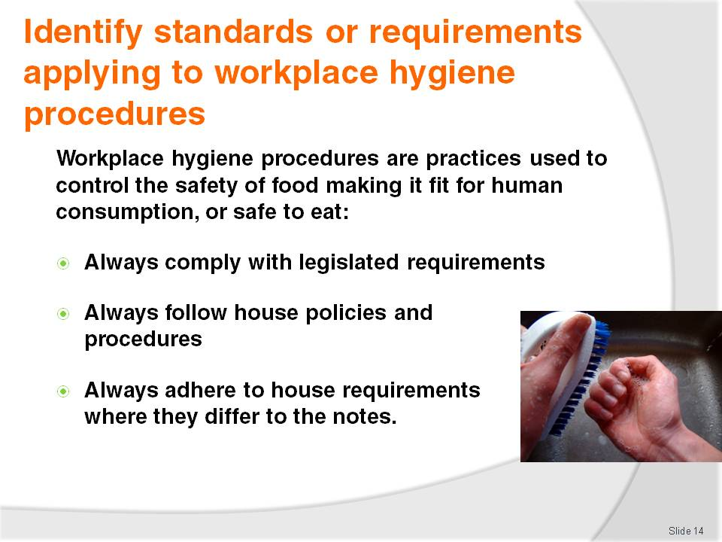
Slide No | Trainer Notes
Trainer advises trainees workplace hygiene procedures are practices used to control the safety of food making it fit for human consumption and safe to eat explaining they must:
Always comply with legislated requirements – or they could be penalised and or fined
Always follow house policies or procedures – or they could lose their job
Always follow house policies where they differ from the notes – because the requirements of the employer must always take priority.

Slide
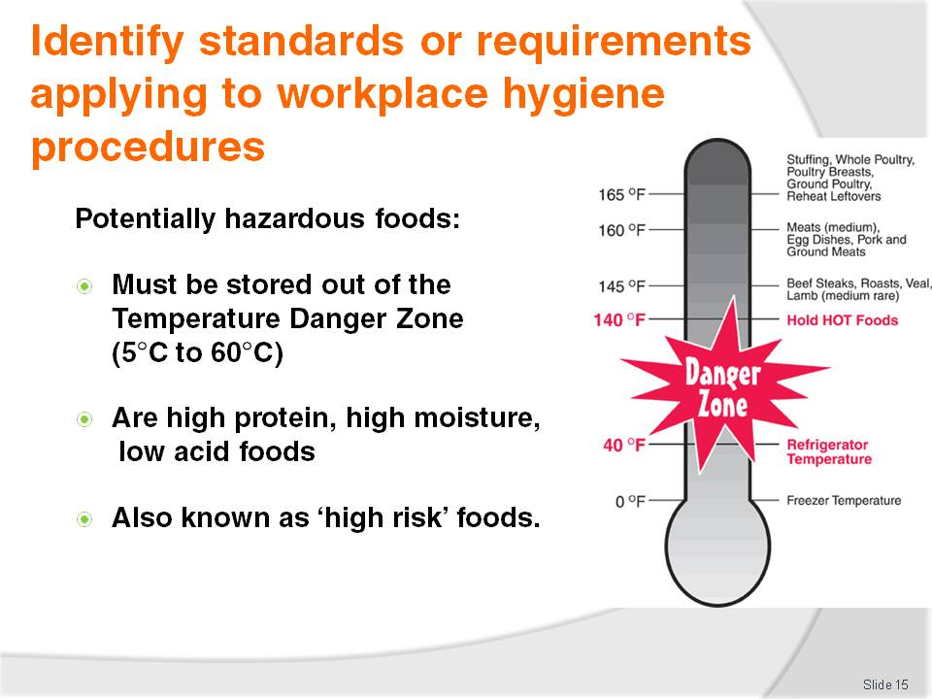
Slide No | Trainer Notes
Trainer introduces trainees to the concept of ‘potentially hazardous foods’ stating:
Potentially hazardous food is food that must be stored under special temperature conditions – to prevent the growth of food poisoning bacteria, or to prevent the formation of toxins in the food
Potentially hazardous food focuses on high protein, high moisture, low acid foods – examples to follow on next slides
Special attention must be paid to ‘potentially hazardous foods’ to make sure they are stored correctly at the right temperature (that is, out of the Temperature Danger Zone [5°C - 60°C]).

Slide
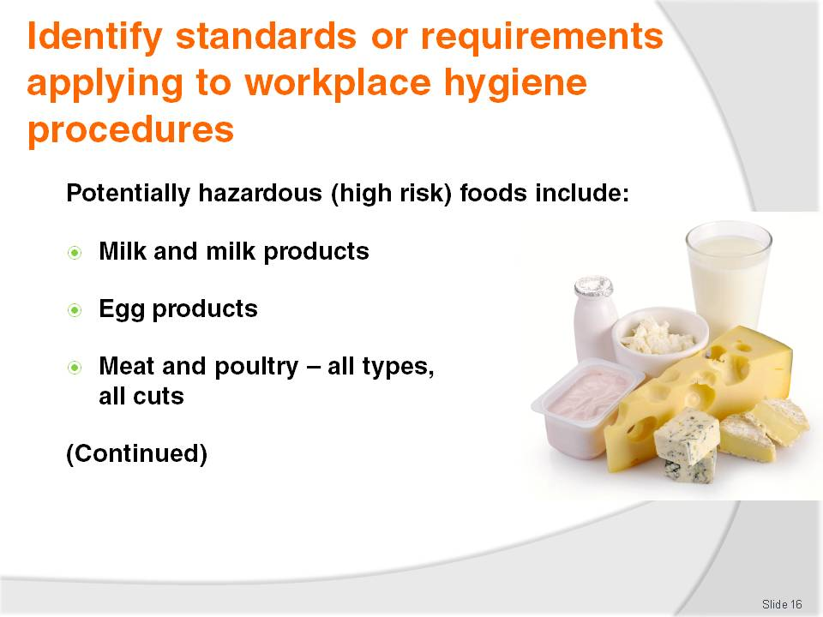
Slide No | Trainer Notes
Trainer presents examples of ‘potentially hazardous food’:
Milk and milk products, soft cheeses – butter, yoghurt, custards, cream cakes, cheese, baked custard tarts and dips
Egg products – quiche, fresh pasta, duck and game bird eggs, all eggs, mayonnaise (whole egg)
Meat and poultry – all cuts and types. Includes beef, ham, veal, pork, chicken, turkey – includes legs, mince, steaks, chops, cutlets, breast, wings.

Slide
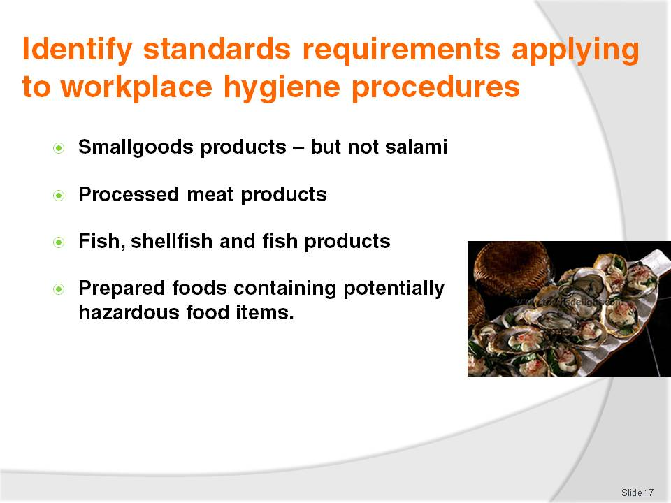
Slide No | Trainer Notes
Trainer continues to present to trainees examples of high risk foods:
Smallgoods products – ham, pressed chicken, but note most salami is not a high risk food due to its high salt and low moisture content
Processed meat products including chicken – paté, meat pies, sausages, sausage rolls, coagulated blood (in, for example, black pudding), rissoles, meat balls
Fish, shellfish, fish products, fish soups and fish stocks – caviar, fish balls, patties, salads, sauces and stews
Other prepared food dishes containing high risk food products – pizza, prepared meals, pre-made sandwiches and rolls, salads and cooked rice and cooked pasta.

Slide
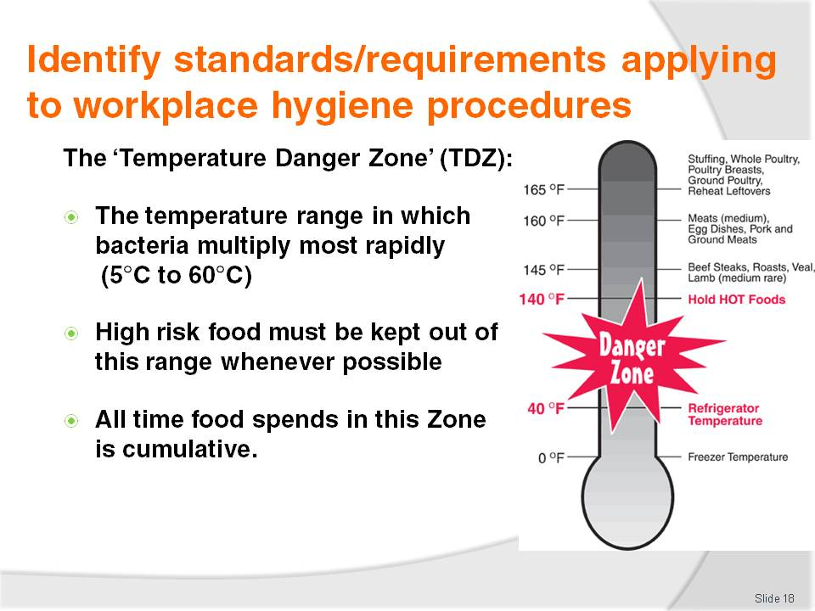
Slide No | Trainer Notes
Trainer explains to trainees the importance of the Temperature Danger Zone to food safety stating:
The Temperature Danger Zone is the temperature range in which bacteria multiply most rapidly
The range is 5°C to 60°C
Every effort must be made to keep potentially hazardous food out of this temperature range
Where food must to be in this range (such as when it is being prepared), the amount of time the food spends in this zone must be minimised
It is important to note all time food spends in the Temperature Danger Zone is cumulative. For example, if a piece of meat is left out on the bench for one hour, refrigerated and then brought back out into the kitchen, the time it then spends in the Temperature Danger Zone is added to the previous time – the clock (and the bacteria count) does not get reset to zero when the food was put in the fridge again.

Slide
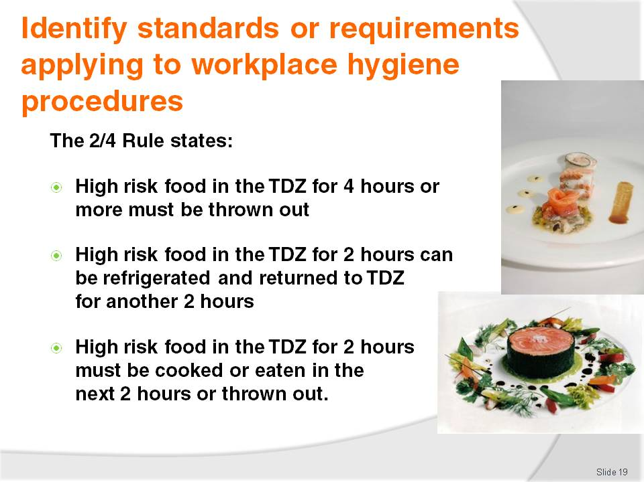
Slide No | Trainer Notes
Trainer introduces trainees to the 2/4 Rule stating awareness of the 2/4 rule is critical in applying safe food handling procedures, explaining the 2/4 rule states:
Potentially hazardous foods that have been in the Temperature Danger Zone for 4 hours (or more) must be discarded/thrown out
Potentially hazardous foods that have been in the Temperature Danger Zone for 2 hours can be refrigerated and then returned to the Temperature Danger Zone for another 2 hours, maximum
When high risk food has been in the Temperature Danger Zone for 2 hours it must be cooked or eaten within the next 2 hours or thrown out
There are no exceptions to this rule.

Slide
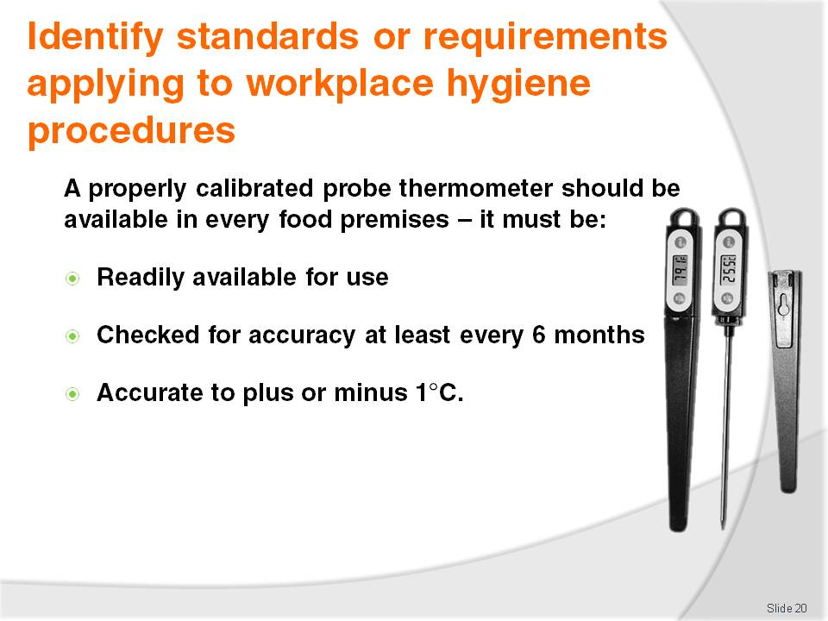
Slide No | Trainer Notes
Trainer tells trainees all food premises should have at least one independent, calibrated food thermometer available to check the temperature of food (on delivery, during processing, while on display), and food equipment (such as fridges, coolrooms, freezers, bain-maries, food warmers). Trainer advises ‘calibration’ refers to testing the thermometer to prove it is giving accurate readings
Trainer advises a probe thermometer is best (not an infra-red one as they provide only surface temperature readings, as opposed to internal readings), stating the thermometer must be:
Readily available for food handling staff to use as required – it should not be locked away in an office where it cannot be easily accessed
Checked/calibrated very six months (minimum) to ensure it is giving an accurate reading. Instructions on how to do a hot and cold calibration to check the accuracy of the thermometer are sometimes included in the instructions accompanying the thermometer
Thermometers must be accurate to plus or minus 1°C or they must be repaired or replaced.

Slide
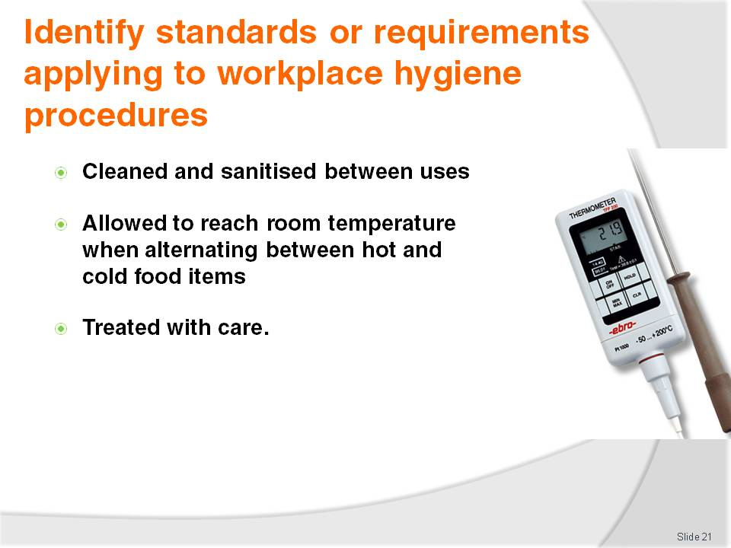
Slide No | Trainer Notes
Trainer continues presenting to trainees requirements regarding probe food thermometers advising they must be:
Cleaned and sanitised between uses when it is being used to check the temperature of food – the use of a sanitising wipe to clean and sanitise the probe is common
Allowed to reach room temperature when being alternated between use on hot and cold food or vice versa – to allow the thermometer to reach ambient temperature before being used
Treated with care – do not knock, drop or damage it: if it is knocked, dropped or damaged, it should be immediately checked for accuracy.
Class Activity – Demonstration
Trainer shows a probe thermometer to trainees and shows them how to:
Use the thermometer to take the temperature of food and food equipment (refrigerators, bain maries)
Clean & sanitise the probe with a sanitising wipe
Undertake a hot and cold calibration of the thermometer to verify its accuracy.

Slide
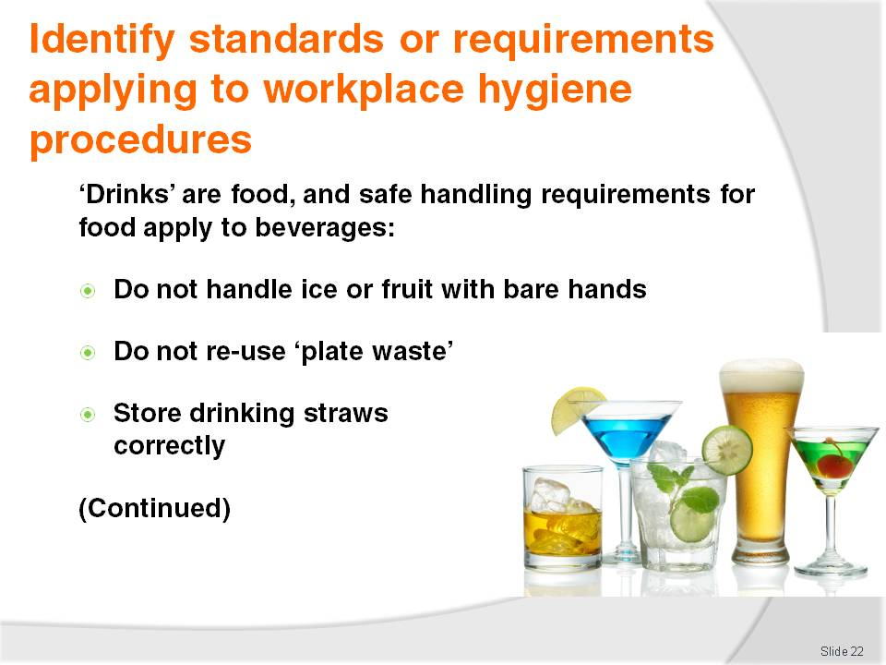
Slide No | Trainer Notes
Trainer presents trainees with requirements for food handlers working in a bar area advising ‘beverages’ are regarded as food, and the following practices apply when working in a bar environment with ‘food’ and ‘drinks’:
Use a fork or tongs when putting fruit or ice in a glass – do not use fingers
Do not re-use any fruit, straws, beverage, food, garnish left by a customer, or which comes back from the tables – all plate waste must be thrown out
Ensure drinking straws are correctly stored – they must be stored so they are kept free from flies, dust and contamination. They must be able to be obtained one at a time without other straws being touched meaning it is not acceptable to store straws in a glass or other container on the bar.

Slide
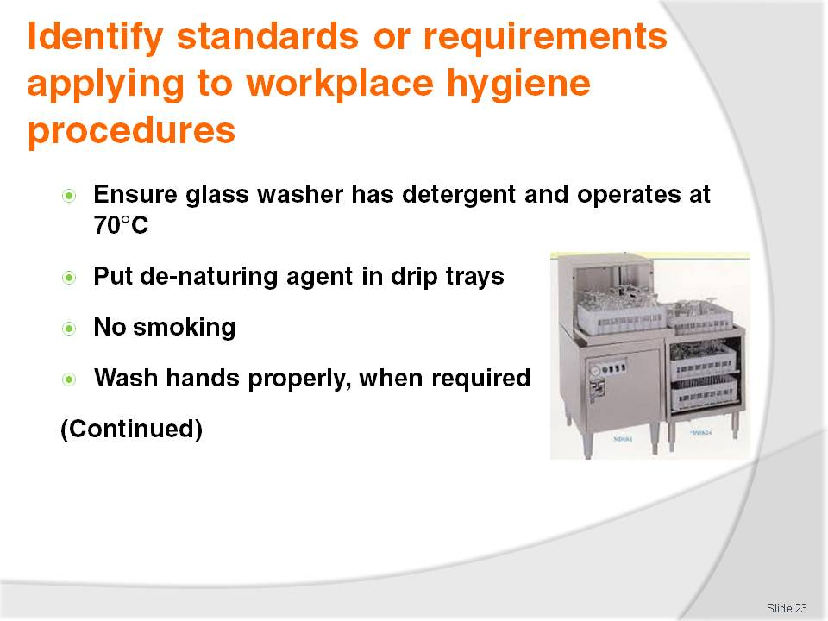
Slide No | Trainer Notes
Trainer continues to present food handling requirements for bar staff:
Check glass washing machine has detergent, and is operating at the prescribed temperature which is 70°C
Put de-naturing agent in drip trays (drip trays are trays which are placed under beer drawing taps to catch the drips/overflow from glasses) – there must be sufficient de-naturing agent to actually de-nature the waste beer and stop the premises pouring this waste beer back into the beer keg or otherwise re-using it
No smoking or spitting behind the bar
Wash hands at all times that kitchen-based food handlers are required to wash their hands – see later slides for full details on effective hand washing for food handlers (examples include: before starting work; whenever they become contaminated’ after using the toilet; after handling a handkerchief or nasal tissue; after handling chemicals and or waste).

Slide
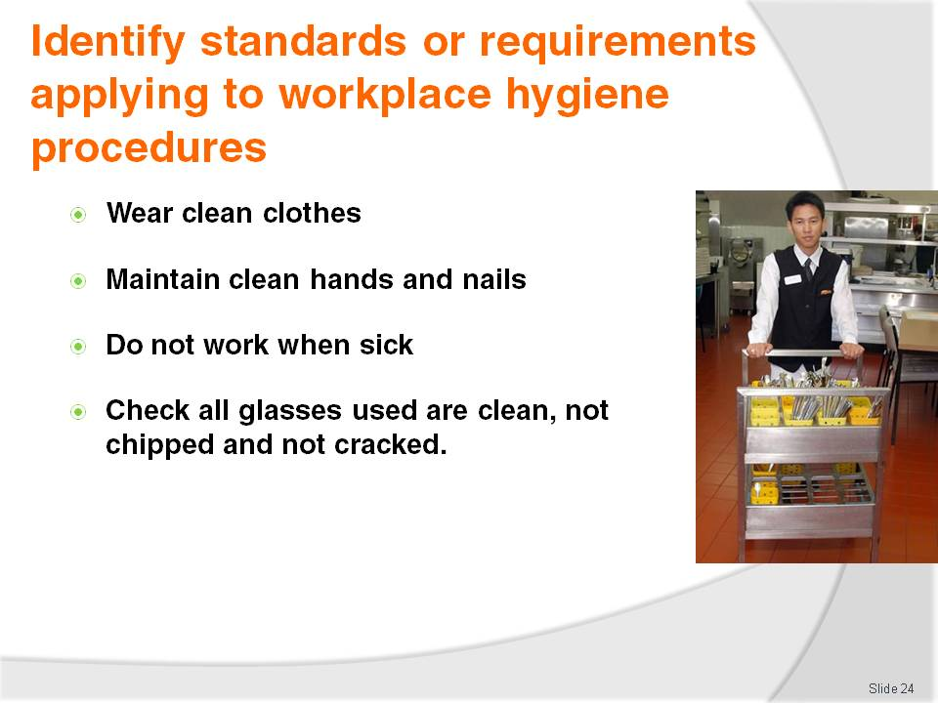
Slide No | Trainer Notes
Trainer continues to present food handling requirements for bar staff:
Ensure clean clothes, hands and fingernails whenever working in a bar – the same standards apply to bar staff as to kitchen workers and other food handlers
Stay away from work if ill or suffering from an infected cut. Notify doctor of status as a food handler so they can ensure fitness to return to work, free from disease, after an illness. Many employers require food handlers to provide a medical clearance certificate after an absence from work due to illness declaring their fitness for work on return
Ensure all glassware and utensils are clean – plates and glasses must also be free of chips and cracks: chips and cracks can harbour food poisoning bacteria.

Slide
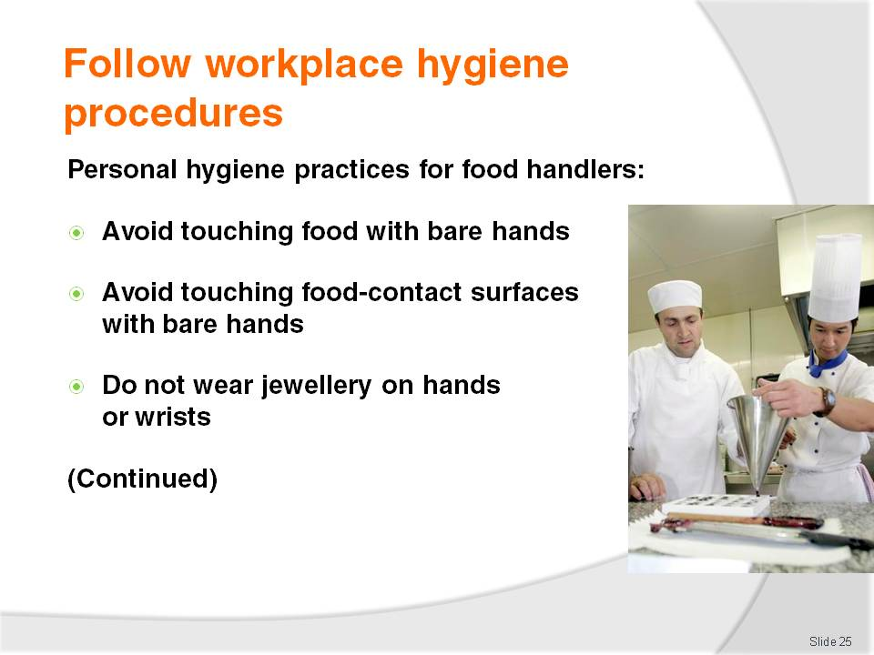
Slide No | Trainer Notes
Trainer stresses to trainees it is vital all workplace hygiene procedures are complied with at all times, without exception, presenting ‘personal hygiene’ as one important aspect with the following requirements:
Avoid touching food with the bare hands – use tongs, a spatula, fork, serving spoon or gloves when touching food especially food that will not be further cooked or processed
Avoid touching food surfaces with the bare hands – this means avoiding touching preparation benches, preparation equipment and the food contact surfaces of serving items such as plates, bowls and cups with the bare hands
No jewellery to be worn on hands and wrists – food can lodge in the jewellery, deteriorate and then fall back into food. There is also a chance stones or gems may fall out from rings and jewellery into the food providing a physical contaminant. If a ring must be worn, cover it using a coloured band-aid and disposable glove.

Slide
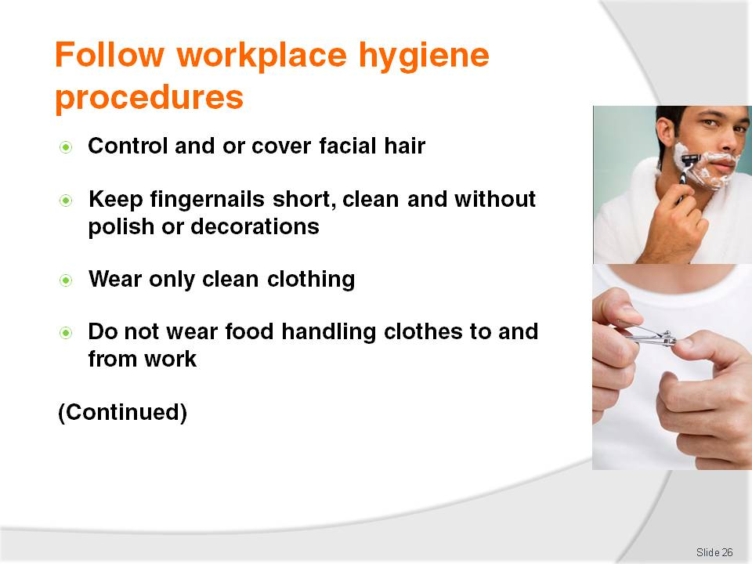
Slide No | Trainer Notes
Trainer continues presenting personal hygiene requirements for food handlers reminding them they must realise their health and actions have a major impact on food safety:
Facial hair must be kept neat and controlled – hair should either be covered or sprayed to keep it controlled in such a way that hairs do not fall into food. Long hair must be tied back, and beards should also be covered. In kitchens and food areas, hair nets or hats should be worn
Fingernails must be short, clean and free of polish (including clear nail polish) –cracked fingernails and chipped nail polish can harbour bacteria and may also flake off into food. Fingernail decorations and artificial nails are also prohibited
Clothing must be clean – a minimum requirement is for clean clothes for each shift with further changes as spillages and 'working dirt' dictate
Do not wear ‘food handling’ clothes to and from work – they can come into contact with dirt and bacteria which may then be transferred to the work area and or food.

Slide
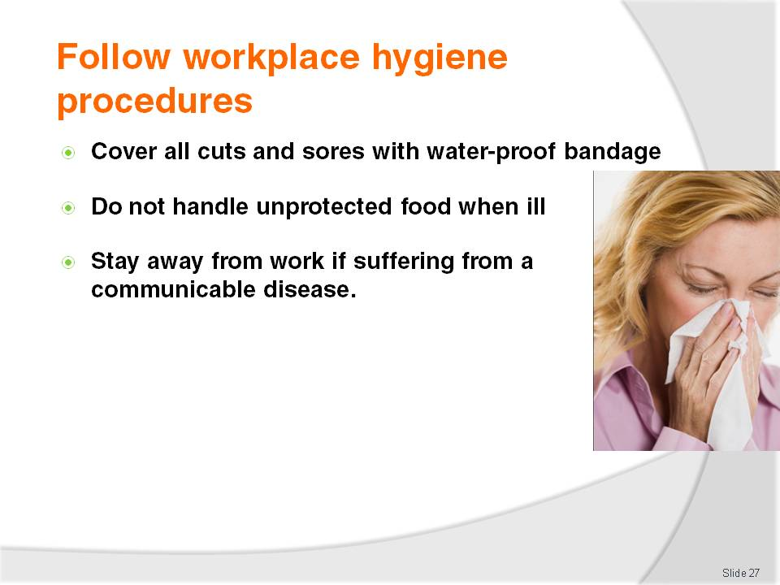
Slide No | Trainer Notes
Trainer continues presenting personal hygiene requirements for food handlers urging them to take personal hygiene seriously:
Cuts and sores must always be covered – a coloured, water-proof dressing must be applied and a finger stall also used where necessary. A disposable glove can also be worn where the cut or sore is on the hands
Food handlers in the acute state of a common cold must not handle uncovered food – but they may, for example, work where food is in sealed containers, such as in a bottle shop or a retail shop where all food sold is in tins or sealed packets
Food handlers with any communicable disease must not deal with food until they receive a certificate from a doctor stating as a food handler they are cleared to work with food – see later notes for more detail.

Slide
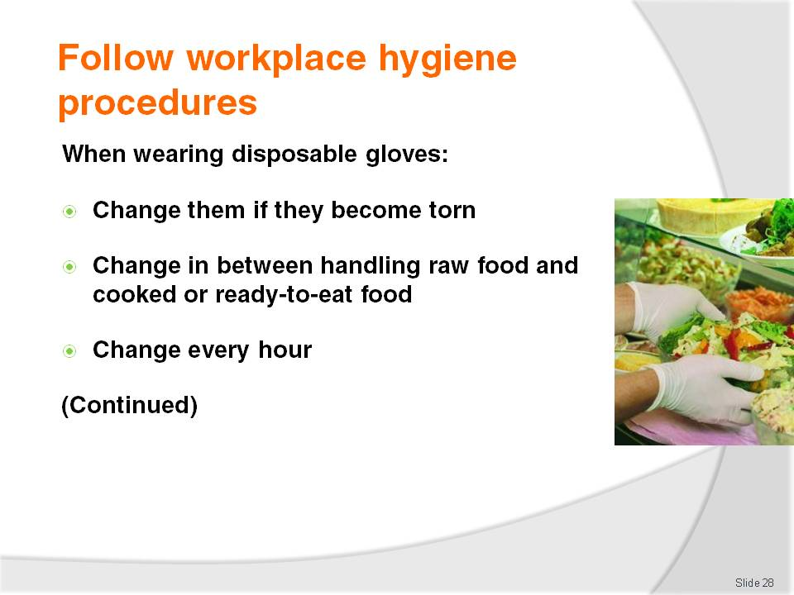
Slide No | Trainer Notes
Trainer tells trainees the use of protective, disposable gloves in food handling is an excellent safe food handling practice but gloves do not fix all food hygiene problems, advising when wearing disposable gloves:
Change gloves immediately they are ripped or torn – do not continue working while wearing torn gloves
Change gloves between handling raw and cooked, ready-to-eat foods – to avoid cross contamination (such as the transfer of bacteria from raw food to cooked, ready-to-eat foods)
Change gloves every hour regardless – the same pair of gloves cannot be worn for longer than this, or worn for an entire shift.

Slide
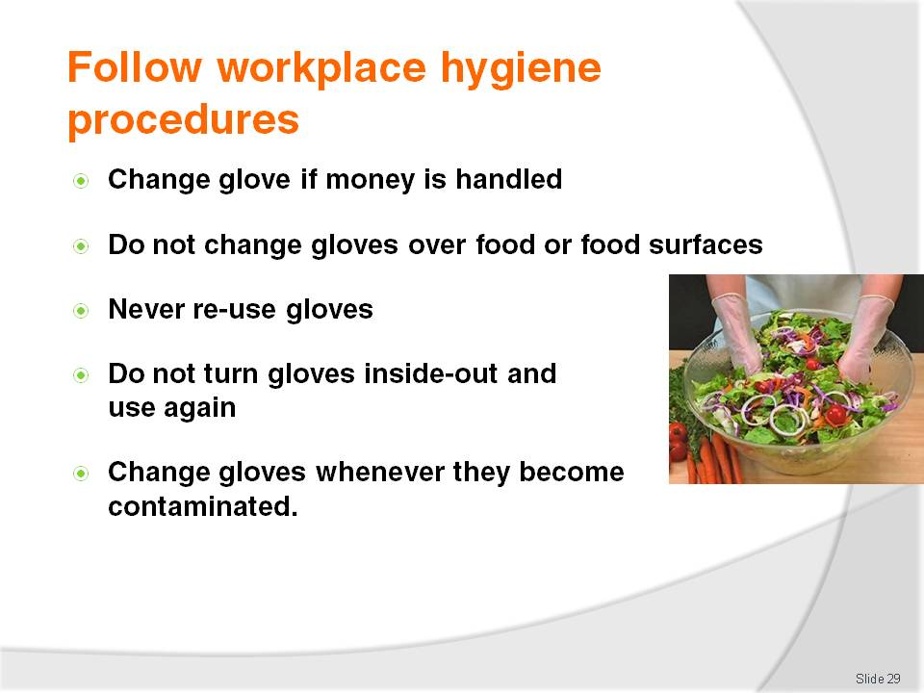
Slide No | Trainer Notes
Trainer continues to present trainees with requirements relating to the use of disposable gloves:
If handling money do not use the same gloved hand to handle food – take one glove off, handle the money with that hand (without the glove on), and then put on a new clean glove before returning to food handling duties
If changing gloves during service, ensure they are not taken off over food or food surfaces – if the gloves contain powder, this may fall out onto food or food preparation surfaces and provide a source of contamination
Do not try to put on gloves that have already been used – disposable gloves must be disposed of out as soon as they are taken off
Do not turn gloves inside out and try to wear them again – see above
Change gloves whenever they become contaminated from whatever source – raw food, blood, sneezing, chemicals, scratching the face, handling rubbish: whenever there is a need to wash hands, change gloves.

Slide
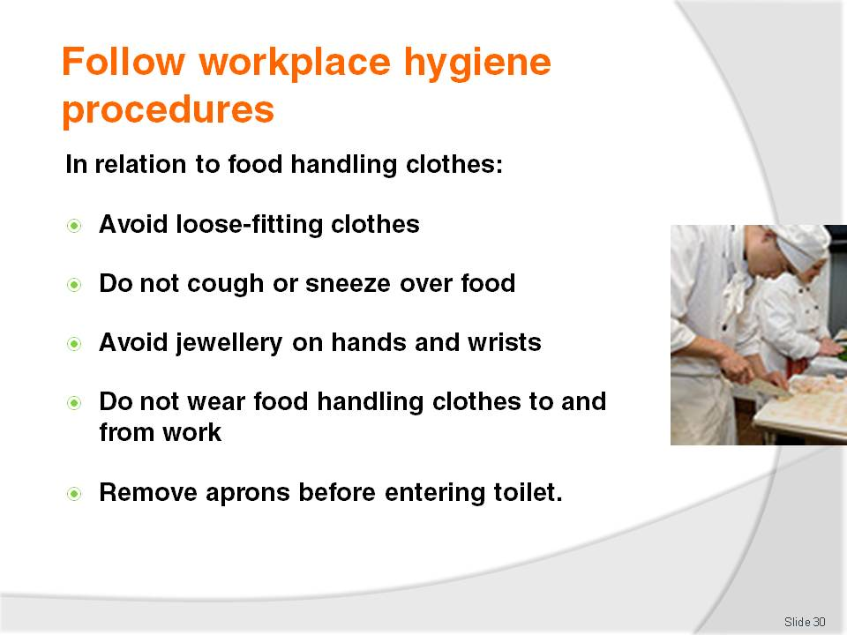
Slide No | Trainer Notes
Trainer explains to trainees clothing worn by food handlers has the potential to pose a food risk, so they must:
Ensure anything from their body or anything they wear does not contaminate food or food surfaces highlighting practical measures in this regard include:
- Avoid loose-fitting clothes – sleeves can hang down into food
- Do not cough or sneeze over food – or food surfaces, equipment, utensils
- Avoid items of facial jewellery that hang down – they are likely to fall into food
- Avoid wearing rings when working with food – especially avoid (or appropriately cover) rings with stones in them
- Do not wear food handling clothes to and from work
- Remove protective clothing (aprons) when using the toilet – to guard against cross contamination.

Slide
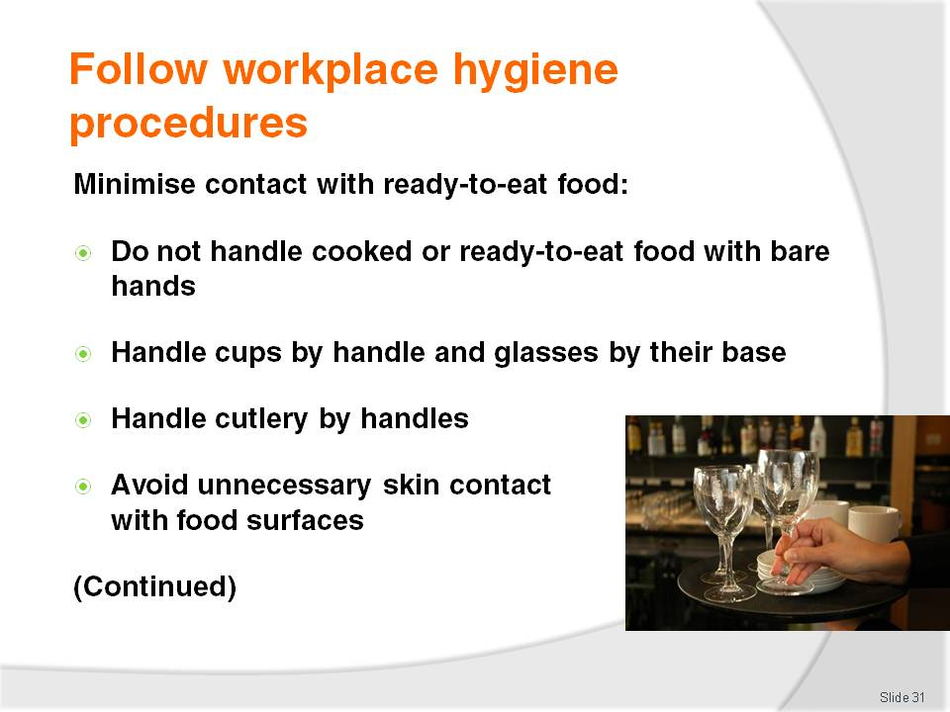
Slide No | Trainer Notes
Trainer advises trainees they must take appropriate measures to minimise contact with ready-to-eat food explaining practical measures in this regard include:
Not handling cooked, and or ready-to-eat food with the bare hands – use tongs
Handling glasses and cups by their base – and not by the rim
Handling cutlery by the handles – not by the part customers put in their mouth
Avoiding unnecessary skin contact with food contact surfaces.

Slide
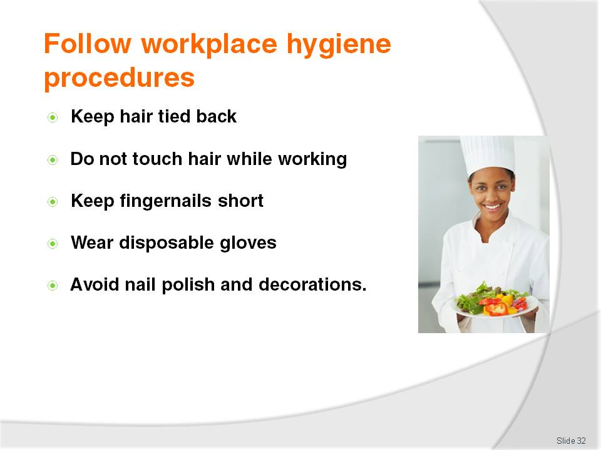
Slide No | Trainer Notes
Trainer continues to identify practices to minimise personal contact with food:
Keep hair tied back – wearing hats or beard nets helps ensure hair does not fall into food
Avoid touching hair while working with food – as this can transfer bacteria
Keep fingernails short – to avoid physical contamination from the nail (and to make them easier to clean)
Wear disposable gloves when handling food – and changing them regularly as required
Avoid nail polish, fingernail decorations and artificial fingernails.

Slide
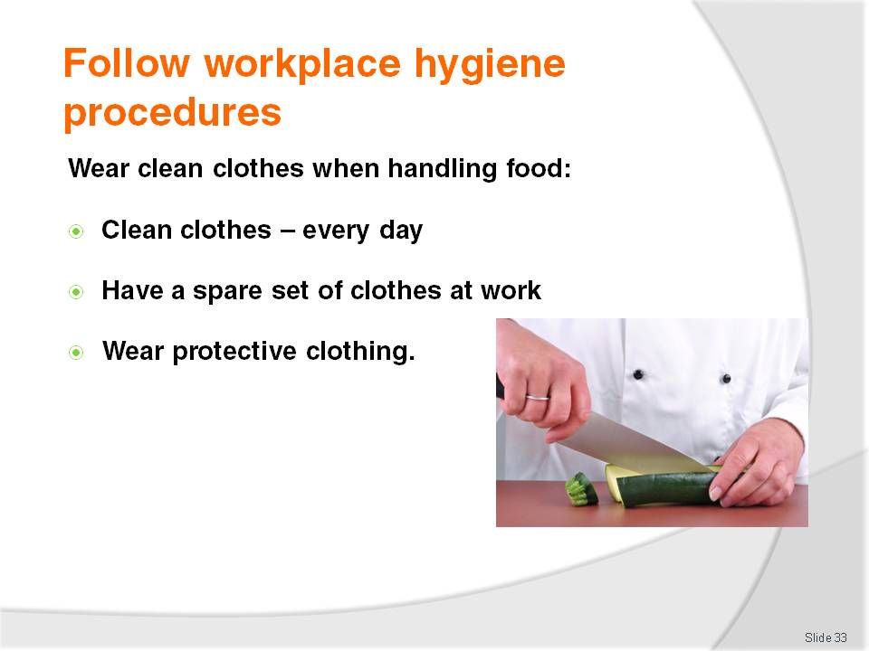
Slide No | Trainer Notes
Trainer indicates to trainees they must wear clean clothing when handling food stating practical measures in this regard include:
Wear clean clothes – to work daily
Have a change of clothes available at work – to change into if one set of clothes becomes dirty or contaminated
Wear protective clothing – such as aprons.

Slide
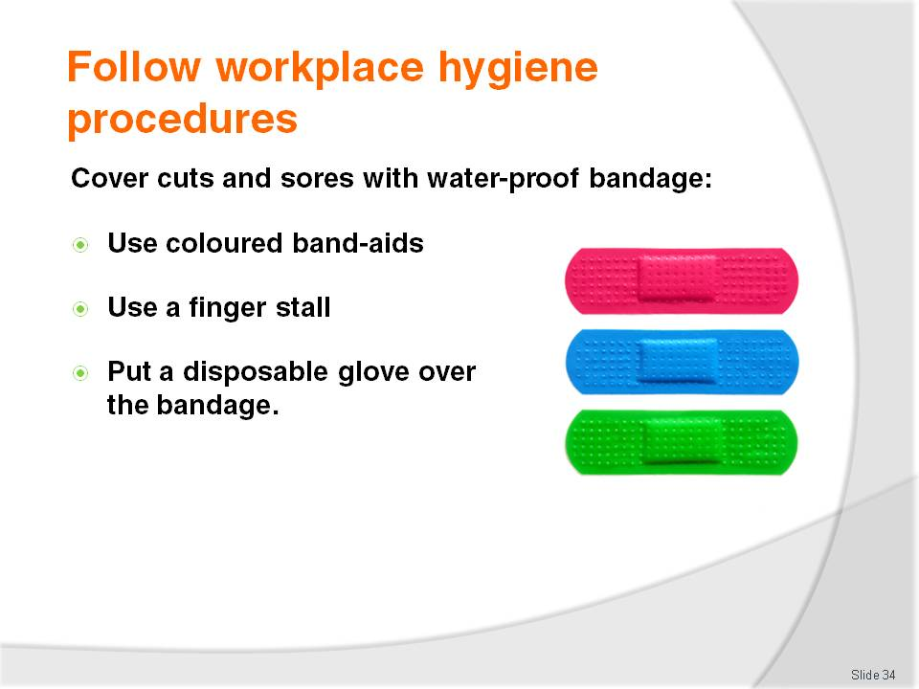
Slide No | Trainer Notes
Trainer states to trainees they must use waterproof bandages and dressing on exposed parts of the body where there are cuts or sores when handling food stressing practical measures in this regard include:
Wear only coloured band-aids when handling food – they are easier to identify if they fall into food
Wear a finger stall over a bandage or dressing on a finger – to give extra protection and security
Wear a disposable glove over a bandaid, dressing or bandage that is on the hand.

Slide
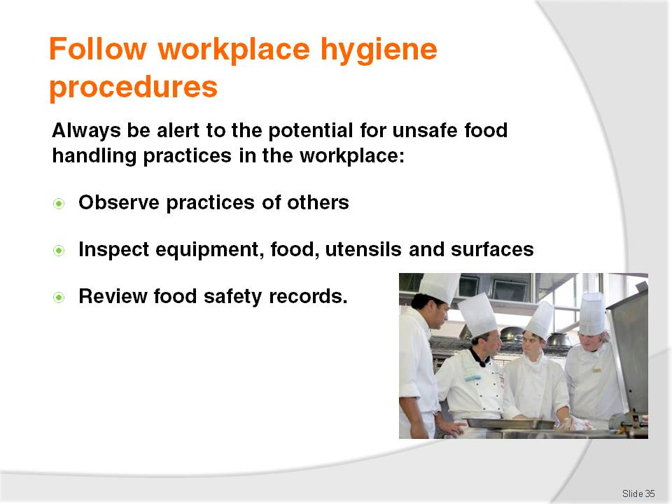
Slide No | Trainer Notes
Trainer informs trainees they are obliged to be constantly alert to the possibility of unsafe food handling practices occurring in the workplace so they can report them in order that appropriate corrective action can be taken indicating the three main ways to identify problems in relation to food safety are:
Personal observation of conditions and staff practice
Inspection of raw materials, premises, equipment and final products
Review of food safety records – to identify out-of-control situations.

Slide
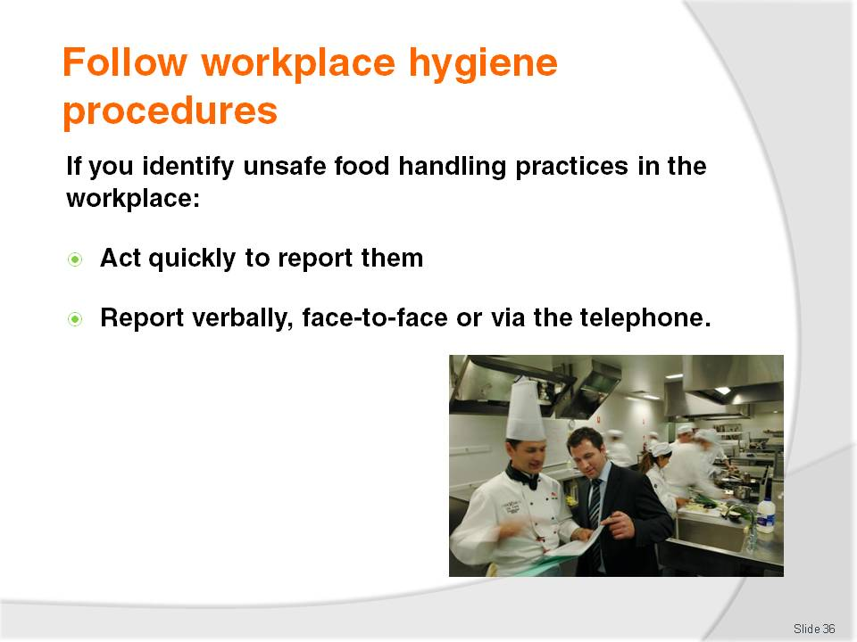
Slide No | Trainer Notes
Trainer advises trainees when unsafe food handling practices are identified in the workplace they must be reported highlighting speed is important in responding to and reporting inconsistencies and ‘out of control’ situations so the recommended methods of reporting are:
Face-to-face
Verbally, over the phone.
Both of these methods allows the person being reported to, to ask questions and fully understand the situation.

Slide
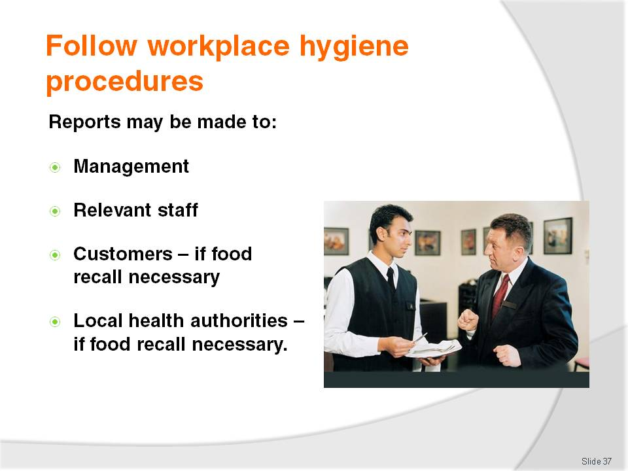
Slide No | Trainer Notes
Trainer recommends to trainees reports about unsafe food handling practices should be made to:
Management – senior management; the owner; a food safety supervisor (where available)
Relevant staff – who are involved in the problem, or will be involved in fixing the problem
Customers – only where a recall of food has been decided as being necessary
Local health authorities – only where a food recall has been implemented.

Slide
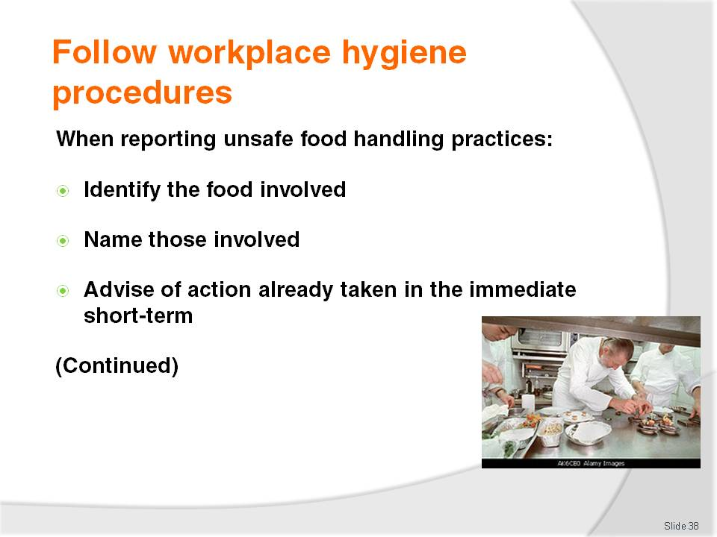
Slide No | Trainer Notes
Trainer suggests to trainees when reports about unsafe food handling practices are made, consideration should be given to covering the following:
Identifying the food involved – by type, location, amount, stage of processing it had reached
Naming the people involved – staff and customers (where appropriate)
Reporting any action already taken – to limit the potential negative impacts.

Slide
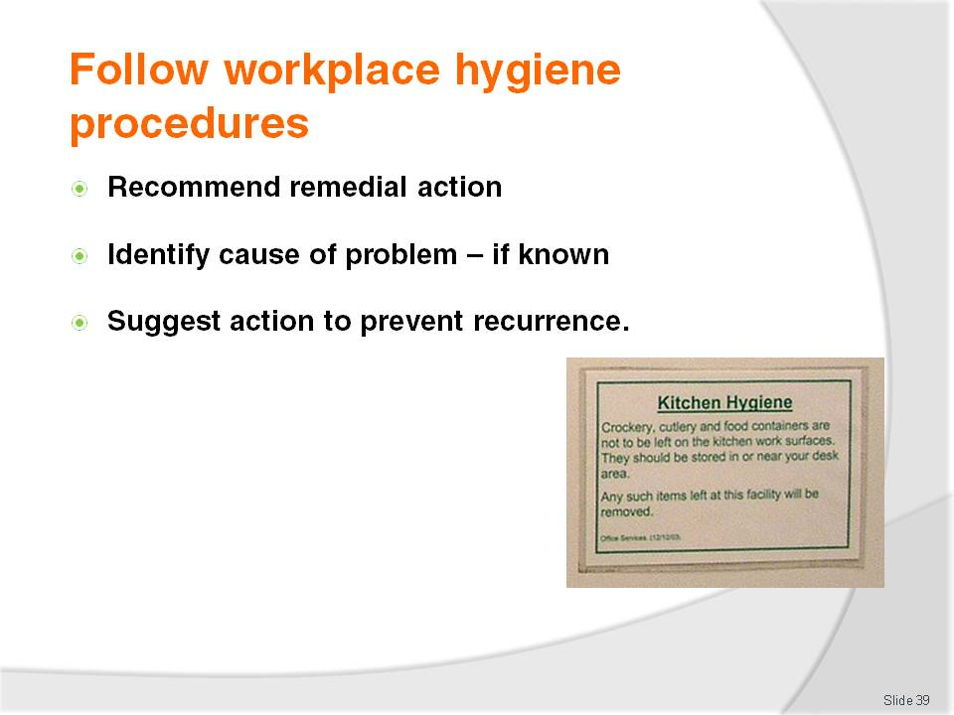
Slide No | Trainer Notes
Trainer continues to advise trainees of information to convey when reporting an unsafe food handling practice in the workplace:
Recommending action for limiting the future potential negative impacts – in relation to the impact of the unsafe practice that has been identified
Identifying (if known) what caused the out of control situation – so appropriate remedial action can be taken, or a focus for investigation is provided
Describing thoughts about what should be done – to prevent a recurrence of the problem.

Slide
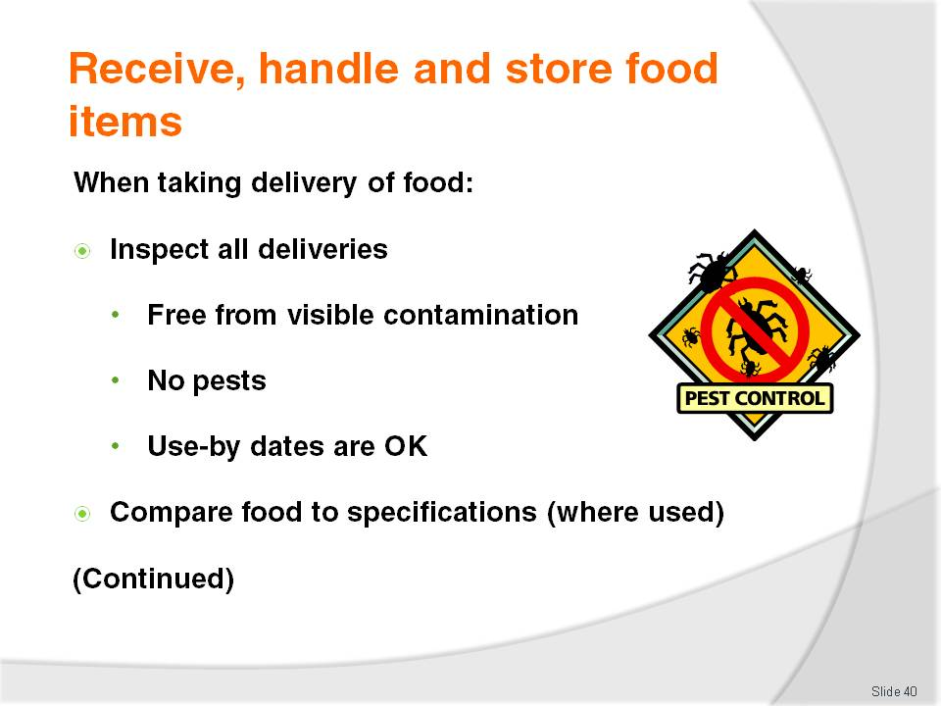
Slide No | Trainer Notes
Trainer advises trainees regarding safe food handling requirements in relation to accepting food (‘food receipt’) deliveries from suppliers into the premises are:
Inspect the deliveries – conduct a visual inspection of deliveries to make sure:
- The food is free from visible contamination – for example, frozen food must be hard frozen; packaging and wrapping must not be torn; the integrity of tins and packets has not been compromised and they are not leaking; the food was not delivered amongst chemicals; the food does not smell ‘off’; cans are not ‘blown’
- The delivery does not bring in pests or rodents – spiders, cockroaches, mice
- The use-by dates of the food are acceptable – reject any food delivered beyond its use-by date or where it is believed the premises will not be able to use the food delivered before it reaches its use-by date
Compare the food delivered to any product specifications set for food items – not all establishments will have these specifications in place but where they are being used, they should be checked. If the food delivered does not meet specifications it must be rejected.

Slide
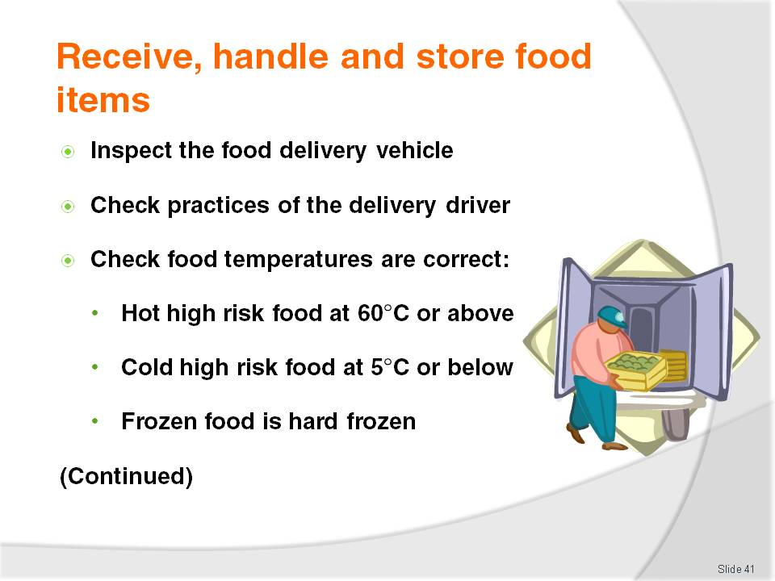
Slide No | Trainer Notes
Trainer continues to tell trainees about checks to be made when receiving food from suppliers in to the premises:
Inspect the food delivery vehicle – check it is clean (see definition below) and is a dedicated food delivery vehicle. Food should not be delivered to food premises in private vehicles – dedicated food transport vehicles should be used
Check the practices of the delivery driver – check things such as:
- Whether or not food is protected during the delivery process – is the delivery vehicle left unlocked during deliveries? Is food placed on the footpath? Are there chemicals mixed in amongst the food items?
- Personal hygiene of the delivery driver
Check the temperature of the food is in accordance with the following using a properly calibrated thermometer:
- Frozen food should be hard frozen with no evidence of defrosting: - 15°C is the recommended temperature
- Hot food that is ‘potentially hazardous’ must be at 60°C or above
- Potentially hazardous refrigerated food must be at 5°C or below.
Note: potentially hazardous food may be accepted where the delivery driver can prove the combination of time and temperature have not adversely impacted on food safety. In general terms, if the food has been in the Temperature Danger Zone for 2 hours or longer the food should be rejected. When accepting a delivery of potentially hazardous food in the Temperature Danger Zone, it should be used immediately and not be subject to the standard stock rotation principle of First In, First Out.

Slide
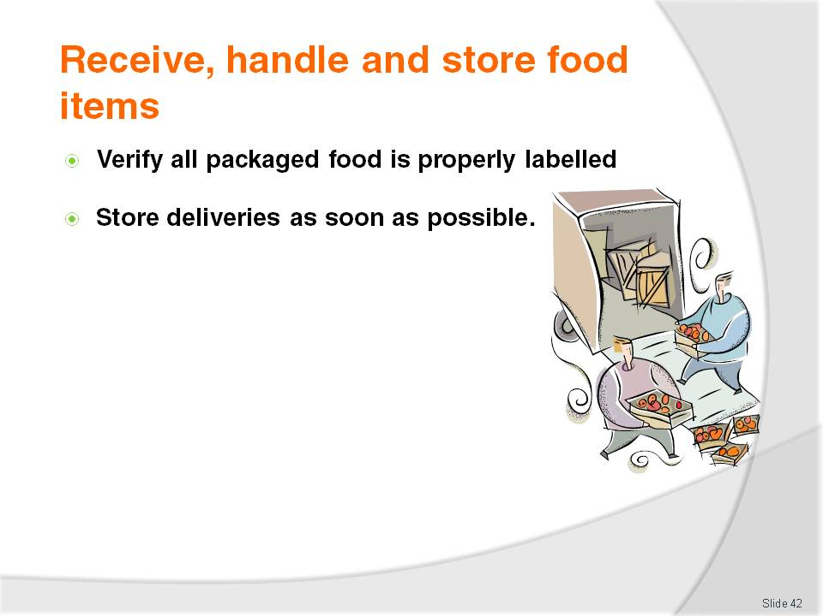
Slide No | Trainer Notes
Trainer continues to tell trainees about checks to be made when receiving food from suppliers in to the premises:
Check all packaged food is properly labelled with the name of the supplier, manufacturer or vendor – all food delivered into a food premises must be able to be identified to assist with food recalls and to help identify the source of problems or contamination where an outbreak of food poisoning occurs
Store all deliveries as soon as possible after they have been delivered and checked – never leave refrigerated or frozen food lying around in the receival area as their temperature will quickly rise.

Slide
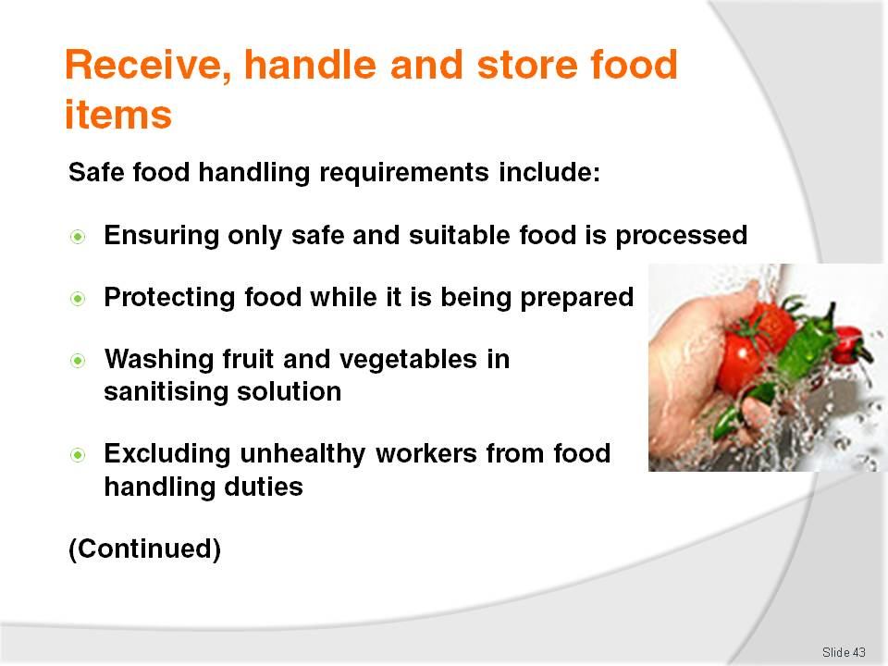
Slide No | Trainer Notes
Trainer explains to trainees ‘food handling’ is any activity that involves the handling of food (including preparing, cooking, thawing, serving, displaying food), highlighting it is important these notes are read in conjunction with other food safety information provided throughout the course.
Ensuring only safe and suitable food is processed – food unfit for consumption must not be processed. This includes foods that:
- Looks or smells ‘off’
- Shows other signs of contamination
- Exceeds its use-by date, or food taken from a source where the integrity of the packaging has been compromised
Protecting food being prepared from contamination – this includes preventing contamination from:
- Physical sources – such as hairs, broken glass, dead flies, dirt, dust, airborne contamination
- Chemicals – such as fly spray or the introduction of cleaning chemicals into the food
- Microbiological contamination – which may be caused by leaving potentially hazardous food in the Temperature Danger Zone for too long while it is being processed, or failing to cook food at the correct temperature
High risk food should reach an internal temperature of 75°C which should be verified with a thermometer
Ensuring all fruit and vegetables are washed in a sanitising solution before being prepared
Excluding unhealthy people from food handling and processing activities.
Slide
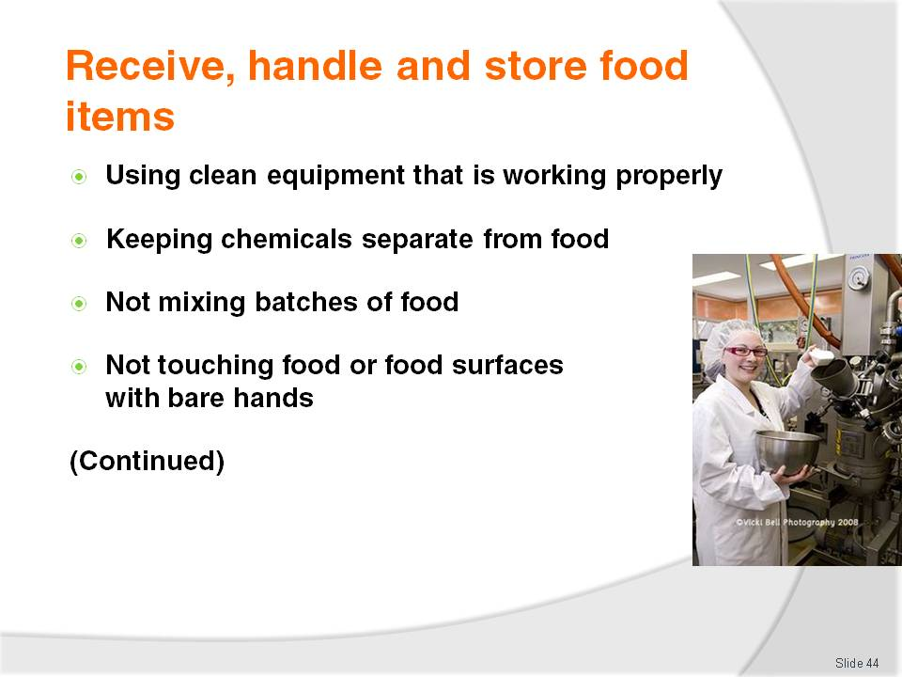
Slide No | Trainer Notes
Trainer continues to provide trainees with examples of safe food handling practices:
Using clean equipment and utensils that have been sanitised and are in proper working order – any piece of food equipment not working properly either raises OSH risks for staff or presents the possibility the food processing job it was intended to do (such as to cook food to a certain temperature, or store or display food at a certain temperature) may not be achieved thereby introducing the potential for food poisoning
Ensuring chemicals are kept separated from food and food utensils and equipment during processing – it is a requirement that all chemicals are stored separately from food
Keeping individual batches of processed food separate – batches of prepared food should never be mixed together (e.g. in a bain marie) as this can give rise to situations where food may remain able to be served even though it has passed its safe food date/time. Mixing batches of food also causes problems if an internal food recall is needed
Avoiding touching food with the bare hands where that food will not be subsequently cooked – it is best practice to wear disposable gloves or to use utensils to handle all food.

Slide
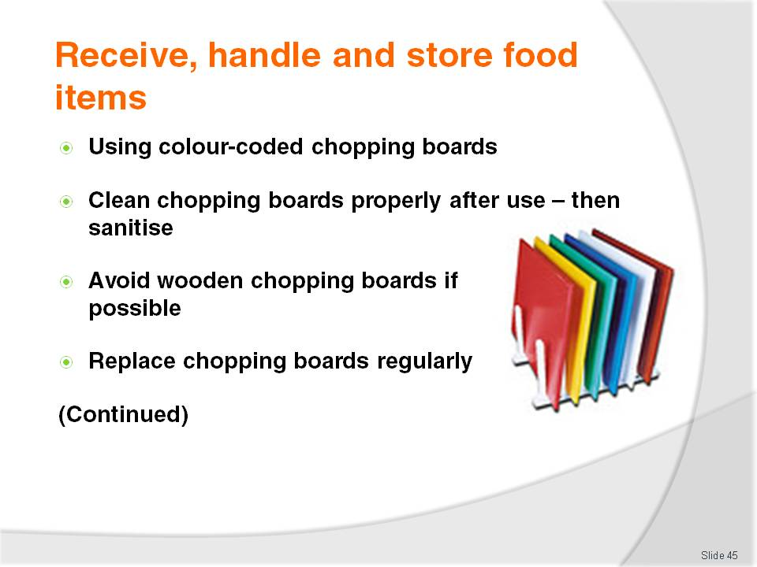
Slide No | Trainer Notes
Trainer continues to provide trainees with examples of safe food handling practices:
Using colour-coded chopping boards to reduce the likelihood of cross contamination. For examples the following colours for boards could be used as follows:
- White – for dairy products only
- Red – for raw meat only
- Blue – for seafood only
- Yellow – for poultry only
- Brown – for cooked meat only
- Green – for fruit and vegetables only
After use all boards should be scraped with a flat metal scraper and washed. Note: Polyboards can be put through the dishwasher and sanitised
Wooden boards are not the preferred option but if they are used, they should be washed with hot soapy water, rinsed and sanitised
All chopping boards must be replaced regularly to guard against the problems associated with cross contamination.
Class Activity – Demonstration
Trainer shows trainees colour-coded chopping boards explaining how and why they are used to prevent cross contamination, and:
Demonstrates how to clean and sanitise a chopping board.

Slide
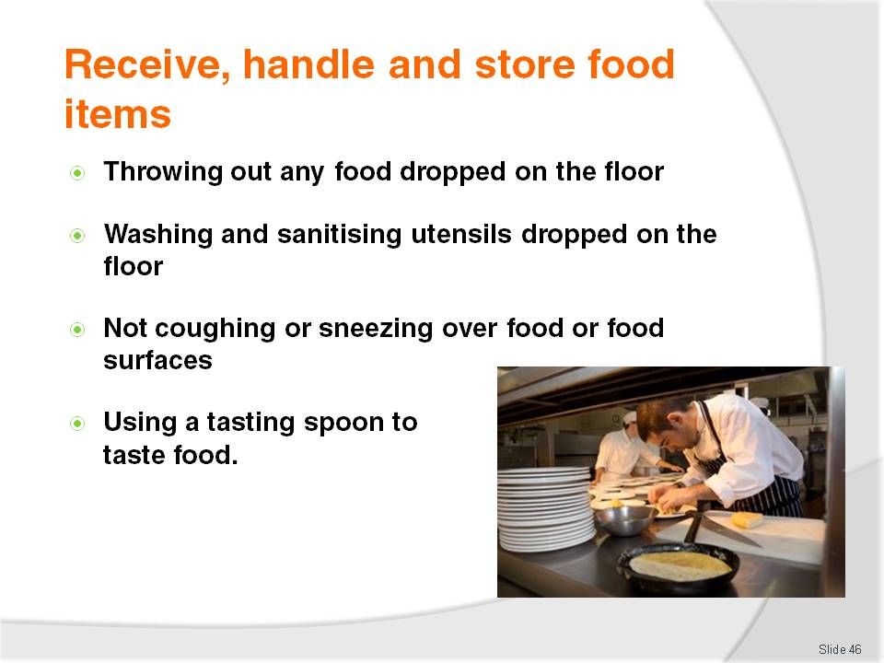
Slide No | Trainer Notes
Trainer continues to provide trainees with examples of safe food handling practices:
Discarding any food dropped on the floor – never use any food after it has been dropped on the floor
Washing and sanitising any food handling tool, implement or utensil that has been dropped on the floor before re-using it
Avoiding coughing or sneezing over food or food preparation utensils, equipment or surfaces
Using a tasting spoon to taste dishes – never use any utensil to taste food and then replace it in the dish/pot, or use it for stirring.

Slide
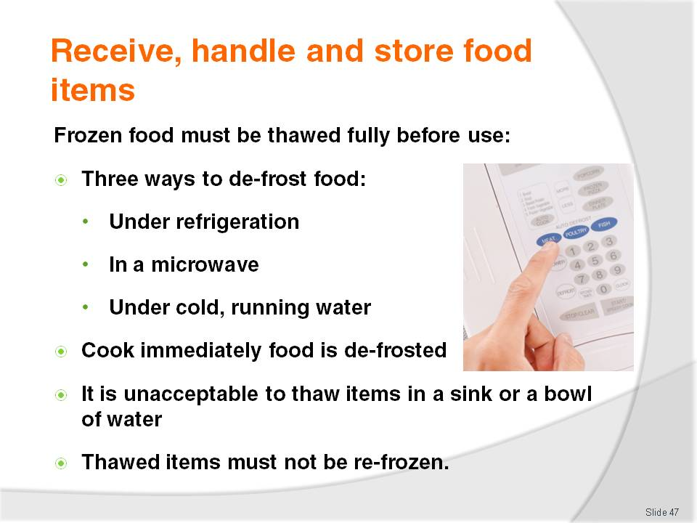
Slide No | Trainer Notes
Trainer continues to provide trainees with examples of safe food handling practices with reference to de-frosting (‘thawing’) stating frozen food must be thawed before use indicating there are only three acceptable ways to thaw food:
In a refrigerator or coolroom – large pieces of meat may take two to three days to defrost so planning ahead is vital: this is the preferred method of thawing as the food is always out of Temperature Danger Zone
If pressed for time, use a microwave to defrost, moving pieces of food during the procedure – food should be immediately cooked once taken from the microwave after defrosting
Run the item under cold water (less than 20°C) – only suitable for small portions or small items.
Trainer further notes:
All meats should be cooked immediately after thawing
It is not acceptable to thaw items out by placing them in a bowl or sink of water
De-frosted foods must not be frozen again.

Slide
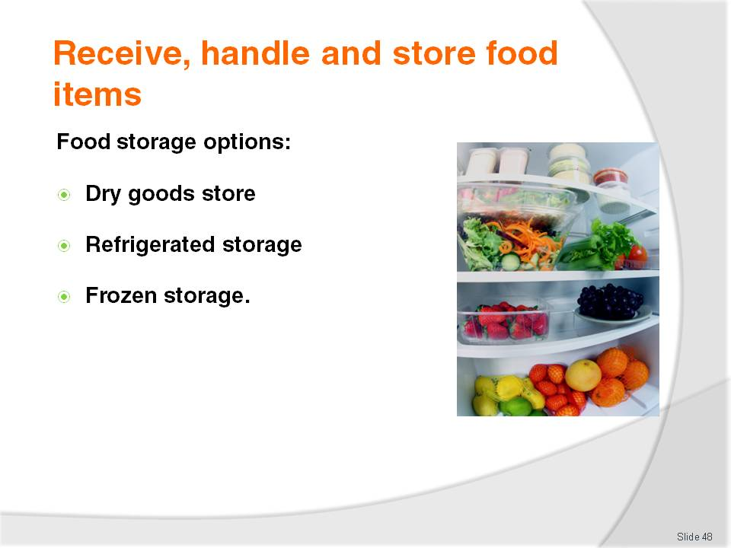
Slide No | Trainer Notes
Trainer introduces ‘storing of food’ to trainees explaining this refers to the storage of food in the premises after it has been delivered, and before it is processed or cooked.
Trainer identifies the three food storage options:
Dry goods store – the dry goods store is a non-refrigerated store where canned and dried food is kept. It may be room-size, a variety of cupboards and or a pantry. Shelves are commonly used to store dry food goods
Refrigerated storage – is used for fruit and vegetables, dairy products, meat and all other potentially hazardous foods. Refrigerated storage may occur using coolrooms, under-counter refrigeration units or domestic refrigerators
Frozen storage – freezers are used to store frozen produce. Freezers may be chest type, up-right, or walk-in, but they must be maintained such that the food remains hard frozen (recommended temperature is -15°C). Every time the freezer is used, it should be standard practice to visually check the temperature gauge and notify management where there is a problem – do not overload freezers as it takes too long for the middle of products to freeze.
Class Activity – excursion
Trainer arranges for trainees to visit a food premises and:
Talk to management and staff about their safe food handling practices
View the food storage, preparation and service areas
Observe staff practices relating to food handling
Look at workplace food safety records maintained by the business.

Slide
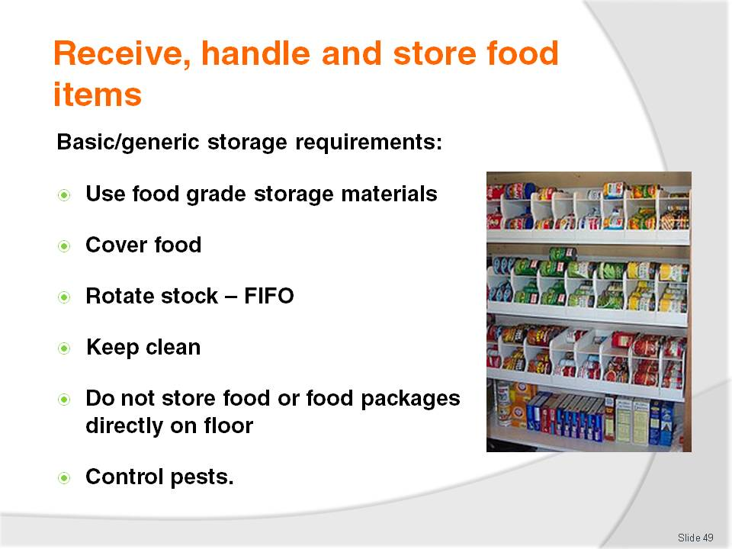
Slide No | Trainer Notes
Trainer provides trainees with basic storage requirements:
Use food grade materials to store food susceptible to contamination – such as stainless steel
Cover food in storage – to protect it from contamination
Rotate stock to ensure it is used in the correct sequence – the method used for most food is called ‘First In, First Out’ (see later slide): any food exceeding its use-by date must be thrown out
Keep all storage areas and equipment clean
Never store food (including packaged food) directly on the floor – use shelves
Ensure pests and rodents are excluded from food storage areas – conduct a regular (at least weekly inspection to check this, and take appropriate action when evidence of pests or rodents is discovered).

Slide
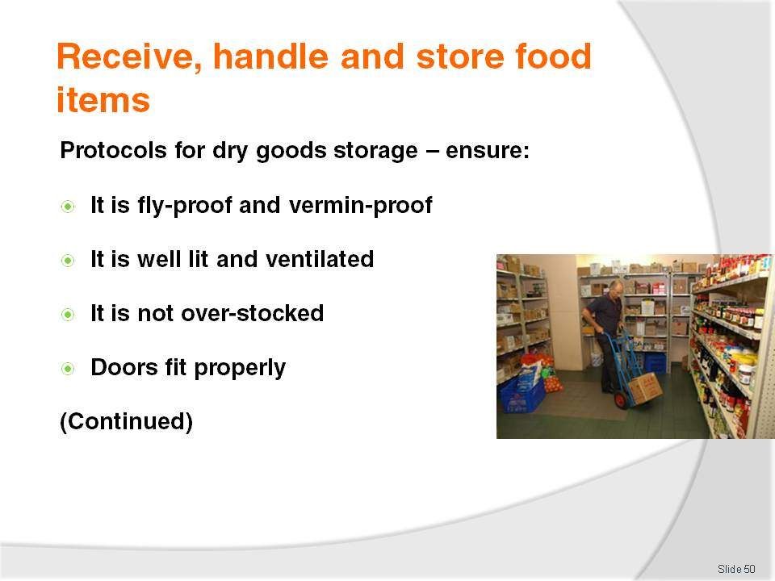
Slide No | Trainer Notes
Trainer advises trainees regarding storage requirements for dry goods store stating they should ensure:
The area is fly- and vermin-proof – to minimise contamination by pests
It is well ventilated and lit – to deter pests and to allow staff to see what they are doing and identify and remedy spillages and vermin
It is never overstocked – excess stock costs money, clutters things up, and increases the chance of out-of-date stock
It is fitted with doors making a proper fit when fully closed – to help exclude pests.

Slide
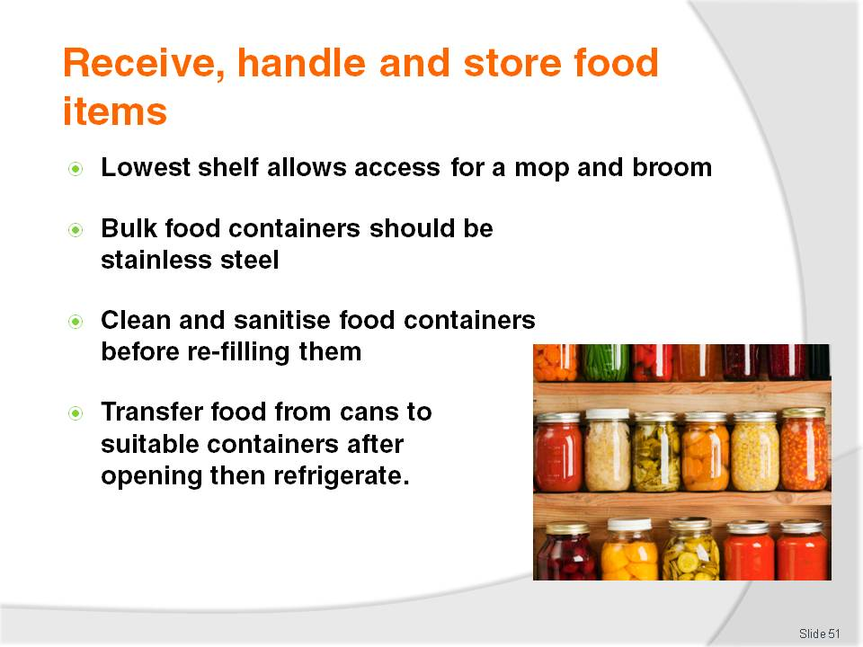
Slide No | Trainer Notes
Trainer continues to provide advice to trainees regarding dry goods storage:
The lowest shelf is sufficiently far enough above floor level to enable air circulation around goods, and allow mops and brooms to get under the shelves when cleaning is required
Bulk food containers are made from food grade materials and have tight-fitting lids – plastic garbage bins are not permitted to be used for food storage as they are liable to splitting, do not have a smooth internal surface to facilitate cleaning and do not protect sufficiently against mice and rats
Food storage containers are cleaned and sanitised before being re-used or re-filled – to guard against batch-mixing
Any canned, tinned or bottled food must be transferred to an appropriate container and refrigerated once the container has been opened – it is not acceptable (for example) to open a can, use half the contents and then return the open can to dry storage. The food must be transferred to a plastic or stainless steel (or other appropriate) container and then placed in the refrigerator.

Slide
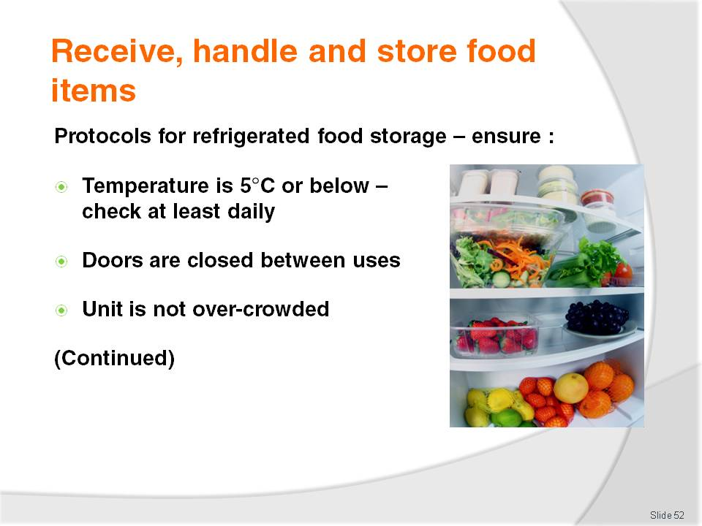
Slide No | Trainer Notes
Trainer provides direction to trainees regarding use of refrigerated food storage units stating they must ensure:
The temperature is kept at 5°C or below and is checked with an independent calibrated thermometer – checks must be done at least once per day. The maximum time high risk foods should be stored at 5°C or below is 7 days. Foods should be eaten within this time or discarded. Where the temperature is 3°C or less, this time could extend beyond 7 days
The coolroom or refrigerator door is closed between uses and an effort made to minimise opening times by planning openings – an open door raises the temperature and makes the unit more expensive to operate
The cool room is not overcrowded – to enable air to circulate freely around food items.

Slide
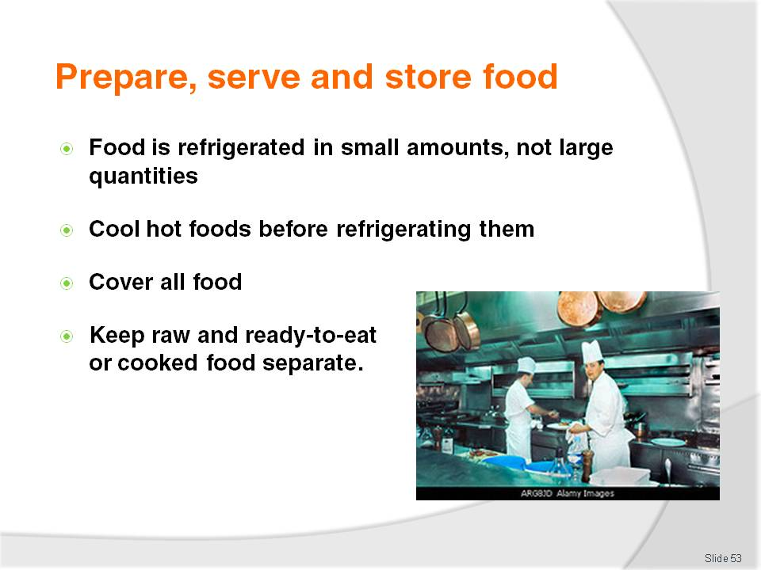
Slide No | Trainer Notes
Trainer continues providing advice to trainees in relation to use of refrigerated storage:
Food loads put into the coolroom or refrigerator are broken down into smaller units to enable faster cooling – where large units of food are placed in the refrigerator it takes a lot longer for the core of the food to move out of the Temperature Danger Zone
Hot foods should be allowed to cool (for example, by placing the food in pots and then into tubs full of a water-ice mixture) before being placed in the cool room. Frequent stirring of the food will help it to cool quicker. The ‘Two-step rule’ for cooling hot foods must be complied with – see later slide
All food is covered and protected from contamination – plastic film with a label attached to identify the food and date it was placed under refrigeration should be used
Potentially hazardous raw food is separated from cooked or ready-to-eat foods – this is to prevent cross contamination. Never store potentially hazardous raw food above cooked or ready-to-eat foods as there is the potential for raw blood or juice to drip down onto the food below.

Slide
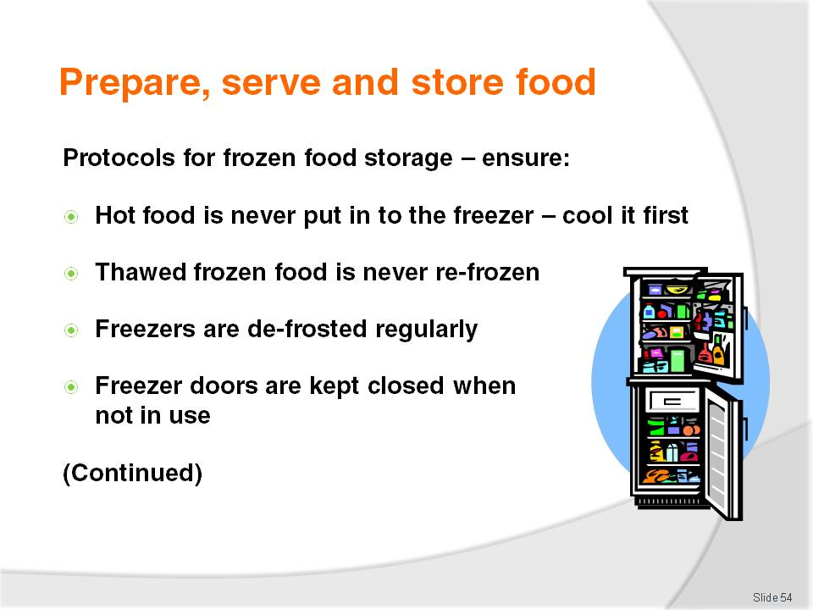
Slide No | Trainer Notes
Trainer provides direction to trainees regarding use of frozen food storage units (freezers) stating they must ensure:
Hot food is never frozen – cool it first following the two-step rule for cooling hot food (see Section 1.5)
Thawed items must never be refrozen – once de-frosted, food should be used or thrown out
Freezers are defrosted regularly – to maintain operating effectiveness and encourage turnover of items
Freezer doors are kept closed when the freezer is not in use – to keep cold air in.

Slide
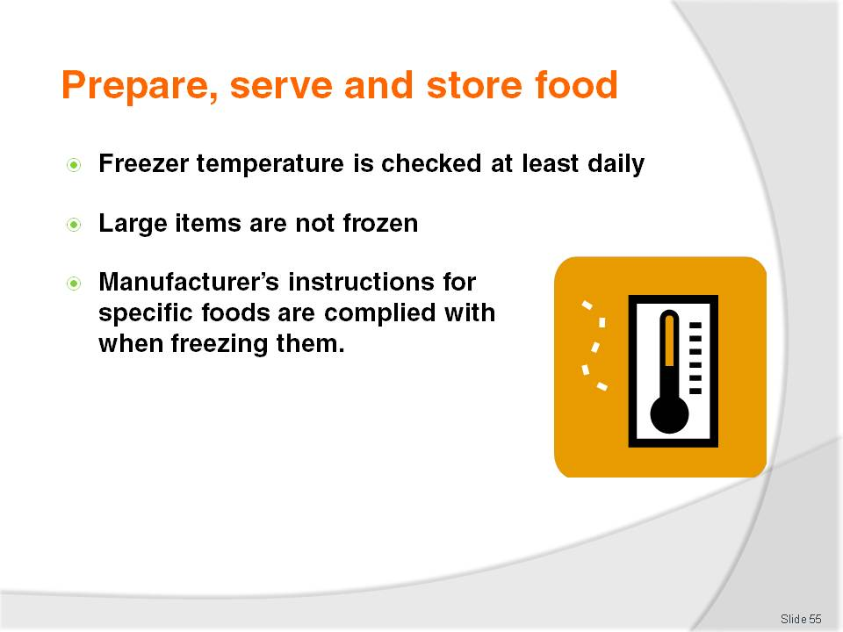
Slide No | Trainer Notes
Trainer continues to provide advice to trainees regarding use of freezers to store food:
Freezer temperature is be checked at least daily – to ensure correct operating temperature
Large pieces or amounts of food are not frozen as this encourages others to defrost the item and then re-freeze it – in practice this means freezing slices of meat rather than slabs of meat, and using shallow storage containers rather than deep ones to freeze food
Manufacturer’s instructions regarding the storage of frozen food products are followed – these may relate to storage temperatures and the length of time the product can be stored (for quality and or safety reasons).

Slide
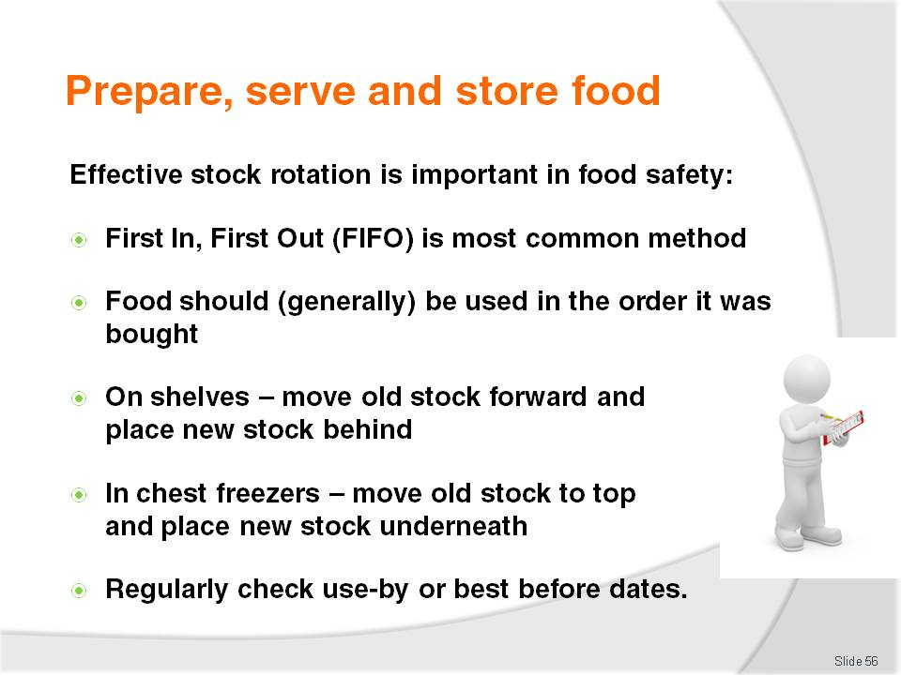
Slide No | Trainer Notes
Trainer instructs trainees proper stock rotation is also an important element of safe food handling indicating:
Effective stock rotation for foods means using the FIFO approach to stock rotation – First In, First Out. This method requires food to be used/served in the order it was delivered meaning the foods in stock the longest are used first. In practice this means when storing food:
- Old and existing stock must be moved forward on the shelf and the newly delivered stock must be placed behind it – this allows the stock at the front (the oldest stock) to be used before the newer stock
- Existing product in a chest freezer should be removed and the new stock placed at the bottom of the freezer – the existing/old stock is then replaced in the freezer on top of the newer stock
- Check use-by dates of products – and store them so the nearest date is at the front so it will be used first.
Class Activity – Demonstration
Trainer shows trainees how to rotate stock in accordance with FIFO method of stock rotation, using:
Food on shelves
Food in coolroom
Food in freezers.

Slide
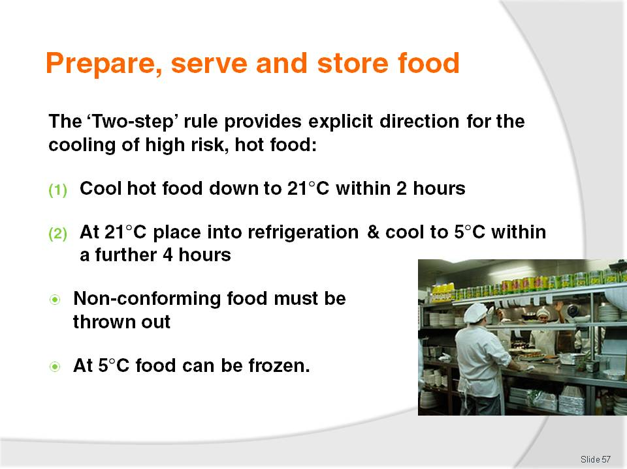
Slide No | Trainer Notes
Trainer advises trainees regarding application of the ‘Two-step rule’ for cooling hot food stating:
Step 1: Cool hot food down from 60°C to 21°C within 2 hours of removing the food from the stove, oven or other cooking unit
Step 2: Once the food has reached 21°C it should be placed into a refrigerator or coolroom, and then cooled to 5°C (or below) within a further 4 hours
If the cooling of high risk food does not meet these criteria, the food must be thrown out to optimise food safety
Once the food has reached 5°C, it can safely be put in the freezer.

Slide
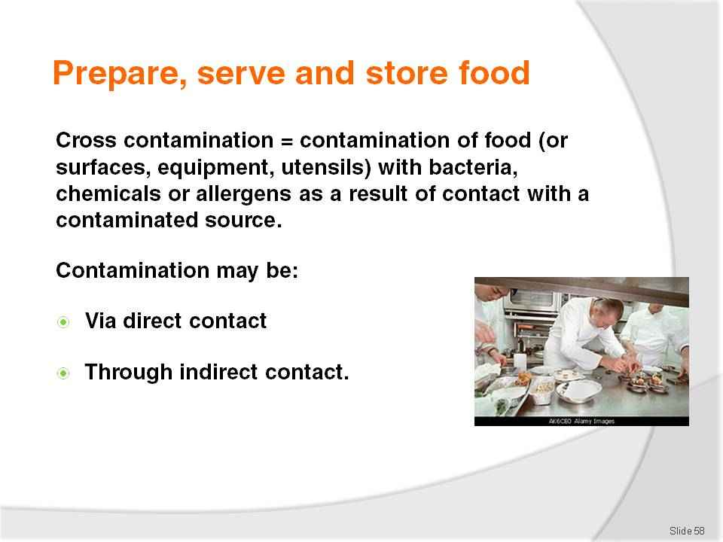
Slide No | Trainer Notes
Trainer explains ‘cross contamination’ to trainees indicating:
Cross contamination is the contamination of food (or food preparation surfaces, equipment, utensils) with bacteria, chemicals or allergens as a result of contact with a contaminated source. Bacteria cannot fly, jump or hop so they depend on people to move them around from place to place via direct contact or through indirect contact
Examples of direct contact are:
- Using a knife to cut raw meat and then using the same knife to cut cooked, ready-to-eat meat without cleaning and sanitising the knife in between tasks – the blood and residual meat on the knife will carry bacteria and this will be transferred by the knife to the previously safe cooked, ready-to-eat meat
- Using a chopping board to cut raw chicken and then using the same chopping board to cut cooked meat for salads without cleaning and sanitising the board in between tasks – the chopping board will carry bacteria from the uncooked chicken (the cooking process should destroy the bacteria) which will then be transferred to the previously safe to eat cooked meat
Examples of indirect contact are:
- Coughing or sneezing into the hand, and then using the hand to prepare or touch food or to touch a food preparation surface without first washing it to remove the contaminants.

Slide
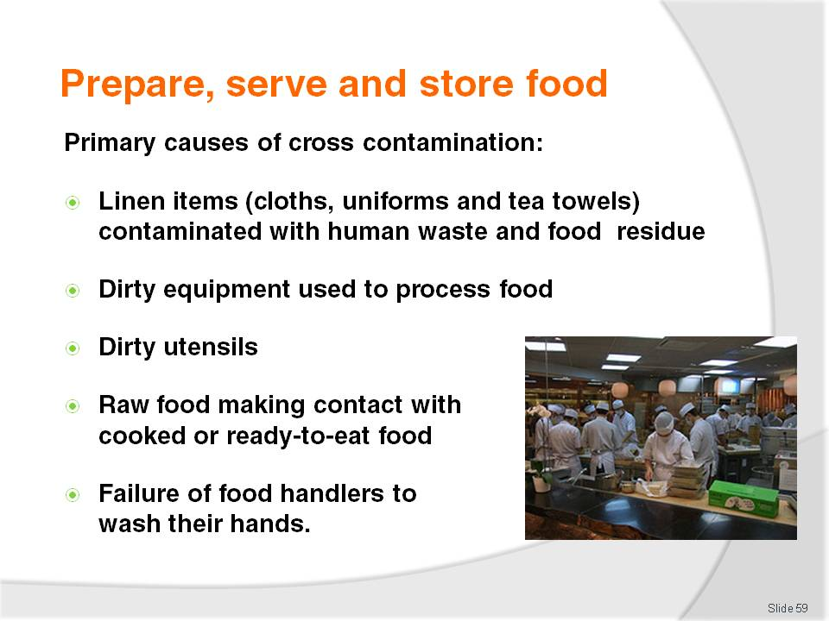
Slide No | Trainer Notes
Trainer explains to trainees the primary causes of cross contamination are:
Linen items (uniforms, tea towels, towels, swabs, handkerchiefs, cloths) that are contaminated with human waste such as blood and secretions, and food residue (such as food that has been wiped up after a spillage or in order to clean a plate for presentation purposes)
Dirty equipment – which is used to process, hold or serve food
Dirty utensils – which is used to serve or eat food
Raw food making contact with cooked or ready-to-eat food – or surfaces that will be used to prepare or serve cooked or ready-to-eat food
Failure of food handlers to wash their hands when and as required.

Slide
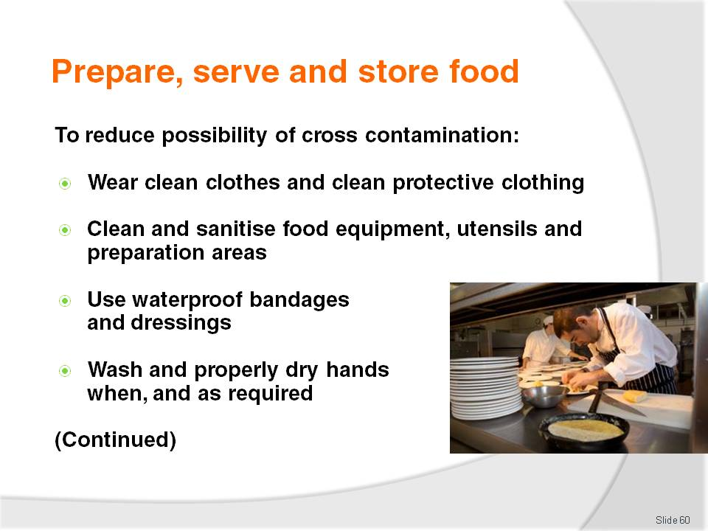
Slide No | Trainer Notes
Trainer explains to trainees the following techniques will help reduce the likelihood of cross contamination:
Wearing clean clothes and clean protective clothing for each shift
Cleaning and sanitising food equipment, utensils and preparation areas in accordance with the cleaning schedule for the premises – including cleaning and sanitising of preparation benches in between preparing raw high risk food and other foods
Using waterproof bandages and dressings on cuts and sores
Washing – and properly drying – hands when and as required.

Slide
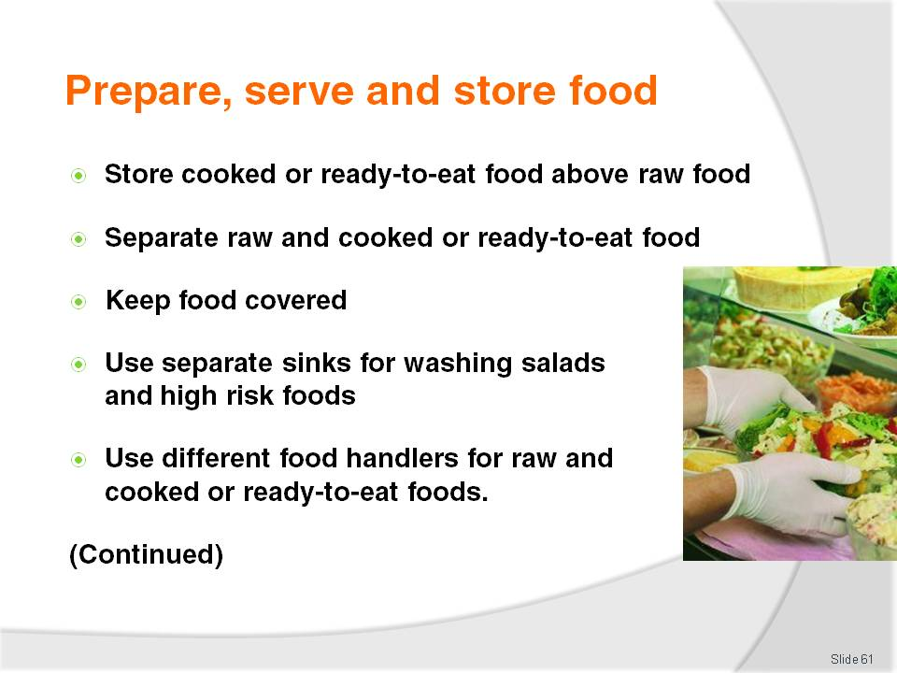
Slide No | Trainer Notes
Trainer continues to explain to trainees techniques to help reduce the likelihood of cross contamination:
Storing cooked, ready-to-eat food above raw high risk foods – to prevent dripping of blood or juices onto food that will not be cooked again before being eaten
Separating the storage of raw and cooked or ready-to-eat foods – to prevent touching of foods causing transfer of bacteria from raw to cooked items
Keeping foods covered as much as possible when in storage, while being processed and displayed
Using separate sinks for washing ready-to-eat salad items and vegetables and other high risk foods – this includes a requirement a sink used for thawing high risk foods by running it under cold water should take place in a different sink to the one used for washing salad items and vegetables
Allocating different food handlers to raw foods and cooked or ready-to-eat foods.

Slide
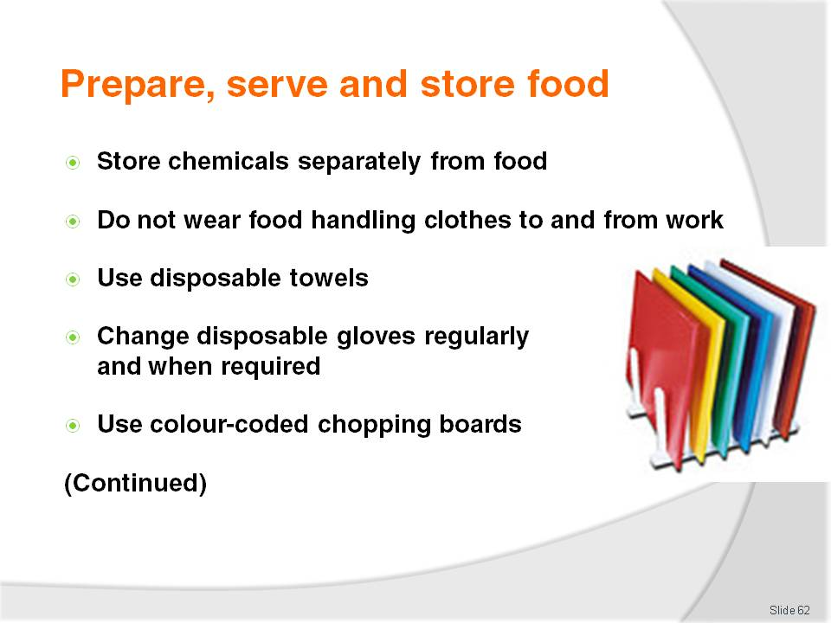
Slide No | Trainer Notes
Trainer continues to explain to trainees techniques to help reduce the likelihood of cross contamination:
Storing chemicals separately – away from food items
Not wearing food handling clothes to and from work
Using disposable towels – instead of cloth towels
Changing disposable gloves whenever there would be a need to wash hands – such as in between handling raw high risk food and cooked or ready-to-eat food: gloves should be changed every hour regardless
Using colour-coded chopping boards – instead of the same board for all foods.

Slide
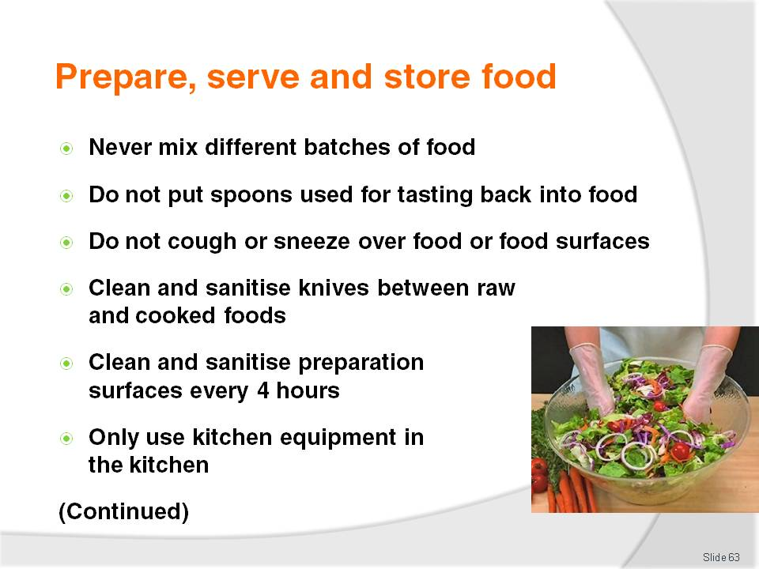
Slide No | Trainer Notes
Trainer continues to explain to trainees techniques to help reduce the likelihood of cross contamination:
Not mixing batches of food – use all of one batch and replace with new batch in cleaned and sanitised containers
Refraining from tasting food and replacing the spoon back in the pot, tray
Not coughing or sneezing over food or food preparation equipment, utensils or surfaces
Cleaning and sanitising knives in between cutting raw high risk foods and cooked or ready-to-eat foods
Cleaning and sanitising food preparation benches and equipment that are in constant use at least every four hours
Avoiding the use of equipment and materials - including cleaning materials - between other areas of the premises (such as bathrooms and bedrooms) and the kitchen.

Slide
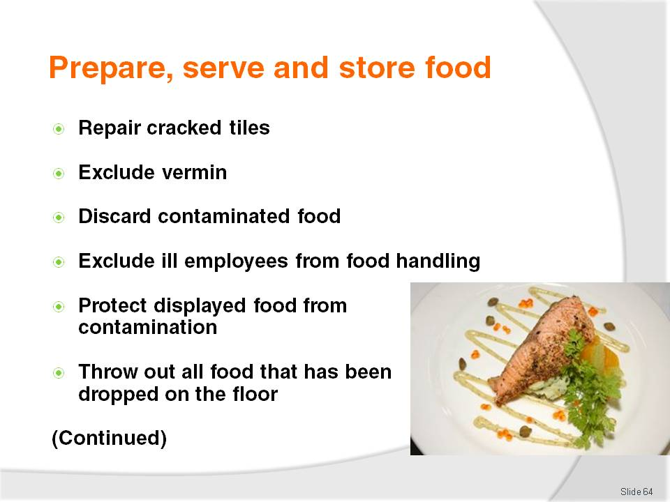
Slide No | Trainer Notes
Trainer continues to explain to trainees techniques to help reduce the likelihood of cross contamination:
Repairing cracked surfaces in the food preparation area – cracks can harbour food waste and bacteria
Excluding pests and implementing an effective pest control program – which may necessitate the use of a qualified professional external pest control company
Discarding all food known to be contaminated – or suspected of being contaminated
Excluding food handlers who are ill from food handling and food-related activities
Displaying food in such a way it is protected from contamination by customers, especially children – including the use of sneeze guards, monitoring patron actions where self-service food is available and taking appropriate action when the potential for cross contamination is identified
Disposing of any food dropped on the floor – food is unfit for use, sale or consumption as soon as it has been dropped on a floor of any kind.

Slide
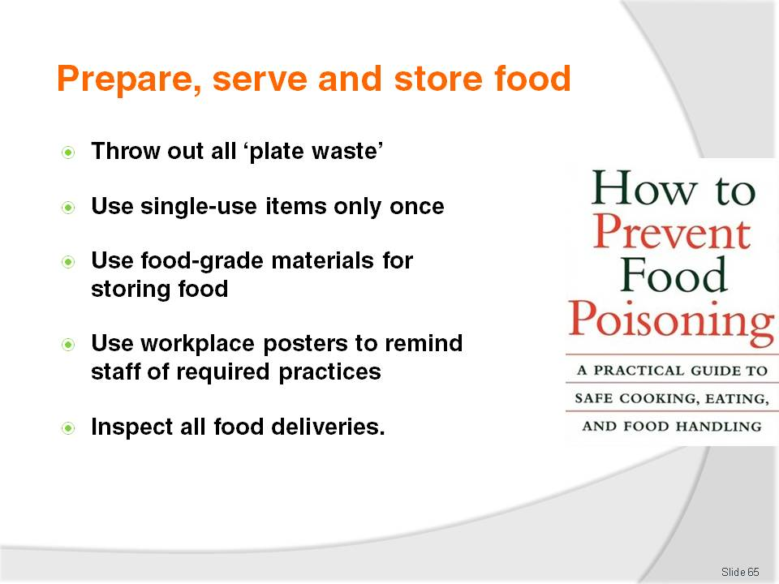
Slide No | Trainer Notes
Trainer continues to explain to trainees techniques to help reduce the likelihood of cross contamination:
Disposing of any food returned from a patron (known as ‘plate waste’) – this includes food and beverage items
Disposing of any single-use item used once or which has become contaminated (or is suspected of being contaminated) for any reason
Using only food grade equipment to store foodstuffs
Putting up signs or posters in the workplace to remind food handlers about cross contamination
Inspecting food deliveries into the premises to ensure they are not contaminated by any visible sources.

Slide
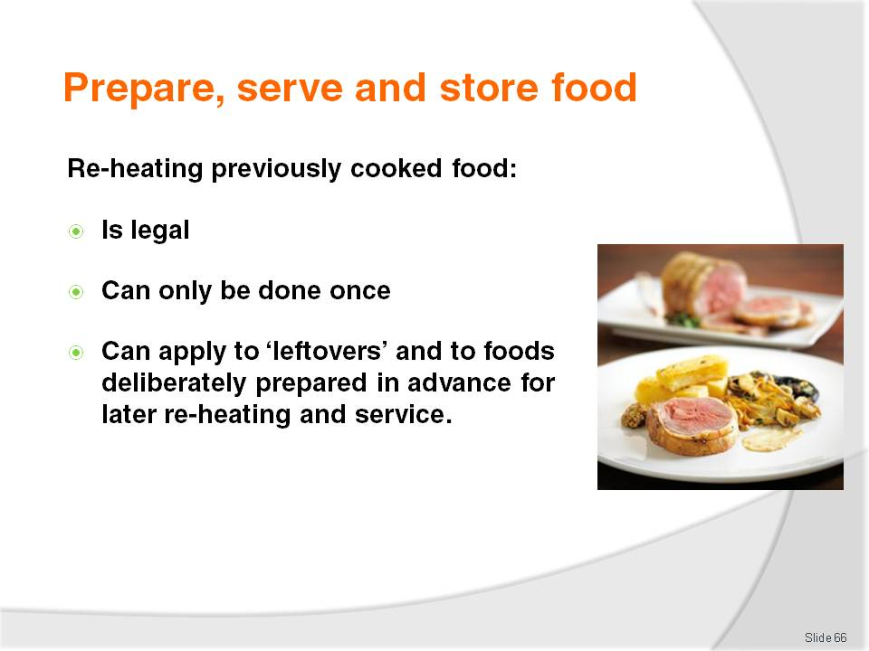
Slide No | Trainer Notes
Trainer advises trainees regarding the re-heating of previously cooked foods stating:
It is quite legal to use or to reheat leftovers but there are several safe food hygiene practices to follow in order to do it safely
Food can only be re-heated once – if not used, it must then be thrown out
Leftovers, or food intentionally cooked beforehand and refrigerated or frozen for later use, are known as ‘previously cooked food’.

Slide
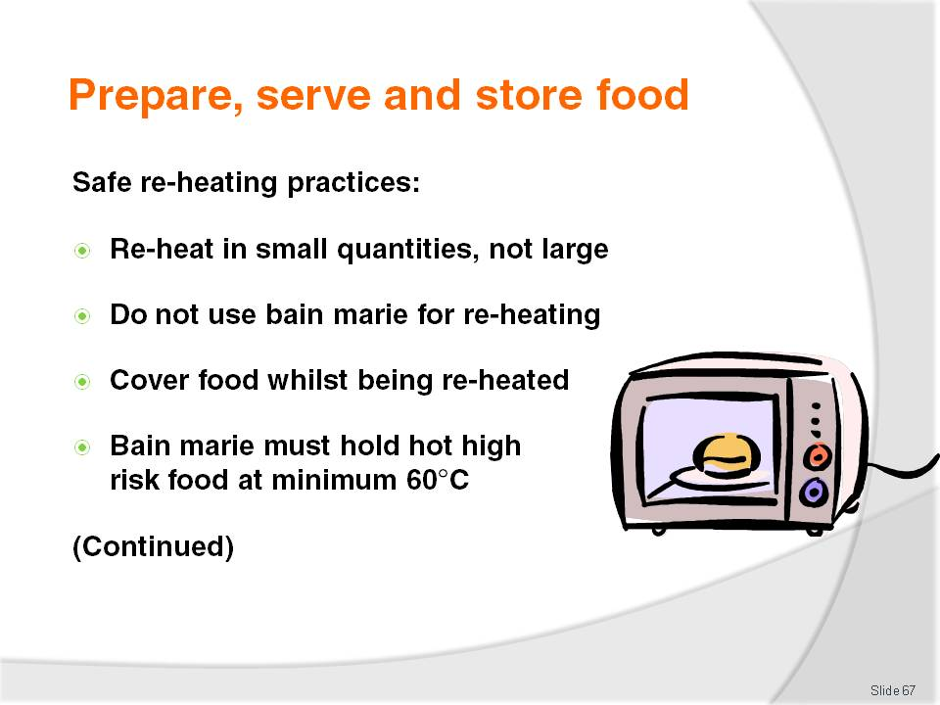
Slide No | Trainer Notes
Trainer instructs trainees regarding safe re-heating practices:
Reheat previously cooked food in small quantities, not large – this reduces the time food spends in the Temperature Danger Zone (5°C to 60°C) and helps retain food quality while optimising food safety
Do not use a bain-marie for reheating; they are only hot holding devices and not designed as heating units
Food must be protected from contamination while it is being re-heated
The bain-marie must hold the heated high risk food at a minimum 60°C so as to be above the Temperature Danger Zone (or The 2/4 Rule must be applied).

Slide
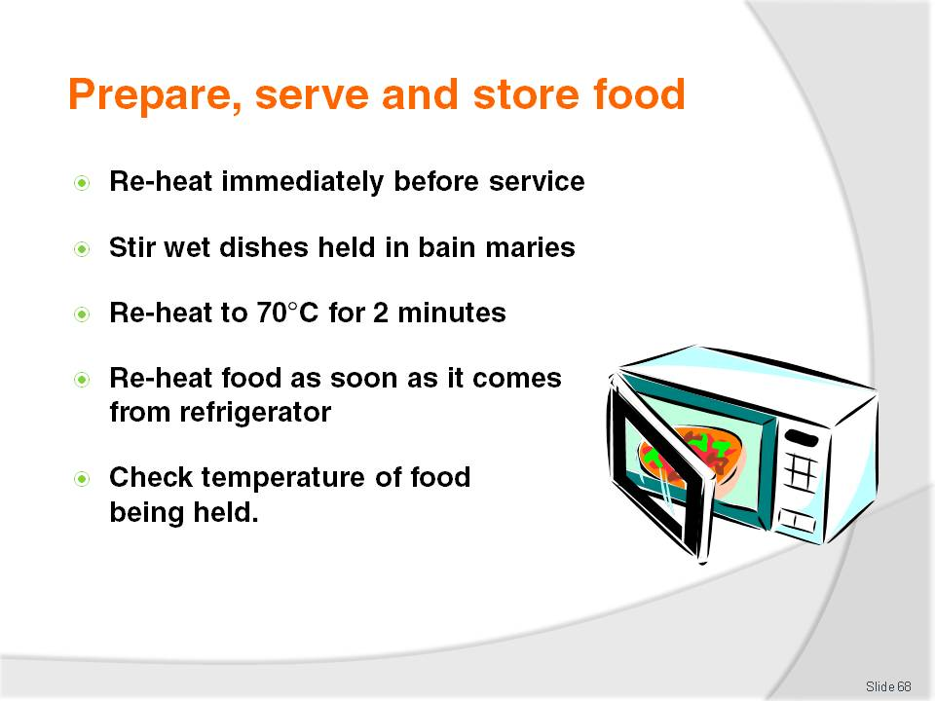
Slide No | Trainer Notes
Trainer continues to instruct trainees regarding safe re-heating practices:
It is preferable for food to be reheated immediately before service rather than to reheat in bulk and held; this optimises food safety and helps maintain the highest food quality
Stir wet dishes held in the bain-marie regularly to make sure the food does not cool down to below 60°C; this applies even where the units have overhead heating lights
Previously cooked food, coming from the cool room or a refrigerator to be reheated should be raised to 70°C (for 2 minutes) as soon as possible and then kept at a minimum of 60°C ; never leave previously cooked food sitting around in the kitchen on a preparation bench in the Temperature Danger Zone
A temperature monitoring probe should be used to check the internal temperatures of food that is re-heated; never rely on guesswork, or the visual appearance of the food.

Slide
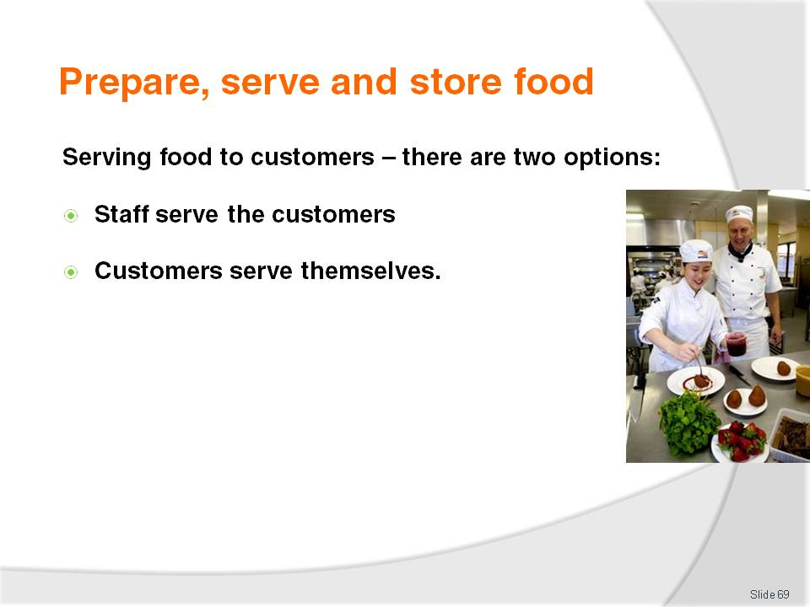
Slide No | Trainer Notes
Trainer presents information to trainees about the service of food to customers noting there are two options in this regard:
Staff serve customers –for in-house dining or take away: this is where staff plate the food or put it into take away single use containers
Customers serve themselves – this is where food is presented at buffets and customers select the food they want and plate it themselves.

Slide
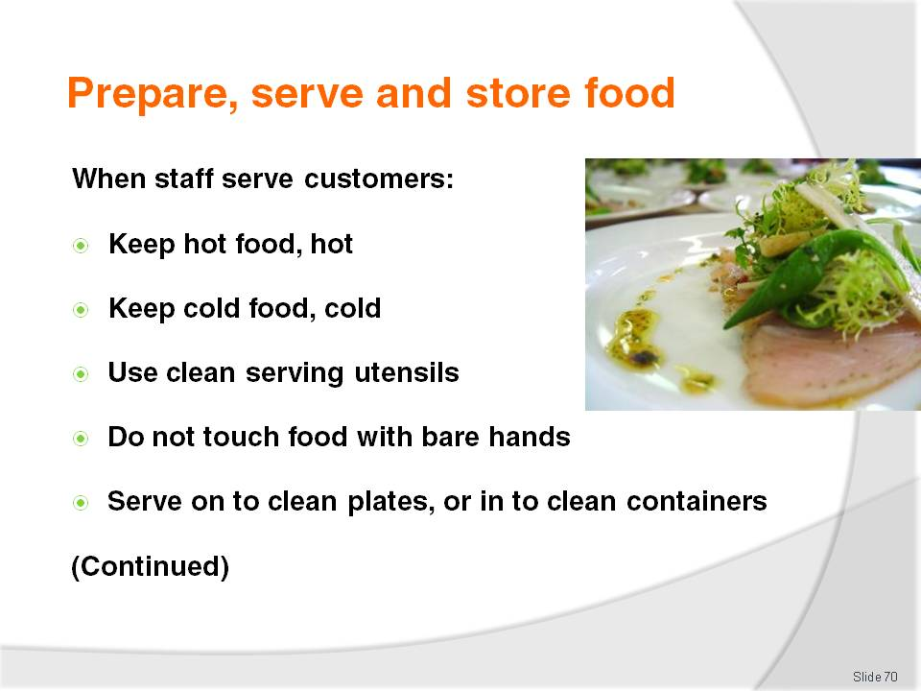
Slide No | Trainer Notes
Trainer provides trainees with requirements regarding service of food to customers by staff:
Potentially hazardous food must be kept out of the Temperature Danger Zone. The temperature of any display units must be taken regularly (at least once per service session) to verify the temperature is correct. Remember: keep hot food, hot at 60°C or above and keep cold food, cold at 5°C or below
Clean serving utensils must be used – change hourly
Never touch food with bare hands – always use disposable gloves, tongs or some other item (greaseproof paper, a fork, a spatula) to create a barrier between the hands and the food in order to prevent cross contamination
Food must be served into or onto clean plates, bowls or other items (such as single use containers – see following slide).

Slide
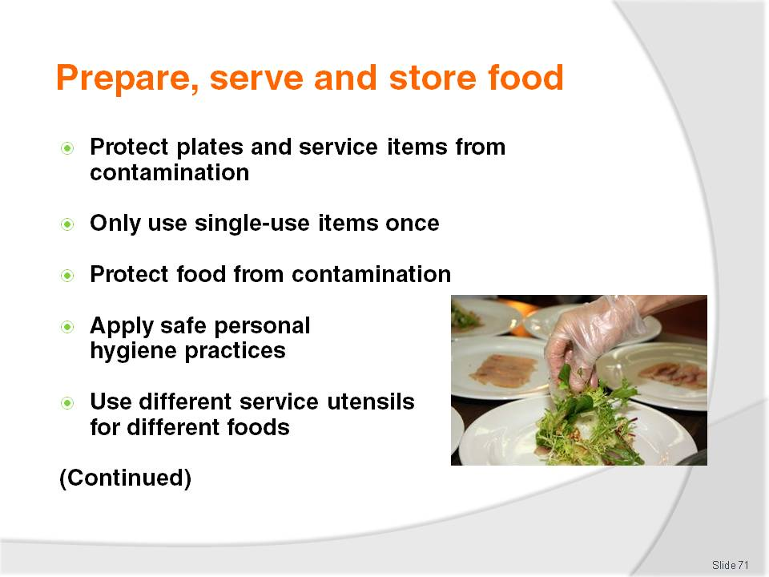
Slide No | Trainer Notes
Trainer continues to provide trainees with requirements regarding service of food to customers by staff:
Plates and similar must be stored at the service point in such a way to protect them from contamination, including contamination by flies, dust, customers. Where food is served into single-use containers (see later slide), these containers must be only used once
All single-use items (food and drink containers, straws, lids) must be stored to protect them against contamination
Food must be kept protected from contamination; keep doors on display units closed, and use lids where provided on storage units
Staff must apply safe food handling and personal hygiene practices such as:
- Not coughing, sneezing onto food
- Washing hands as required – see later notes
- Using disposable gloves, as required, and changing when required
- Never using food dropped on the floor
- Never using food that has been contaminated in any way
Use different utensils to serve different food items – to avoid cross contamination (and also to eliminate different foods [or colours] being mixed in with other foods, which is often not wanted by the customer).

Slide
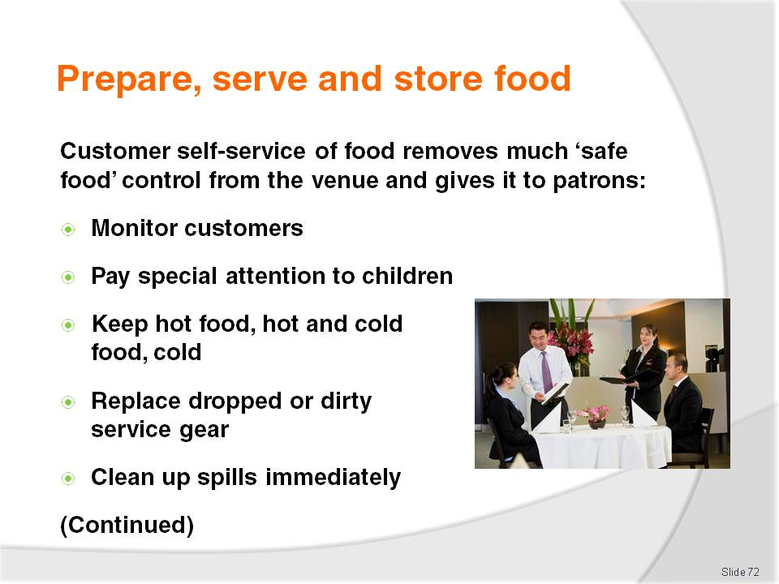
Slide No | Trainer Notes
Trainer provides trainees with instruction regarding requirements for self-service of food by customers:
Providing this option for customers will present a higher level of risk from contamination because many elements of control have been given over to the customer. It remains a legal responsibility on the venue to ensure the integrity of food offered in this style of service: if food safety cannot be fully guaranteed by allowing the service of food in this manner it should not be offered in this way. Re-consider the service style and use another service or presentation method
Customer activities are regularly monitored so unsafe practices can be identified and remedial action taken. This means a staff member must be appointed to watch customers in order to prevent them from doing anything to compromise the safety of the food, and to remove food when it has been contaminated
Special attention is paid to children at self-serve areas as they are prone to handling food with their hands as well as taking food and then putting it back
Hot food is kept hot (60°C and above), and cold food is kept cold (5°C and below)
Any utensils dropped by customers are immediately replaced with clean and sanitised ones
Spills are cleaned up immediately.

Slide
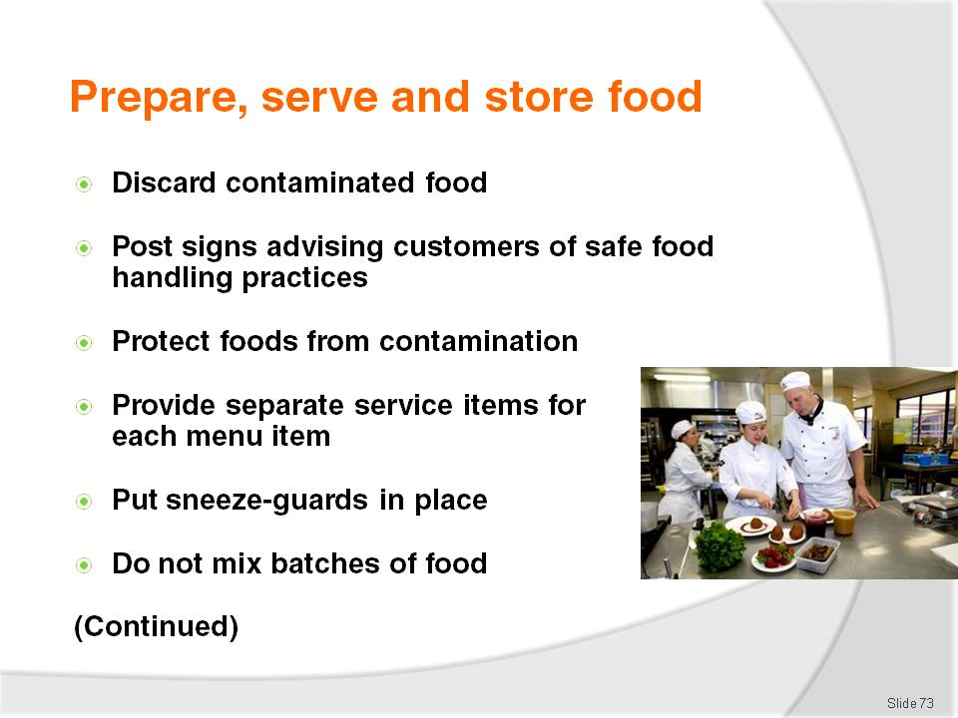
Slide No | Trainer Notes
Trainer continues to provide trainees with instruction regarding requirements for self-service of food by customers:
Any contaminated food is thrown out – this includes contamination caused by customers coughing or sneezing over the food
Signs are posted advising customers of safe food handling practices – such as asking them:
- Not to use utensils in other foods
- To refrain from coughing and sneezing over the food
- To refrain from handling any of the food with their bare hands
- To supervise children
Foods are covered and protected – from contamination when not actually being used
Separate utensils are provided – for each food item
Sneeze-guards are in place – to protect food
Batches and or trays of food items are not mixed – stock rotation is important but so is the need to keep batches separate.

Slide
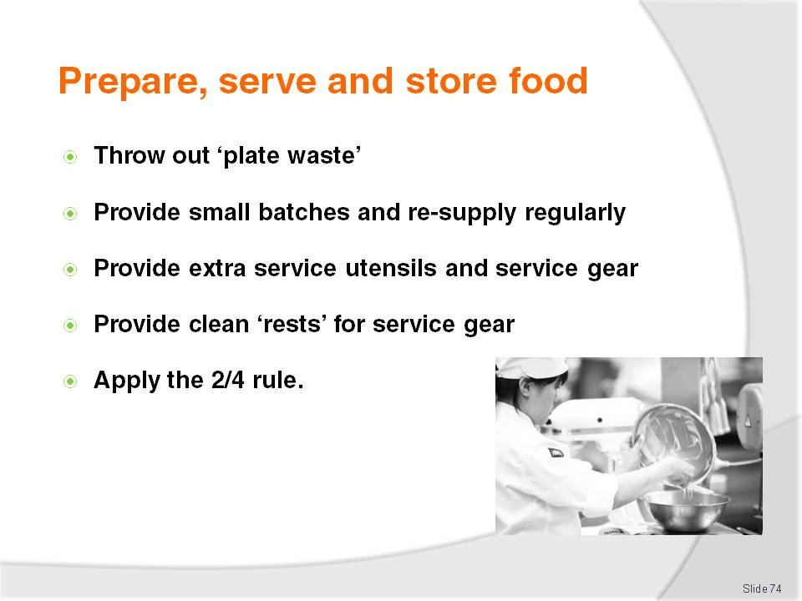
Slide No | Trainer Notes
Trainer continues to provide trainees with instruction regarding requirements for self-service of food by customers:
Throw out any plate waste or returned food – it must never be re-served
Small batches of food are put on the buffet – and replaced frequently, rather than putting out large trays or large amounts of food to begin with
Extra utensils are provided – there always seems to be a need for more service spoons and forks
Clean ‘rests’ for utensils (service spoons and forks) are provided and changed regularly to prevent cross-contamination
The 2/4 rule is being complied with.
Class Activity – Excursion
Trainer arranges for visit to a venue so trainees can:
View staff serving food to dine-in customers
View staff serving take away foods to customers
View customer self-service of food
Talk to management and staff
Observe and note good and unacceptable food safety practices
Observe storage and use of single use items.

Slide
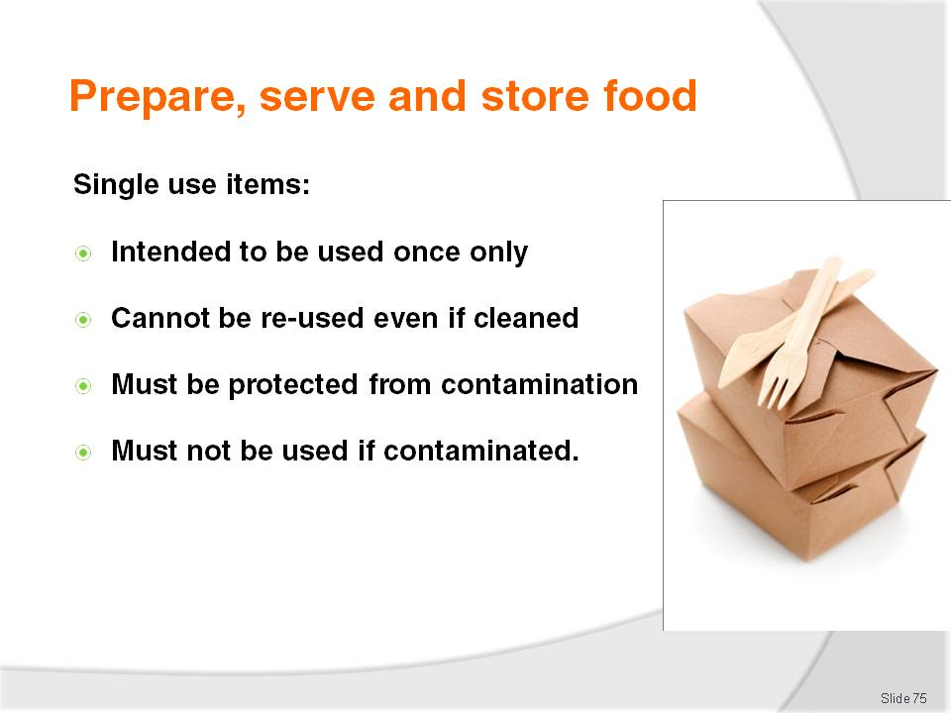
Slide No | Trainer Notes
Trainer introduces concept of single use items to trainees explaining a single-use item is something intended to be used once in relation to food and then disposed of, noting:
Single-use items must not be re-used even if they are cleaned in between uses – customers are free to re-use them at home as they see fit: customers may also re-fill single-use cups themselves from drink dispensing machines. Note: single-use containers may, however, be used by the business for non-food activities – such as collecting or storing dirty cutlery
Must be stored and or displayed so as to be protected from contamination – this contamination may be via:
- Flies, pests and vermin
- An infected food handler
- Airborne contamination
- Physical contamination
- Customers
Must not be used if they have been contaminated – or there is suspicion they may have been contaminated: this can include:
- Disposing of any single-use items handled by customers
- Disposing of any single-use items dropped on the floor
- Disposing of any single-use items where the protective packaging they were delivered in has been compromised.
Class Activity – Presentation of examples
Trainer presents sample single use items to trainees so they understand what they are:
Examples of single-use items include:
- Take away food and drink containers – including pizza boxes, coffee cups, boxes for hamburgers, packaging for rolls and sandwiches
- Drinking straws
- Disposable gloves
- Plastic cutlery
- Tooth picks
- Food wrappers – around items such as hamburgers and other take away menu items.

Slide
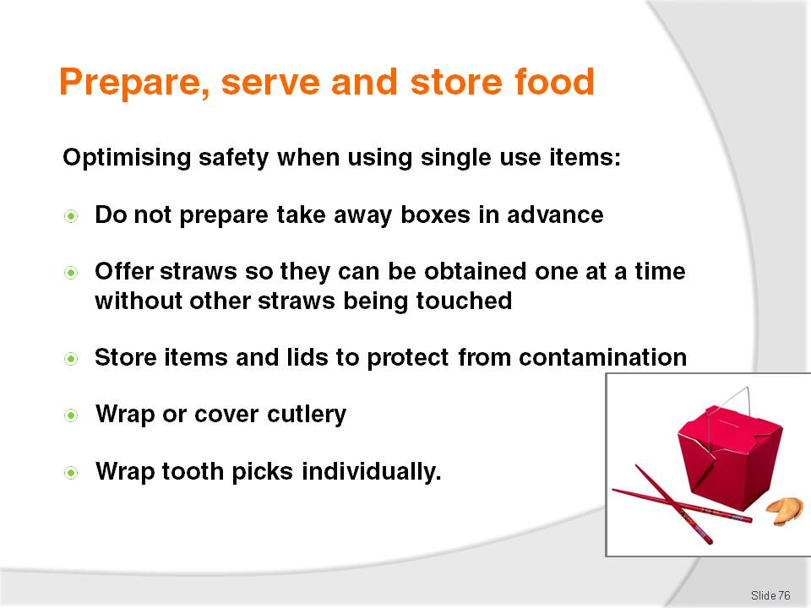
Slide No | Trainer Notes
Trainer presents to trainees practical measures to optimise safety when using single use items:
Not preparing pizza boxes in advance and leaving them ‘open’ – this allows airborne and other contamination to settle inside the boxes on the food contact area: pizza boxes should be constructed ‘to order’, when required
Providing drinking straws in containers allowing only one straw at a time to be dispensed without others in the container being touched: an alternative is to only use individually wrapped drinking straws
Storing take away food containers (for food and beverages) upside down – so the food contact surface of the container is not exposed
Storing the lids to take away containers safely – so the side making contact with the drink or food is protected
Disposable cutlery should be kept covered or individually wrapped
Toothpicks should be individually wrapped.

Slide
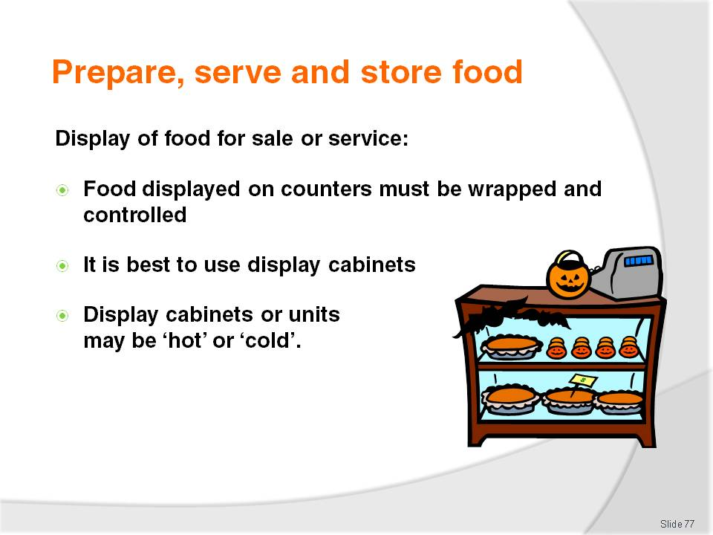
Slide No | Trainer Notes
Trainer introduces the display of food for service or sale highlighting:
Any food displayed on a service counter must be wrapped – to protect it from contamination (this does not apply to fresh fruit). Where pre-prepared sandwiches and pre-filled rolls are stored on a service counter (that is, not under refrigeration), some system must apply (such as the use of colour-coded stick-on labels, or written times on the wrapping/container) to provide control over the length of time the food spends in the Temperature Danger Zone. Pre-prepared sandwiches and/or filled rolls must not be sold/eaten when they have spent four hours or more in the Temperature Danger Zone
It is best to use display cabinets to display food for sale or service
Display cabinets can be either hot or cold.

Slide
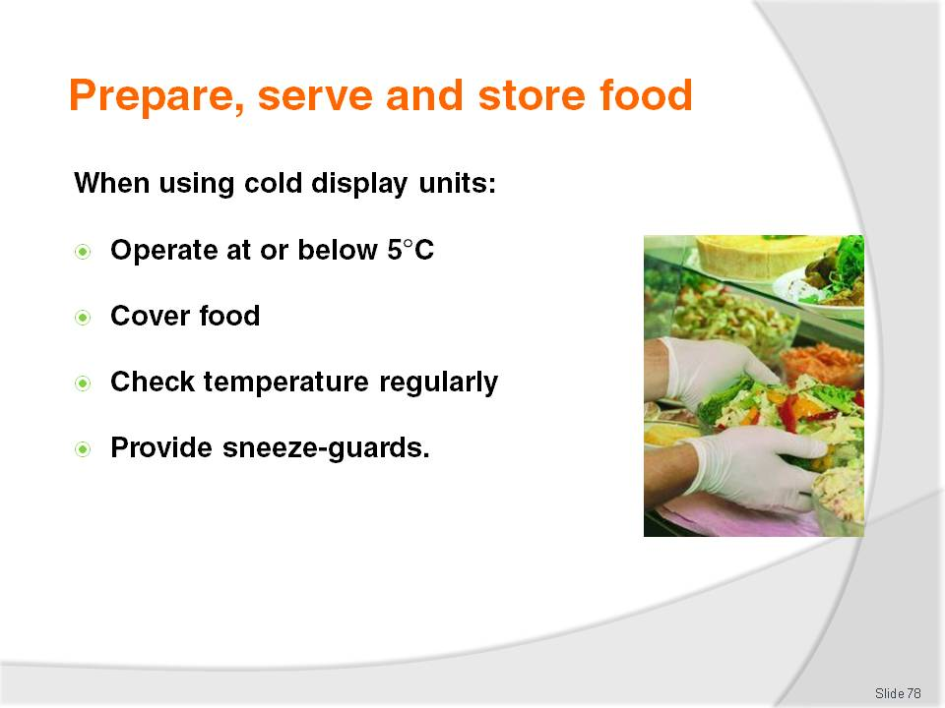
Slide No | Trainer Notes
Trainer advises trainees when using cold food display cabinets:
Potentially hazardous food should be at or below 5°C
Food should be covered or wrapped to prevent contamination
Temperatures must be regularly checked (at least daily – once every session, or every four hours is preferable) using an independent, properly calibrated thermometer
Protective guards (‘sneeze guards’) must be provided (where appropriate) to prevent customers breathing, sneezing or coughing over the food.

Slide
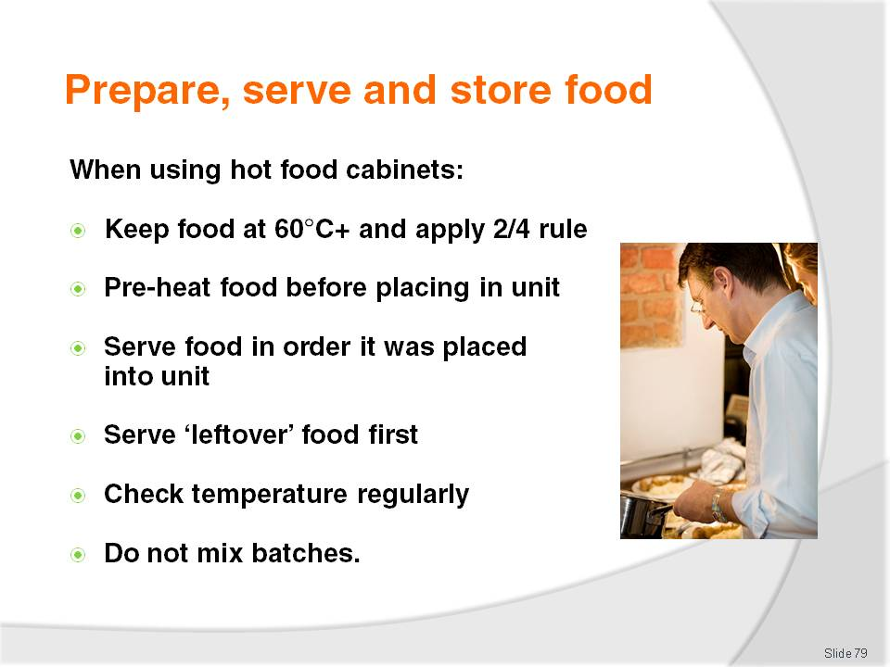
Slide No | Trainer Notes
Trainer advises trainees when using hot food display cabinets (bain marties and pie warmers):
The temperature of potentially hazardous food must be over 60°C (or the ‘2/4 Rule’ must be applied)
Food to be put in hot food cabinets must be preheated rapidly before being placed in the cabinet – do not use the hot holding unit to heat the food to service temperature. Pre-heat the food and place it into a pre-heated display unit
Food should be served in the order it was placed in the cabinet to minimise risk of contamination, as well as guard against loss of taste, appearance and quality
Hot foods left from the day before should be served first, following the guidelines set out in ‘Re-heating previously cooked food’ – foods can only be re-heated once. Note: some premises have an SOP of discarding all left-over food
Temperatures of food must be regularly checked (at least daily, preferable each session or every four hours) using an independent thermometer
Food must not be topped-up but rotated to keep it fresh and avoid mixing batches.

Slide
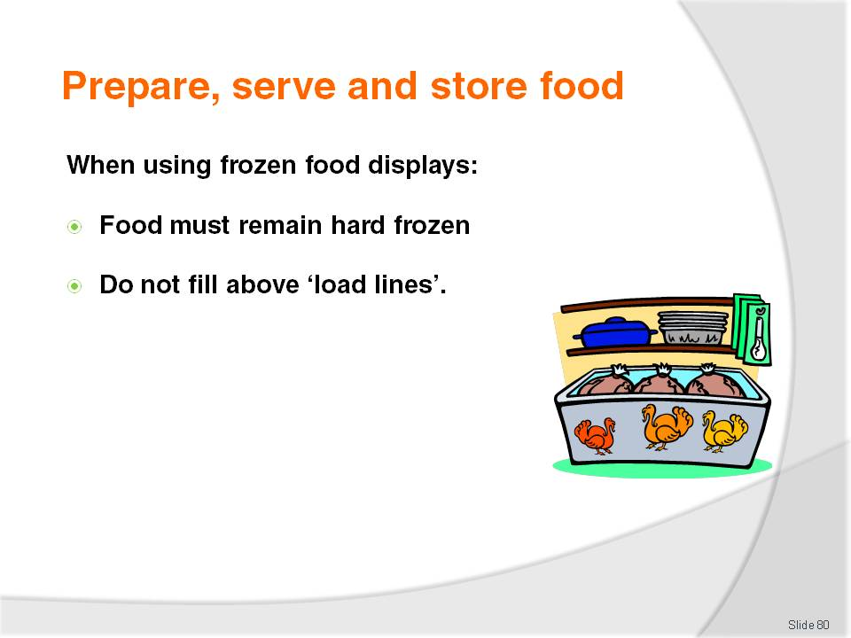
Slide No | Trainer Notes
Trainer advises trainees when using frozen food display cabinets:
The food must remain ‘hard frozen’ while on display, meaning there must be no visible sign the product has started to thaw
When using freezers with ‘load lines’, never fill above the load lines as this food will quickly thaw because the required low temperature does not exist above this line.

Slide
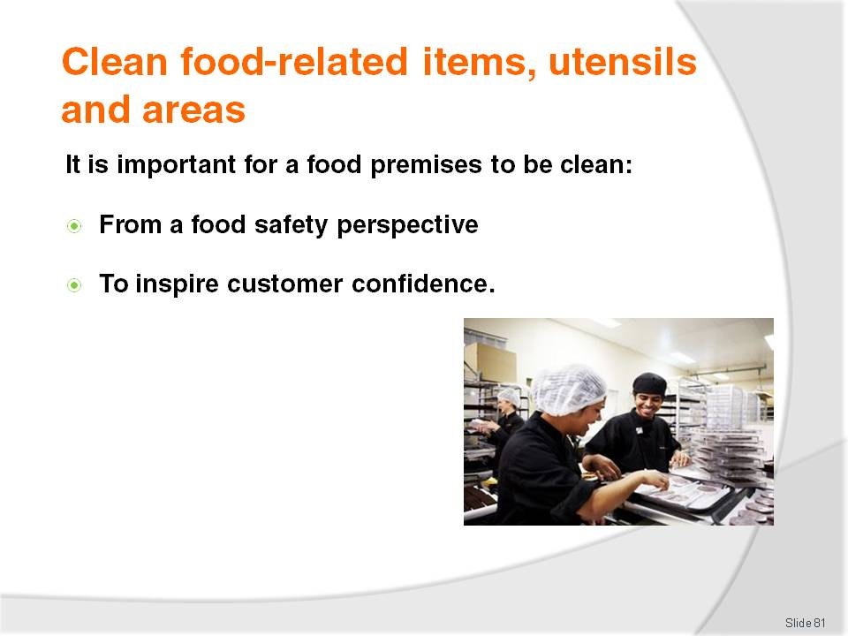
Slide No | Trainer Notes
Trainer highlights to trainees it is important for venues to be clean:
From a food safety perspective – cleaning and sanitising are basic requirements for all floor areas, equipment, utensils and food surfaces
To inspire customer confidence in the venue – and the food it serves: if a venue looks clean, customers will infer safe food and will tend to return to the premises to keep buying.

Slide
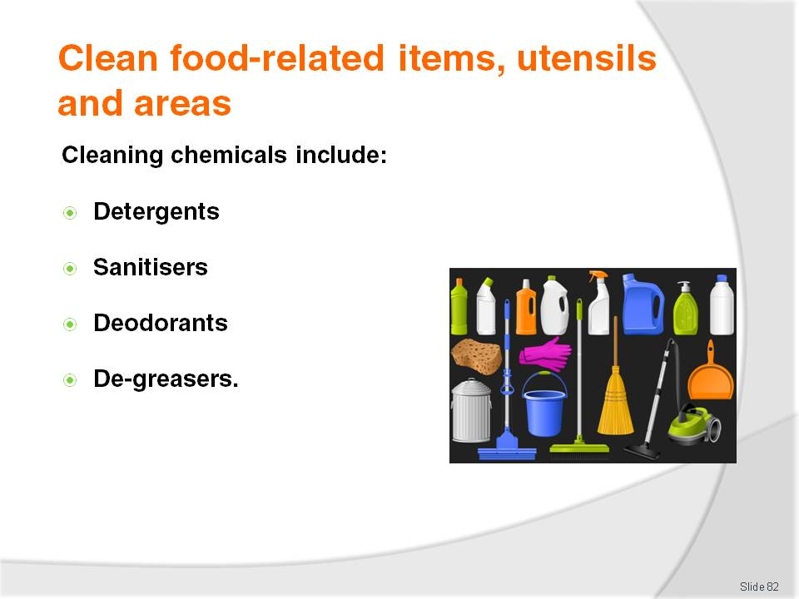
Slide No | Trainer Notes
Trainer advises trainees about chemicals used in cleaning include:
Detergents – used to remove dirt and grime from a variety of surfaces and items (cutlery and crockery, pots and pans, kitchen utensils and equipment, floors, walls and ceilings, food preparation surfaces and benches. Available in different concentrations to meet different cleaning demands, and available to suit different water conditions (hard water and soft water). Dilute according to manufacturer’s instructions for the cleaning job being undertaken
Sanitisers – used to sanitise items (food preparation surfaces, utensils, food equipment and food areas) by eliminating bacteria or reducing the number of bacteria to safe levels. Make sure nominated ‘contact time’ are adhered to for the product being used – always use according to manufacturer’s instructions
Deodorants – used to control smells and bad odours in waste bins. The use of deodorants is not a substitute for proper cleaning but can be used in the short-term to mask objectionable smells while the cause of the problem is being otherwise addressed
De-greasers – a chemical designed to cut through grease and fatty deposits. Commonly used in rubbish bins and waste bins to help remove the build-ups present in these containers.
Class Activity – Guest Speaker
Trainer arranges for a representative from a chemical supply company to visit trainees and:
Present samples of cleaning chemicals
Describes their use for cleaning in a food premises
Demonstrates their use
Provides manufacturer’s instructions for each chemical
Provides Material Safety Data Sheets for each chemical
Identify safety operating requirements when using chemicals.

Slide
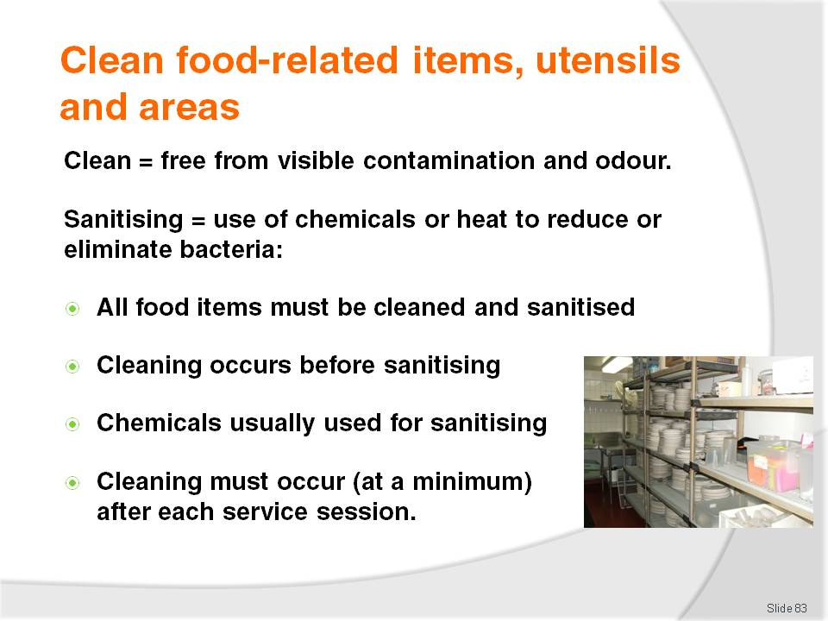
Slide No | Trainer Notes
Trainer provides trainees with relevant definitions regarding ‘cleaning’:
By definition, clean means free from visible debris (dirt, food, grime) and free from objectionable odour. The reference to ‘odour’ is only relevant when the definition is applied to rubbish bins
All food preparation equipment and surfaces must be kept in a clean and sanitary condition
‘Cleaning’ is the removal of visible dirt and debris (including objectionable odour) either from crockery, cutlery, glasses, equipment or fixtures and fittings
‘Sanitation’ (or ‘sanitising’) is the destruction of microbes using either hot water and or chemicals
Cleaning is performed before sanitation
This requirement for items to be clean and sanitary applies to chopping boards, bowls, food storage containers, food display equipment, preparation benches, walls and ceilings and anything in the food preparation, or food service area used to prepare, handle, process, serve, display or otherwise come into contact with food
Cleaning (using detergent and sanitiser) must occur at least ‘after each session’ – it is not acceptable to use an item or surface all day and only clean it once at the end of the day. It must be cleaned for example after breakfast, after lunch and then again after dinner. Some premises may require cleaning every 4 hours.

Slide
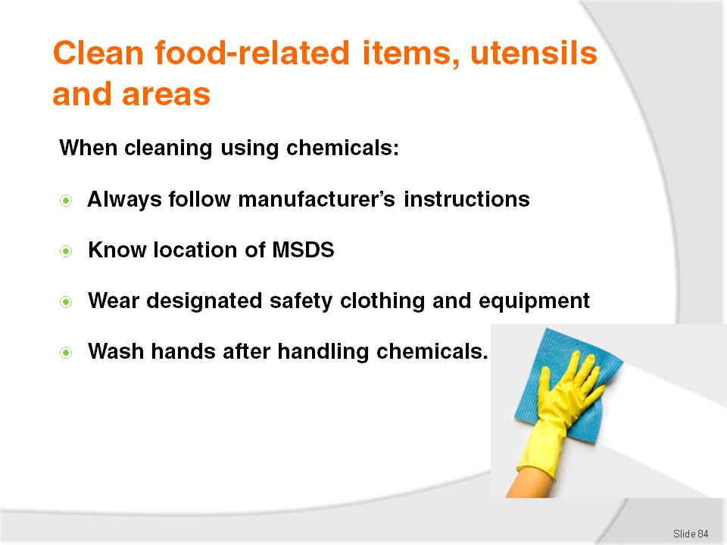
Slide No | Trainer Notes
Trainer provides trainees with safety advice regarding use of chemicals:
Always follow manufacturer’s instructions – in relation to dilution rates, contact time, water temperature and how the chemical is to be applied/used (for example, some chemicals are applied un-diluted; some are mixed with water in a bucket; some are applied using a trigger spray bottle)
Know where the MSDS are for the chemicals in use at the premises – in case there is an accident with the chemical. These sheets will provide immediate first aid information and other safety information in the case of (for example) a spill, ingesting of the chemical, getting the chemical in eyes
Always use the designated safety equipment and or clothing for the job being undertaken – known as ‘personal protective equipment and clothing’: this may include the use of gauntlets, respirators, face masks, leather aprons and steel-capped boots
Always wash hands after using cleaning equipment and or chemicals.
Class Activity – Handouts/Observation
Trainer provides:
Sample MSDS for trainees to read – so they become familiar with contents of these sheets
Drums/containers of chemicals drawing trainee attention to labels, directions for use, safety requirements.

Slide
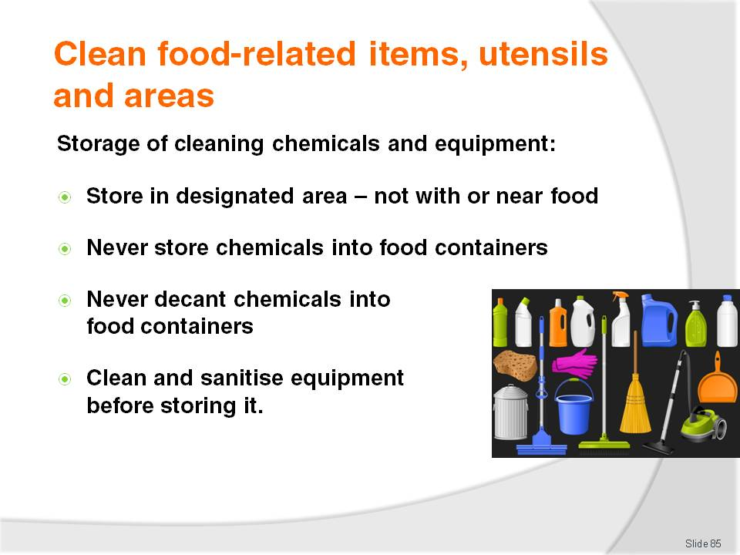
Slide No | Trainer Notes
Trainer provides trainees with directions regarding the storage of cleaning chemicals and cleaning equipment:
Always store chemicals in a designated chemical storage area
Never store chemicals alongside or near food
Never store chemicals in food or beverage containers
Always clean and (where necessary) sanitise cleaning equipment before storing it.

Slide
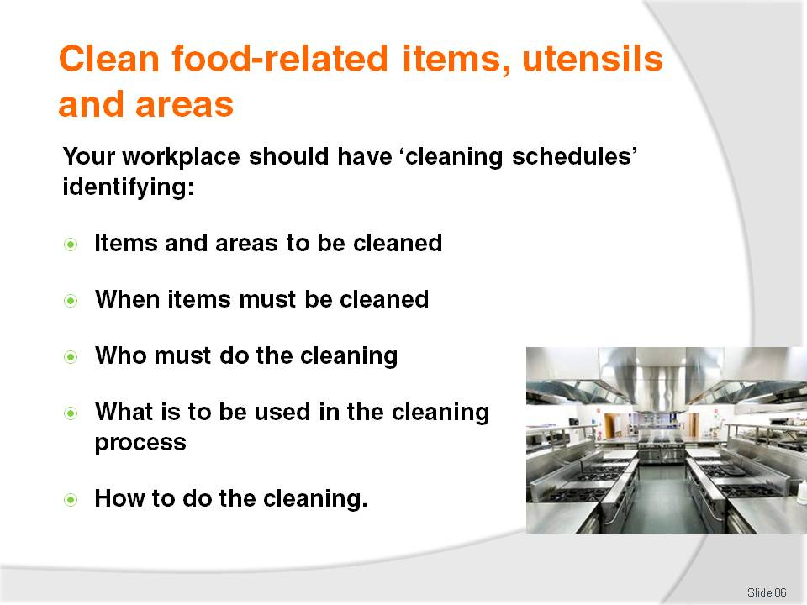
Slide No | Trainer Notes
Trainer identifies for trainees all venues should use ‘cleaning schedules’ identifying:
The food-related items and areas that need to be cleaned – by name, or other description of item/area
When they need to cleaned – giving a time by hour (for example, 10:00AM, 2:00PM and 6:00PM) or general time of day (such as ‘after lunch’)
By whom they must be cleaned – indicating either a staff member by name, or by job position or job title
What is to be used in the cleaning process – identifying chemicals and cleaning equipment that have to be used
Detailed cleaning instructions – to explain how each item is to be cleaned: this may include advice on how to dis-assemble an item and re-assemble it after cleaning.
Class Activity (1) – Handouts
Trainer provides trainees with sample cleaning schedule and cleaning instructions (see Trainee Manual – ‘Sample cleaning instructions’) and reads through these with trainees explaining them and ensuring trainees understand their use.
Class Activity (2) – Individual Exercise
Trainer asks trainees to identify one food item/area and asks them to produce an effective set of cleaning instructions for the item/area.
Trainer analyses instructions and provides constructive feedback, as required.

Slide
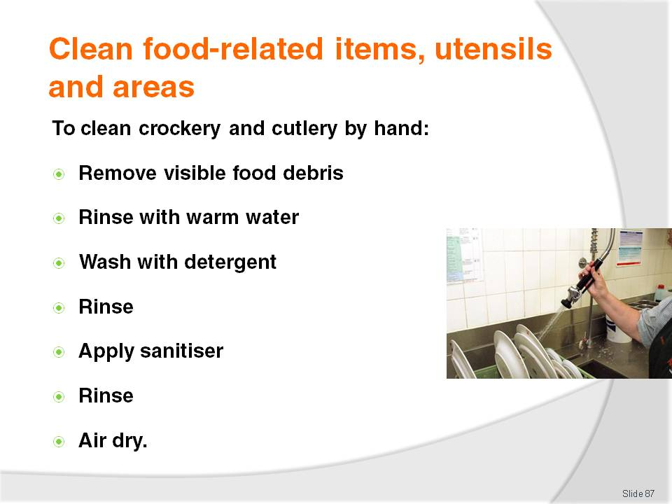
Slide No | Trainer Notes
Trainer provides trainees with directions for washing eating utensils (crockery and cutlery) by hand:
Remove visible food debris – for example, scrape the plates
Rinse with warm water – to remove loose dirt and loosen other debris
Wash with a detergent – to remove remaining dirt and food debris
Rinse again – to remove the detergent and debris
Apply a sanitiser – to kill bacteria: very hot water may also achieve the same result
Rinse – to remove the sanitiser (if recommended by manufacturer of the sanitiser)
Allow to air dry – do not dry with tea towels as this may introduce contamination to surfaces that have just been cleaned and sanitised.
Class Activity – Demonstration and Practical Exercise
Trainer demonstrates how to wash crockery and cutlery by hand and provides opportunity for trainees to practice same.

Slide
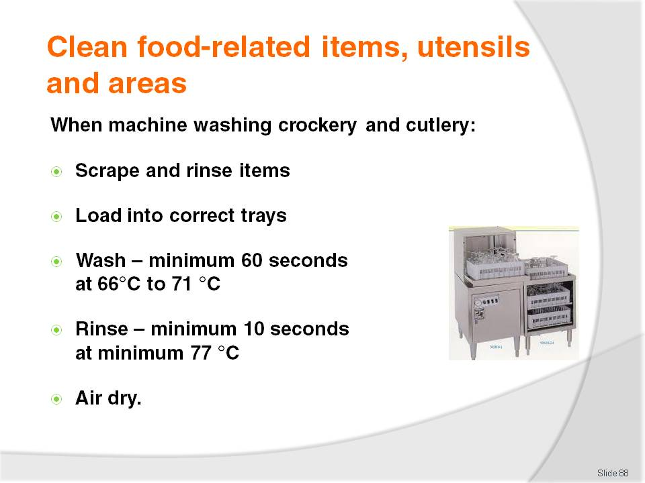
Slide No | Trainer Notes
Trainer gives trainees guidelines for washing eating utensils and dishes by machine:
Scrape and rinse items prior to stacking in trays – use the right trays/racks for the right items. There are different trays and racks for plates, cups, cutlery
Wash for a minimum of 60 seconds at a temperature between 66°C and 71°C
Rinse for a minimum of 10 seconds at a temperature of at least 77°C
Allow to air dry.
Class Activity – Demonstration and Practical Exercise
Trainer shows trainees how to load and wash crockery and cutlery into a dish washing machine and provides opportunity for trainees to practice same.

Slide
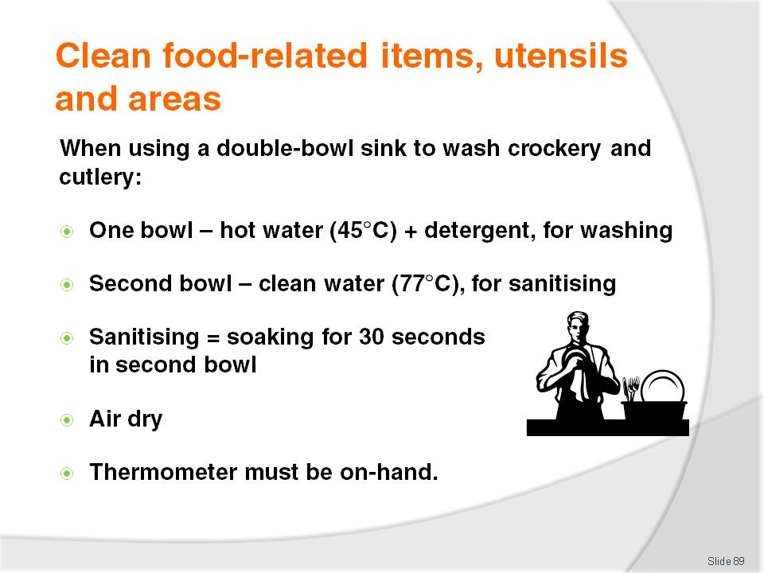
Slide No | Trainer Notes
Trainer advises trainees regarding use of a double-bowl sink to wash crockery and cutlery:
One bowl must contain water at 45°C and detergent – for washing
One bowl must contain clean water at a minimum of 77°C – for sanitising
Sanitising must involve soaking the items for a minimum of 30 seconds – it is not acceptable to just run hot water over items to remove the suds
Allow to air dry
A thermometer must be on hand to check water achieves the required temperatures as identified.

Slide
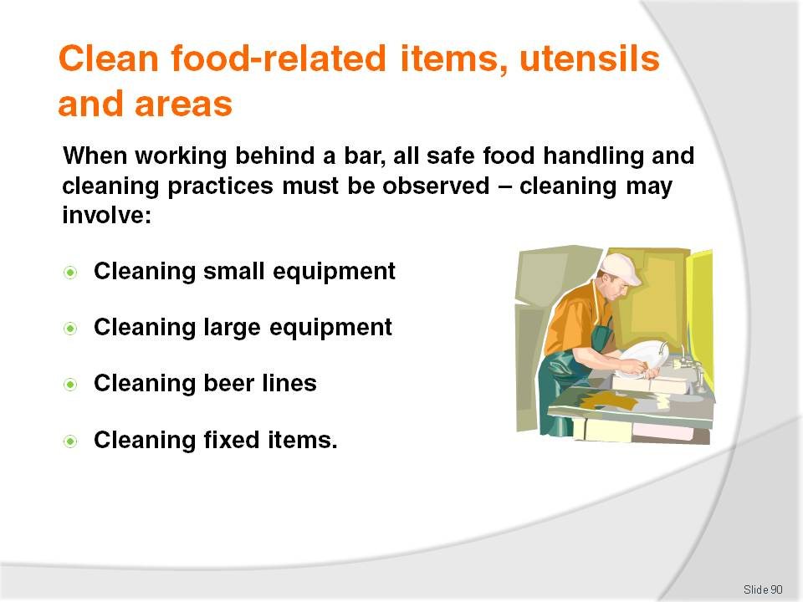
Slide No | Trainer Notes
Trainer states to trainees when working in a bar serving alcoholic and or non-alcoholic drinks they need to pay attention to safe food handling practices, including cleaning, in the same way other food handling staff do highlighting working behind a bar can involve:
Cleaning of small equipment such as drip trays (including those provided under beer taps, under post mix nozzles, and those inside refrigerated equipment), chopping boards, knives, spoons, glassware, cocktail shakers and measures
Cleaning of large equipment such as refrigerators – with special attention to the seals around doors which can become sticky due to dripping drinks being passed over them. Large bar equipment also includes ice machines and glass chillers
Cleaning of beer lines – where beer is dispensed from kegs using beverage dispense lines, these should be cleaned at least weekly according to brewery instructions using only chemicals approved by the brewery: in hot weather beer delivery lines should be cleaned twice a week
Cleaning of fixed items – such as the bar counter, cash registers and mirrors: these are not really related to ‘food safety’ as such but they help give the bar the appropriate ‘clean’ look customers want.
Class Activity – Excursion
Trainer arranges for trainees to visit a licensed venue and:
Talk to cleaning staff
View facilities
Observe cleaning practices for:
- Small equipment
- Large equipment
- Beer lines
- Fixed items.

Slide
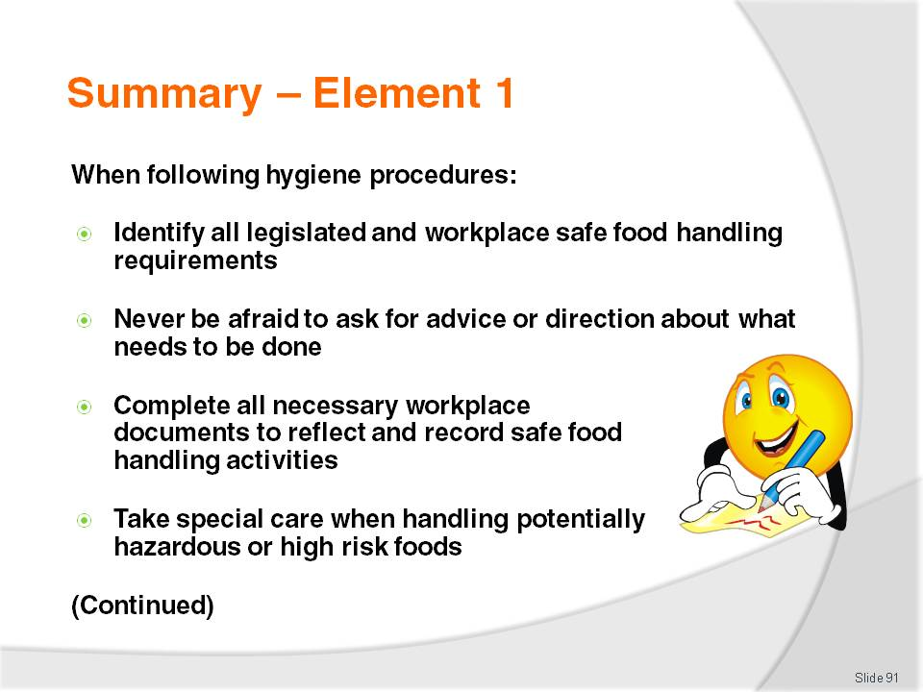
Slide No | Trainer Notes
 | Trainer provides a recap of the Element asking questions to check trainee understanding and responding to questions from trainees, as required.

Slide
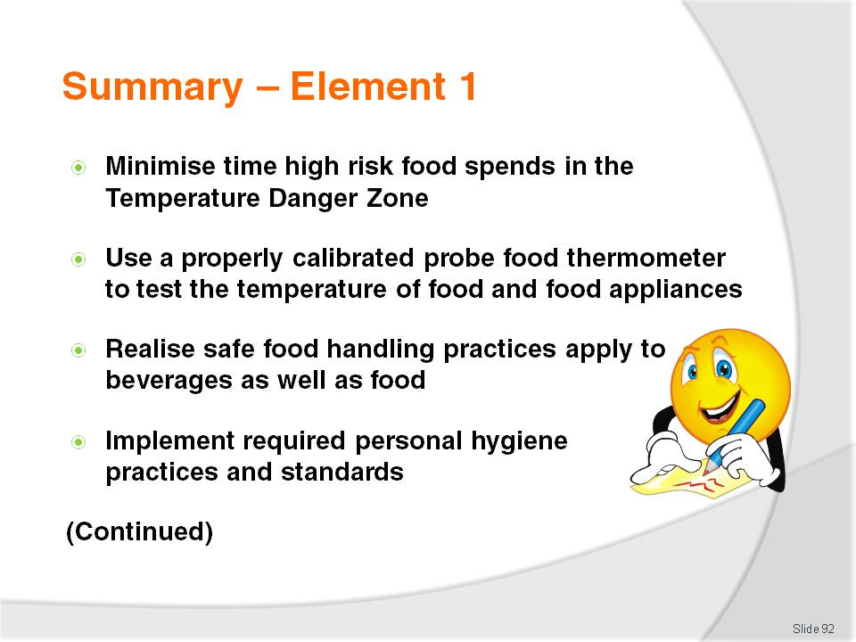
Slide No | Trainer Notes
 | Trainer provides a recap of the Element asking questions to check trainee understanding and responding to questions from trainees, as required.

Slide
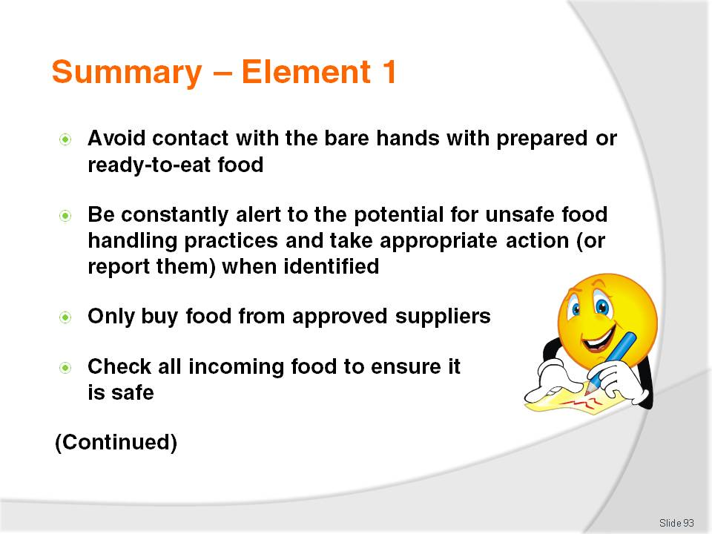
Slide No | Trainer Notes
 | Trainer provides a recap of the Element asking questions to check trainee understanding and responding to questions from trainees, as required.

Slide
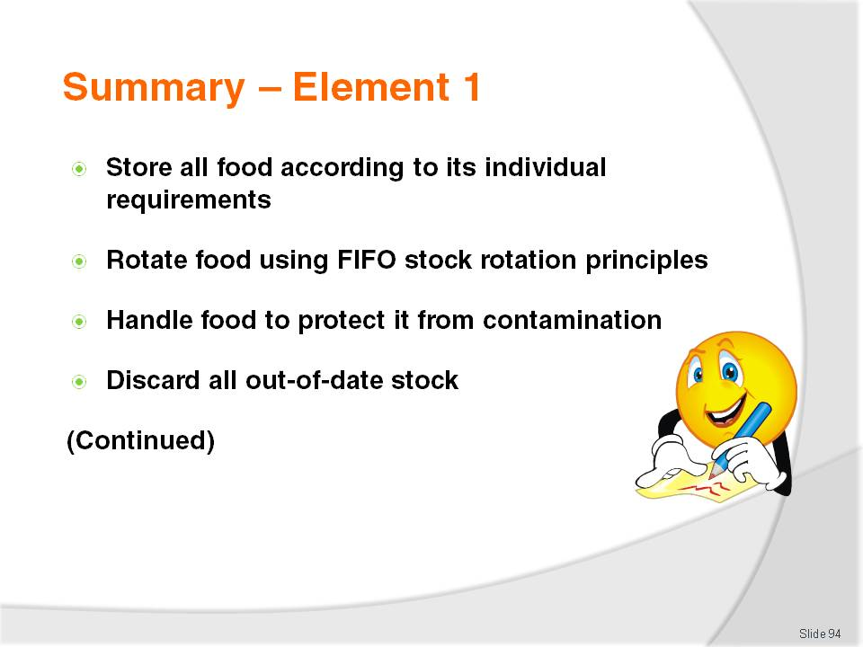
Slide No | Trainer Notes
 | Trainer provides a recap of the Element asking questions to check trainee understanding and responding to questions from trainees, as required.

Slide
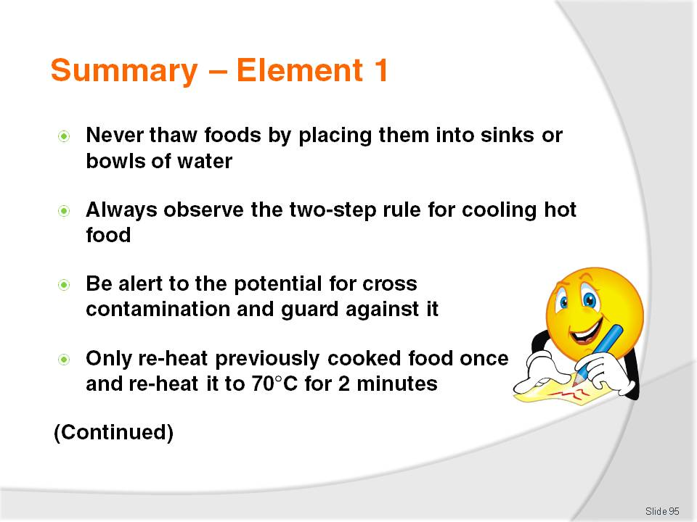
Slide No | Trainer Notes
 | Trainer provides a recap of the Element asking questions to check trainee understanding and responding to questions from trainees, as required.

Slide
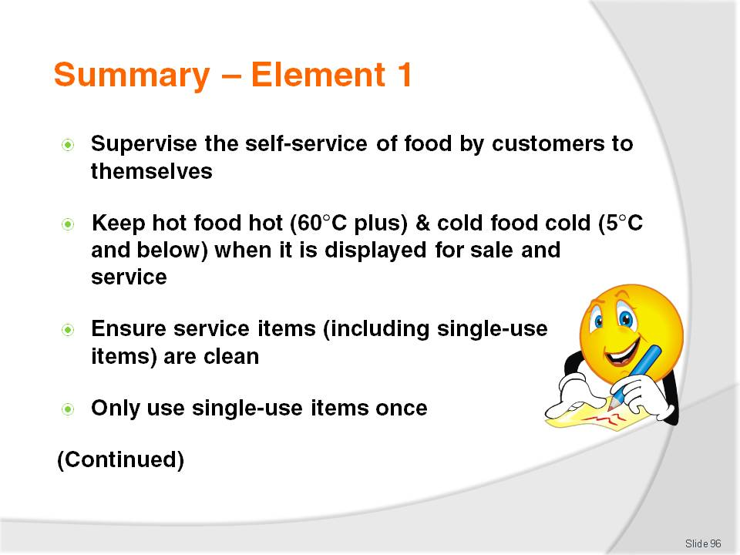
Slide No | Trainer Notes
 | Trainer provides a recap of the Element asking questions to check trainee understanding and responding to questions from trainees, as required.

Slide
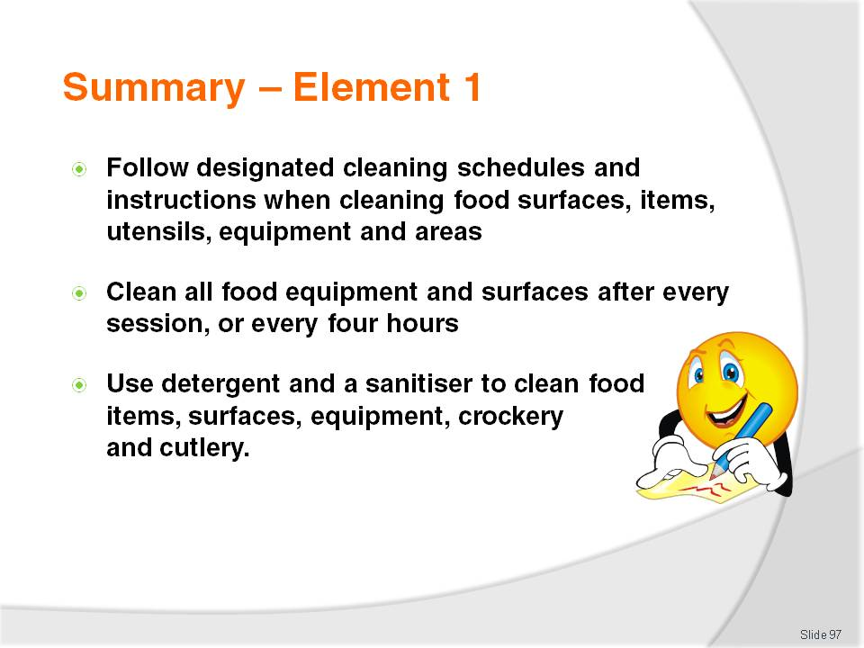
Slide No | Trainer Notes
 | Trainer provides a recap of the Element asking questions to check trainee understanding and responding to questions from trainees, as required.

Slide
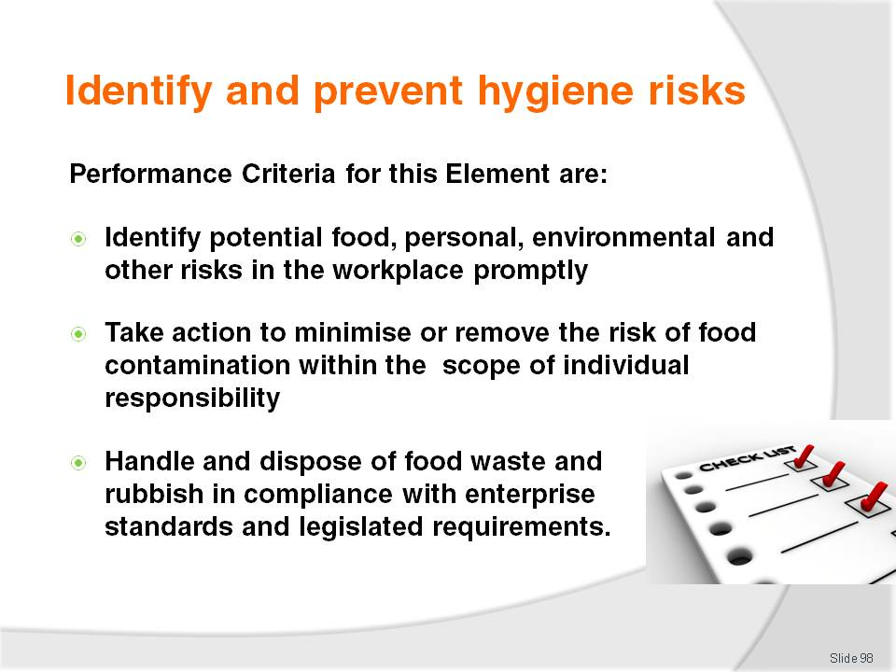
Slide No | Trainer Notes
Trainer identifies for trainees the Performance Criteria for this Element, as listed on the slide.
Class Activity – Discussion
Trainer asks trainees questions regarding workplace food safety risks by asking questions such as:
What possible food risks exist in your workplace and how are they addressed? Are they addressed effectively?
What possible personal risks exist in your workplace in relation to food safety and how are they addressed? Are they addressed effectively?
What possible environmental risks exist in your workplace in relation to food safety and how are they addressed? Are they addressed effectively?
What action would you take if you identified an unsafe work practice in your workplace? Why?
What action would you take if you identified unsafe food in your workplace? Why?
What protocols exist in your workplace for removing food waste from the kitchen and food areas?
What protocols apply to the storage of waste on the premises (externally) and the removal of waste (including food waste) from the premises?

Slide
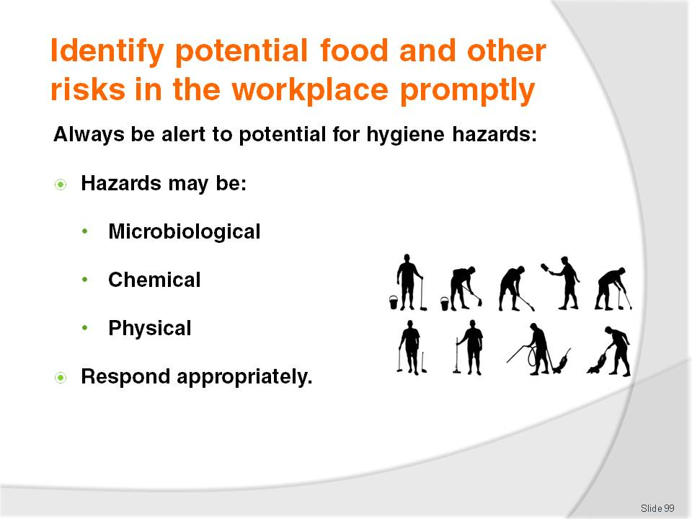
Slide No | Trainer Notes
Trainer notes for trainees all food handling staff must always be alert to the possibility of any risks posed by hygiene hazards in the workplace creating a threat to the safety of food, identifying:
A food hazard may be seen as any microbiological, chemical or physical contaminant in food
Keys in responding to these threats are:
- Awareness
- Constant vigilance
- Immediate reporting
- Quick and effective responses.

Slide
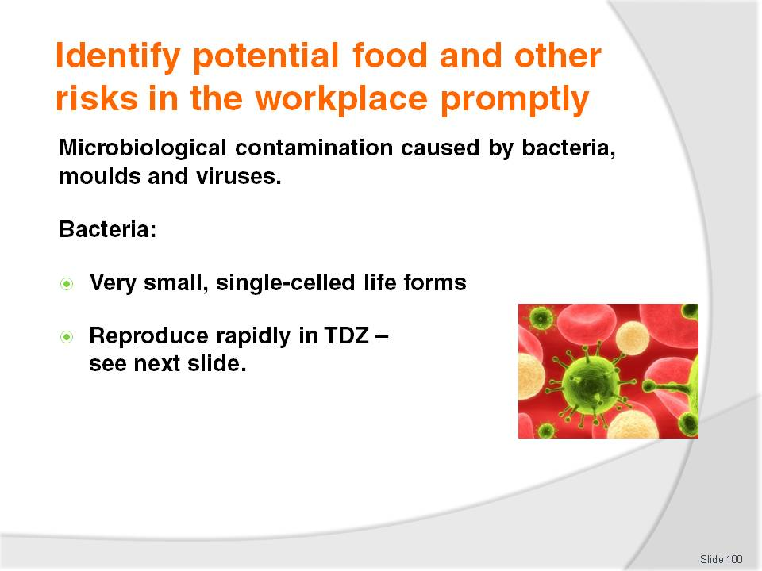
Slide No | Trainer Notes
Trainer explains to trainees microbiological contamination is caused by bacteria, moulds, and viruses via intoxication or infection, covering bacteria by stating:
These are single-celled life forms and are found everywhere. They are found in the air, soil, on our hands, equipment and utensils. Bacteria live in both humans and animals, growing and multiplying rapidly, aided by warmth, moisture, time, food and oxygen. They are so small that several million can fit onto a pinhead
Bacteria reproduce rapidly and the average bacteria take about 10 to 20 minutes to reproduce. If the environment is favourable, bacteria can grow from 1 to over 2 million bacteria in the space of 7 hours
Bacteria favour high temperatures, and multiply rapidly when the temperature is high. The Temperature Danger Zone in which bacteria will multiply rapidly is between 5°C to 60°C.

Slide
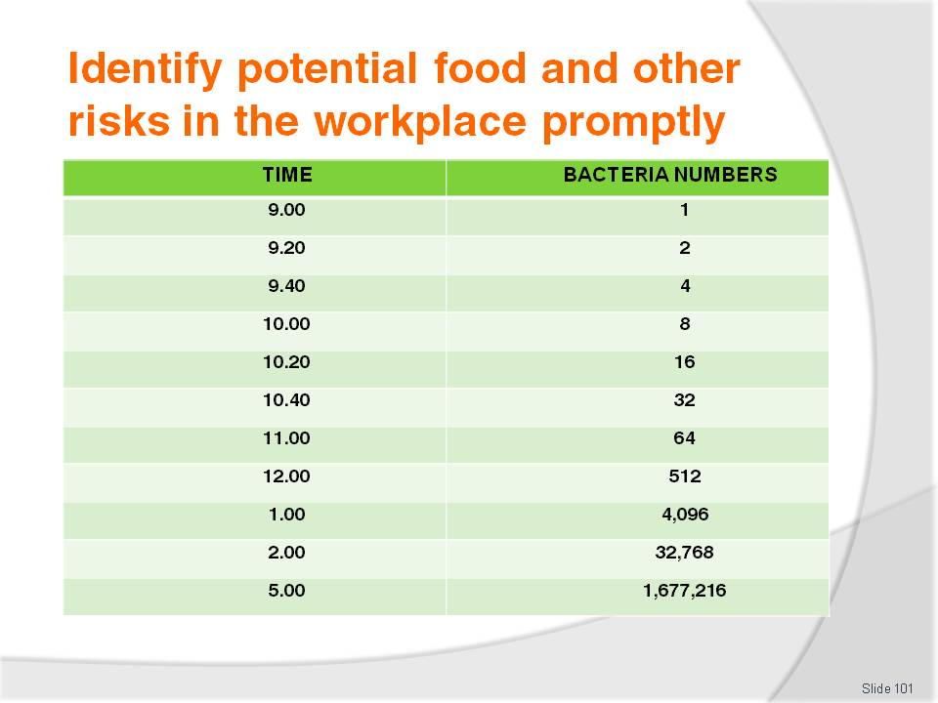
Slide No | Trainer Notes
 | Trainer highlights the rapid growth of bacteria (via ‘binary fision’) explaining the above table starts with just one bacterium and, in real life, there is never just one bacterium contaminating food or a surface.

Slide
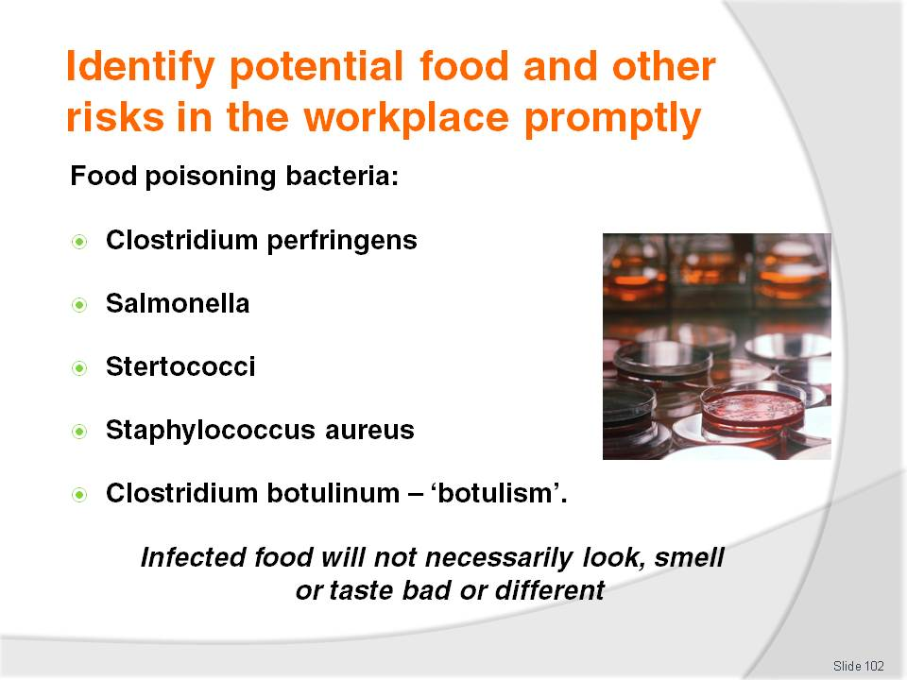
Slide No | Trainer Notes
Trainer introduces several problem bacteria to trainees explaining there are many more than the following:
Clostridium perfringens – usually caused when food is cooked, chilled overnight and re-heated, or found in foods that are cooked 'rare'. The initial source of the contamination is faeces (man, birds, animal or insects) which is introduced somewhere along the food chain or production line (failure of staff to wash their hands after the toilet; flies carrying it onto food; contamination at the abattoir)
Salmonella – a very common contaminant. Faecal contamination is a prime source (failure of staff to wash hands after the toilet; flies carrying it onto foods; leaky plumbing; fish harvested from waters polluted by sewage)
Streptococci – caused by nasal or oral discharges into food (coughing, sneezing), either directly or via hands that have been so contaminated
Staphylococcus aureus – a rapidly acting bacteria where the main source is the food handler: nose, throat, mouth, skin, pimples and cuts, either via direct or indirect contamination
Clostridium botulinum – a rare bacteria but a very lethal contaminant (with a 65% mortality rate). Can occur when heat processing of tins and jars is incomplete allowing hardy spores (see below) to survive and cause the problem. Any tin that 'spurts' when opened, is leaky or is 'blown', or jars with broken seals must be discarded as this is a sign of botulism contamination: there is no adverse smell and food must not be tasted to test it as the small amount ingested during tasting can kill
There is usually no sign food has been infected by bacteria. It will not always look, smell or taste different to food that is not contaminated by bacteria.
Slide
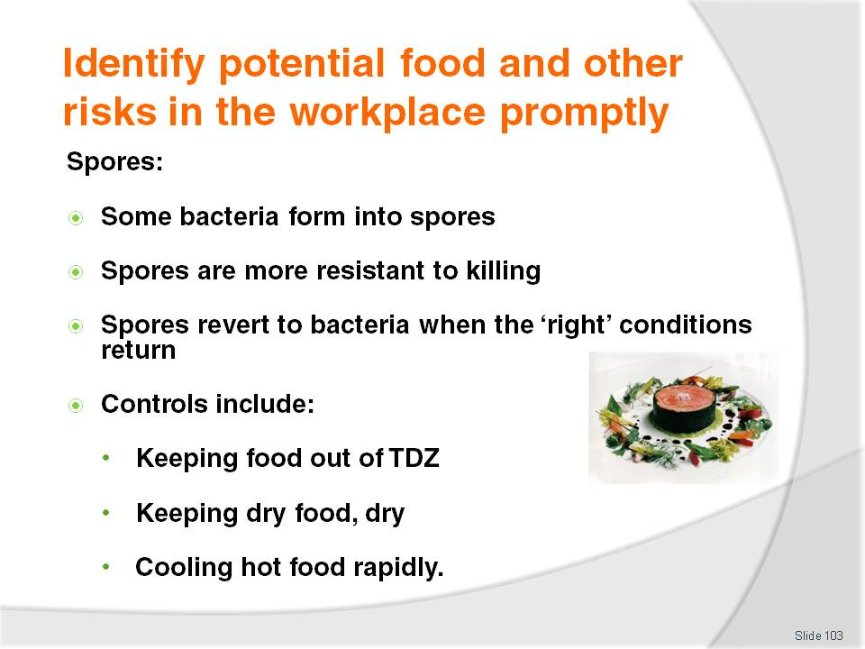
Slide No | Trainer Notes
Trainer explains to trainees some bacteria can survive in harsh environments by changing into spores stating spores have a thick coat which makes them very tough and difficult to kill:
When bacteria form into spores, they can re-form back into bacteria when conditions return to being favourable: the spores are resting, not growing – they are simply waiting for ideal growth conditions (warmth, moisture) to return and they begin multiplying again
Not all bacteria form spores because spores may not be killed by normal cooking
Spores can be stopped from becoming active bacteria by:
- Keeping food above 60°C
- Keeping food below 5°C
- Keeping dry food, dry
- Cooling hot foods quickly through the Temperature Danger Zone, rather than just allowing them to cool for long periods at kitchen temperatures.

Slide
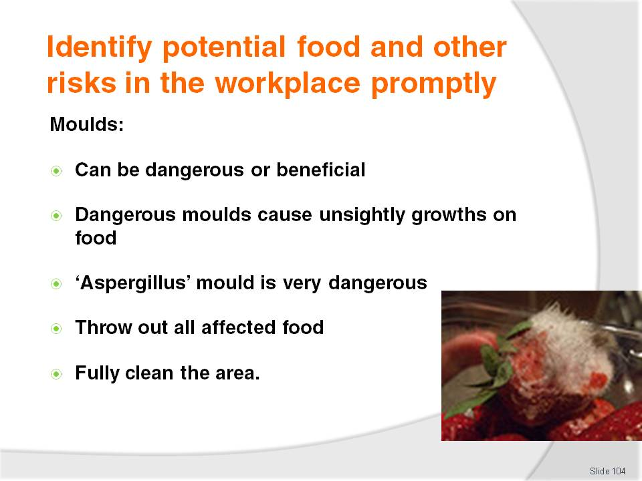
Slide No | Trainer Notes
Trainer introduces ‘moulds’ to trainees as another example of microbiological contamination stating they can be harmful or useful to food, adding certain moulds damage the food on which they grow and (in some cases) moulds can be very dangerous if they are eaten by humans while other moulds are used to enhance food, for example those used in cheese making – the blue vein in ‘blue vein’ cheese is a cultivated mould:
Most moulds cause spoilage in food – moulds usually take the form of unsightly growths, off colours and off flavours. These moulds are recognised as being fuzzy or having furry growths and are generally found on bakery products, vegetables, overripe fruit and semi-dried meat
One very dangerous mould is the aspergillus mould, which grows on peanut plants. Aspergillus thrives in warm, moist conditions and produces a toxin called aflatoxin. A tiny amount of aflatoxin can cause liver cancer
Moulds reproduce by forming spores containing the genetic material for the mould. Unlike bacteria, moulds do not need to die to release their spores. The spores are ‘set free’ and spread through the air in the wind or carried by animals or water. The spore settles on a food source puts down roots and grows a trunk and branches just like a tree grows from a seed in good soil. Each spore can reproduce rapidly in a favourable environment
Discard all mould-affected food – do not just scrape off the affected area and use the rest of the item
Undertake a full clean of the area – such as a cool room where mould has been detected.

Slide
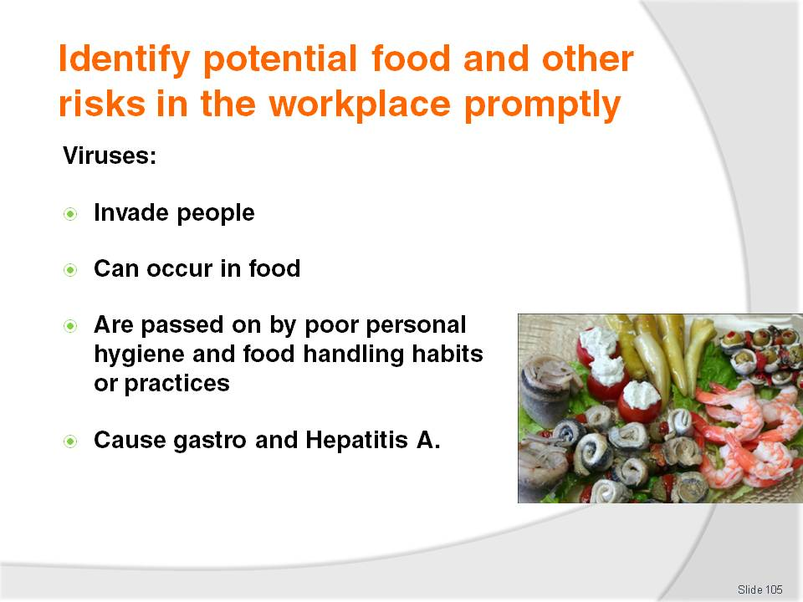
Slide No | Trainer Notes
Trainer advises trainees about viruses and food safety:
Viruses invade a living host cell – such as a person (food handler), seafood, fruit and vegetables
Can be passed on by ingesting infected food or as a result of unsafe personal food handling practices
Examples are gastro-enteritis and Hepatitis A.
Class Activity – Guest Speaker
Trainer arranges for Health Official to attend and talk to trainees about:
Microbiological contamination of food
Examples of food poisoning bacteria, viruses and moulds
How microbiological contaminants affect food and impact food safety
Ways food handlers can prevent microbiological contamination of food
Stories of the effects of microbiological contamination of food
Naturally occurring poisonous foods.

Slide
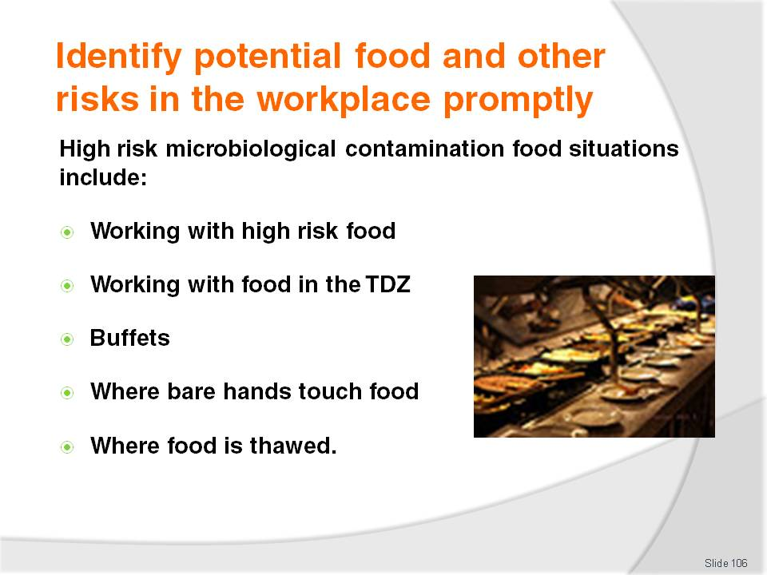
Slide No | Trainer Notes
Trainer describes for trainees examples of high risk food handling situations that may include microbiological contamination include:
Working with any high risk and potentially hazardous foods
Working in temperatures that promote rapid bacterial growth – that is, in the Temperature Danger Zone (5°C to 60°C). This may occur when raw foods are being processed, prepared for cooking at normal kitchen temperatures. The amount of time high risk food spends in the Temperature Danger Zone must always be minimised
Displays of food and buffets – where the temperature may be compromised (hot food may fall below 60°C, cold food may rise above 5°C), plus there is always the danger members of the public (untrained in correct food handling procedures) may contaminate the food
Processing of food where it is touched by the bare hand and then not subsequently cooked
Any situation requiring thawing and re-heating always poses a risk because the food may stay in the Temperature Danger Zone too long.

Slide
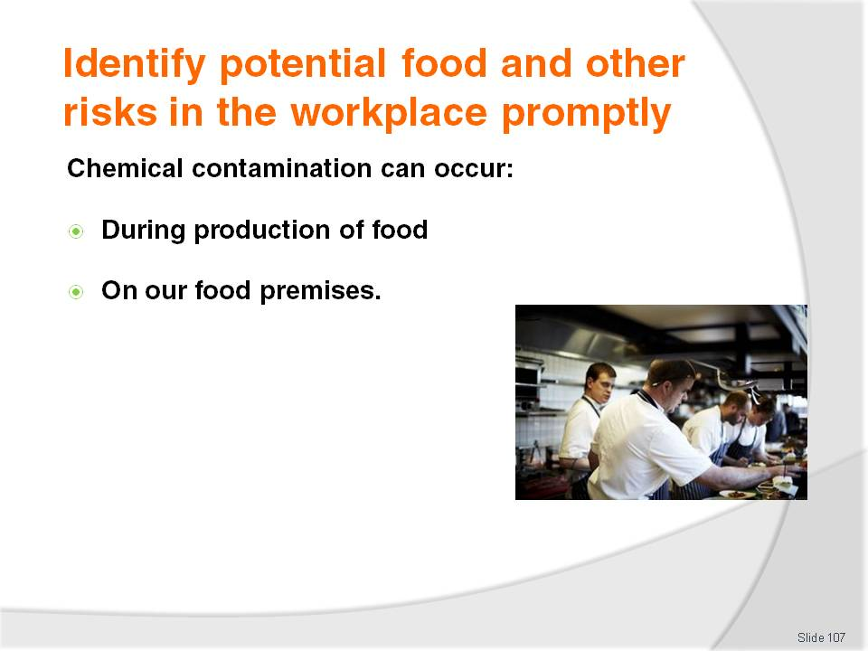
Slide No | Trainer Notes
Trainer tells trainees chemical contamination of food can occur:
As a result of chemicals used on the food when it is grown – meaning items are contaminated when they arrive in the premises
When chemicals find their way inadvertently into the food on the premises – due (for example) to careless practices in food areas and improper handling of food and chemicals.

Slide
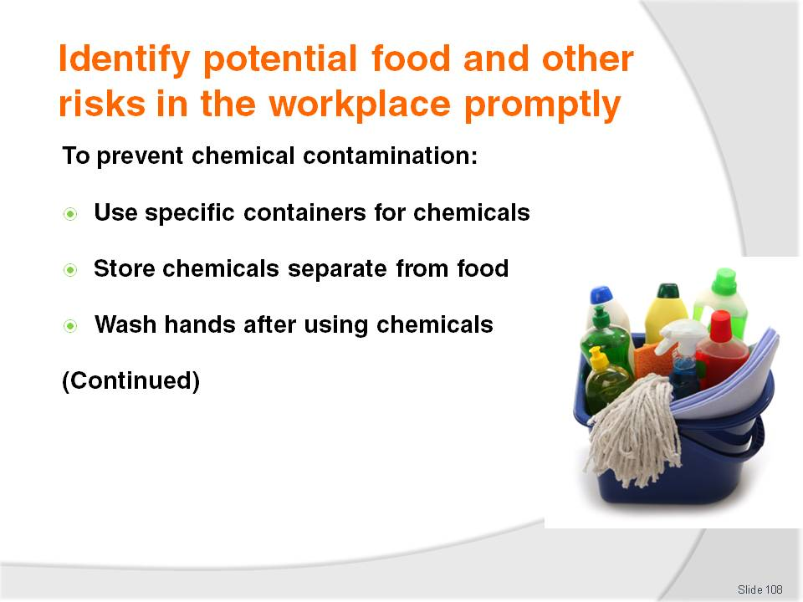
Slide No | Trainer Notes
Trainer informs trainees the following practices will help prevent chemical food poisoning:
Specific measuring vessels should always be allocated for chemicals – never use food service items (jugs, glasses, cups, bowls, measuring spoons) to obtain, measure or pour any chemical
All chemicals must be stored away from food areas at all times – chemicals must never be stored in the kitchen or with food
Always wash hands after using chemicals and before handling food or food items, utensils or preparation surfaces.

Slide
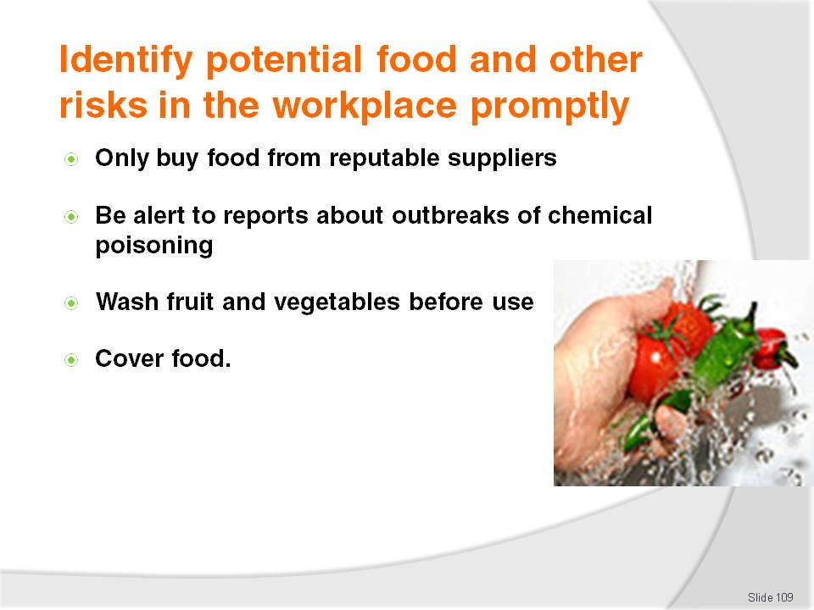
Slide No | Trainer Notes
Trainer continues to inform trainees about practices to help prevent chemical food poisoning:
Only buy food from reputable suppliers who can guarantee their produce is chemical-free
Be aware of alerts advising about contaminated food from a certain location, country or source
Always wash fruit and vegetables before using them in a sanitising solution
Cover food whenever it is not being processed or prepared – to protect from contamination by fly sprays and similar.

Slide
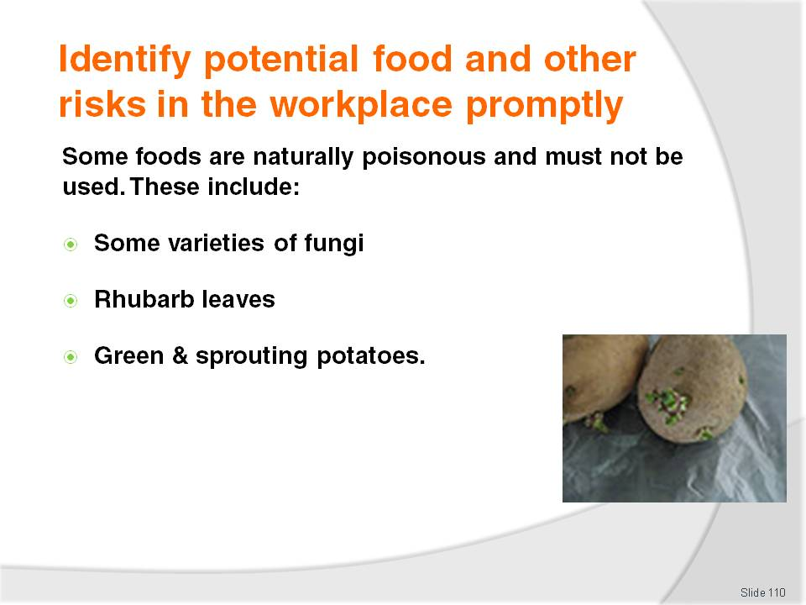
Slide No | Trainer Notes
Trainer states to trainees ‘Naturally occurring poisonous foods’ are also classified as part of the ‘chemical contamination’ threat:
Mushrooms – certain fungi can be poisonous but those purchased from reputable suppliers should be safe. Do not buy mushrooms from people calling door-to-door, and do not use in a commercial setting mushrooms picked by private individuals
Rhubarb leaves are poisonous so great care should be given when stemming them. The stem of the rhubarb is safe to eat
Green and sprouting potatoes contain a substance called 'solanine' which has been linked with food poisoning outbreaks so green potatoes should be discarded, returned to the supplier or rejected on delivery.

Slide
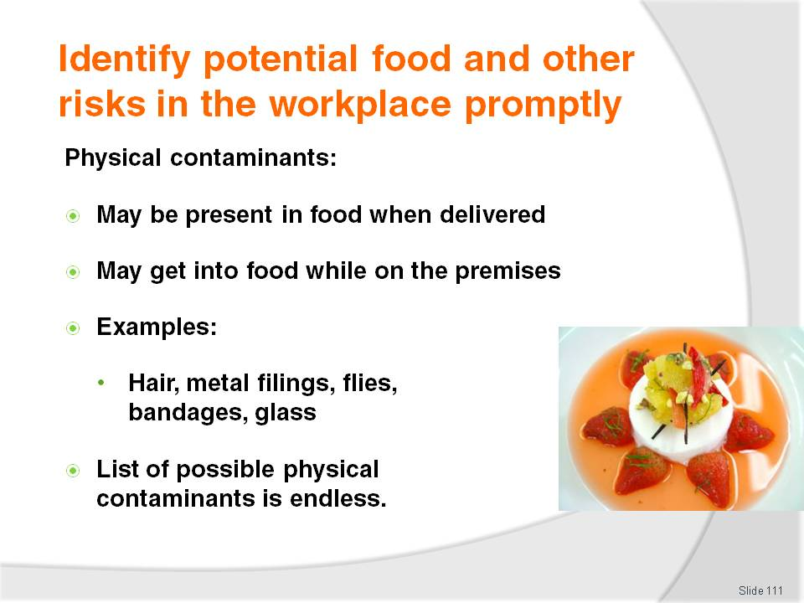
Slide No | Trainer Notes
Trainer stresses to trainees they must always be on their guard to ensure foreign objects do not find their way into food for human consumption highlighting the foreign object may have found its way into the food before the product or item arrived at the premises so constant vigilance is required, all the time.
Trainer presents examples of physical contaminants:
Hair from the head or beard
Metal filings left by can openers
Flies and insects – and their droppings
Band-aids
Bits of glass
These are only a small sample of possible physical contaminants. The list is endless.

Slide
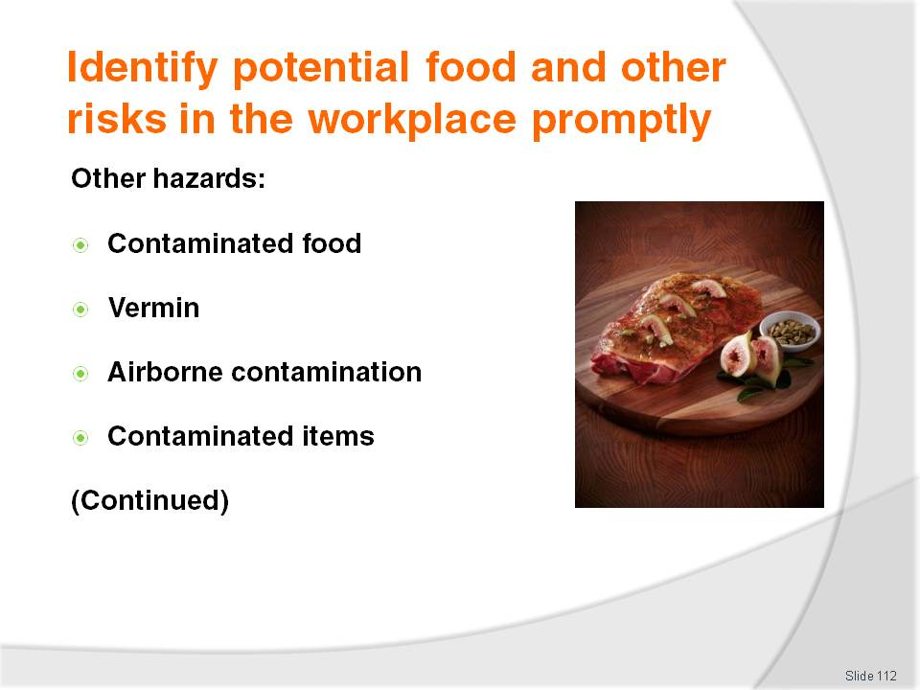
Slide No | Trainer Notes
Trainer provides trainees with examples of ‘other hazards’ in relation to food safety highlighting all the following are examples of food hazards they need to be aware of and constantly searching for:
Contaminated food – either from the supplier or food that becomes contaminated on-site
Vermin – including sighting of vermin and evidence of their presence (droppings, webs, holes in the wall, eggs)
Airborne contamination – either due to natural causes (sand/dust storms, weather) or due to internal causes (dust, renovations)
Contaminated items – such as linen, tea towels and kitchen swabs that may be contaminated with human waste (blood and secretions) and or food.

Slide
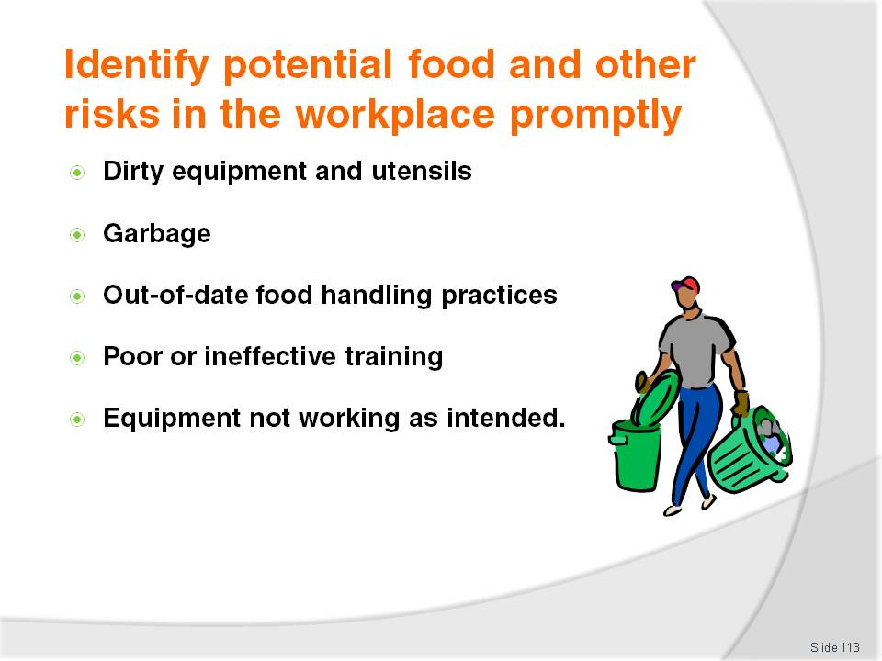
Slide No | Trainer Notes
Trainer continues presenting examples of ‘other’ food hazards:
Dirty equipment and utensils – including items not properly cleaned and or sanitised after use, items dropped on the floor and items contaminated by clothing, coughing/sneezing, or cross contamination of any sort
Garbage – all rubbish and waste presents a potential hazard whether it is stored in bins inside the premises or in containers outside the premises: remember hands must be washed after handing garbage and all garbage containers must be kept clean
Out-of-date food handling practices – hazards can occur where:
- The nature of the food operations being undertaken have changed – the venue may have changed its service style or undergone some significant change
- The food equipment being used has altered – a new/different oven, fryer or cooking range has been installed
- The food items being processed have changed – new menu items have been introduced and there has been no appropriate alteration to the previous food handling protocols to accommodate the risks and hazards introduced by these changes: all food handling practices must be appropriate for the current situation applying in the workplace
Colleagues with inappropriate training – even where staff have undertaken a food safety course there is no guarantee the lessons they have learned. Where workers are using incorrect food service practices and or failing to observe other safe food handling principles (especially in relation to personal hygiene, hand washing) there is a need for re-training
Equipment not operating as intended by the manufacturers – this typically includes all food processing and holding equipment (especially fridges, freezers, pie warmers and bain maries) as well as thermometers.

Slide
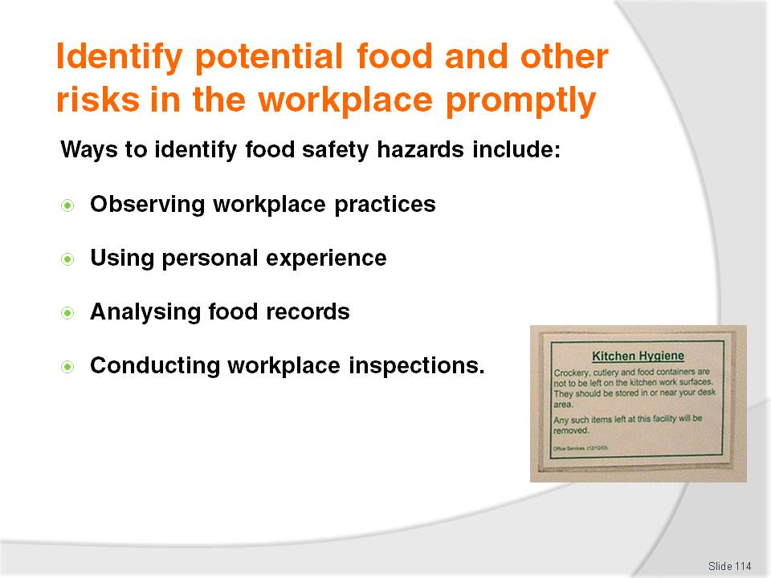
Slide No | Trainer Notes
Trainer instructs trainees the standard ways to identify food safety hazards in the workplace are:
Personal observation – watching what happens in the workplace and being alert to the potential for hazards to arise at any time, any day
Personal experience with items – a growing body of knowledge with food, procedures, equipment and the workplace will be an invaluable resource in helping identifying problems out-of-control situations and other circumstances posing a risk to food safety
Analysis of food safety records, documents and logs – where the workplace maintains records of its food activities (temperature record logs; food production sheets; maintenance reports) a regular review of these can reveal issues such as incorrect temperatures (meaning the need for repairs/service to refrigeration units), staff that should be excluded from food handling (on the basis of illness records, injury registers), malfunctioning equipment (via corrective action reports), and food that needs to be disposed of (as indicated by a range of inspection checklists)
Regular and scheduled workplace inspections (also known as ‘audits’) – designed to verify safe food handling protocols and identify unsafe operations, equipment, areas or protocols.

Slide
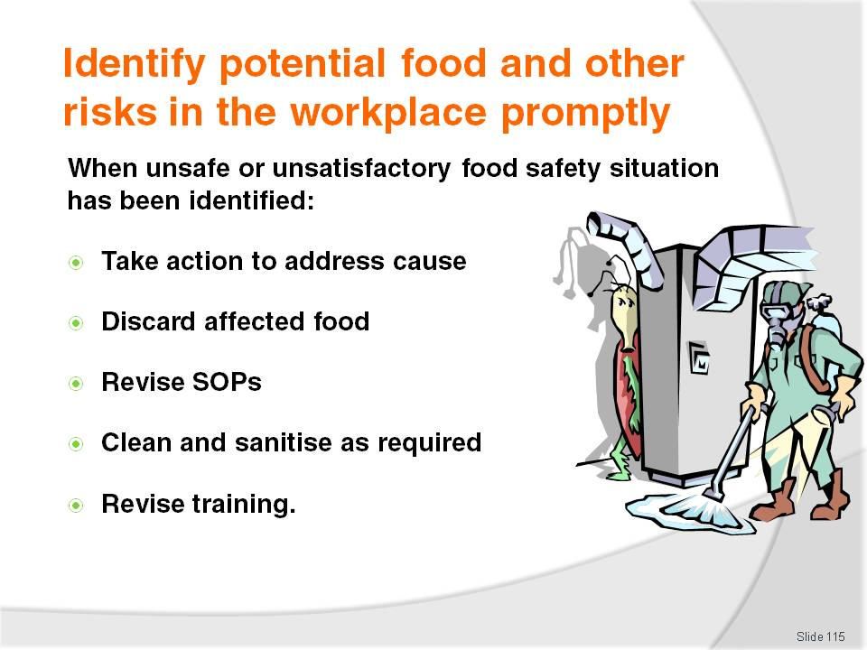
Slide No | Trainer Notes
Trainer stresses to trainees when an unsafe or unsatisfactory food safety situation has been identified there is a need to:
Address the cause and take action on unsafe food and contaminated equipment, utensils and food contact surfaces
Discard and affected (unsafe) food – or food where a suspicion exists that it could be unsafe
Revise existing operational practices – to prevent a recurrence of the problem and or address new situations that have arisen
Clean and sanitise all contaminated utensils, surfaces and equipment involved in the incident – it is not sufficient to dispose of the affected food: the surfaces, equipment or utensils it has made contact with must be cleaned and sanitised
Implement revised staff training – so new protocols are passed on to food handling staff.

Slide
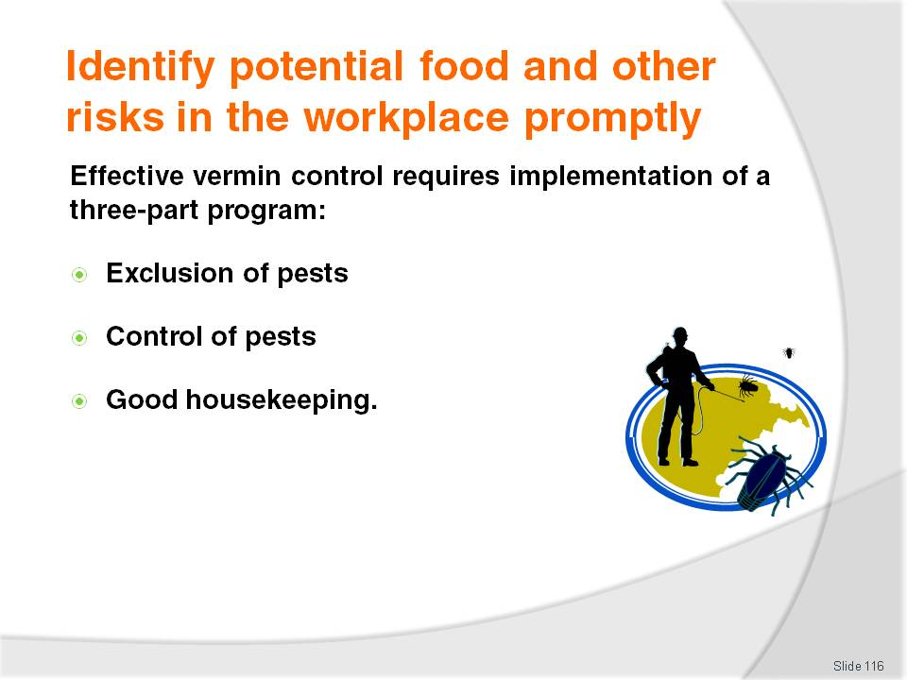
Slide No | Trainer Notes
Trainer advises trainees about need for effective pest (vermin) control stating a three-party approach is required:
Physical exclusion of pests – also known as ‘Build them out’
Chemical and mechanical control – also known as ‘Chase them out’
Sound housekeeping practices – also known as ‘Starve them out’.

Slide
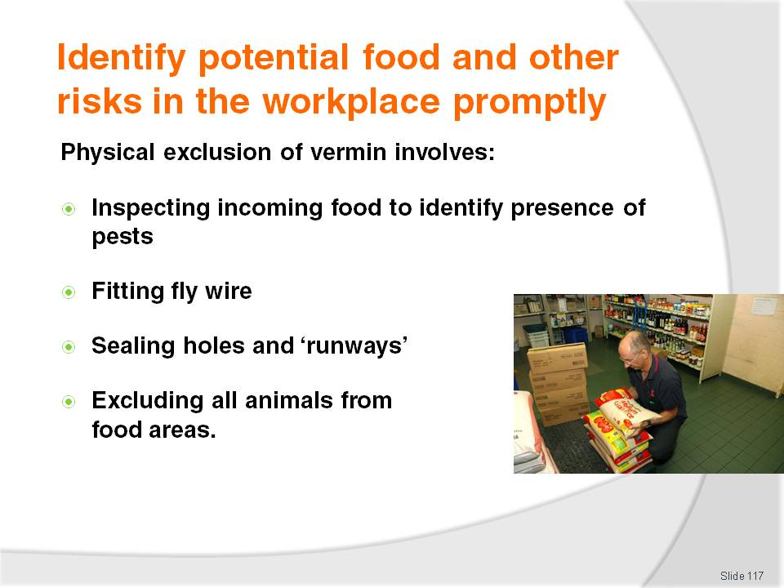
Slide No | Trainer Notes
Trainer advises trainees physical exclusion of vermin involves:
Checking all deliveries to eliminate pests coming in with foodstuffs
Correct fitting of fly wire to doors and windows
Sealing of holes around pipes and other fittings allowing pests entry to the premises – paths taken by mice are referred to as ‘runways’
Exclusion of animals from food areas – including pets but note there may be a legal requirement to allow ‘assistance dogs’ into customer food areas.

Slide
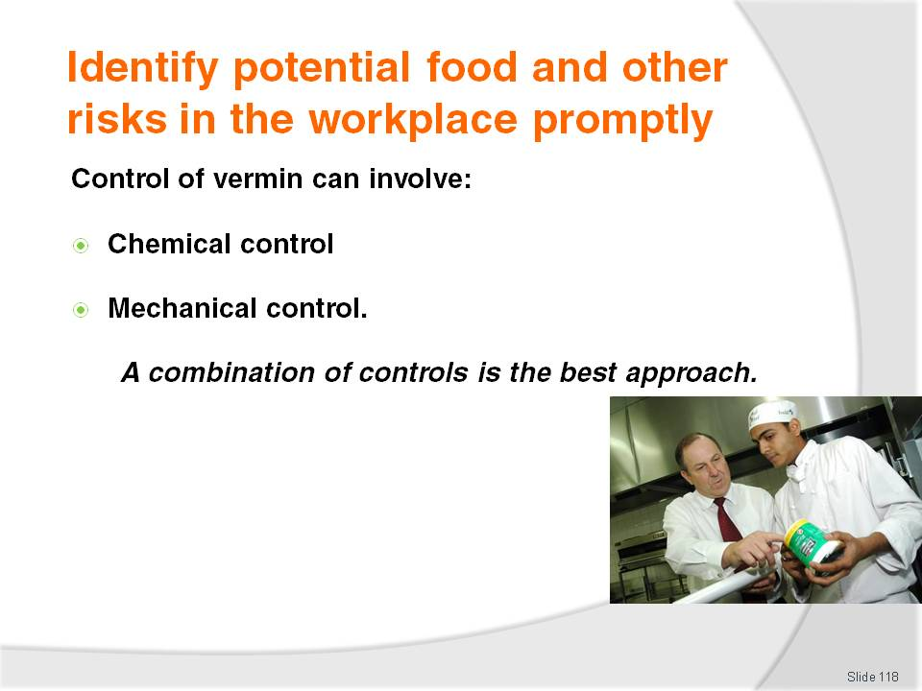
Slide No | Trainer Notes
Trainer advises trainees control of vermin involves killing vermin that has entered the premises and includes the use of:
Chemical products – such as:
- Fly sprays
- Baits
- Fogging
Mechanical control:
- Electronic fly zappers
- Air curtains
- Traps.

Slide
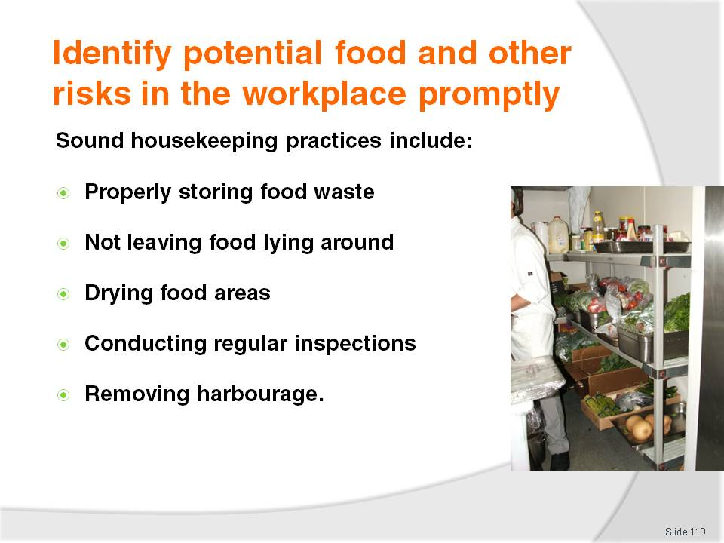
Slide No | Trainer Notes
Trainer advises trainees sound housekeeping practices to help control vermin include:
Properly storing food waste – in bins with lids; keeping lids closed when bins are not being used
Ensuring no food is left lying around – after service sessions and cleaning have finished
Drying food areas – after cleaning to remove sources of water
Regular inspections – to detect infestation so appropriate action can be taken
Removing harbourage – by getting rid of (or properly storing) cartons or boxes that could provide a home for vermin.
Class Activity – Guest Speaker
Trainer arranges for a representative from a pest control company to attend and:
Talk to trainees about pest control
Provide tips and advice on vermin control
Explain how professional companies undertake vermin control in food premises
Identify frequency of service and costs involved
Provide stories of examples of vermin infestation in food premises
Describe action venues must take in addition to professional external pest control services to ensure venue remains free from vermin infestation.

Slide
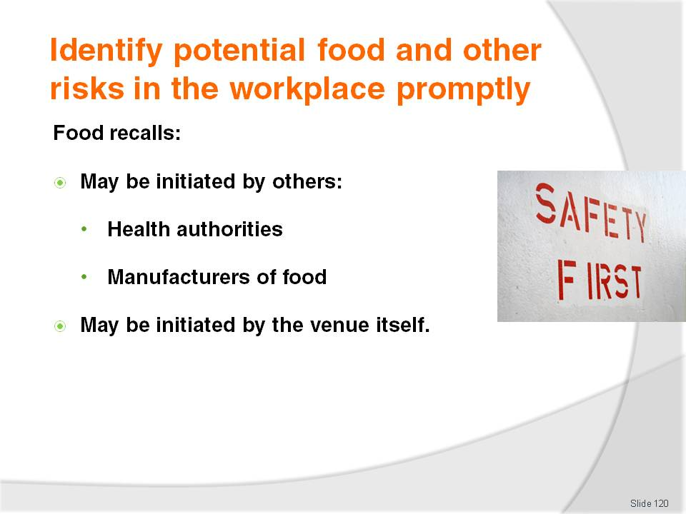
Slide No | Trainer Notes
Trainer explains to trainees a food recall may be initiated by:
Health or food authorities – usually as a result of advice, for example, from a food manufacturer recommending the recall, or as a result of authority investigations
The workplace – if it becomes aware it has prepared and sold food with the potential to cause food poisoning or a risk to public health.

Slide
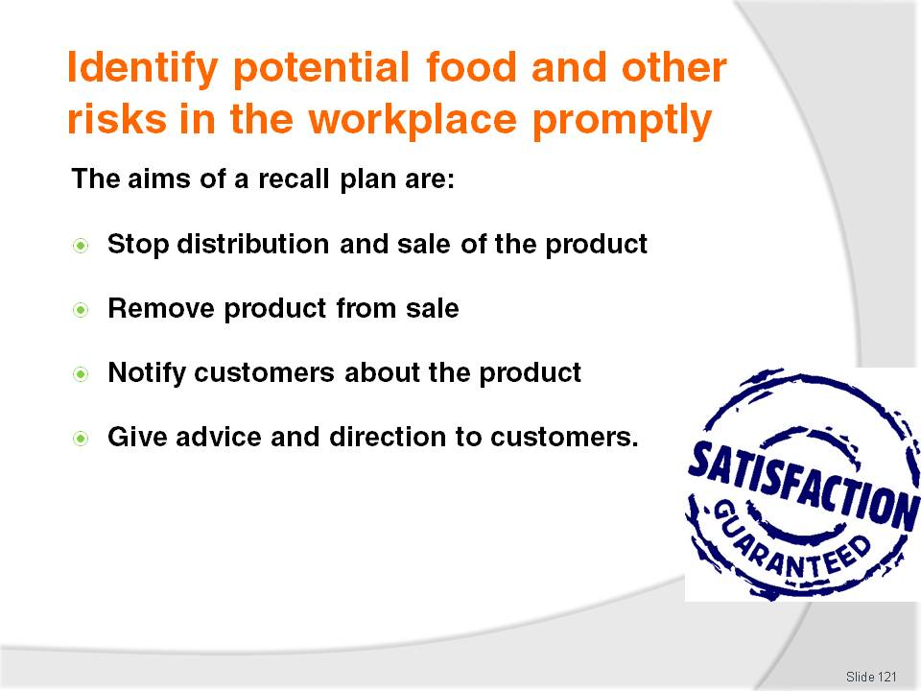
Slide No | Trainer Notes
Trainer explains to trainees venues should prepare a plan (in advance) to handle recalls when they become necessary highlighting the immediate aims when a recall is needed are to:
Stop distribution and sale – of affected or suspect products
Remove the affected product from sale – to contain the potential problem
Notify the customers who are known or believed to have received the affected goods – so they do not eat the items and so they can return them
Warn the public of the danger – to discharge common law ‘duty of care’ requirements and provide advice on the appropriate action to take.

Slide
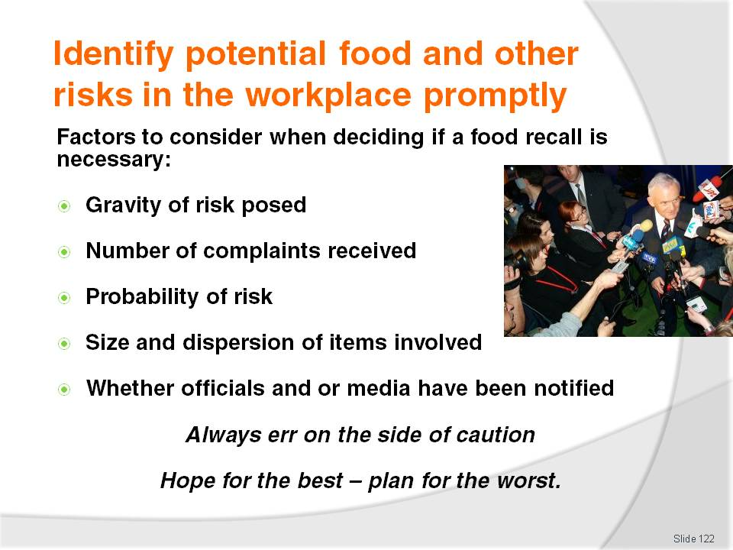
Slide No | Trainer Notes
Trainer explains to trainees when deciding whether or not to recall food produced by the venue the following factors should be taken into account:
The gravity of the complaint or defect and the safety implications it poses, basing deliberations on the understanding where there is a risk of death, illness or injury to anyone then a Food Recall is necessary
The number of complaints or reports received by the premises – regarding ill health, symptoms of food poisoning, the presence of a physical contaminant in the food
The probability of contamination having occurred during the manufacturing process
The size and dispersion of the food items in question
If health officials and or the media have already been notified.
Class Activity – Guest Speaker
Trainer arranges for a health official and talk to trainees about:
Requirements for venues to plan for food recalls
Details that should be included in a food recall plan
Sample food recall documents and models for trainees to follow or use as a basis for their own recall plans
How authorities will notify venues there is need for a food recall
Their experiences dealing with food recalls.

Slide
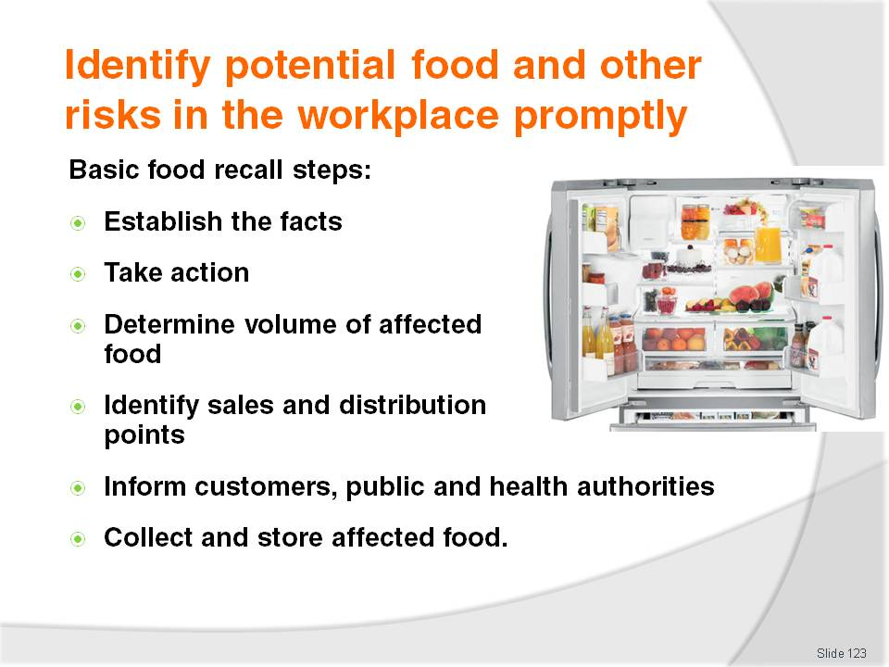
Slide No | Trainer Notes
Trainer presents generic steps to follow when preparing a food recall plan or responding to the need to recall food:
Establish the facts of the situation – to serve as the basis for the recall and the action to be taken
Take action – such as:
- Take no action – where no action is needed based on the facts as opposed to just ‘hoping for the best’
- Withdraw the product – from sale, distribution or display
- Initiate a food recall – if the product has been sold or distributed outside the premises
Work out the quantity or volume of food involved and how staff, officials or customers could identify it
Identify where the product was sold, supplied or distributed from
Inform customers as soon as possible not to eat the affected product – and ask them to return the food. This can include:
- Notifying anyone sitting down/ and eating that they should stop eating the product
- Notify any individual or group who is known to have purchased the food as a takeaway item not to consume the product: there may be no identifiable individuals or groups, as trade is comprised of the general public (passing trade, local businesses, shoppers, locals and tourists), but in other instances there may be local businesses, tradespeople, schools, who regularly buy from you – the Food Recall plan would require preparation of a list of these customers in terms of their telephone numbers, fax numbers, street addresses, contact persons in order to facilitate quick contact with them if the need arises
- A full list of in-house patrons (where the premises is a hotel or motel style) should be available from the Front Office reservation computer system
- Patrons who have dined in food outlets may be partially identifiable via the Bookings Book or Sheet in such outlets if this record exists
Inform local Health authority – so they can assist with the recall
Tell the public by (for example) placing warning signs in the venue, placing a food recall notice in local newspapers
Collect and safely store affected food (labelled as unsafe food and separated from other food) to assist, where needed, with investigations.
Class Activity – Small Group Activity
Trainer provides trainees with Internet access and asks them to:
Visit http://www.foodstandards.gov.au/consumerinformation/foodrecalls
Read this site and relevant links
Take notes on food recall protocols recommended
Report back to the class on their findings.

Slide
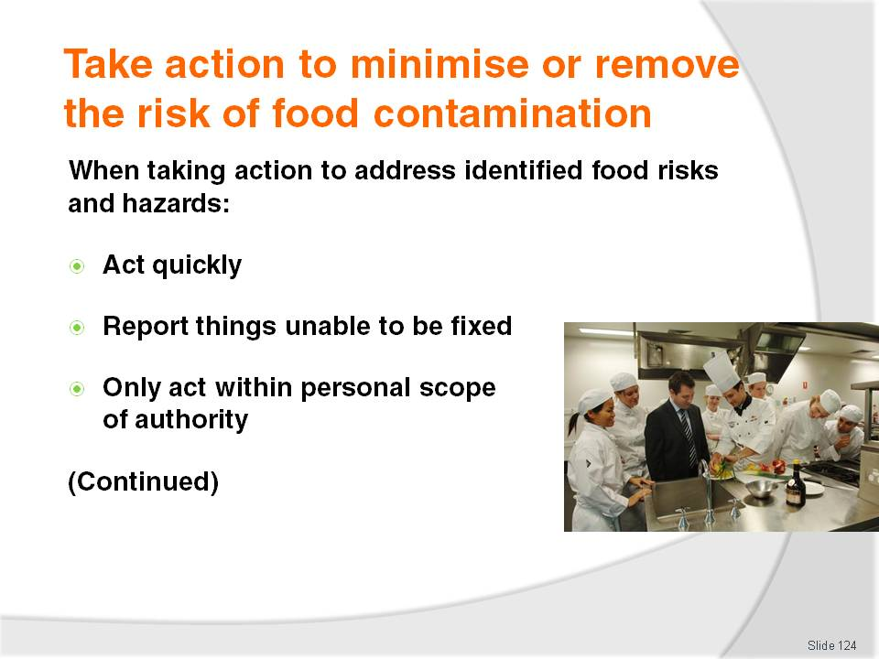
Slide No | Trainer Notes
Trainer informs trainees whenever a risk of food contamination has been identified, it must be addressed explaining when taking action :
Action must be taken quickly – act immediately as opposed to waiting until the shift or session has finished
Report things unable to be fixed – if the problem cannot be readily or immediately fixed, report it to management
Only take action if the action falls within designated ‘scope of authority’ – report all other problems: special training may be required to undertake certain action; certain tasks may be restricted to nominated staff.

Slide
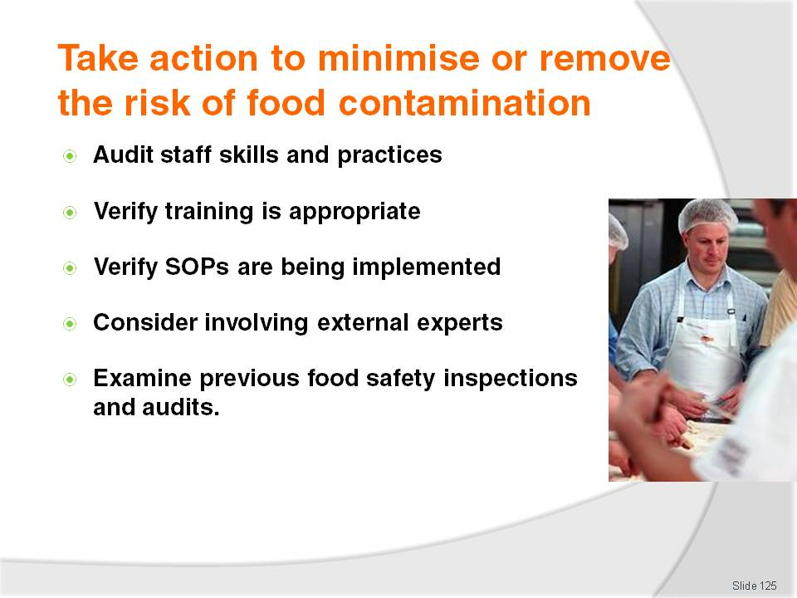
Slide No | Trainer Notes
Trainer continues to present trainees with responses to identified food safety risks and hazards:
Audit the safe food handling skills of staff – many food-related problems can be traced to a failure by staff to adhere to required practices and protocols
Ensure training is appropriate, effective and being implemented to all staff, when and as required
Check to determine if standard house policies and procedures are being implemented – again, the cause of many problems is a failure to follow house policies and procedures
Consider involving external experts – to provide objective and professional input regarding the issues
Refer to previous internal and or external food safety audits – to identify previous similar instances, and to determine any earlier action taken in this regard.

Slide
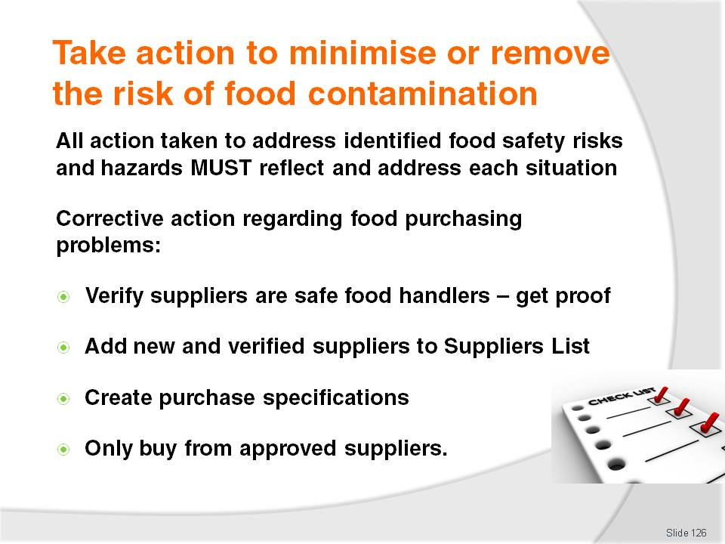
Slide No | Trainer Notes
Trainer highlights the action taken to address identified food safety risks and hazards must reflect and address the individual problem.
Trainer advises trainees they will be provided with examples of possible (common) at each stage of food handling or processing, as identified earlier in the course, beginning by explaining corrective action relating to the ‘Purchasing of Food’ can include:
Obtaining proof from suppliers they are registered as a food supplier and have safe food handling protocols in place
Adding new suppliers to Approved Suppliers List, where necessary
Setting purchase specifications for suppliers to comply with
Ensuring food is only bought from businesses listed on the Approved Suppliers List.

Slide
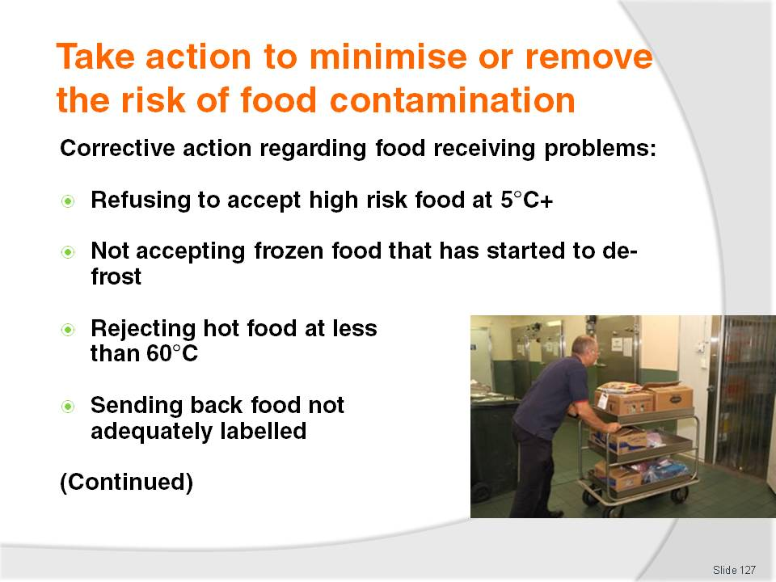
Slide No | Trainer Notes
Trainer explains to trainees in relation to hazards relating to the ‘Accepting deliveries into the premises’ process, corrective action may include:
Refusing or rejecting refrigerated high risk foods that are delivered at more than 5°C , unless satisfied it has been outside that temperature for less than 2 hours
Refusing or rejecting frozen produce not hard frozen, that is, where the product has started to thaw, or has become ‘soft’
Refusing or rejecting hot food delivered at less than 60°C , unless convinced it has been at this temperature for less than 2 hours
Refusing or rejecting products which are not adequately marked with manufacturer’s details.

Slide
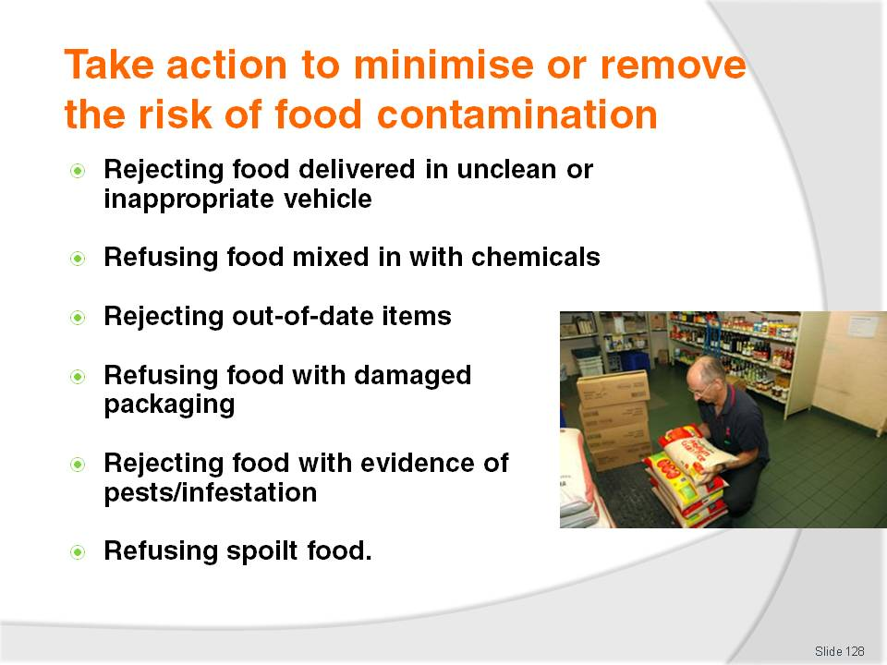
Slide No | Trainer Notes
Trainer continues to advise trainees about possible corrective action to take when addressing problems associated with receiving food into the premises:
Refusing or rejecting food delivered in an unclean vehicle, or which is being delivered in an inappropriate vehicle such as a private car or vehicle
Refusing or rejecting foods delivered mixed in with chemicals
Refusing or rejecting out-of-date foodstuffs
Refusing or rejecting food items delivered in damaged packages where the integrity of the food may have been compromised
Refusing or rejecting food items where there is evidence of vermin
Refusing or rejecting food items that look or smell unacceptable.

Slide
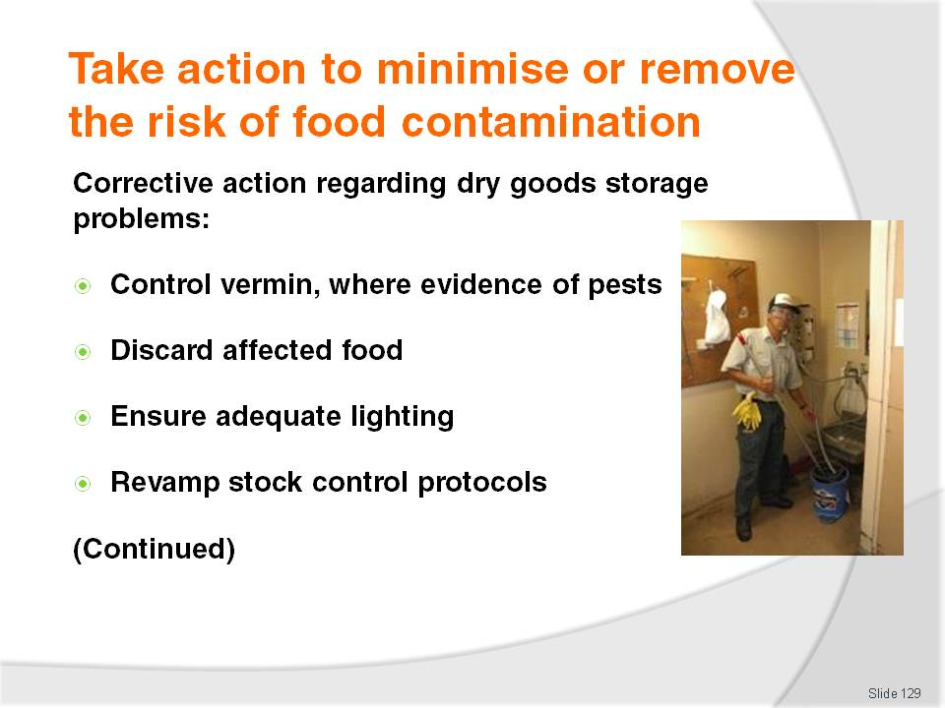
Slide No | Trainer Notes
Trainer explains to trainees in relation to hazards relating to ‘Dry goods storage’, corrective action may include:
Where there is evidence of pest or rodent infestation:
- Laying baits
- Engaging the services of a licensed pest control company
- Investigating where they are getting in and making repairs – fitting fly wire, filling in holes
Throwing away all infested or contaminated food
Up-dating and or repairing lighting, globes, fluorescent tubes that have blown – to help identify evidence of vermin, and better identify problems that may be present
Revamping stock control measures – if there is out-of-date stock.

Slide
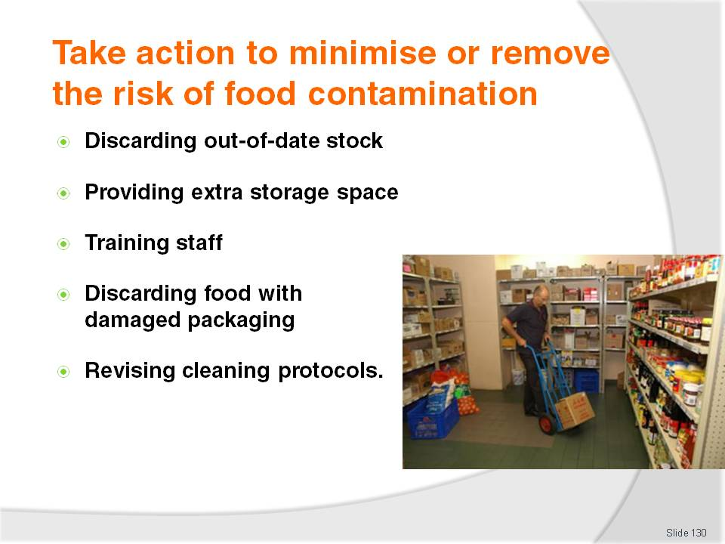
Slide No | Trainer Notes
Trainer continues to advise trainees about possible corrective action for problems associated with food in dry goods storage:
Throwing away out-of-date food – do not use it
Allocating more space for dry storage of food where conditions are too crowded or cramped
Training staff in stock control and or rotation procedures – if these are not being properly implemented
Discarding products with damaged packaging
Revising cleaning protocols – allocating more time, obtaining more or better equipment and or chemicals, providing training in cleaning, cleaning the area more frequently.

Slide
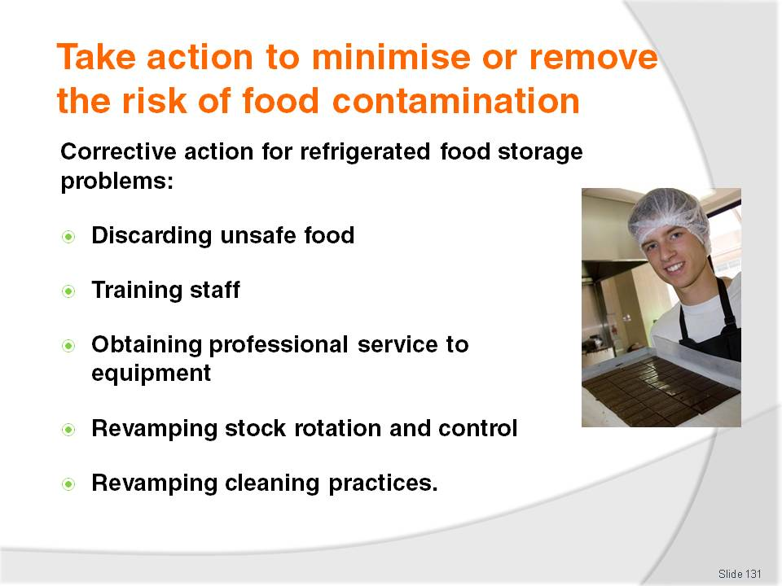
Slide No | Trainer Notes
Trainer explains to trainees in relation to hazards relating to ‘Refrigerated food storage’, corrective action may include:
Discarding all food:
- Exceeding the 2/4 rule
- Beyond its use-by date, or similar
- Where there is evidence – or even just a belief –cross contamination has occurred
Training staff – in correct better cleaning techniques and practices
Calling in a refrigeration mechanic where the refrigeration units are reading above 5°C: consider implementing a preventative maintenance schedule through a reputable refrigeration company to help ensure all refrigeration remains in proper working order all the time
Revamping stock control and rotation procedures, as required
Revamping cleaning procedures, as necessary.
Class Activity – Group Questions
Trainer asks trainees to give examples of when and under which conditions each of the identified possible ‘corrective actions’ may need to be implemented to respond to unsafe food-related practices or hazards or threats.

Slide
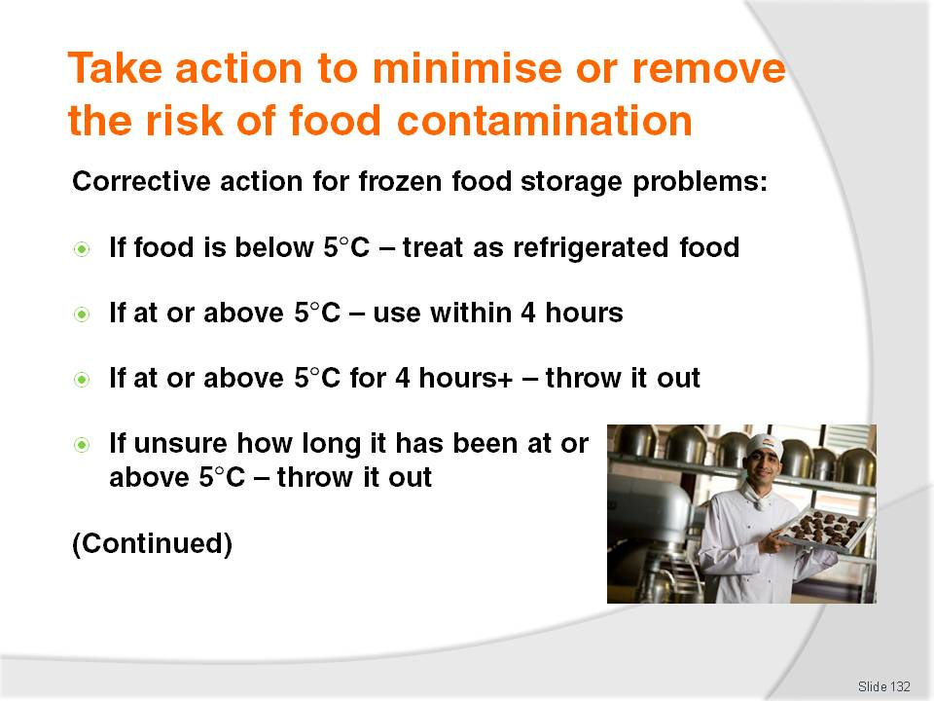
Slide No | Trainer Notes
Trainer explains to trainees in relation to hazards relating to ‘Frozen food storage’, corrective action may include:
Where frozen food has thawed out but is still below 5°C, staff are allowed to refrigerate it and then treat it as refrigerated food
Where frozen food has been allowed to reach 5°C or higher (perhaps the freezer has broken down or there has been an extended power failure) for less than 4 hours – it may be used within 4 hours
If the frozen food has been at 5°C or more for more than 4 hours – throwing it out
If the frozen food has been at 5°C or more for an indefinite amount of time – that is, there is uncertainty about how long it has been at 5°C or above – discard it all.

Slide
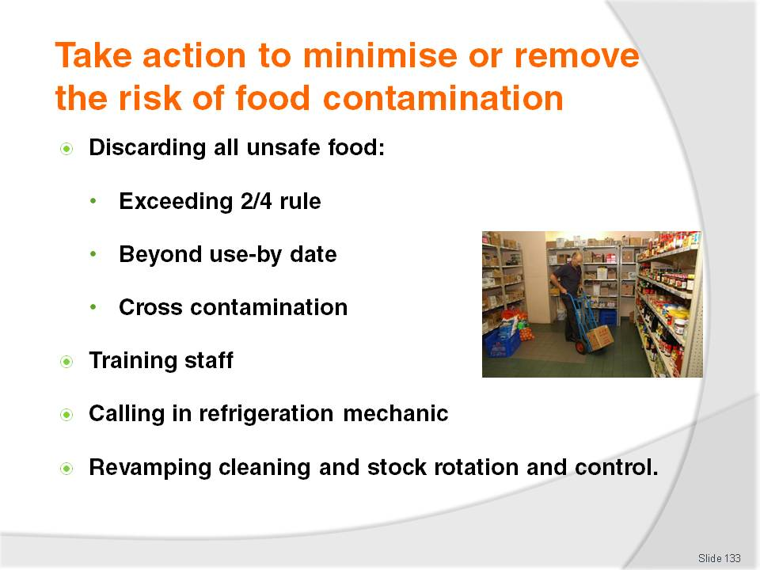
Slide No | Trainer Notes
Trainer continues to explain to trainees corrective action that may be taken to address frozen food storage hazards and risks:
Discarding all unsafe food:
- Food exceeding the 2/4 rule
- Food beyond its use-by date, or similar (‘best before’ date)
- Food where there is evidence – or a belief –cross contamination has occurred
Training staff in cleaning techniques and practices
Calling in refrigeration mechanic where the freezer units are reading above -15°C
Considering implementing a preventative maintenance schedule through a reputable refrigeration company
Revamping stock control and rotation procedures, as required
Revamping cleaning procedures, as necessary.

Slide
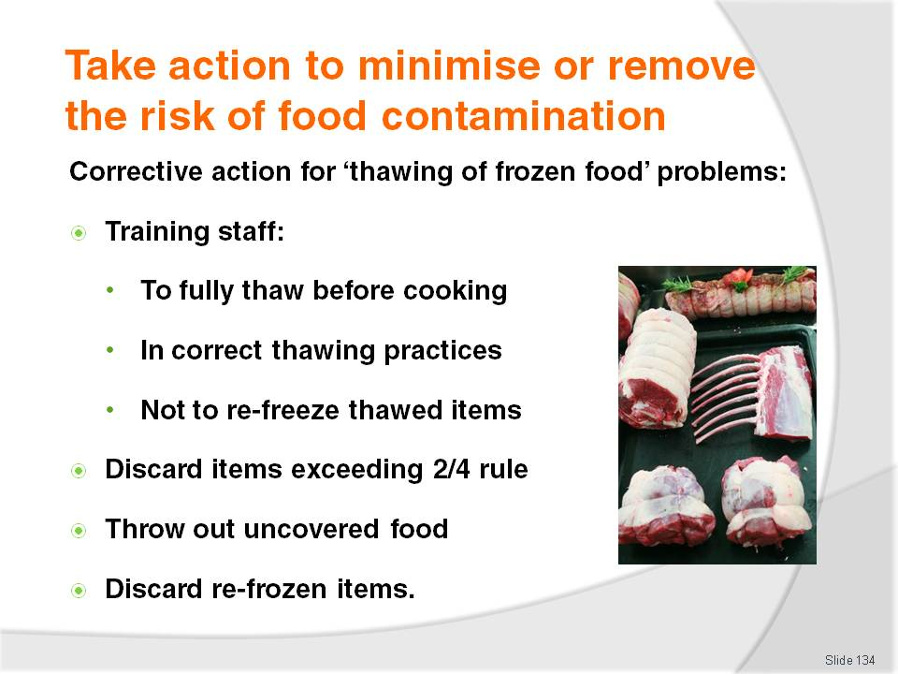
Slide No | Trainer Notes
Trainer informs trainees in relation to hazards relating to the ‘Thawing of frozen food’, corrective action may include:
Training staff to wait until food is fully thawed before cooking – food remaining frozen or partially frozen must not be cooked until it has fully thawed
Training staff in proper thawing practices, including the need to plan defrosting needs
Training staff not to freeze thawed product
Discarding all food exceeding the 2/4 rule
Throwing out all food that is defrosted in an uncovered state, or which has defrosted in damaged packaging
Discarding all food that has been thawed and re-frozen.

Slide
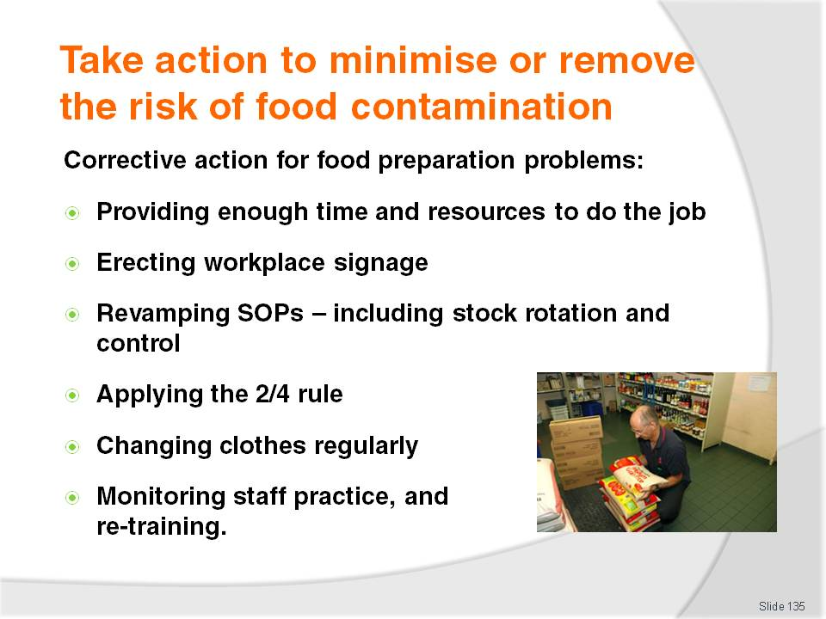
Slide No | Trainer Notes
Trainer states to trainees corrective action in relation to ‘food preparation’ hazards or risks or identified problems may include:
Ensuing sufficient time and resources to facilitate compliance with correct food handling practices – this may be providing gloves, extra utensils (knives, chopping boards, bowls), and or providing more time (for hand washing, for doing things properly, for cleaning)
Placing signage in the workplace to prompt and remind staff of correct safe food handling practices
Revamping preparation procedures and practices so as to minimise time food spends in the Temperature Danger Zone – this may include spending time planning food preparation activities on a daily basis, or food item by food item basis
Improving stock control and rotation procedures – if out-of-date items are being identified during this phase
Applying the 2/4 rule – to all potentially hazardous foods
Changing cleaning cloths regularly – at least hourly; consider using disposable paper towels instead of cloths
Monitoring the performance of individual staff members in relation to food preparation and food safety issues, and suggesting improvements to practice where this is deemed necessary; train or re-train staff as required.

Slide
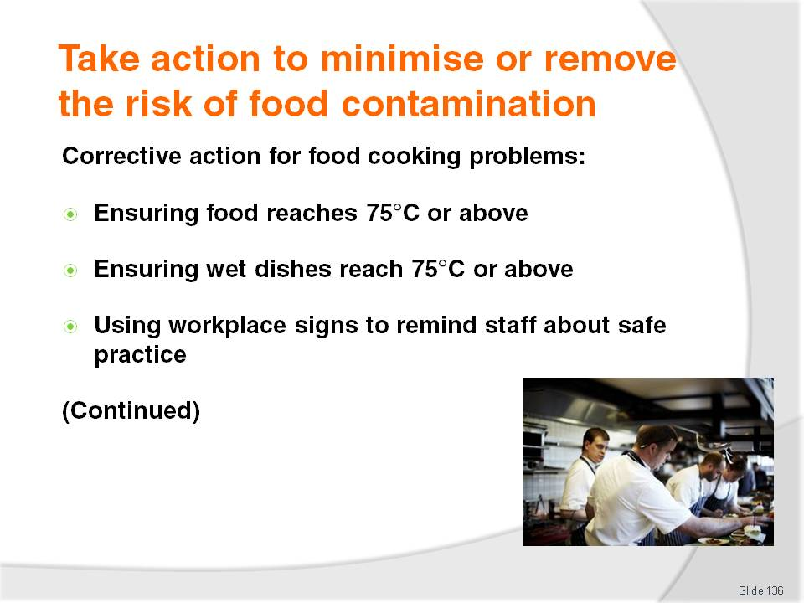
Slide No | Trainer Notes
Trainer tells trainees about possible corrective action in relation to hazards relating to ‘Cooking food’:
Ensuring food reaches 75°C or above – check the temperature in the thickest part of the meat, or in the middle of the pot or container; use a probe thermometer (not guesswork or an infra-red thermometer) to read the temperature
Ensuring all soups, stews and sauces reach 75°C
Placing signs in the workplace to remind staff of correct safe cooking practices.

Slide
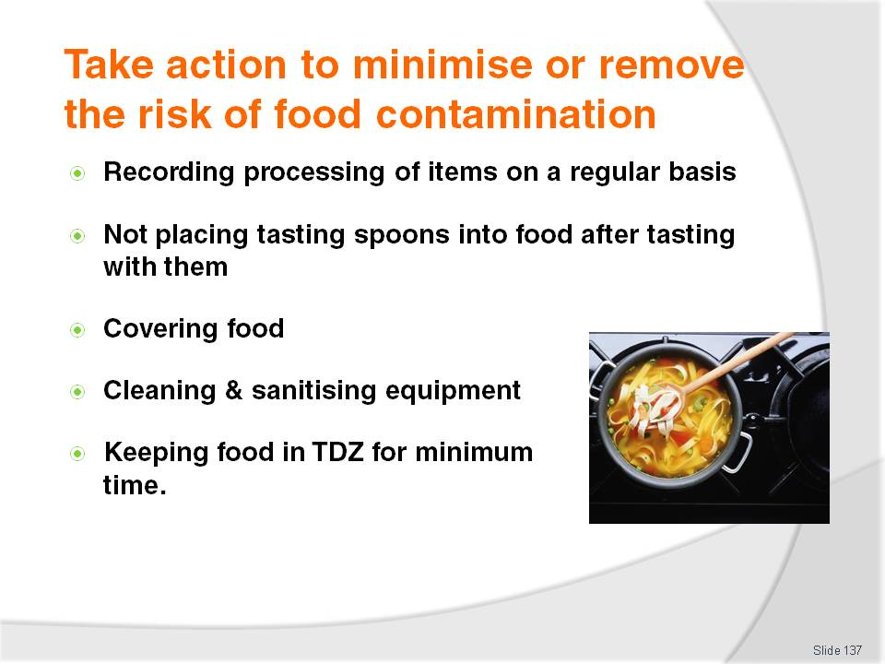
Slide No | Trainer Notes
Trainer continues to tell trainees about possible corrective action in relation to hazards relating to ‘Cooking food’:
Recording the times, temperatures and processes associated with the production of two high risk foods once a month on an ‘Internal Review – Process Temperature’ log or similar to verify correct practices are being adhered to
Ensuring tasting of food is done with spoons not then used to stir the dish – to avoid cross contamination
Covering food during the cooking process as far as is practicable – to protect from airborne contamination, flies
Cleaning and sanitising pots and all items used for cooking – and storing them under clean conditions when they have been cleaned and sanitised
Minimising the time food spends in the Temperature Danger Zone – this requires the cooking procedure to quickly attain a temperature above 60°; this may mean food produced using a low temperature or long slow cooking process cannot use in a commercial setting.

Slide
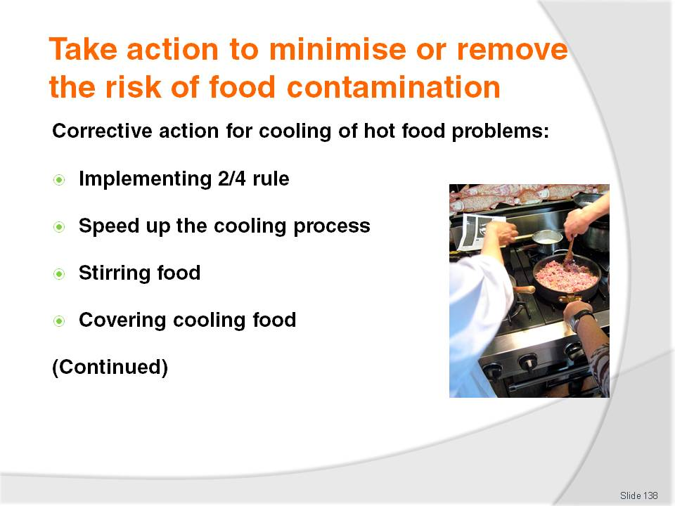
Slide No | Trainer Notes
Trainer informs trainees about possible corrective action in relation to hazards relating to ‘Cooling of hot food’:
Ensuring the Two-Step rule for the cooling of potentially hazardous hot foods is being applied
Helping hot foods to cool down by placing hot pots or containers into iced water baths – to speed up the cooling process
Stirring wet dishes – to help release heat
Covering cooling dishes – to protect against contamination.

Slide
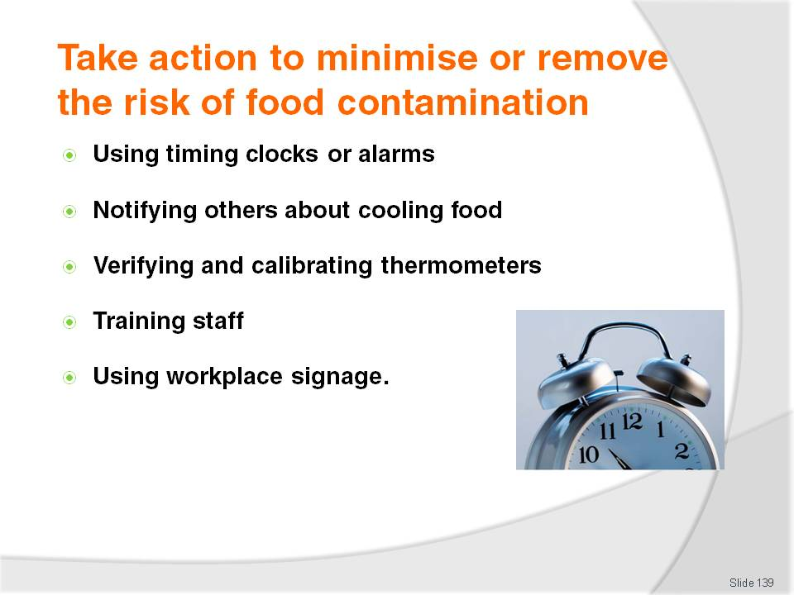
Slide No | Trainer Notes
Trainer continues to inform trainees about possible corrective action in relation to hazards relating to ‘Cooling of hot food’:
Setting clocks, watches or alarms to notify of required timeframes – so cooling foods are not forgotten and left ‘too long’ at room temperatures for cooling
Making sure new staff at any change of shift are notified in relation to any food that is cooling – so they can take over management of the cooling food
Verifying thermometer readings – by calibrating food thermometers at least every six months
Training staff as required in cooling procedures
Placing signs around the workplace to remind staff of what is required in relation to the cooling of food.
Class Activity – General Discussion
Trainer asks trainees to identify circumstances under which the above corrective action may need to be implemented.

Slide
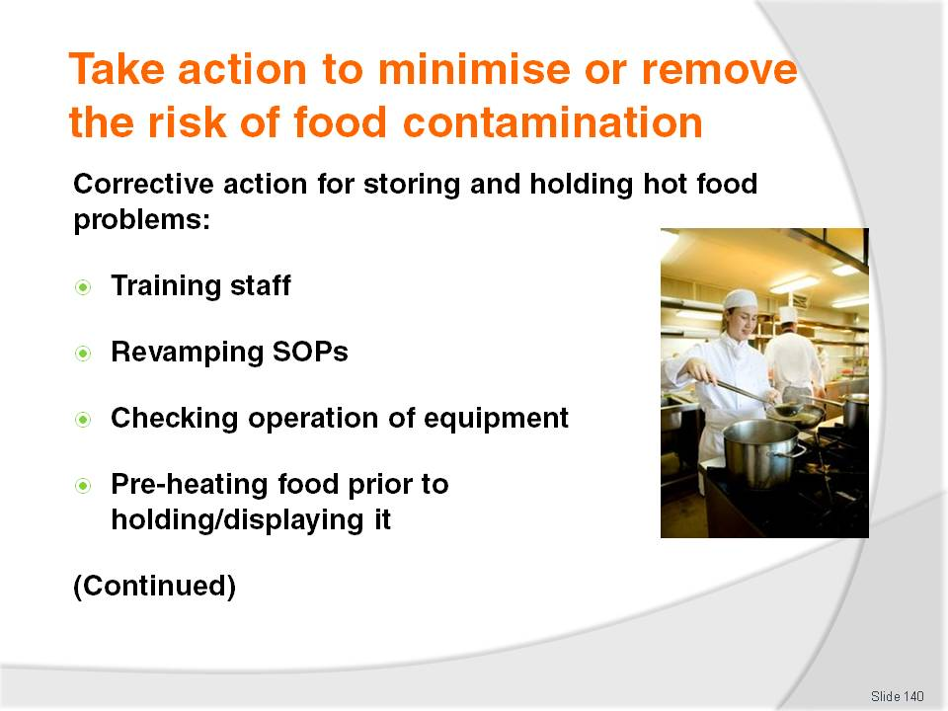
Slide No | Trainer Notes
Trainer instructs trainees about possible corrective action that may need to be taken in relation to hazards relating to ‘Storing and holding of hot food’:
Training staff as required – in relation to practices such as food handling, heating of food, food display, stock rotation and cleaning protocols
Revamping hot holding procedures – to ensure food stays at or above 60°C
Checking operational efficiency and accuracy of all hot holding equipment – and providing professional service and maintenance to units as required
Pre-heating all food properly (to 75°C) prior to placing it into hot holding devices – pre-heated food must be placed into pre-heated units.

Slide
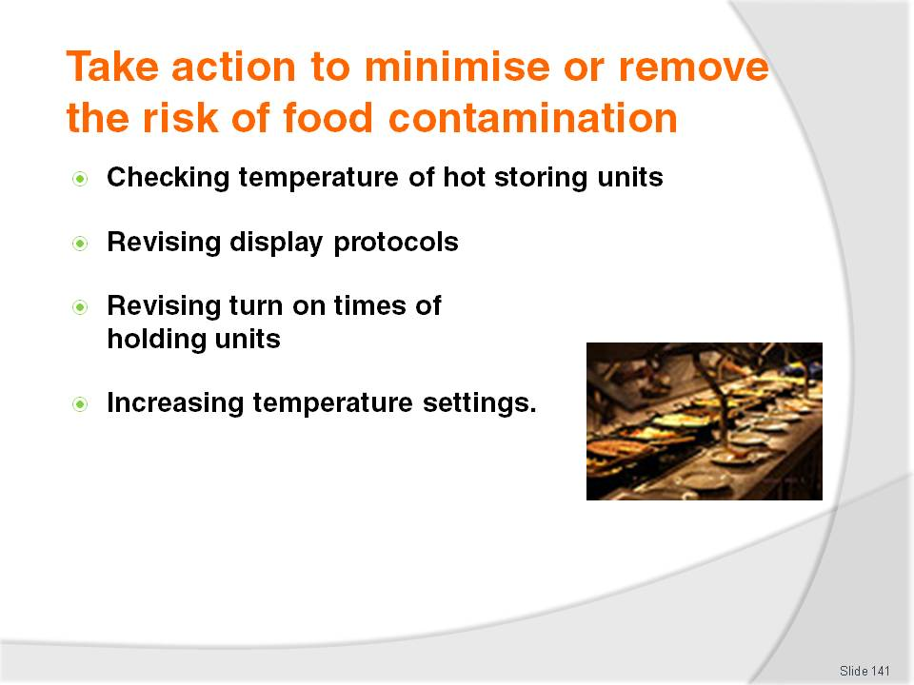
Slide No | Trainer Notes
Trainer continues to instruct trainees about possible corrective action that may need to be taken in relation to hazards relating to ‘Storing and holding of hot food’:
Ensuring temperatures of all hot held food are being taken as required using a properly calibrated thermometer – to verify correct holding temperatures are being achieved
Revising display protocols if tags, price signs, product descriptions are actually touching food
Revamping times when bain maries and pie warmers are turned on – turning them on earlier to allow sufficient time for them to get to 60°C or above
Operating bain maries and or pie warmers at higher settings so as temperature of food reaches 60°C.

Slide
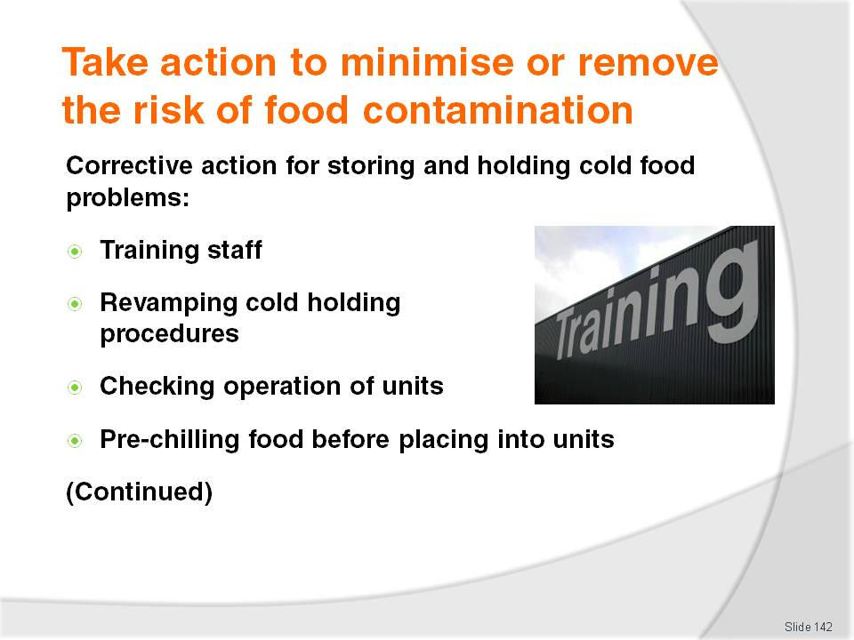
Slide No | Trainer Notes
Trainer informs trainees about possible corrective action that may need to be taken in relation to hazards relating to ‘Storing and holding of cold food’:
Training staff as required – in (as appropriate) food handling, cooling of hot food, display of food, stock rotation and cleaning protocols
Revamping cold holding procedures – to ensure food stays at or below 5°C
Checking operational efficiency and accuracy of all cold holding equipment and providing required regular service and maintenance
Ensuring all food going into cold display units is already at or below 5°C – pre-chill units before loading them with cold food.

Slide
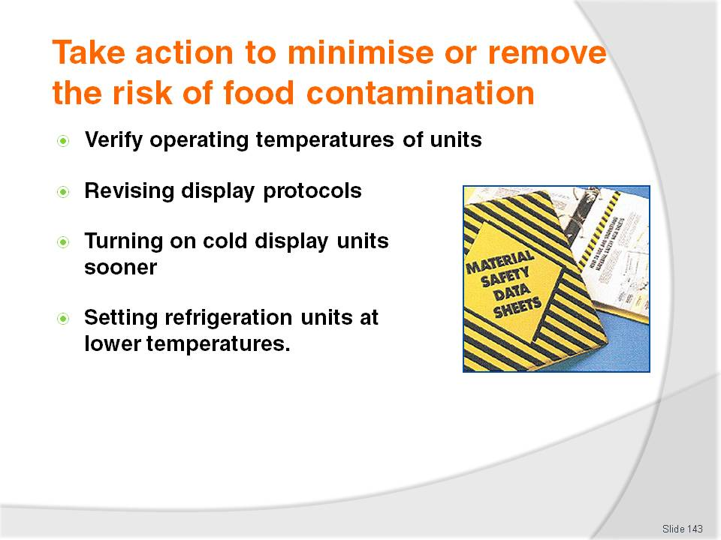
Slide No | Trainer Notes
Trainer continues to inform trainees about possible corrective action that may need to be taken in relation to hazards relating to ‘Storing and holding of cold food’:
Ensuring temperatures of all cold held food are being taken as required using a properly calibrated thermometer
Revising display protocols if tags, price signs, product descriptions are actually touching food
Revamping times when cold display are turned on – turning them on earlier to allow sufficient time for them to get to 5°C or below
Operating units at lower settings so as food reaches 5°C or less.
Class Activity – General Discussion
Trainer asks trainees to identify circumstances under which the above corrective action may need to be implemented.

Slide
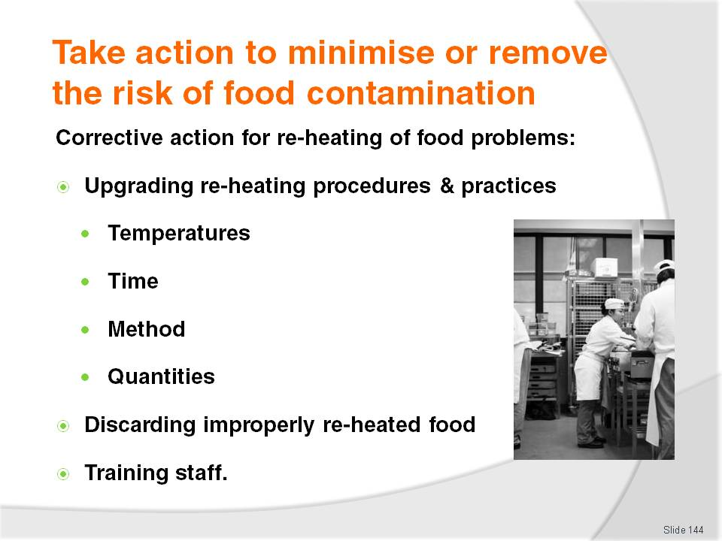
Slide No | Trainer Notes
Trainer provides advice to trainees regarding possible corrective action to address hazards and risks relating to ‘Re-heating of food’:
Revamping re-heating procedures and practices:
- To ensure 75°C or higher for at least 2 minutes is attained, and that the food display holding protocols ensure 60°C or higher is maintained
- To re-heat quicker and or in smaller quantities
Throwing out re-heated food failing to reach a core temperature of 75°C or higher
Training staff – as required.

Slide
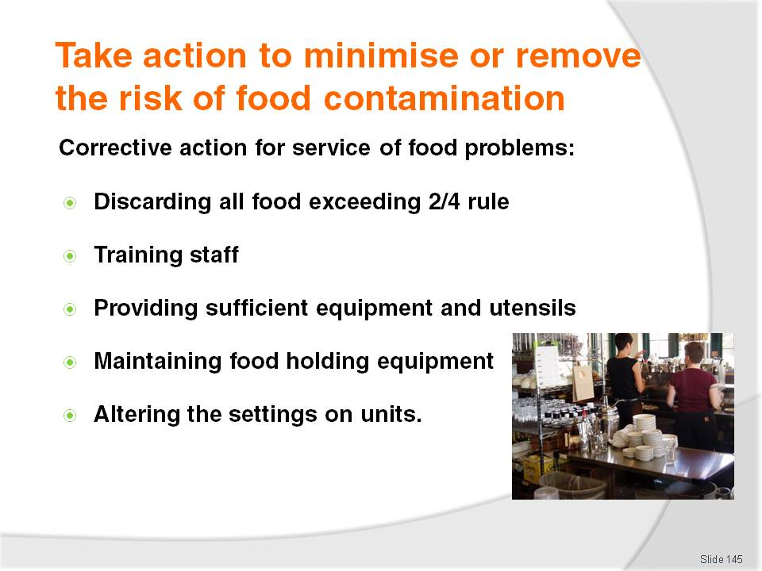
Slide No | Trainer Notes
Trainer advises trainees about possible corrective action required in relation to hazards relating to the ‘Service of food’:
Discarding all food exceeding the 2/4 rule
Training staff in correct food handling and serving practices
Providing sufficient equipment and utensils to enable separate (and multiple) utensils for each food item
Maintaining food holding equipment so the required holding temperatures for hot and cold food can be obtained
Altering the settings on units so required display or holding temperatures can be achieved.

Slide
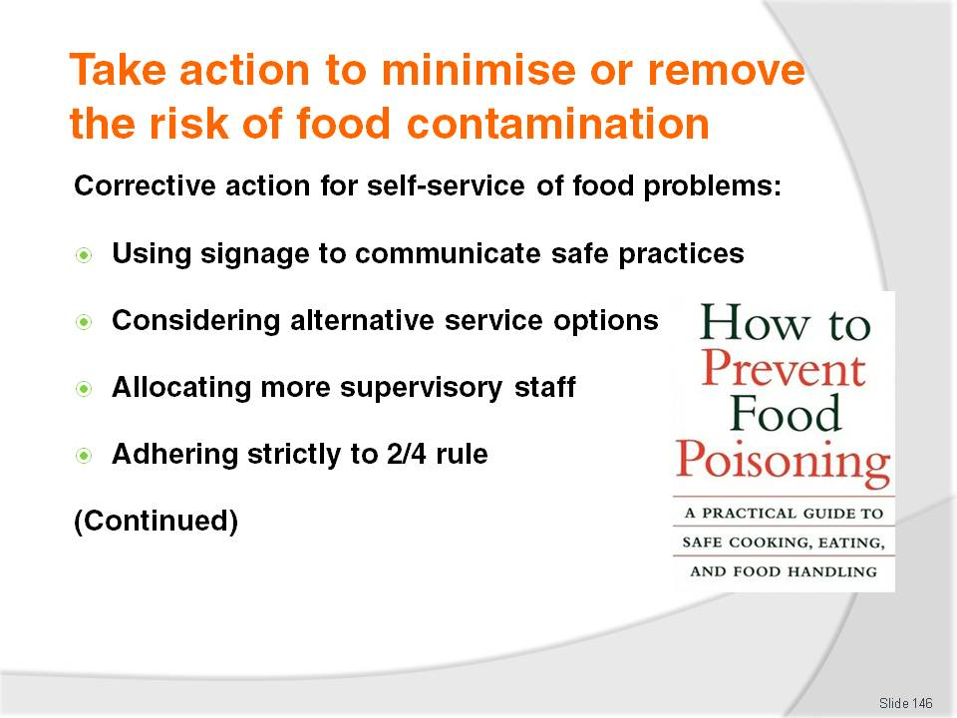
Slide No | Trainer Notes
Trainer gives trainees direction regarding possible corrective action that may need to be taken regarding the ‘Self-Service of food’ by customers:
Preparing and placing food handling signage and advice near the food – advising customers of what to do, and what not to do in order to enhance food safety
Considering alternative serving options – if the safety or integrity of food cannot be guaranteed where self-service is used
Allocating additional staff to observe customer food handling practices – and help and take action where required
Discarding all food exceeding the 2/4 rule.

Slide
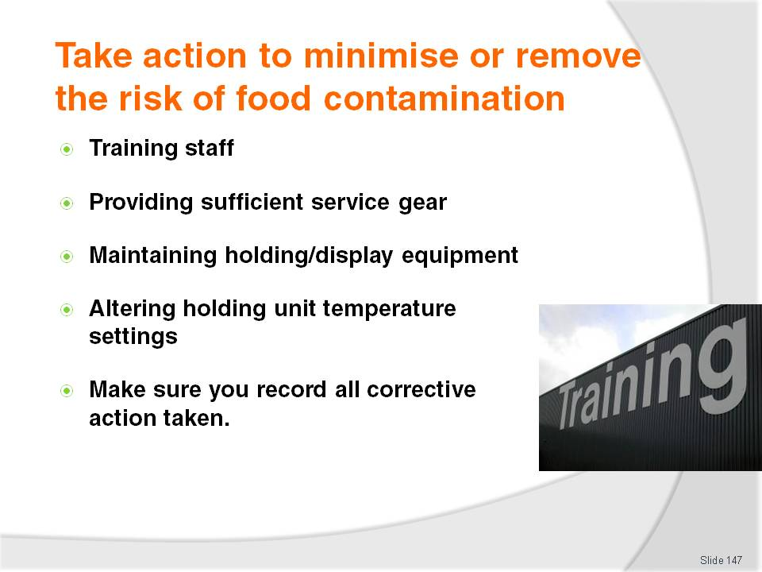
Slide No | Trainer Notes
Trainer continues to provide possible corrective action advice regarding self-service of food by customers to themselves:
Training staff in correct monitoring procedures – and in appropriate customer relations skills to facilitate compliance with requirements
Providing sufficient equipment and utensils to enable separate (and multiple) utensils for each food item
Maintaining food holding equipment so the required holding temperatures for hot and cold food can be obtained
Altering the settings on units so the required display or holding temperatures can be achieved.
Class Activity – Handout
Trainer provides sample CAR (Corrective Action Report) record) to trainees and:
Explains why this document is used (to prove and record corrective action taken by venues or individuals to address identified workplace food safety issues)
Describes how to complete the record identifying examples of what might be included in the CAR
Identifies who completes the record (the person undertaking the corrective action, or management, or a designated other person).

Slide
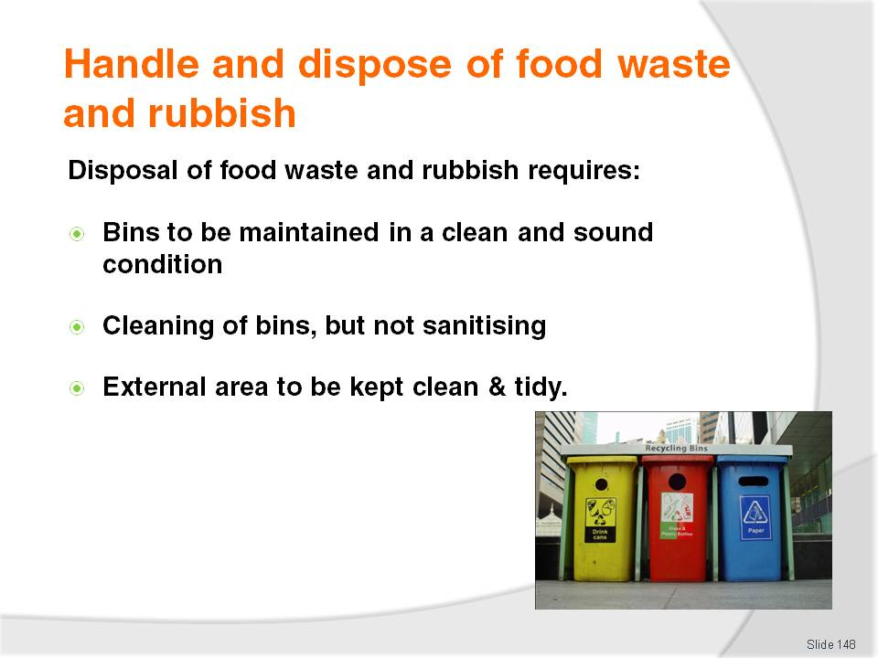
Slide No | Trainer Notes
Trainer tells trainees correct handling and disposal of food waste and other rubbish is an important food safety consideration as waste is a major source of contamination, presenting the following requirements:
All bins – internal and external – should be maintained in a sound condition (that is working properly, no leaks) and kept clean
There is no requirement to sanitise bins but this may be a house rule in some food premises:
- Cleaning an internal bin may require a simple wipe with a cloth dipped in hot water and detergent
- Cleaning an external bin may require the use of a gong brush, high pressure hose, detergent, degreaser and deodoriser
The external waste area must also be kept clean to avoid attracting pests and to help control smells. A yard broom can be used to sweep the area and a high pressure hose used with detergent and a deodoriser.

Slide
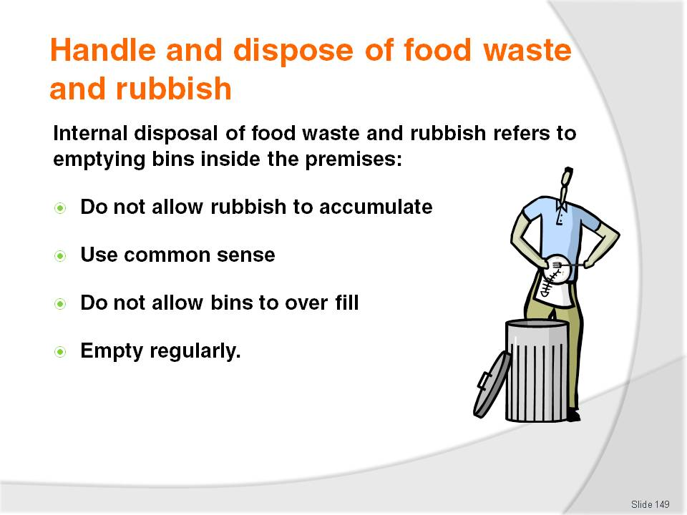
Slide No | Trainer Notes
Trainer presents information to trainees regarding the internal disposal of food waste and rubbish:
This relates to removing rubbish and waste food from inside the premises.
In practice this means emptying bins located in the:
- Kitchen
- Food preparation areas
- Dish washing areas
- Back-of-house food areas
It is a standard requirement waste never be allowed to accumulate
Common times for emptying bins include:
- When they are nearly full – never wait until they are full as this encourages over-filling which results in waste falling out of the bins and onto the floor
- At the end of a service session – such as ‘after lunch’, ‘after dinner’
- At a specific time of the day – ‘at 2:00PM’, ‘at 10:00PM’
- After a nominated time has elapsed – ‘every 30 minutes’, ‘every hour’.

Slide
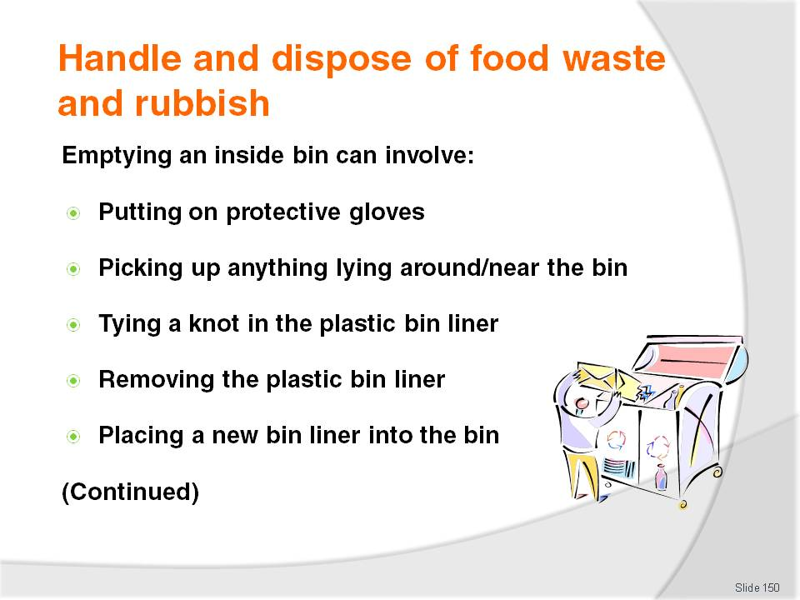
Slide No | Trainer Notes
Trainer suggests to trainees emptying internal bins could involve the following steps:
Putting on protective gloves – depending on the nature of the waste in the bin these may disposable gloves or gauntlets
Picking up anything lying around or near the bin – to remove it from the floor and put it in the bin
Tying a knot in the plastic bin liner – to prevent waste falling from the bag
Removing the plastic bin liner – carefully looking for signs of breakage and or leaking
Placing a new bin liner into the bin – and securing it in place according to the type of bin liner and or bin.

Slide
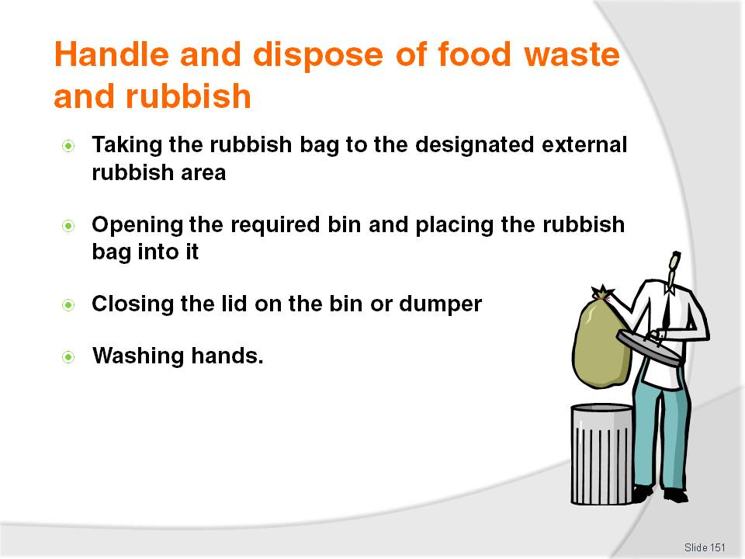
Slide No | Trainer Notes
Trainer finalises the steps in emptying an internal bin:
Taking the bin liner or rubbish bag to the designated external rubbish area – which may be a rubbish bin or dumper
Opening the required bin and place the bin liner or bag into it – making sure all the contents go into the bin or dumper
Closing the lid on the bin or dumper – to help prevent access to food waste by pests and vermin
Washing hands – making sure not to wash them in a sink used for food preparation.

Slide
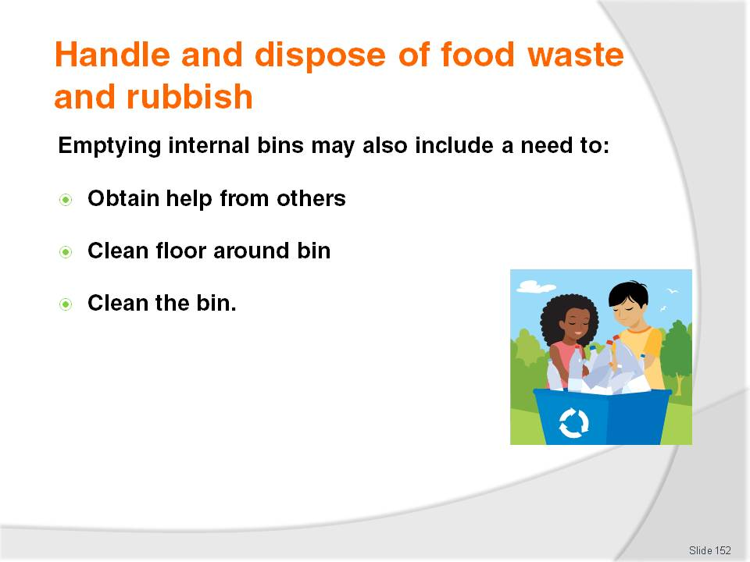
Slide No | Trainer Notes
Trainer mentions to trainees the following needs may also be involved in emptying internal bins:
Obtain help from another person to lift or move the bin
Clean the floor area under and around the bin that has been emptied – with detergent and sanitiser, drying the area to help avoid slips
Clean the inside and outside of internal bins at least daily – many food premises clean their internal bins after each service session, using detergent and (where necessary) a de-greasing agent.
Class Activity – Demonstration and Practice
Trainer:
Demonstrates how to empty an internal bin including replacement of bin liner, cleaning around the bin, and cleaning inside and outside the bin
Provides chemicals, equipment and opportunity for trainees to practice same.

Slide
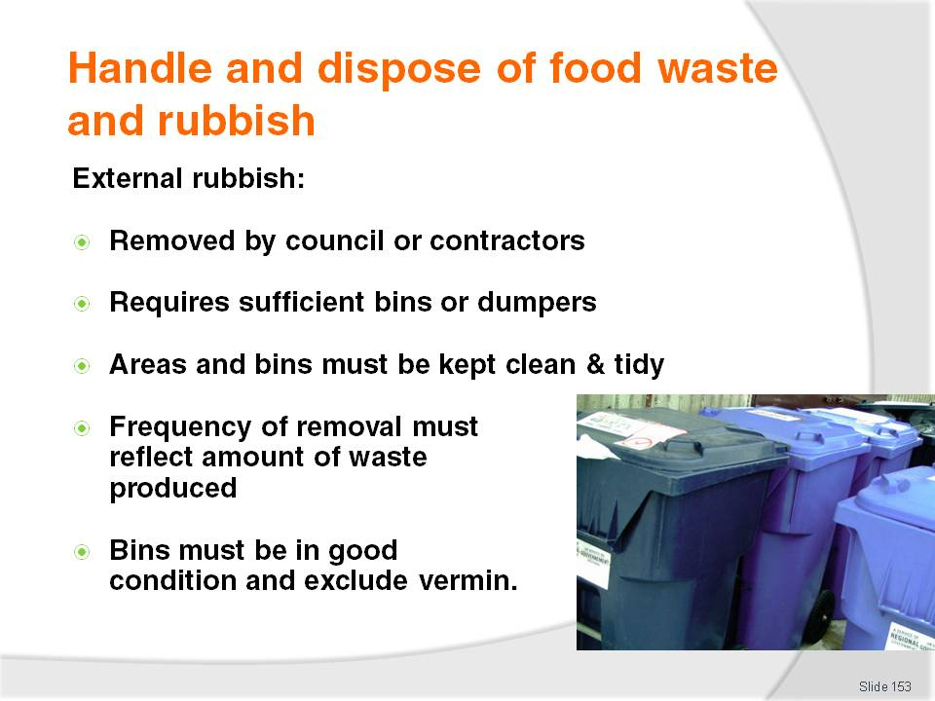
Slide No | Trainer Notes
Trainer provides direction to trainees regarding the removal of external rubbish from venues:
Waste in external areas must also never be allowed to accumulate.
Rubbish is commonly removed by the local council or a private company on a fee-for-service basis
Food premises should supply sufficient bins or receptacles to cater for whatever waste is produced. If rubbish is scattered all around the existing bins, and it is flowing over the tops of bins, more bins need to be provided
The rubbish area must be also be kept in a clean and tidy condition – in general rubbish must be stored in such a way as to minimise contamination and avoid providing harbourage for cats, vermin and birds
Frequency of disposal of the external rubbish must reflect the amount and type of waste generated. The use of commercial companies to clear this rubbish may be required: attention should be paid to increasing garbage pick-ups during peak trading periods (due to increased amount of waste created) and hot weather (due to the potential for objectionable smells to be created)
All garbage bins must be in good condition and must exclude pests which usually means they will have to be fitted with tight-fitting lids which must be kept in position so as to provide protection against vermin gaining access to the rubbish.

Slide
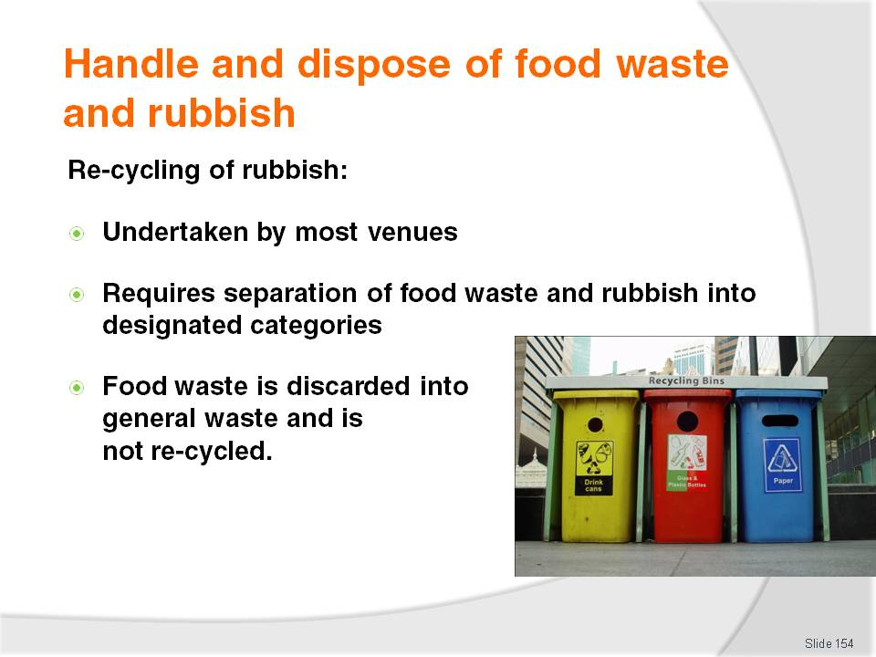
Slide No | Trainer Notes
Trainer explains to trainees it is standard practice for all venues to re-cycle their waste wherever possible:
This may require sorting waste into separate bins or containers as follows:
- Plastics
- Cardboard and paper
- Glass – jars and bottles
- Cans, tins and metal products
Actual food waste is not sorted or re-cycled but simply thrown out in general waste.
Class Activity – Guest Speaker
Trainer arranges for a representative from a waste collection company to attend and:
Discuss rubbish removal options
Costs associated with using contractor to collect rubbish
Re-cycling options and categories
Tips for minimising waste.

Slide
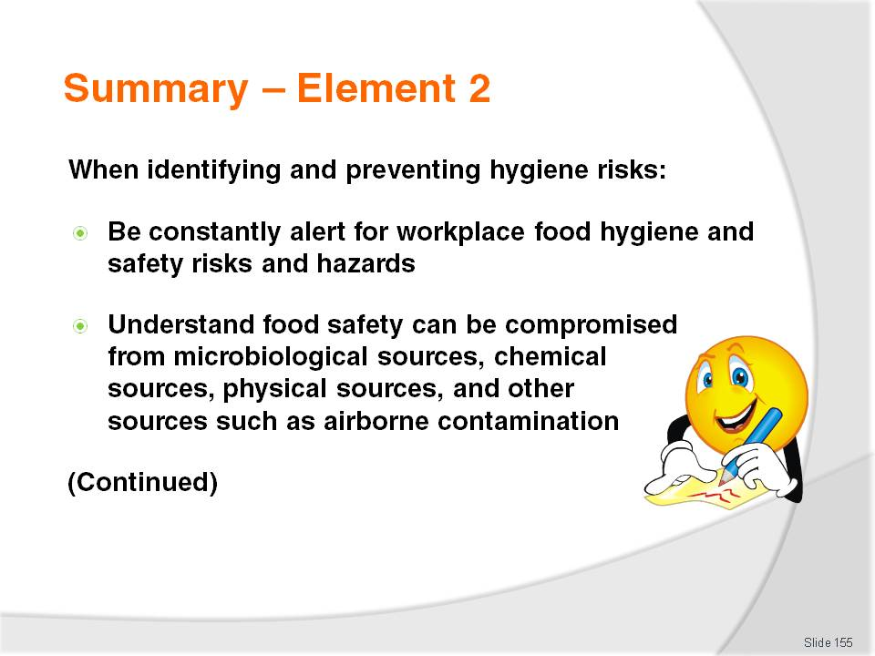
Slide No | Trainer Notes
 | Trainer provides a recap of the Element asking questions to check trainee understanding and responding to questions from trainees, as required.

Slide
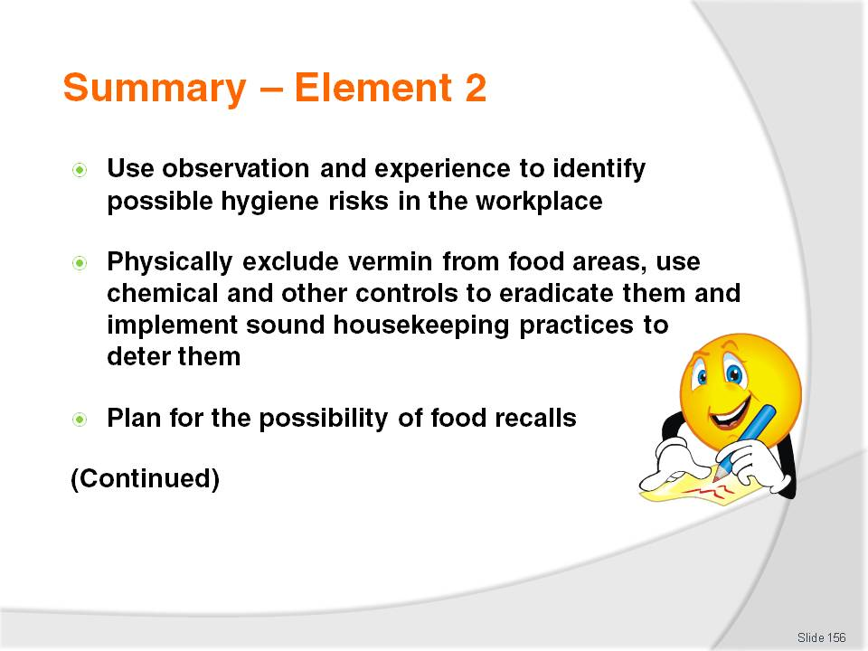
Slide No | Trainer Notes
 | Trainer provides a recap of the Element asking questions to check trainee understanding and responding to questions from trainees, as required.

Slide
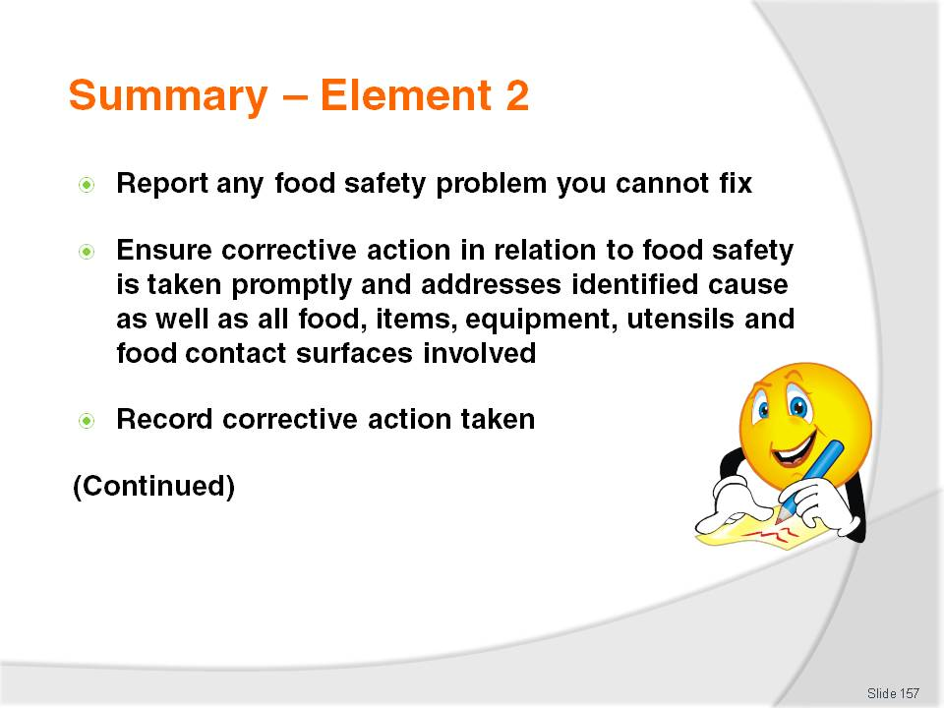
Slide No | Trainer Notes
 | Trainer provides a recap of the Element asking questions to check trainee understanding and responding to questions from trainees, as required.

Slide
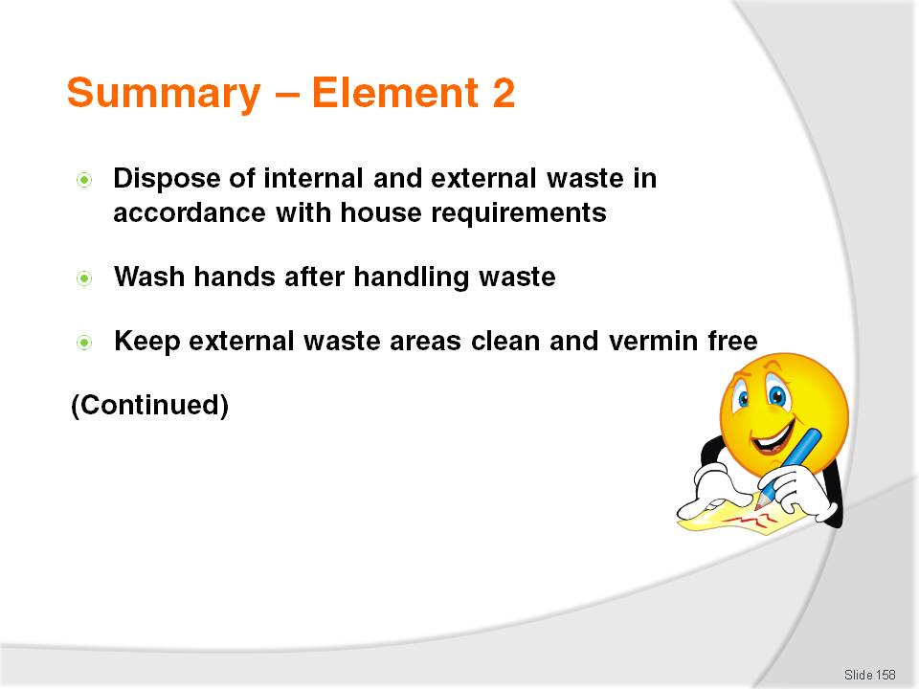
Slide No | Trainer Notes
 | Trainer provides a recap of the Element asking questions to check trainee understanding and responding to questions from trainees, as required.

Slide
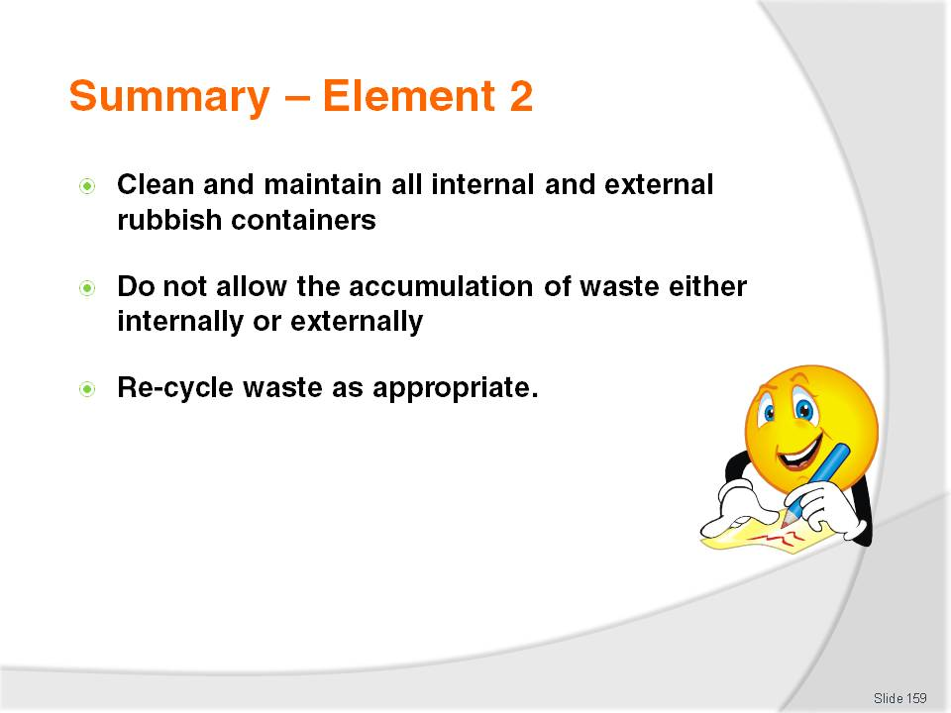
Slide No | Trainer Notes
 | Trainer provides a recap of the Element asking questions to check trainee understanding and responding to questions from trainees, as required.

Slide
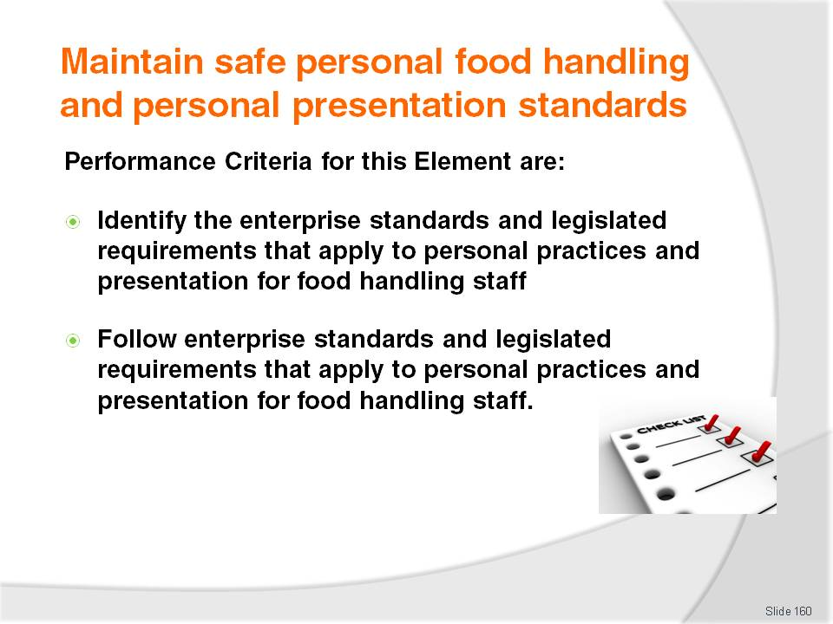
Slide No | Trainer Notes
Trainer identifies for trainees the Performance Criteria for this Element, as listed on the slide.
Class Activity – Discussion
Trainer asks trainees questions regarding personal hygiene and personal presentation requirements asking questions such as:
What personal presentation standards apply to food handlers in your workplace?
What are the legislated requirements for personal; hygiene, personal practices and personal standards in your workplace for food handlers?
When should food handlers refuse to attend for work if they are ill/not feeling well?
Why might an employer require a food handler to provide a medical certificate, on their return to work after an absence caused by illness, stating as a food handler they are fit to return to work?
Why should food handlers wear hair nets or hats?
When should food handlers wash their hands?
Describe how food handlers should wash and dry their hands to ensure they are safe to handle food.

Slide
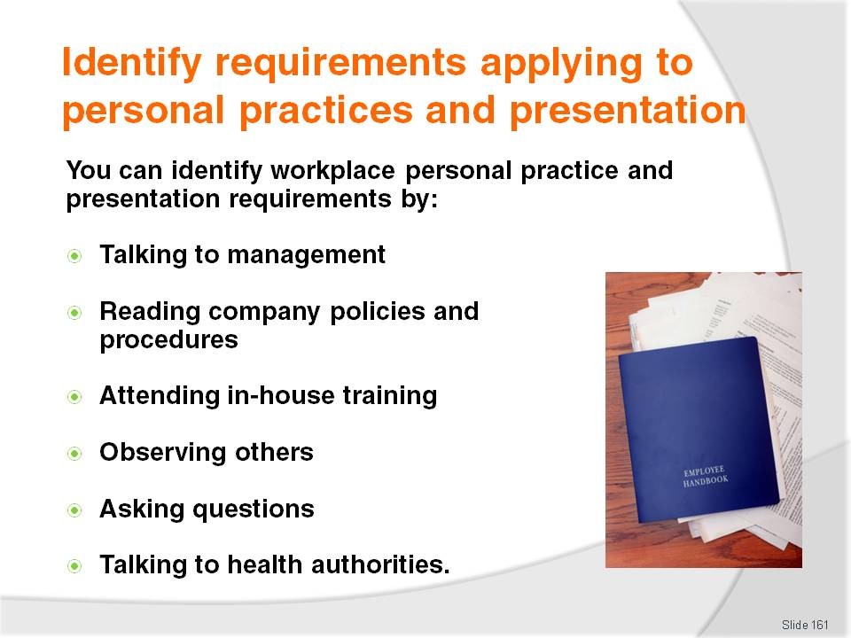
Slide No | Trainer Notes
Trainer explains to trainees that in addition to safe food handling practices and protocols, enterprise standards and legislated requirements can also apply to the personal practices and presentation of food handling staff, stating these requirements can be identified by:
Speaking with management, supervisor and more experienced staff to ask them what requirements apply
Reading company policies and procedures applying to food – including those relating to safe food handling, staff work practices, personal hygiene, personal presentation and staff sickness. These policies and procedures may be available:
- In a staff handbook
- In a ‘Policies and procedures manual’ available for inspection by staff in staff rooms, meal rooms and change rooms
- Through an in internal intranet system
- As checklists and posters in the workplace – strategically located to provide staff with on-the-spot directions to help create and maintain a safe food environment
Attending all mandatory in-house training – many employers require all food handlers to attend and successfully complete a ‘basic food hygiene’ course (or similar) before they are allowed to handle food in any way. Some employers require all food handlers to have completed an externally conducted, and approved food safety course in addition to internal training (or as an alternative to it)
Observing practices of other staff and food handlers – and following their lead
Asking questions – of trainers, supervisors, other staff, co-workers
Talking to health authorities – and asking them what applies and what has to be complied with.
Class Activity – Guest Speaker
Trainer arranges for a senior manager or owner of a food premises to attend and talk to trainees about:
Potential negative impacts of not complying with appropriate personal practice, health and presentation requirements
The requirements they have for staff personal practice, health and presentation
How they address staff failing to comply
Training available to communicate these requirements
How staff become aware of these requirements
Why each requirement was put in place.

Slide
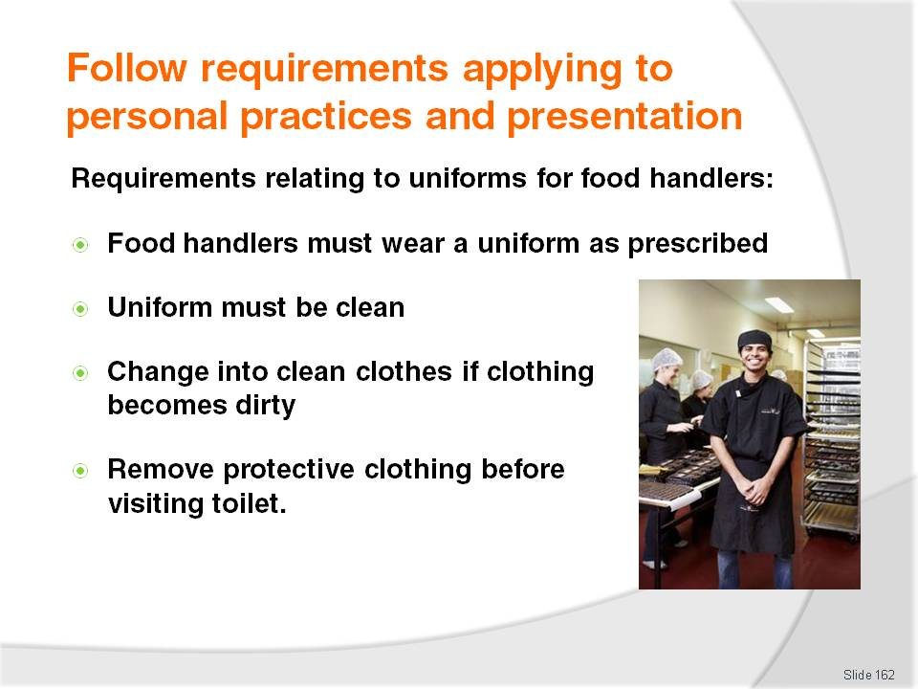
Slide No | Trainer Notes
Trainer reminds trainees all the enterprise standards and legislated requirements identified by investigation, research, training, talking to management and reading internal policies and procedures must be adhered to at all times by food handlers.
Trainer identifies requirements relating to staff uniforms as being common throughout the industry highlighting for food handlers:
Most food establishments require a nominated uniform or other personal protective clothing to be worn when working
Protective clothing (apron, hat, coat, trousers) worn by food handlers must be clean – dirty clothing may directly or indirectly contaminate food and/or food preparation equipment or surfaces. All food handlers are obliged to ensure their clothing does not contaminate food or food-related equipment, utensils or surfaces
Clothing that becomes dirty and a risk to food must be changed – to avoid cross contamination. Outer clothing needs to be changed when it has become soiled as a result of handling exposed (that is, not packaged) high risk raw food and there is then a need to handle exposed ready-to-eat food
Protective clothing such as aprons, overalls, hats, gloves and other outer protective clothing and equipment should be removed before visiting the toilet.

Slide
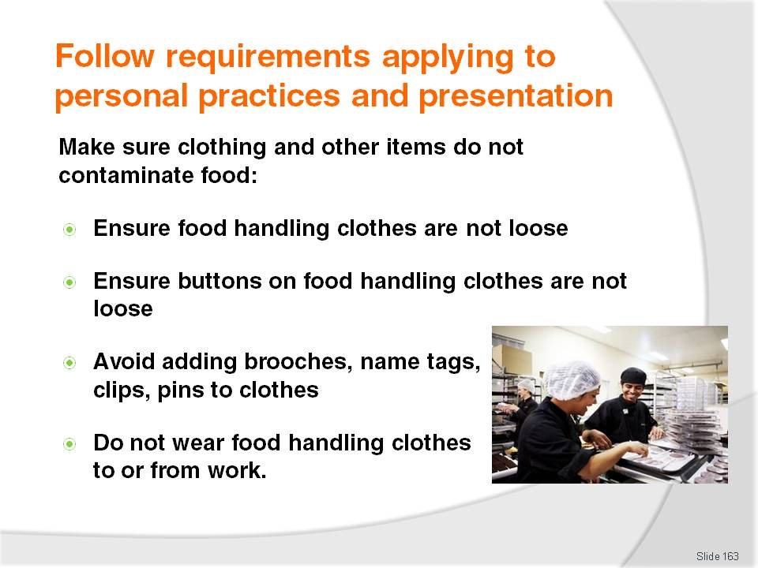
Slide No | Trainer Notes
Trainer advises trainees they must take care to ensure none of their clothing or other items they wear will contaminate the food they handle explaining the biggest cause of concern in this regard is items falling into the food and present a physical contamination problem, and clothing making contact with food or food contact surfaces and providing a source of cross contamination.
Trainer presents practical measures to help guard against contamination from clothes:
Ensure uniform or food handling clothes are not loose – or sleeves can dangle into food, and present an OSH danger
Ensure buttons on food handling clothes are not loose – to prevent them falling into food and presenting a physical contaminant
Avoid adding brooches, name tags, clips, pins to clothes – unless they are securely fastened and unable to fall off
Do not wear food handling clothes to and from work – as they can pick up dirt and present a cross contamination hazard.

Slide
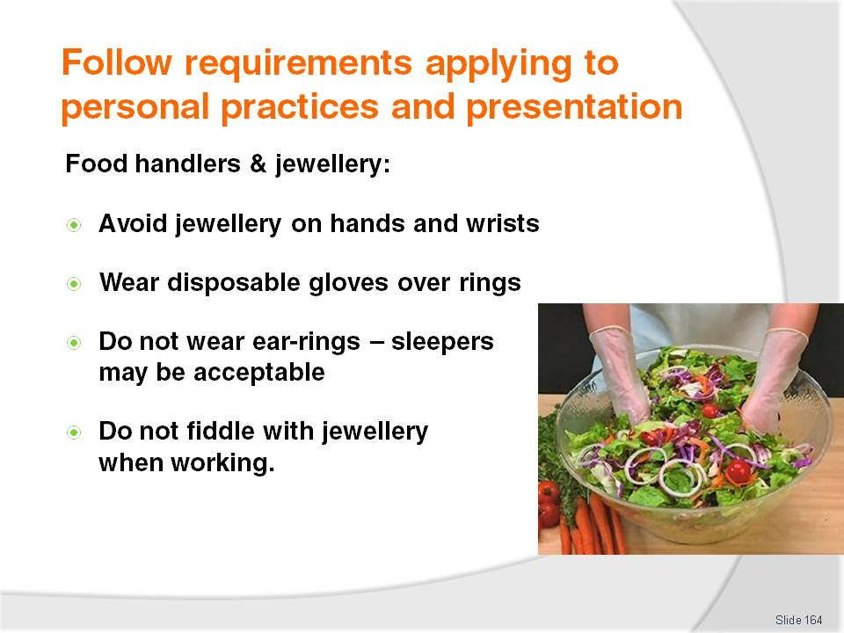
Slide No | Trainer Notes
Trainer presents trainees with practical measures to avoid food safety problems from jewellery:
As a food handler avoid all jewellery – and watches – on hands and wrists. Even plain, banded rings can cause a potential food poisoning source
Disposable gloves should be when handling food if these are worn. Some house rules ban the wearing of all jewellery by food handlers
Do not wear ear-rings – ear-rings that dangle are the worst but not wearing them at all is preferable. Sleepers may be acceptable but check house rules first
Avoid fiddling with jewellery – especially ear-rings in pierced ears. This can cause cross contamination and also loosen items making them more likely to fall off.

Slide
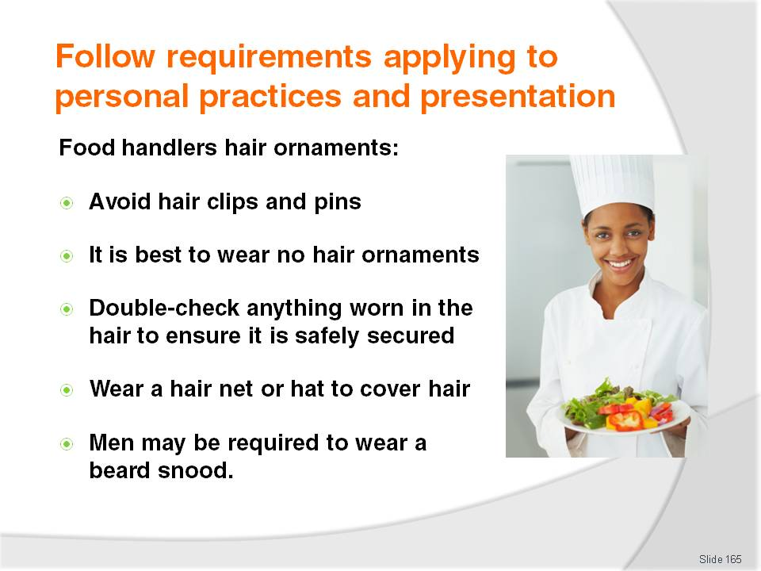
Slide No | Trainer Notes
Trainer highlights practical measures to trainees relating to the wearing of hair ornaments for food handlers:
Do not wear hair clips or hair pins
As a food handler it is preferable to wear no hair ornaments at all
If something is worn in the hair, double-check to ensure it is securely fastened in place
Wear a hair net or hat to guard against items falling out of the hair and into food or into food preparation equipment or onto food preparation surfaces
Men may be required to wear a beard snood – to stop facial hair falling into food.

Slide
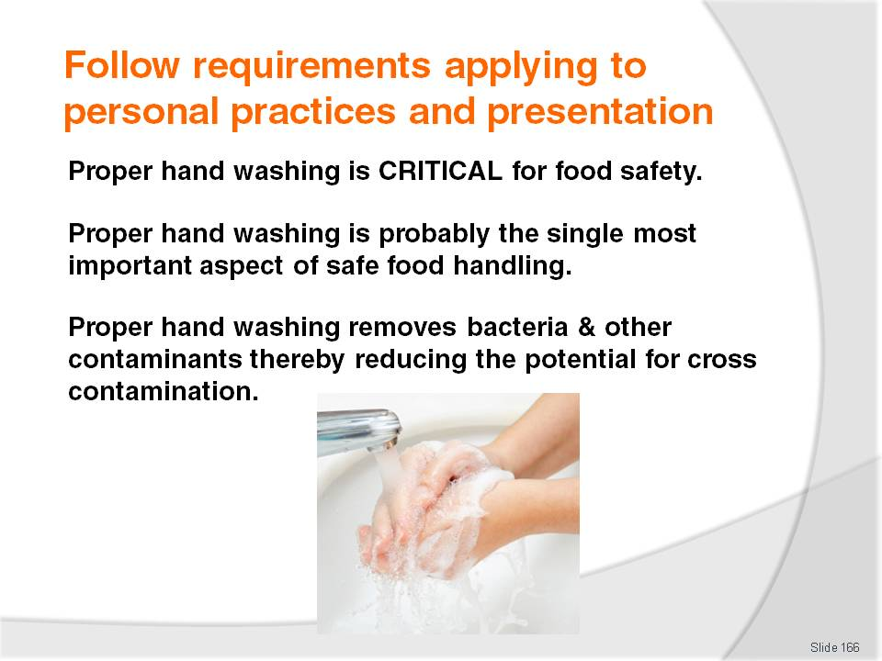
Slide No | Trainer Notes
Trainer introduces the topic of hand washing to trainees emphasising this is an extremely important section and stressing health authorities believe the single most important aspect in preventing food poisoning outbreaks is for food handlers to wash their hands properly and to wash them ‘when required’.
Trainer stresses hands need to be washed in order to remove potential food poisoning sources from the hands so the possibility of cross contamination is reduced.

Slide
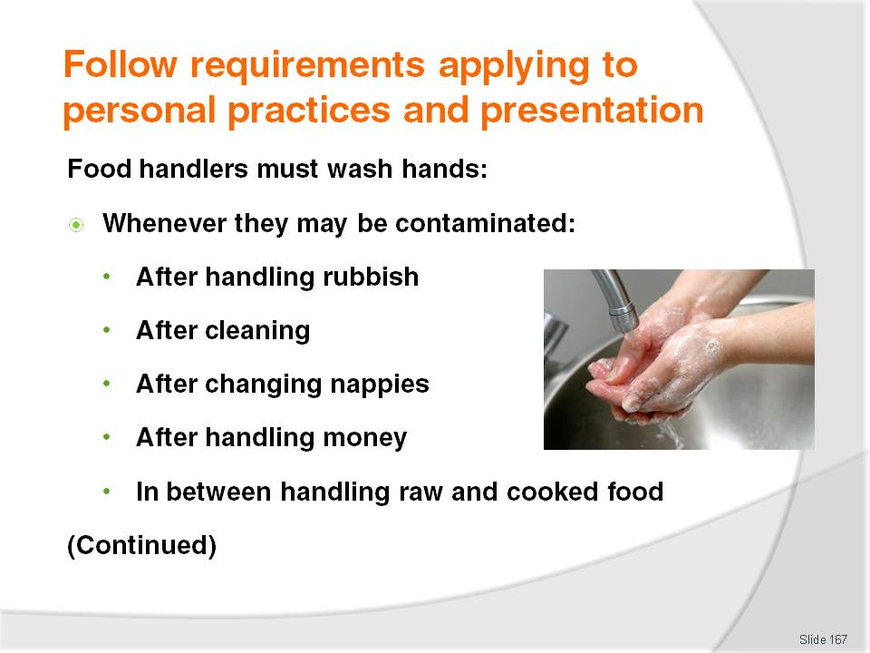
Slide No | Trainer Notes
Trainer identifies to trainees the times when food handlers must wash their hands:
Any time the hands are likely to be a source of contamination – this can cover a wide range of possible circumstances and it is impossible to identify them all but the following is a representative list:
- After handling rubbish and before handling food or food contact surfaces
- After undertaking cleaning duties and before handling food or food contact surfaces
- After handling animals and before handling food or food contact surfaces
- After changing a baby’s nappy and before handling food or food contact surfaces
- After handling money and before handling food or food contact surfaces
- In between handling raw food (meat, fish or chicken) and handling other foods such as cooked and/or ready-to-eat food.

Slide
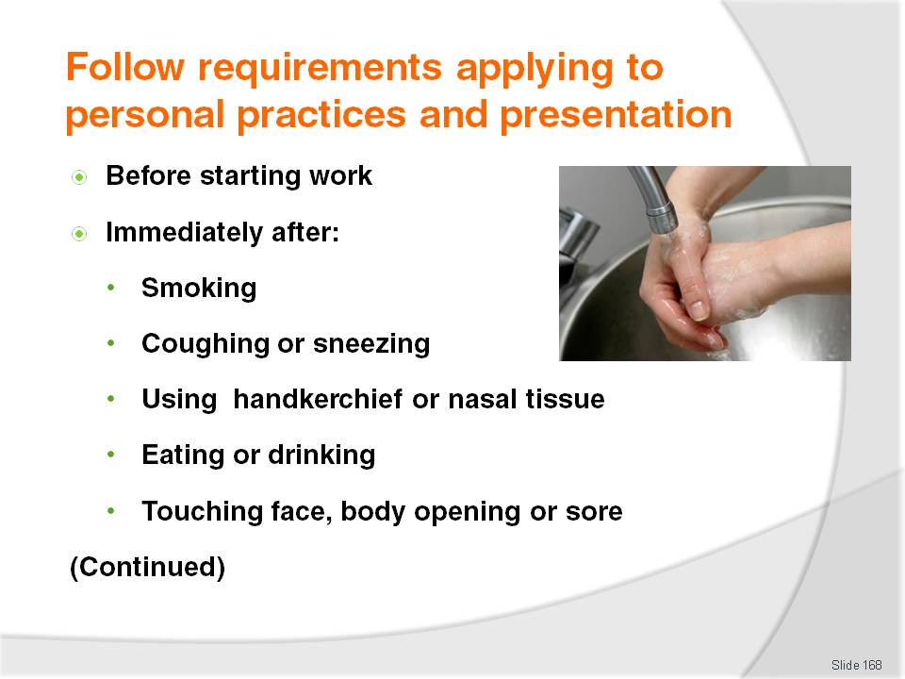
Slide No | Trainer Notes
Trainer continues to identify to trainees the times when food handlers must wash their hands:
Before starting food handling duties – this means food handling staff must wash their hands when they arrive at work even though they may have showered, bathed or washed their hands at home before coming to work
Immediately after engaging in nominated activities proven to be associated with bacterial transfer or cross contamination. The nominated activities include:
- Smoking – including using tobacco products
- Coughing or sneezing
- Using a handkerchief or nasal tissue – which includes blowing the nose
- Eating or drinking
- Touching hair, scalp, mouth, nose, ears, anybody opening or any wound.

Slide
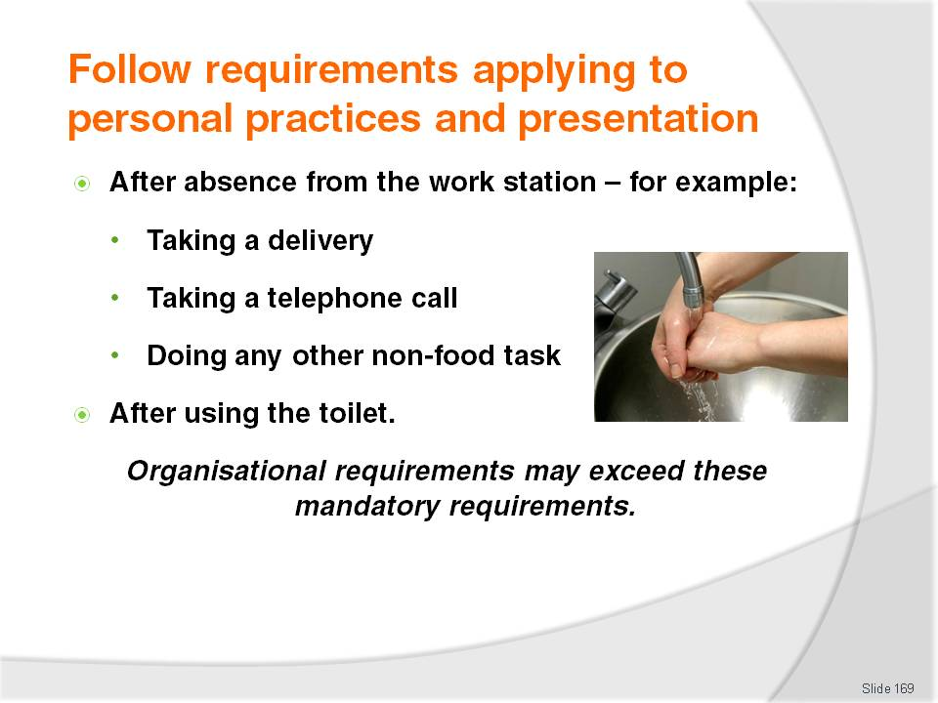
Slide No | Trainer Notes
Trainer continues to identify to trainees the times when food handlers must wash their hands:
After any absence from the work station – this means every time a food handler leaves the kitchen (or other place where they are handling food), they must wash their hands on their return to work and before they handle food. These absences from the work station may involve or be caused by:
- Leaving the kitchen to accept a delivery of food into the premises from a supplier
- Taking a phone call
- Doing another job that is not a food-related task
Immediately after using the toilet and before handling food or food contact surfaces – this applies to all instances where the toilet was used and includes a requirement to wash hands after urination as well as after defecation.

Slide
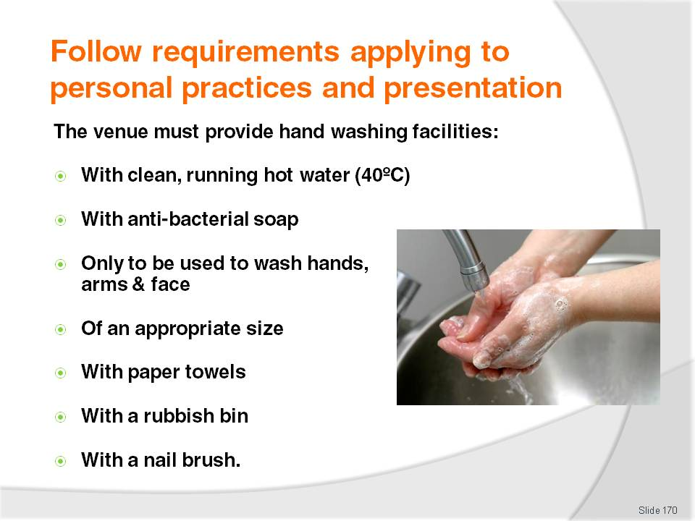
Slide No | Trainer Notes
Trainer tells trainees management in food premises must provide staff with hand washing facilities which are:
Be supplied with a continuous supply of warm running, potable water – the accepted temperature of this water to be 40ºC
Be supplied with soap – most food premises use bulk soap dispensers dispensing liquid anti-bacterial soap: the use of bars of soap is to be avoided as the soap can transfer bacteria
Only be used for washing hands, arms and face – the wash hand basins must not be used for other purposes such as a food preparation sink. Sinks in the kitchen or food preparation area used for other purposes (washing vegetables, preparing food) must not be used for hand washing
Be of an appropriate size enabling the effective washing of hands
Be supplied with appropriate means of drying the hands – this can be single-use (paper) towels and hot air dryers. It is not acceptable for a business to provide only a hot air dryer. Re-usable towels can be used provided they are washed and dried after every use – this is extremely unlikely to happen in most businesses so the preferred option is to use paper disposable towel
Be supplied with a bin – for disposing of used disposable towels
Consideration should also be given to providing a nail brush so proper hand washing (including cleaning under the fingernails) can occur.

Slide
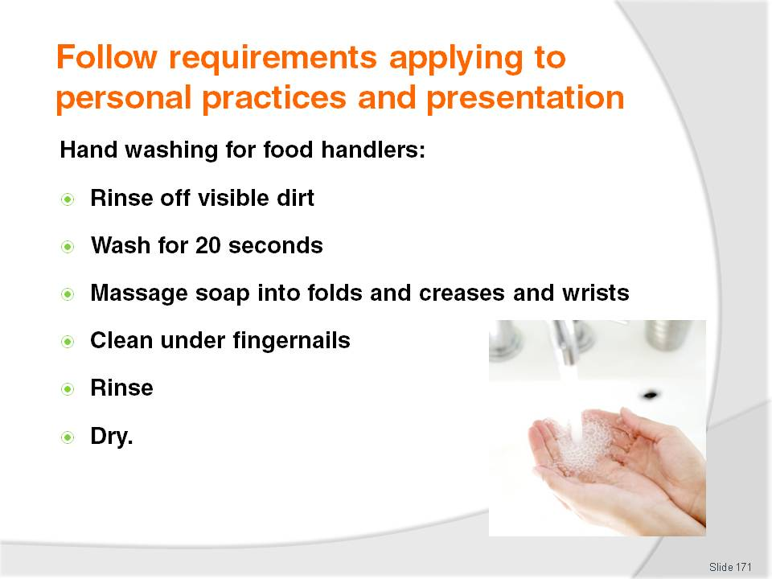
Slide No | Trainer Notes
Trainer explains to trainees how they should wash their hands as food handlers:
Rinse off visible and easy to remove dirt
Wash their hands for at least 20 seconds
Thoroughly and vigorously massage the soap into the folds and creases of the hands and wrists
Clean under the fingernails
Rinse the soap from the hands
Thoroughly dry the hands – the preferred method of drying hands is to:
- Shake off excess water
- Dry with paper towel
- Finish with hot air dryer.
Class Activity 1) – Demonstration
Trainer shows trainees how to correctly wash hands.
Class Activity (2) – Exercise
Trainer uses commercially available hand washing demonstration kit (see http://www.foodstars.com.au/Handwashingkit.htm) to demonstrate importance of proper hand washing.

Slide
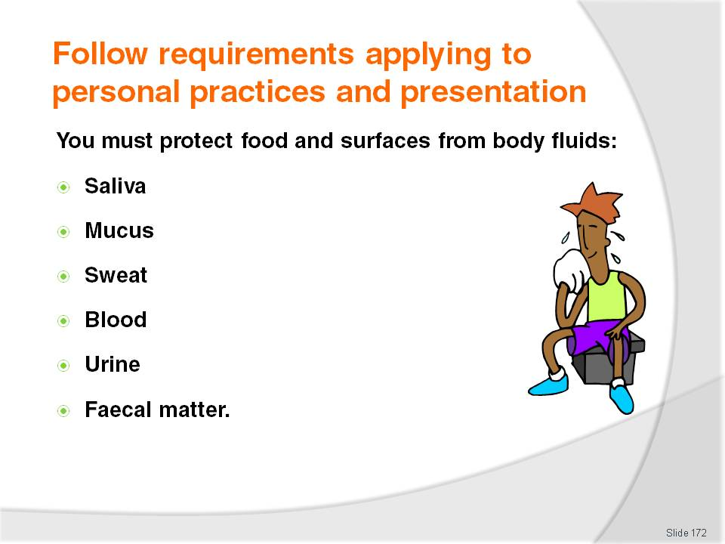
Slide No | Trainer Notes
Trainer states to trainees it is important for food handlers to protect food and food-contact surfaces from ‘body fluids’ which can be seen to include:
Saliva
Mucus
Sweat (perspiration)
Blood
Urine
Faecal matter.

Slide
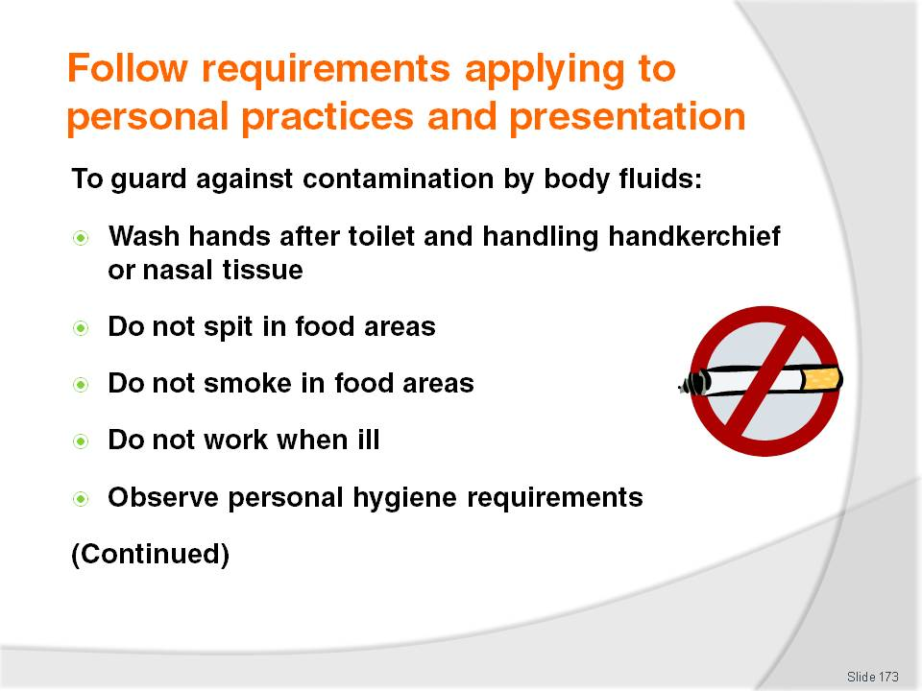
Slide No | Trainer Notes
Trainer presents trainees with practical ways food handlers can protect food and food-contact surfaces from body fluids:
Washing hands thoroughly after using the toilet
Washing hands thoroughly after handling a handkerchief or nasal tissue to cough or sneeze into, and or using it to blow the nose
Refraining from spitting in any food area
Refraining from smoking or chewing tobacco in any food area
Staying away from work when suffering cold or flu symptoms – and obtaining a doctor’s certificate stating as a food handler it is safe to return to work
Observing all personal hygiene rules.

Slide
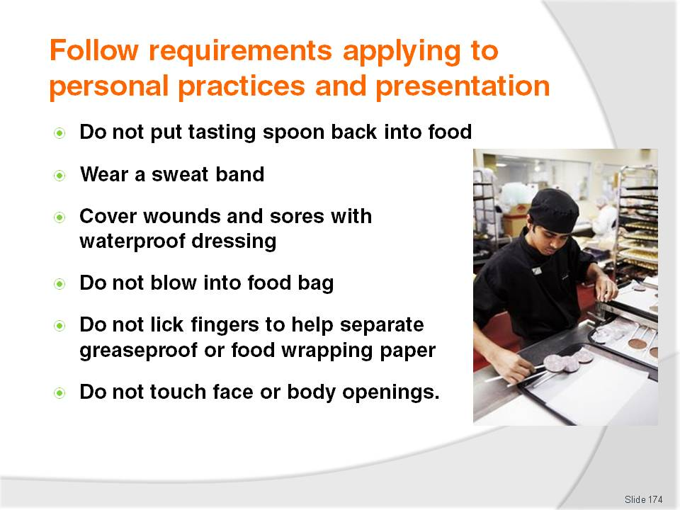
Slide No | Trainer Notes
Trainer continues advising trainees of action to take to prevent contamination of food and food preparation surfaces by body fluids:
Avoiding the tasting of food with a spoon and then returning the utensil to the food
Wearing a sweat band – or mopping areas that sweat and then thoroughly washing hands: consider wearing anti-perspirant
Covering all cuts and sores with approved waterproof dressings and bandages – and adding a finger stall and or disposable glove, as appropriate
Not blowing with the breath into a bag to be used to wrap food – such as take away foods
Not wetting fingers to assist with separating sheets of wrapping paper when packaging take away foods
Not touching anybody opening – such as ears, eyes, nose; thorough hand washing must occur if this happens.

Slide
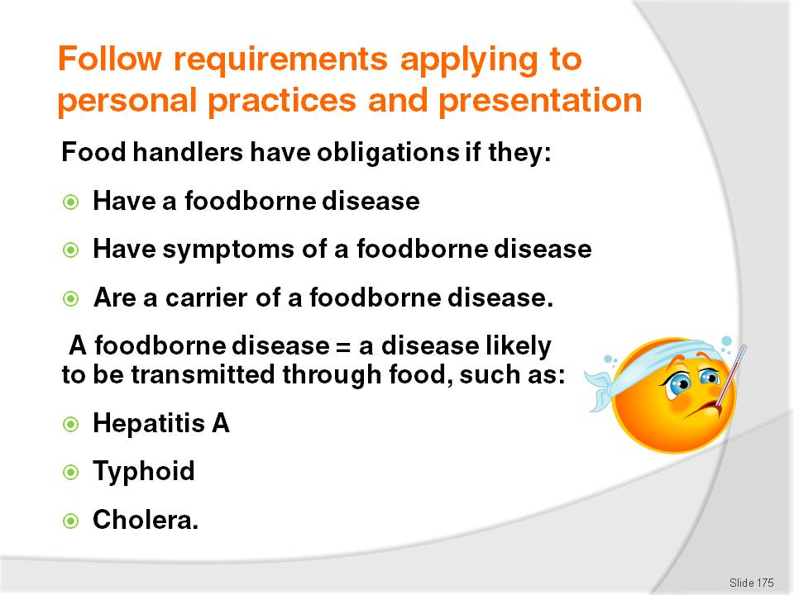
Slide No | Trainer Notes
Trainer explains to trainees they have obligations on them if they have – or have symptoms of – a food borne disease highlighting:
They can only know they have a foodborne disease or if they are a carrier of a foodborne disease if they have been to a doctor and had tests to identify the illness
Common sense must be used when determining if they have symptoms of a foodborne disease – see next slide for examples of symptoms
Food borne diseases are serious and potentially life threatening and include (but are not limited to) Hepatitis A, typhoid and cholera.
Class Activity – Handout
Trainer distributes copies of ‘Tables of pathogens transmitted by food contaminated by infected food handlers’ (see Trainee manual) to trainees and discusses the diseases listed with the intention of raising awareness about foodborne diseases.

Slide
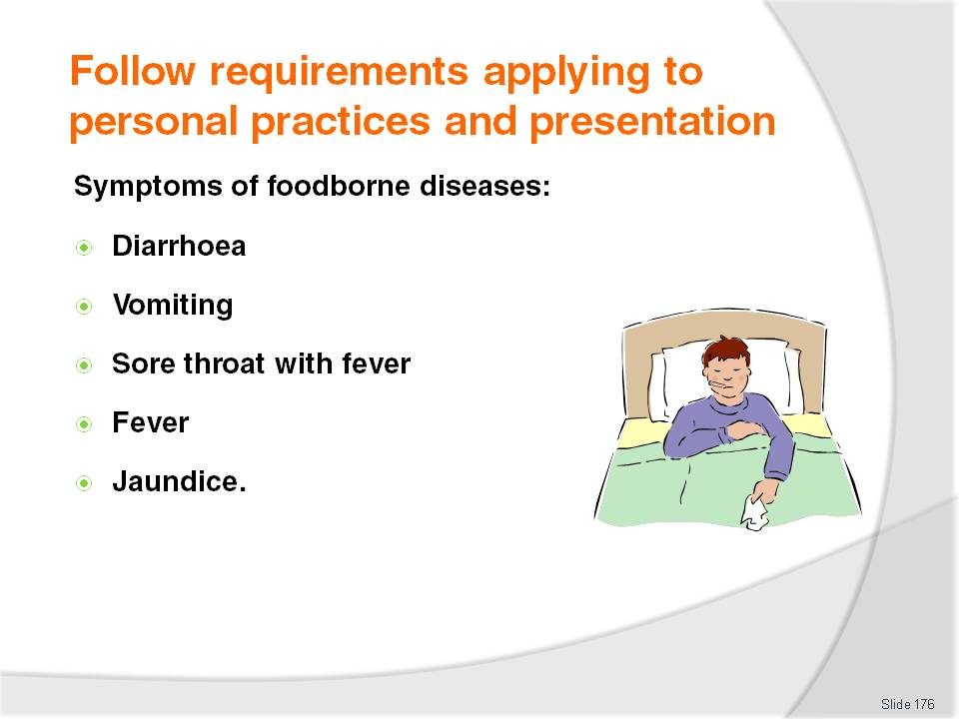
Slide No | Trainer Notes
Trainer provides trainees with examples of symptoms of a foodborne disease:
Diarrhoea
Vomiting
Sore throat with fever
Fever
Jaundice.

Slide
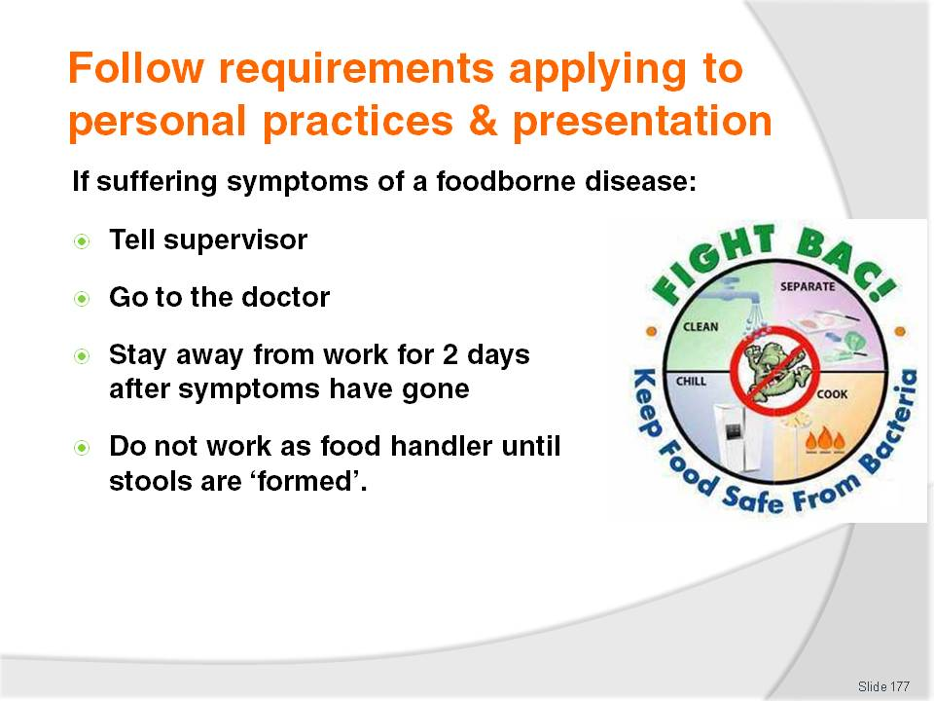
Slide No | Trainer Notes
Trainer identifies for trainees the obligations they are under as food handlers if ill:
If affected by symptoms of a foodborne disease:
- Notify supervisor
- Seek medical advice
- Stay away from work for 48 hours after symptoms disappear
- Do not return to work until stools are ‘formed’ (solid).

Slide
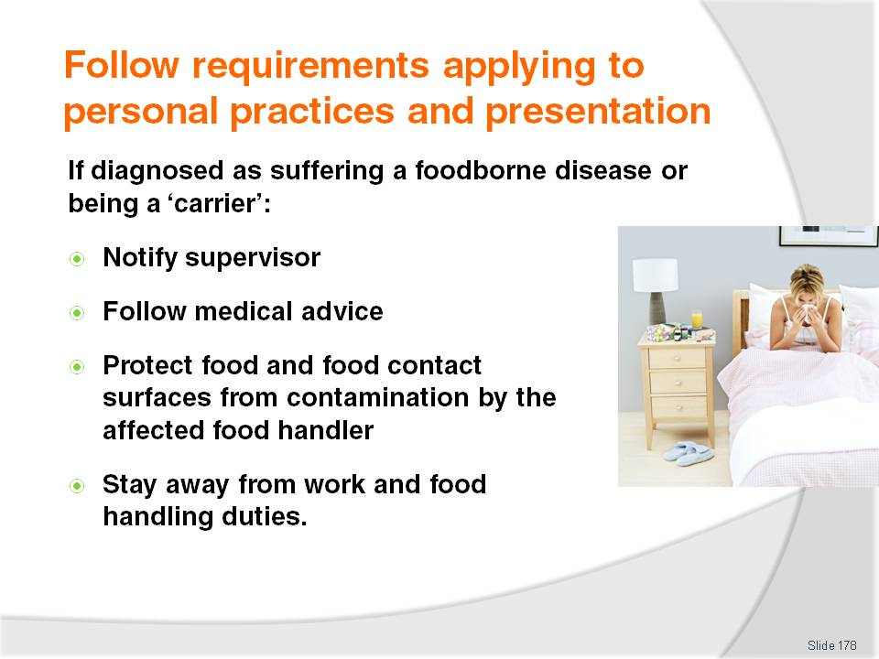
Slide No | Trainer Notes
Trainer tells trainees if they are diagnosed by a doctor as having a foodborne disease, or as being a carrier of a foodborne disease, they must:
Tell supervisor – so they can make suitable arrangements (such as obtain replacement staff, or transfer person to other non-food handling duties)
Follow medical advice and direction – about what work can be safely undertaken; how long to refrain from food handling duties; medication to take
Take necessary action to protect food from contamination – including protection of actual food; protection of food contact equipment, utensils and surfaces; discarding food thought or known to have been contaminated when the food handler was handling the food before the foodborne disease was diagnosed.
Class Activity – Guest Speaker
Trainer arranges for a Health department representative to attend and talk to trainees about:
Local laws regarding sickness and food handlers
Symptoms of illness and foodborne diseases
Role of doctors and the health department in dealing with sick food handlers
Consequences and penalties for food handlers who do not comply with legislated requirements
Action food handlers should take if they think/know they are ill
Requirements applying when food handlers have ‘a condition’.

Slide
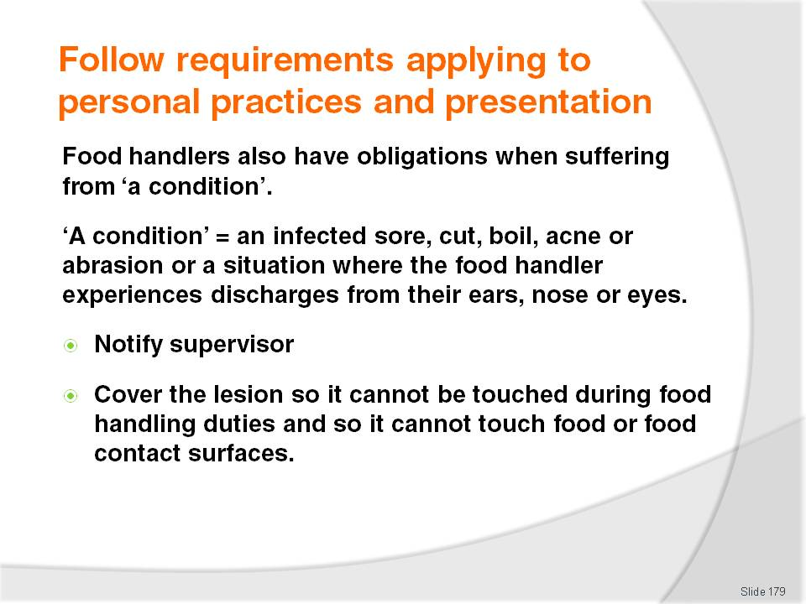
Slide No | Trainer Notes
Trainer informs trainees that food handlers are also under certain obligations when suffering from ‘a condition’, explaining:
A condition is an infected sore, cut, boil, acne or abrasion or a situation where the food handler experiences discharges from their ears, nose or eyes
Where a food handler is suffering from such a condition they must notify their supervisor unless they:
- Do not have direct contact with food, food contact surfaces, crockery, cutlery or glassware
- The skin lesion is on a covered part of the body so he sufferer cannot touch it while handling food.

Slide
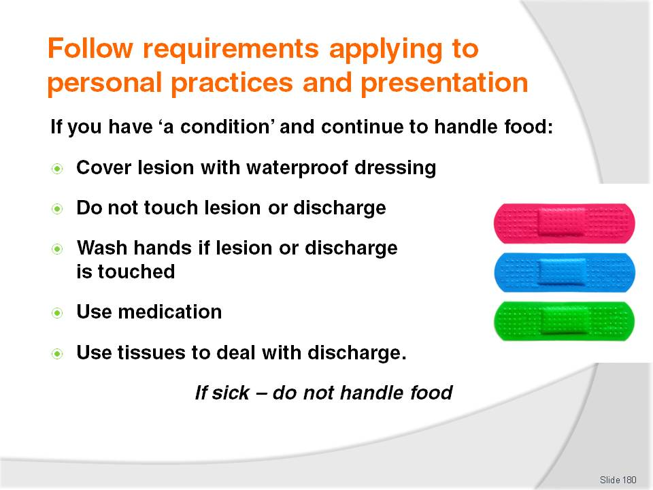
Slide No | Trainer Notes
Trainer tells trainees if a food handler with ‘a condition’ does continue working (whether food handling or other work activities) they must ensure measures are taken to avoid contaminating food – these measures may include:
Covering the lesion completely with a waterproof bandage or dressing – to prevent it making contact with food and food contact surfaces
Not touching the lesion or discharge while working – to avoid potential from cross contamination
Washing hands thoroughly if the lesion or discharge is touched – to guard against cross contamination
Using appropriate medication for the problem – to speed up recovery from the condition
Using disposable tissues (as opposed to a handkerchief or kitchen swab) to handle discharge, followed by proper hand washing – to protect against cross contamination.

Slide
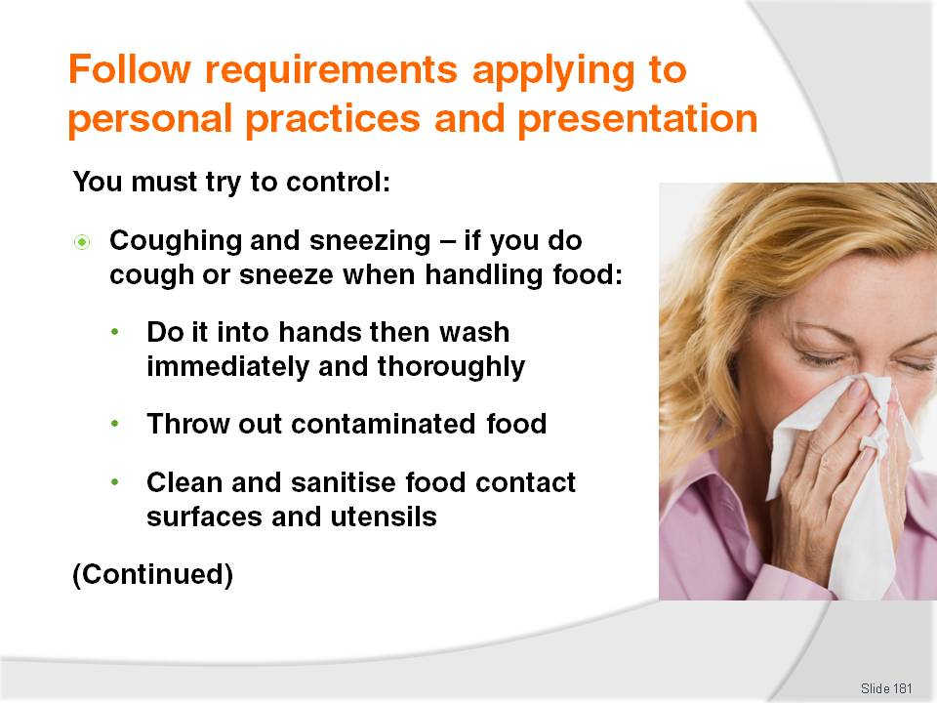
Slide No | Trainer Notes
Trainer highlights to trainees all food handlers need to try to control personal habits and sub-conscious actions in order to further optimise food safety:
Try to refrain from coughing or sneezing onto unprotected food – where a cough or sneeze is inevitable (or unexpected) and unprotected food is present, the recommended procedure is to:
- Cough or sneeze into hands and then thoroughly wash hands
- Dispose of any food that has been contaminated – any food that has been coughed or sneezed onto
- Clean and sanitise any food surfaces, equipment or utensils that have been contaminated.

Slide
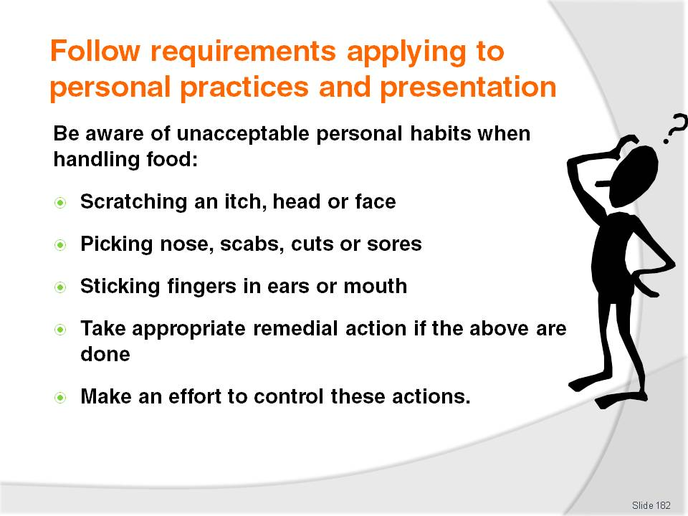
Slide No | Trainer Notes
Trainer advises trainees food handlers must also discipline themselves to refrain from certain personal habits:
Do not scratch (such as scratching an itch; scratching head when thinking), pick nose, cuts, sores and scabs, or touch eyes, nose, mouth or ears while at work
This is another major source of contamination transferring bacteria from the skin or other areas to food, utensils or food preparation/contact surfaces. If these do occur:
- Dispose of any food that has been contaminated
- Clean and sanitise any food surfaces, equipment or utensils that have been contaminated
- Try not to do it again.

Slide
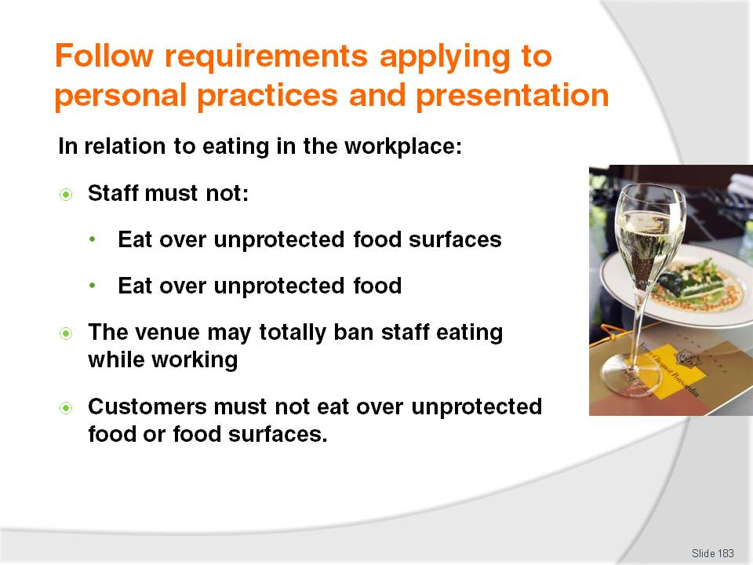
Slide No | Trainer Notes
Trainer advises trainees in regard to eating in the workplace by food handlers:
When staff eat in food areas they must:
- Not eat any food over an unprotected food surface – such as food preparation equipment, preparation benches, serving equipment or crockery, cutlery or glassware
- Not eat any food over any unprotected food – this applies to raw food, ready-to-eat food or any food that is not covered, wrapped or packaged so that it cannot become contaminated through food falling onto it
Individual premises may have house policies totally forbidding the consumption of food while working
These requirements in relation to eating over unprotected food and unprotected food surfaces applies to anyone on the premises – including members of the public, customers and visitors.

Slide
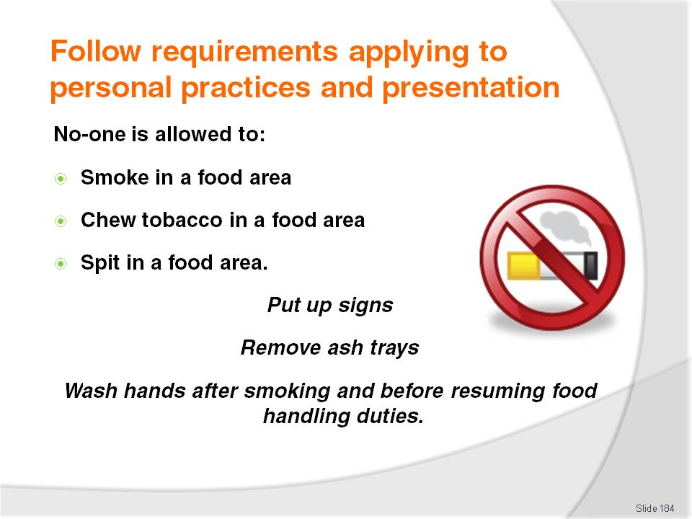
Slide No | Trainer Notes
Trainer informs trainees regarding smoking and spitting in food areas:
In any food area, food handlers (and any other person) must never:
- Smoke
- Chew tobacco
- Spit
It is a good idea to put up ‘No Smoking’ posters in all food areas and to remove ash trays from these areas
Hands must be washed after smoking and before returning to work as a food handler to remove any bacteria transferred from the mouth/lips to the fingers as part of the smoking process.

Slide
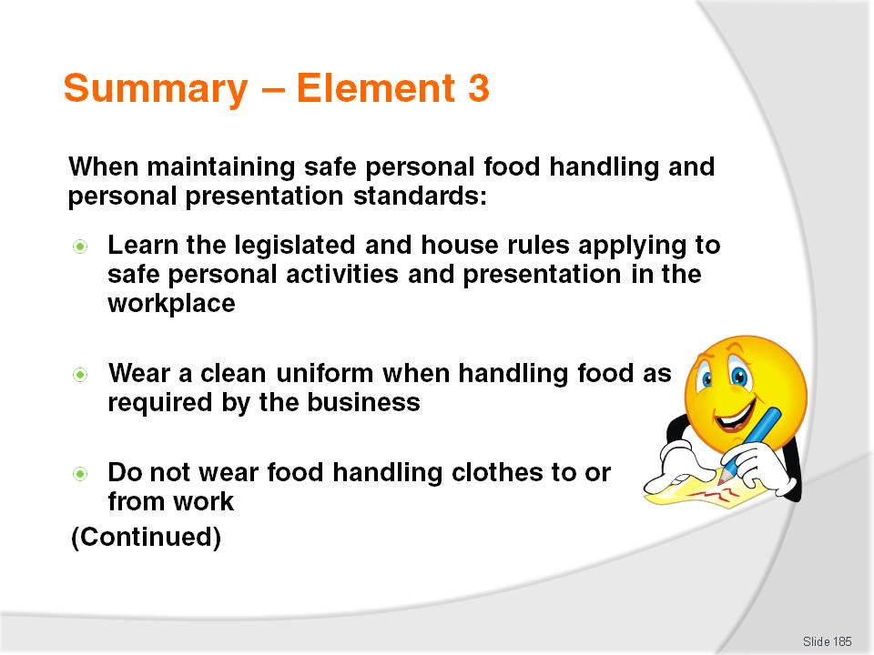
Slide No | Trainer Notes
 | Trainer provides a recap of the Element asking questions to check trainee understanding and responding to questions from trainees, as required.

Slide
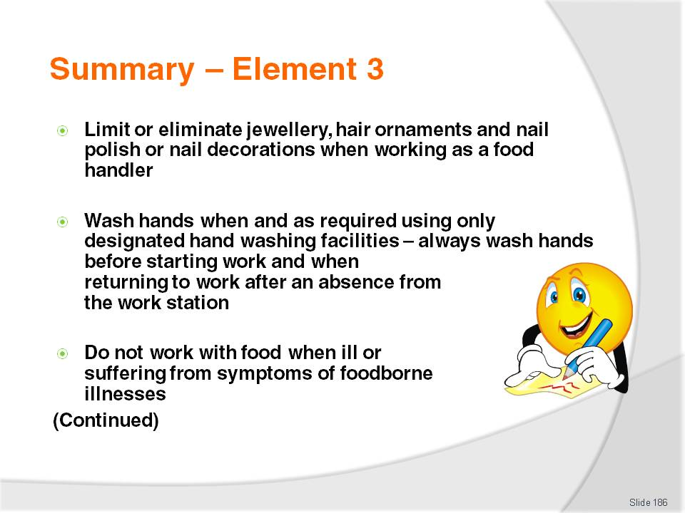
Slide No | Trainer Notes
 | Trainer provides a recap of the Element asking questions to check trainee understanding and responding to questions from trainees, as required.

Slide
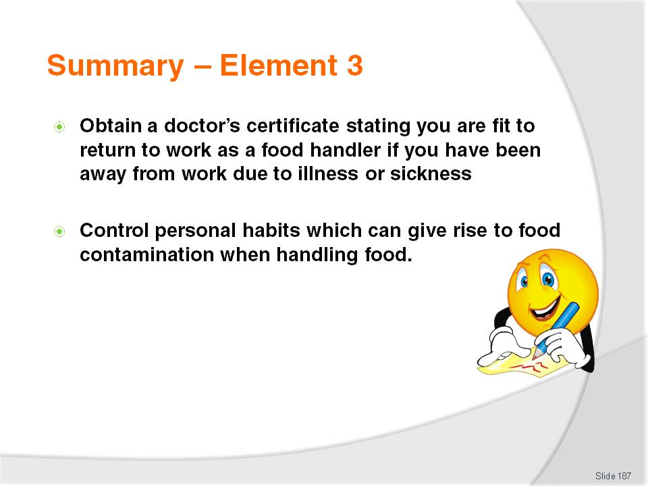
Slide No | Trainer Notes
Trainer provides a recap of the Element asking questions to check trainee understanding and responding to questions from trainees, as required.
Trainer thanks trainees for their attention and encourages them to apply course content as required in their workplace activities.

Recommended training equipment
Access to food facilities such as kitchen, goods receival area, storage areas (dry goods, refrigerated goods, frozen goods), service areas, food preparation and cooking, dishwashing and pot washing, storage areas for clean crockery, cutlery and cooking equipment
Host country safe food handling/food safety legislation at a national, regional and local (as/where appropriate) – this must also address obtaining sample/relevant food safety programs/plans applicable to the country and/or any Codes that apply
Copy of ‘Safe Food Australia’ (also known as ‘Chapter 3’ of the Australia New Zealand Food Standards Code)
Probe food thermometer – including spare batteries; sanitising wipes; storage container; instructions. An infra-red thermometer should also be purchased to show trainees what not to use and to demonstrate the limitations of this option.
Access to display units, refrigeration units and bain maries for demonstrations (cleaning; taking temperature reading). Access to hot and cold refrigerated food to demonstrate how to take temperature readings.
Examples of food safety records that may be kept by food premises – such as:
- Approved Food Suppliers List
- Goods Receiving Form
- Cold Storage Temperature Log
- Ready To Eat Food On Display Log
- Equipment Calibration Log
- Internal Review Process temperature Log
- Corrective Action Record/Report (CAR).
Colour-coded chopping boards
Range of cleaning chemicals such as detergent, sanitiser, deodoriser, degreaser – Material Safety Data Sheets should accompany each of these.
De-naturing agent (for use in drip trays)
Range of cleaning items such as mop and bucket, brushes, broom, cleaning cloths
Sink, anti-bacterial soap, hot water, paper towel and hot air dryer to demonstrate how to correctly wash and dry hands
Disposable gloves
Sample cleaning schedules and cleaning instructions for individual pieces of food preparation equipment such as mixers, ovens, toasters, cook tops), utensils (beaters, strainers, knives) and food preparation areas (floors, walls, ceiling, exhaust fans)
Hand washing demonstration kit – see http://www.foodstars.com.au/Handwashingkit.htm

Examples of single use items – take away food and beverage containers; cutlery; serviettes; drinking straws; tooth picks; food wrappers and packaging
Colour coded labels – used to control time food is displayed for sale/service
Hair nets, beard snoods.

Instructions for Trainers for using
PowerPoint – Presenter View
Connect your laptop or computer to your projector equipment as per manufacturers’ instructions.
In PowerPoint, on the Slide Show menu, click Set up Show.
Under Multiple monitors, select the Show Presenter View check box.
In the Display slide show on list, click the monitor you want the slide show presentation to appear on.
Source: http://office.microsoft.com
Note:
In Presenter View:
You see your notes and have full control of the presentation
Your trainees only see the slide projected on to the screen
More Information
You can obtain more information on how to use PowerPoint from the Microsoft Online Help Centre, available at: http://office.microsoft.com/training/training.aspx?AssetID=RC011298761033
Note Regarding Currency of URLs
Please note that where references have been made to URLs in these training resources trainers will need to verify that the resource or document referred to is still current on the internet. Trainers should endeavour, where possible, to source similar alternative examples of material where it is found that either the website or the document in question is no longer available online.

Appendix – ASEAN acronyms
AADCP | ASEAN – Australia Development Cooperation Program.
ACCSTP | ASEAN Common Competency Standards for Tourism Professionals.
AEC | ASEAN Economic Community.
AMS | ASEAN Member States.
ASEAN | Association of Southeast Asian Nations.
ASEC | ASEAN Secretariat.
ATM | ASEAN Tourism Ministers.
ATPMC | ASEAN Tourism Professionals Monitoring Committee.
ATPRS | ASEAN Tourism Professional Registration System.
ATFTMD | ASEAN Task Force on Tourism Manpower Development.
CATC | Common ASEAN Tourism Curriculum.
MRA | Mutual Recognition Arrangement.
MTCO | Mekong Tourism Coordinating office.
NTO | National Tourism Organisation.
NTPB | National Tourism Professional Board.
RQFSRS | Regional Qualifications Framework and Skills Recognition System.
TPCB | Tourism Professional Certification Board.







